PURCHASE LETTER OF INTENT
Issued to Seller |  | Phoenicium Ltd | Shlomi, Israel, 2283200
 |  | Attention (PIC) | Dr. Samuel Schidem
 |  | Ref | Mr. Nilesh Thakkar
LOI Issue No. and Date |  | Bull/2607/007 , Saturday, 26th July 2025
Valid Till |  | Saturday 2nd August , 2025 (2000HRS Dubai Time)
Purchase Incoterms |  | CIF AWSP, China
Issued by Buyer |  | Bullfrog Trading LLC | Office No. 206, The Business Centre, Opp. Burjuman Mall, Al Hamriya, Bur-Dubai, Dubai, United Arab Emirates
 |  | Attention (PIC) | Mr. Vaman Kumar, CEO
Sr. No. | Parameters | Details
01 | Commodity | Copper Cathode Grade A as per LME Standard
02 | Origin | Pls Advise
03 | Quantity | 500MT [+/- 5% in Seller’s option as a trial], 2,000mt Every Month for 12 Months
04 | Incoterms Terms | CIF AWSP
05 | Delivery period | Pls Advise
06 | Price | LME cash bid price on the date of delivery - 20% discount per MT
07 | Contract Confirmation | Subject to Producer’s Confirmation of cargo
08 | Commodity  Specifications | Grade A Copper as per LME Standards. Cargo must conform to the physical and chemical specifications of the following standards;  - BS EN 1978 : 1998 – Cu-CATH-1  - GB/T 467 - 2010 – Cu-CATH-1  - ASTM B115 - 10 – Cathode Grde-1
09 | Payment Terms | By DLC against 2% Performance Bond
10 | Documents for Payment | - Seller’s export permit, and 3 copies  - Commercial Invoice, 3 Original and 3copies  - Packing List, 3 originals and 3 copies  - Certificate of Origin, 3 originals and 3 copies  - Assay Report, signed by office de control of DRC, 3 Original and 3 copies  - Certificate of quantity and quality issued by an international independent surveyor such as CCIC/ALFRED H. KNIGHT / SGS at loading port bonded warehouse in, in 3 original and 3 copies.  - Certificate of quantity and quality issued by an international independent surveyor such as CCIC/ALFRED H. KNIGHT / SGS at discharge port in, in 3 original and 3 copies.  - Container Stuffing report issued by CCIC/ Alfred H. Knight/SGS at loading port.  - Certificate of Movement, issued by seller to declare that the product is clean and free from any lien and or Encumbrance.3 original and 3 copies.  - Insurance Policy of 110% of the invoice value issued by first class insurance company indicating claims payable at China
11 | Other terms & conditions | For DLC, after signing of SPA, Seller must arrange RWA by MT199 from LC receiving bank indicating their readiness to accept LC and issue performance bond 2% of the value of DLC within 2 working days from the receipt of DLC .
12 | Compliance | Seller must send KYC documents to compliance@bullfrog.ae upon siging of SPA but before issuance of DLC.

We look forward to hearing from you within the stipulated LOI Validity and look forward to a long term and mutually fruitful association.

With warm regards,

For & On Behalf of
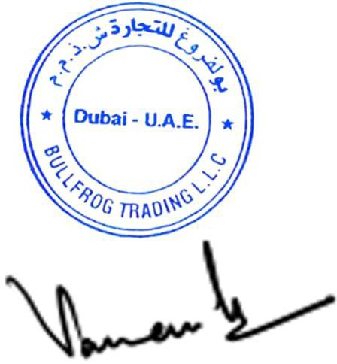
Bullfrog Trading LLC

