PURCHASE LETTER OF INTENT

Issued to Seller
Seller | Bullfrog LLC  Dubai UAE
Attention (PIC) | VK — VK@BULLFROG.AE
Ref | VK
LOI Issue No. and Date | _______________ , 10 March 2026
Valid Till | 15th march 2026
Purchase Incoterms | CIF
Issued by Buyer
Buyer | Bullfrog LLC  Dubai UAE
Attention (PIC) | VK — VK@BULLFROG.AE

Sr. No. | Parameters | Details
01 | Commodity | Bauxite
02 | Origin | Guinea
03 | Quantity | 200000
04 | Incoterms Terms | CIF
05 | Delivery period | 15-20th April, 2026
06 | Price | USD 70
07 | Contract Confirmation | Upon signing of deal recap
08 | Commodity | Al203: 45%
09 | Payment Terms | DLC
10 | Documents for Payment | _______________
11 | Other terms & conditions | _______________
12 | Compliance | _______________

SPECIAL NOTES
thanks
We look forward to hearing from you within the stipulated LOI Validity
and look forward to a long term and mutually fruitful association.
With warm regards,
For & On Behalf of

AUTHORIZED SIGNATORY

For & On Behalf of:
Bullfrog LLC
Signature: ___________________________
Name: ___________________________
Title: ___________________________
Date: 10 March 2026

SIGNATURES
FOR & ON BEHALF OF SELLER  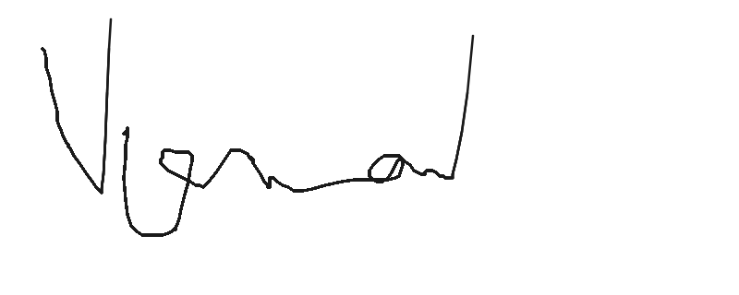  Name: Vaman Kumar  Date: 10 Mar 2026 | FOR & ON BEHALF OF BUYER    Name: vk  Date: 10 Mar 2026

Issued by Bullex Trading Platform

