PURCHASE LETTER OF INTENT

Issued to Seller
Seller | Al Fakhama UAE  UAE
Attention (PIC) | Ali — kumar.vaman@icloud.com
Ref | Ali
LOI Issue No. and Date | IMP-BUL-1003-184 , 10 March 2026
Valid Till | 7 DAYS
Purchase Incoterms | CIF
Issued by Buyer
Buyer | Bullfrog LLC  Dubai UAE
Attention (PIC) | VK — VK@BULLFROG.AE

Sr. No. | Parameters | Details
01 | Commodity | NPK
02 | Origin | EGYPT
03 | Quantity | 50000 MT
04 | Incoterms Terms | CIF
05 | Delivery period | 10-15
06 | Price | USD 100
07 | Contract Confirmation | SPA
08 | Commodity | N50%
09 | Payment Terms | DLC
10 | Documents for Payment | DOCUMENTS AS PER LC
11 | Other terms & conditions | PERFORMANCE BOND 2%
12 | Compliance | DIFC DUBAI

We look forward to hearing from you within the stipulated LOI Validity
and look forward to a long term and mutually fruitful association.
With warm regards,
Bullfrog LLC

Digital Signature:

Date: 10 March 2026

DIGITAL SIGNATURE
FOR & ON BEHALF OF BUYER / ISSUER
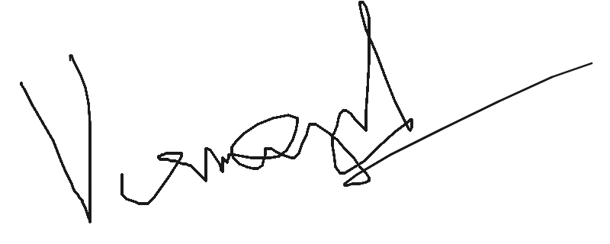
Name: VAMAN KUMAR
Date: 10 Mar 2026

Issued by Bullex Trading Platform

