FULL CORPORATE OFFER (FCO)

Date: 06 May 2026
Reference: _______________
Status: IRREVOCABLE — Binding upon Buyer's acceptance

PREAMBLE
We, the undersigned, hereby confirm and present this Full Corporate Offer for the supply of the commodity described below. This FCO is irrevocable and binding upon acceptance by the Buyer within the stipulated validity period.

PARTIES

SELLER DETAILS
Company: Al Fakhama UAE
Address: UAE
Contact: Ali — kumar.vaman@icloud.com
Bank: Hsbc Bank
SWIFT/BIC: HSBCXXXX

BUYER DETAILS
Company: Bullfrog LLC
Address: Dubai UAE
Contact: VK — VK@BULLFROG.AE
Bank: HSBC BANK
SWIFT/BIC: HSBCXXXXX

COMMODITY DETAILS
Commodity: Granular Sulphur
Quantity: 50000 MT
Origin: Aktau
Unit Price: USD 650
Currency: USD
Incoterm: CIF
Buyer: Bullfrog LLC
Seller: Al Fakhama UAE

Quality Specifications:
S99.95%

DELIVERY TERMS
Loading Port: Aktau
Discharge Port: Zhenjiang
Laycan: 5-15th may 2026
Delivery Terms: CIF

PAYMENT TERMS
Payment Terms: Irrevocable Confirmed DLC

INSPECTION & ANALYSIS
Analysis Agency: SGS
Pre-shipment inspection by SGS at loading port at Seller's cost.
Discharge inspection at Buyer's cost.

DOCUMENTATION
- Full set of Bills of Lading (3/3)
- Certificate of Origin
- Certificate of Analysis / Quality
- Certificate of Weight
- Commercial Invoice
- Packing List
- Insurance Certificate (CIF terms)

VALIDITY
This FCO is valid for five (5) working days from the date of issuance.

AUTHORISED SIGNATORY
Name: _______________
Title: _______________
Company: Al Fakhama UAE
Date: 06 May 2026
Signature: _______________

DIGITAL SIGNATURE
FOR & ON BEHALF OF BUYER / ISSUER
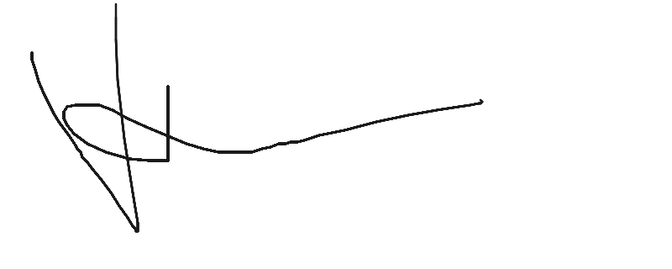
Name: ALI
Date: 06 May 2026

DISCLAIMER: The information contained in this document may be privileged and/or confidential, and is intended only for the use of the person to whom it is addressed. If the reader of this message is not the intended recipient (or such recipient's employee or agent), you are hereby notified not to read, distribute, use or copy this document or the materials attached. If you have received this document in error, please notify the sender and delete the document from your computer. In compliance with regulatory requirements, all messages sent to or from this server are archived and may be read by someone other than the recipient. This document has been scanned for viruses and malware, and may have been automatically archived by Bullfrog Group.

Issued by Bullex Trading Platform

