RECAP - COMMERCIAL TERMS CONFIRMATION

CHAPTER I - INTRODUCTORY & BACKGROUND

Item | Description

Contract Reference | _______________

Effective Date | Date of last authorized signature

Seller | Al Fakhama UAE

Buyer | Bullfrog LLC

Legal Model of Contract | Sales and Purchase Agreement (SPA)

Recap Validity | 5 days

CHAPTER II - SCOPE & COMMERCIAL TERMS

Item | Description

Commodity | Granular Sulphur

Country of Origin | Aktau

Quality / Specification | S: 99.95% (Rejection: <99.95%)
Moisture: 0.02% (Rejection: >0.05%)

Delivery Basis | gif basis Zhejinag Port

Contractual Quantity | 50000 MT

CHAPTER III - FINANCIAL & OPERATIONAL ARRANGEMENTS

Item | Description

Contract Price & Currency | USD 650

Payment Terms | Irrevocable Confirmed Lc at Sight

Loading Window | 5-15th may 2026

Shipping Terms | CIF

CHAPTER IV - MISCELLANEOUS & BOILERPLATE

Item | Description

Governing Law & Jurisdiction | DIFC

Application of Industry Standards | Applicable international industry standards and ICC rules

For and on behalf of the Seller: For and on behalf of the Buyer:
Al Fakhama UAE Bullfrog LLC

Name: Ali — kumar.vaman@icloud.com Name: VK — VK@BULLFROG.AE
Authorised Signatory: _______________ Authorised Signatory: _______________
Title: _______________ Title: _______________
Date: 06 May 2026 Date: 06 May 2026

Signature & Stamp: Signature & Stamp:

ANNEXURE I - COMMODITY SPECIFICATIONS

Sr. No. | Parameters | Details

08 | Commodity | S: 99.95% (Rejection: <99.95%)
Moisture: 0.02% (Rejection: >0.05%)
| Specifications |

DIGITAL SIGNATURE
FOR & ON BEHALF OF BUYER / ISSUER
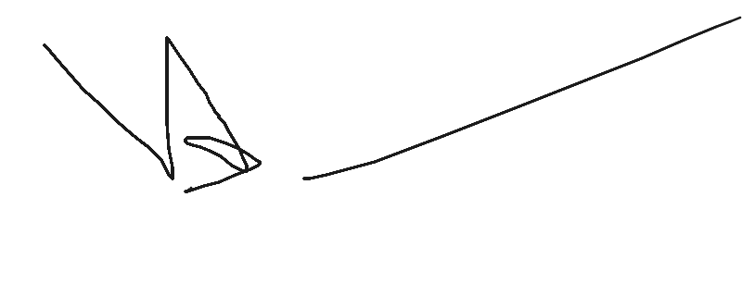
Name: Vaman Kumar
Date: 06 May 2026

DISCLAIMER: The information contained in this document may be privileged and/or confidential, and is intended only for the use of the person to whom it is addressed. If the reader of this message is not the intended recipient (or such recipient's employee or agent), you are hereby notified not to read, distribute, use or copy this document or the materials attached. If you have received this document in error, please notify the sender and delete the document from your computer. In compliance with regulatory requirements, all messages sent to or from this server are archived and may be read by someone other than the recipient. This document has been scanned for viruses and malware, and may have been automatically archived by Bullfrog Group.

Issued by Bullex Trading Platform

