PURCHASE LETTER OF INTENT

Issued to Seller

Bullfrog LLC
Dubai UAE

Attention (PIC)
VK — VK@BULLFROG.AE

Ref
VK

LOI Issue No. and Date
_______________ , 09 March 2026

Valid Till
Monday, 16 March 2026 (2000HRS Dubai Time)

Purchase Incoterms

CIF

Issued by Buyer

Bullfrog LLC
_______________

Attention (PIC)
VK@BULLFROG.AE

Sr. No. | Parameters | Details

01 | Commodity | Manganese Ore

02 | Origin | _______________

03 | Quantity | 10000 MT

04 | Incoterms Terms | CIF

05 | Delivery period | 15-30th April

06 | Price | USD 70

07 | Contract Confirmation | SPA

08 | Commodity | Al203: 45%
| Specifications |

09 | Payment Terms | DLC

10 | Documents for Payment | _______________

11 | Other terms & conditions | _______________

12 | Compliance | _______________

We look forward to hearing from you within the stipulated LOI Validity
and look forward to a long term and mutually fruitful association.

With warm regards,

For & On Behalf of
Bullfrog LLC

SIGNATURES
FOR & ON BEHALF OF SELLER  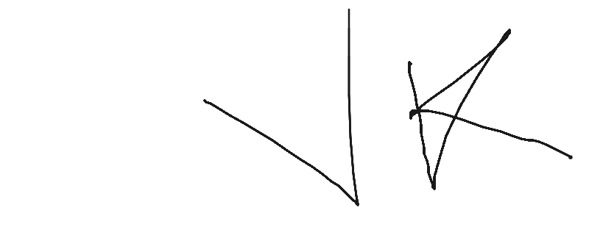  Name: Vaman Kumar  Date: 09 Mar 2026 | FOR & ON BEHALF OF BUYER  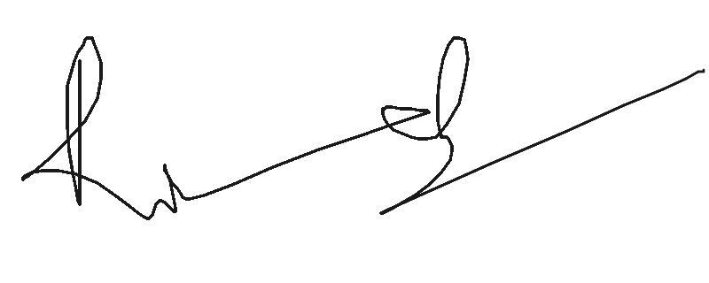  Name: Ricky  Date: 09 Mar 2026

