PURCHASE LETTER OF INTENT

Issued to Seller
Seller | ABC Limited  UAE
Attention (PIC) | AURN — ARUN@ABC.COM
Ref | VK — VK@BULLFROG.AE
LOI Issue No. and Date | IMP-BUL-1005-188 , 10 May 2026
Valid Till | Sunday, 17 May 2026 (2000HRS Dubai Time)
Purchase Incoterms | CIF
Issued by Buyer
Buyer | Bullfrog LLC  Dubai UAE
Attention (PIC) | VK — VK@BULLFROG.AE

Sr. No. | Parameters | Details
01 | Commodity | iron ore
02 | Origin | ANN
03 | Quantity | 50000 MT
04 | Incoterms Terms | CIF
05 | Delivery period | 20th may
06 | Price | USD 100
07 | Contract Confirmation | Subject to Producer's Confirmation of cargo
08 | Commodity | _______________
09 | Payment Terms | By DLC against 2% Performance Bond
10 | Documents for Payment | _______________
11 | Other terms & conditions | _______________
12 | Compliance | _______________

We look forward to hearing from you within the stipulated LOI Validity
and look forward to a long term and mutually fruitful association.
With warm regards,
Bullfrog LLC

Digital Signature:

Date: 10 May 2026

DIGITAL SIGNATURE
FOR & ON BEHALF OF BUYER / ISSUER
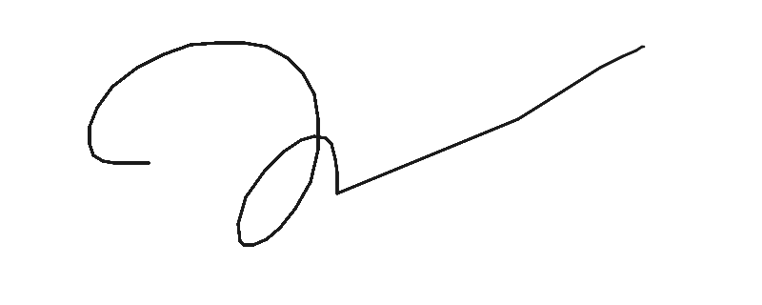
Name: vk
Date: 10 May 2026

DISCLAIMER: The information contained in this document may be privileged and/or confidential, and is intended only for the use of the person to whom it is addressed. If the reader of this message is not the intended recipient (or such recipient's employee or agent), you are hereby notified not to read, distribute, use or copy this document or the materials attached. If you have received this document in error, please notify the sender and delete the document from your computer. In compliance with regulatory requirements, all messages sent to or from this server are archived and may be read by someone other than the recipient. This document has been scanned for viruses and malware, and may have been automatically archived by Bullfrog Group.

Issued by Bullex Trading Platform

