BAUXITE SALE - PURCHASE CONTRACT
Seller’s Contract Number: ALL / MM /2024 / C2.
This contract is concluded on the date of December 23rd, 2024.
Between:
ALLONS MINES AND MINERALS PRIVATE LIMITED (“The Seller”)
Address : Kishore Sagar Road, Chhatarpur, Madhya Pradesh, India. Pin- 471001
Email: allonsminesandminerals@gmail.com
And
BULLFROG TRADING LLC (“the Buyer”)
Address: Office No. 206, The Business Centre, Opp. Burjuman Mall, Al Hamriya, Bur Dubai, Dubai, United Arab Emirates.
Email: info@bullfrog.ae
VIA MUNAVVAR KHAN CEO, MUSKAN MINCHEM,
BHILWARA 311001, RAJASTHAN, INDIA.
Mobile number: 0091 9636200111. EMAIL : MUSKANMINCHEM@GMAIL.COM

Whereas the parties wish to record the contract between them under the following terms and conditions:
- . DEFINITIONS
  - 、In this contract the following defined terms shall apply:
“Base Price” is the price per DMT of Product (before any quality adjustment) as set out or agreed or determined under Article 5.
“Commencement Date” means the date of the first Shipment of Product to the Buyer.
“Contract Year” means a consecutive period of 12 months commencing with the Commencement Date (with respect to the first Contract Year) and the anniversary of the Commencement Date (with respect to each subsequent Contract Year).
“Discharging Port” Mainport, CHINA
“Discharging Port Certificate of Analysis” has the meaning given in Article 8.3.
“DMT” means dry metric tonnes.
“Final Invoice” means the final invoice for payment for the relevant Shipment calculated after discharge at the Discharging Port subject to the provisions of Article 9.
“Force Majeure” has the meaning given in Article 11
“Insolvency Event” means where a liquidator (other than for the purpose of amalgamation or reconstruction), trustee in bankruptcy, receiver and/or manager is appointed in respect of the assets and/or undertakings of a party, or where a party enters into an arrangement of composition with its creditors or any similar appointment, arrangement or composition is made under any applicable law.

“Loading Port” means Visakhapatnam/Jaigarh/Goa/ Porbandar seaport, Eastern India.
“Loading Port Certificate of Analysis” has the meaning in Article 8.2.
“Loading Port Dry Weight” has the meaning given in Article 7.1
“Product” means metallurgical grade bauxite ore exported from Visakhapatnam/ Jaigarh/Goa/ Porbandar seaport, Eastern india, conforming to the specification set out in Article 4.
“Shipment” means each shipment of Product to be delivered to the Buyer in accordance with this contract.
“WMT” means wet metric tons.

- 、TERMS
This contract shall take effect on the date of sign and stamp and shall run until the purchase and sale obligations hereunder have been satisfied, unless terminated earlier in writing and in accordance with the terms of this contract.

- 、PRODUCT QUANTITY: 50,000 WMT(±10%) as trial shipment then upto 2,00,000 tons per month

- 、PRODUCT QUALITY

    - 、The quality of Product to be delivered shall conform with the following base specification:

Total Al2O3 | 45%（43% min）
TiO2 | 4% max
Total SiO2 | 5%（5% max）
Ca0 | 1.5% max
C | 0.5% max
Free Moisture | 10%（12% max)
Particle size 0-200mm | ＞95%

    - The price of the Product shall be adjusted for variations in quality relative to the above base specifications as set out in Article 5.
    - Name of Mine:
Address:

Location:
EC Number:
Validity:
- 、PRICE
The Base Price for the shipment is US$ 70.00/DMT CIF MAIN PORT OF CHINA, with single port discharge. Prices are valid for 3 shipments. Price will be reviewed every three months keeping in view the present market rates and the cost of shipping In case there is any change (increase or decrease) in prices, both parties will sign a separate addendum to this contract.
Buyer will pay all the fees, taxes, duties & charges at the discharge port.

Total Al2O3:
Al2O3=46%, no bonus and no penalty.
Al2O3> 46%, Final Price shall be adjusted up for every 1% higher as Bonus USD1.00 / DMT from Base Price by fractions pro-rata
43% <Al2O3< 45%, the penalty is US$1.0/DMT for every 1% lower. The proportion of deficiency is calculated on pro rata basis.
Al2O3≤43%, the Buyer has the right to reject the shipment or price to be renegotiated by the Seller and Buyer.
Total SiO2:
SiO2 =4%, no bonus and no penalty.
SiO2 < 4%: the Bonus USD1.5/DMT for every 1% lower. The proportion of deficiency is calculated proportionally
6%>SiO2 >5% the Penalty is USD1.5/DMT for every 1% higher. The proportion of deficiency is calculated on pro rata basis
SiO2 ≥ 6% the Buyer has the right to reject the shipment, or price to be renegotiated by the Seller and Buyer.
Free Moisture (%):
Free Moisture>10%, the penalty is US$0.1/dmt for every 1% higher, pro rata for fractions of %
7%>Free Moisture ≤10%, no bonus and no penalty
Free Moisture < 7%, the bonus is US$0.1/dmt for every 1% higher, pro rata for fractions of %
Free Moisture ≥ 12% the Buyer has the right to reject the shipment, or price to be renegotiated by the Seller and Buyer.
Size:
If the size 0-100 mm is below 95%, then penalty applicable at the rate of USD 0.50 PDMT for each 1% decrease, fraction pro-rata.

- 、DELIVERY TERMS AND TIME OF DELIVERY
    - CIF (Actual discharge port), CHINA. The Seller’s designated anchorage port for ocean-cargo declare to be able to safety berth fully loaded vessel of up to 50,000DWT. CIF is defined by in Incoterms 2020.The specific information of the discharging port in China will be reconfirmed separately by both parties through email.

    - Expected loading period：30 days from the date of receipt of LC at our bank， the detail will be confirmed by both parties through email.

    - Buyer’s AGENT AT discharge port:

    - Risk of loss, damage or deterioration of the Product being shipped under this contract shall pass from Seller to Buyer when the Seller placing all the Products on board of the vessel at the port of Loading.

- 、WEIGHT DETERMINATION

The Loading Port certificate of weight and the Discharging Port certificate of weight shall, in accordance with customary industry practice, take into account the weight of the vessel, and any changes to its weight, attributable to fuel, stored water and waste and the consumption or discharge thereof. It shall set out the weight in DMT and WMT taking into account the free moisture of the cargo.

The weight of each Shipment of Product shall be determined at the Loading Port by one independent surveyor (SGS) at the main port of India Loading Port according to the draft survey of the vessel. Weight thus weighed shall be the "Loading Port B/L Weight". The cost of the draft inspection/weight determination at the loading port will be borne by the seller.

Loading Port Dry Weight = Loading Port B/L Weight × (100% - Moisture of Certificate of Analysis Issued by independent surveyor). The Load port Dry weight will be final and binding on both parties and also will be the basis for payment.

- 、SAMPLING AND ANALYSIS:
Sampling and analysis including Al2O3, Total Silica, Free Moisture and Product Size will be carried out at the loading port and the discharge port by an internationally recognized independent inspection agency designated by both the buyer and the seller. The method of sampling and analysis will be based on internationally recognized industry standards.
At the loading port:
Sampling and analysis at the loading port: the sampling of each batch of goods shall be analyzed by an independent inspection agency mutually appointed by both parties at the seller's Wharf, the expense shall be borne by the seller. The independent inspection agency shall issue the quality certificate to prove the product performance parameters specified in Article 4, which shall be used as the basis for the seller to issue the prepayment invoice. The independent inspection agency shall conduct sampling at the loading port according to industry rules. Three samples will be taken each time. These samples will be used to determine the provisional quality and weight of the loaded bauxite. Seal the samples to the seller, the buyer and the independent inspection agency. Buyer or his representative can be present at the time of load port inspection at their expense.

- 、PAYMENT CONDITIONS:

Within 5 working of signing of this contract, Seller should arrange for inspection of mining documents such as mining license, EC copy and a mine inspection at the cost of Buyer. Buyer will issue a fully operative Irrevocable, Confirmable Letter of Credit from a Prime Bank covering 100% of the Invoice value . This letter of credit will contain an allowance for +/- 10% of both quantity and amount. The LC shall allow for payment against presentation of shipping documents as stated in clause 10 below. The LC should be valid for a minimum period of 60 days from the date of issue. The Buyer shall provide the Seller with the draft of the Letter of Credit application for their comment before the Letter of Credit is issued.

BANK DETAILS:

SELLER:

Bank: HDFC BANK LTD

Bank Address: Kishore Sagar Road , Chhatarpur, Madhya Pradesh , India, Pin - 471001

Account name: ALLONS MINES AND MINERALS PRIVATE LIMITED

Account No: 50200086933136

Swift code: HDFCINBB

BUYER:

Bank: National Bank of Fujairah

Bank Address: PO Box 887, Fujairah, UAE

Account Name: Bullfrog Trading LLC

Account No: 012662480485

SWIFT CODE: NBFUAEAFDXB

10. DOCUMENTS:

The following shipping documents will be submitted by the seller to his bank for payment against the LC, the documents must presented within 15 days after B/L date:

Full set (3/3) of clean on board original ocean bills of lading, made out to order and blank endorsed and marked “freight prepaid”

Invoices (1 original + 2 copy) issued by the Seller.

Certificate of weight issued by the independent survey agency at the load port.

Certificate of quality issued by the independent survey agency at the load port.

Certificate of Moisture issued by the independent survey agency at the load port.

Certificate of Origin (Original + 1 copy)

Copy of Insurance confirming claims payable at China

11、DISCHARGING PORT, DEMURAGE/DESPATCH
11.1 Demurrage and despatch charges: Demurrage and despatch charges at the loading port are for the Seller's account. Demurrage and despatch charges at the discharging port are for buyer's account. Demurrage and DESPATCH shall be as per charter Party. Demurrage shall be paid by the Buyer to the Seller for 24 hours per day or in proportion to the time lost (demurrage shall be calculated on the basis of the relevant charter Party) at a discharging rate as per Charter Party Conditions weather working day including Saturdays, Sundays and public holidays.

11.2 Discharging conditions shall be implemented in accordance with the requirements in Schedule A.
11.3 Notice of Readiness to be delivered at anytime, day or night, Sundays and holidays included, whether in port or not (WIPON), whether in berth or not (WIBON), whether customs cleared or not (WCCON) and whether free pratique or not (WFPON), whether shipping documents have been presented to the Buyer/Buyer’s bank or not prior to arrival of vessel and in all respect ready to discharge. The time used for draft survey,the time at which an anchorage is moved to a berth, custom clearance will not count as laytime. Laytime shall commence 24 hours after tendering of NOR, unless discharge commences earlier, in which case time actually used to count.
11.4 Demurrage/Despatch rate: Demurrage and dispatch to be settled within 10 working days after completion discharging against relevant documents.
11.5 Any time loss caused by covid-19 cases or suspected cases among crew on the vessel not to count as laytime.
11.6 If the unloading at the port of destination is affected due to the expired or incomplete certificate of the ship or the customs spot inspection, etc., the unloading time will not be included as laytime.

12、FORCE MAJEURE

If any party (the “Affected Party”) should, despite all reasonable efforts, be prevented, hindered, or delayed, by circumstances constituting Force Majeure from performing any of its obligations under the Agreement, it shall be relieved from performance of said obligations – except for the obligation to make payments – but only during the period that the Force Majeure and its consequences continue and to the extent so prevented, hindered or delayed (the “Force Majeure Suspension Period”). The Affected Party shall not be liable to the other parties for loss or damage, which the other non Affected Party may suffer as a consequence of the Force Majeure Suspension Period

“Force Majeure” includes strike, labour dispute, stoppages, lock-out, fire, explosion, flood, earthquake, closures due to adverse weather conditions, riot, sabotage, civil disturbance, war or threat of war, blockades, insurrections, accident, catastrophic failure, act of God or the elements, epidemics, embargo, fire, unavailability of power, water or other items necessary for the production or processing, legislation, regulation or directive having the force of law, shortage of, delay, interruption or a breakdown in transportation facilities, civil commotion, act or threat of terrorism, unrest or disturbance, war (or the consequence thereof) compliance with any order or instruction of any port, transportation, local or other authority, law, regulations or requirements of any governmental body, cessation or reduction of operation at the Producer’s operations, expropriation whether unlawful or otherwise or any other cause beyond the reasonable control of the Affected Party. For avoidance of doubt, Buyer shall not be entitled to claim the Force Majeure includes a change in market conditions, which affects its demand for Product.

The Affected Party shall use all reasonable endeavours to terminate the Force Majeure and remove, relieve and minimise its consequences. Upon termination of the Force Majeure, the Affected Party shall give notice thereof to the other parties by e-mail within 7 working days （Saturdays, Sundays and public holidays included）.

If the Force Majeure Suspension Period continues for a period of 60 consecutive Days or more, either Buyer or Seller may by notice to the other parties terminate the Agreement. Such termination shall be without liability to any party but shall not prejudice any rights of the parties arising prior to the date thereof.

13、NOTICE
All notice given under this contract shall be in writing or confirmed in writing and shall be addressed to the parties at the addresses set forth earlier in this contract or at such other addresses as each party may from time to time notify the Other

Notice shall be served by actual delivery, fax or e-mail and shall be deemed to be received either when actually delivered or when well received by recipient's fax or e-mail.

A notice with respect to any change of address（both contact and email address) shall effective only when actually received.

14、ASSIGNMENT
Neither party may without the prior written consent of the other assign this contract or any of its right or obligations hereunder to any third party. Any such purported assignment shall be void.

15、ENTIRE CONTRACT: MODIFICATION
This contract constitutes the entire agreement between the Seller and the Buyer concerning the subject matter hereof. All previous documents, undertakings and agreement, weather verbal, written or otherwise, between the parties concerning the subject matter hereof are hereby cancelled and shall not affect or modify. Any modifications of this contract shall be made by written agreement between the parties.

16、LIMITATION OF LIABILITY
No party shall be liable to any other party in its performance of or failure to perform under the contract, whether in contract, tort or breach of statutory duty or otherwise, for any loss of profit or revenue, business interruption, use of any equipment, contract or business opportunities and/or goodwill and/or any indirect or consequential loss, damage or expense.

Save with respect to the minimum and maximum specifications set out in this contract, the Seller gives no warranties as to the quality, condition or specifications of the bauxite to be delivered and any and all conditions, warranties or other terms with respect to the bauxite, including without limitation with respect to description, satisfactory quality, merchantability and fitness of the bauxite for any purpose of the Buyer, are hereby excluded to the fullest extent permitted at law. Buyer’s remedies for the failure to meet maximum and minimum specifications are limited to the right to reject a Shipment or the payment by Seller of penalties as set out in this contract.

17、EVENTS OF DEFAULT AND TERMINATION
Either the Buyer or Seller (the “Non-Defaulting Party”) may terminate this Agreement at any time upon giving notice to the other party (the “Defaulting Party”) in the event of any of the following occurrences (each an “Event of Default”):

- If the buyer fails to pay any amount due under this agreement, and fails to do so within 5 days after the written notice of the seller
- If the seller delays to prepare, collect and deliver goods according to the Article 6 of this contract.
- If the Defaulting Party commits a material breach of this Agreement, and such material breach is either incapable of remedy or, where it is capable of remedy, such material breach remains unremedied for a period of 10 Days following written notice from the Non-Defaulting Party to the Defaulting Party requiring it to do so.
- The occurrence of an Insolvency Event with respect to the Defaulting Party or the Producer; or
- The Defaulting Party disaffirms, disclaims, repudiates, or rejects or challenges the validity or enforceability of this Agreement.

Upon the occurrence and during the continuance of an Event of Default, the Non-Defaulting Party may in its sole discretion do any or all of the following:

- Notify the Defaulting Party of an early termination date (which shall be no earlier than the date of such notice) on which the obligation to make or take delivery of Product shall terminate (Early Termination Date);
- Withhold any payments due to the Defaulting Party until such Event of Default is cured;
- Suspend performance of its obligations under this Agreement until such Event of Default is cured; or
- Insist on specific performance in whole or in part of any subsisting, current or ongoing obligation of the Defaulting Party under this Agreement.

If a notice of an Early Termination Date is given under this section, the Early Termination Date will occur on the designated date whether or not the relevant Event of Default is then continuing.

The termination of this contract pursuant to this Article shall be without prejudice to any party’s entitlement to claim damages or to be paid for amounts properly due.

18、GOVERNING LAW AND ARBIRATION
All Disputes in connection with this contract or the execution thereof shall be settled by friendly negotiation. If no settlement can be reached, the case in dispute shall then be submitted for arbitration as per Singapore International Arbitration Centre rules in effect at the time of applying for arbitration. The decision made by the arbitration tribunal shall be accepted as final and binding upon both parties. The fee for arbitration shall be borne by the losing party unless otherwise awarded by the tribunal.

19、GENERAL
The validity of remaining provisions of the contract shall not be affected by a court, administrative board or other proceedings of competent jurisdiction deciding that any provision or part of this contract is illegal, unenforceable, in conflict with any or contrary to public policy. In such event the parties shall, by amendment to public act, properly replace such provisions by a reasonable new provision or provisions which, as far as legally possible approximate what the parties intended by such original provision and the purpose thereof.

20、SANCTION CLAUSE
For the purposes of this Clause:

“Sanctioned Activity” means any activity, supply of goods, service, carriage, trade or
voyage subject to sanctions imposed by a Sanctioning Authority.
“Sanctioning Authority” means the United Nations, United States of America,
European Union, the People’s Republic of China, Russia, United Kingdom or any
other applicable competent authority or government.
“Sanctioned Party” means any persons, entities, bodies, or vessels designated by a
Sanctioning Authority.

20.1 The Buyer and the Seller each warrant that at the date of this Agreement and
through out its duration they are not a Sanctioned Party.

20.2 Notwithstanding any other provision of this clause or any other provision of this
Agreement, neither Party shall be required to perform any obligations under this
Agreement, which constitutes a Sanctioned Activity or would expose it to the risk of
designation or punitive measures pursuant to any sanctions imposed by the Sanctioning Authority.

20.3、If at any time during the performance of this Agreement, either Party becomes
aware that:

- A Party is in breach of paragraph 1 of this clause; or
- A Party becomes exposed to the risk of designation or to other punitive measures imposed by a Sanctioning Authority; or
- A Party’s performance of this Agreement shall be materially affected by reason of sanctions imposed by a Sanctioning Authority, including but not limited to:

Its or its supplier’s ability to make or take delivery of goods as may be required under the Agreement;
Its ability to arrange or receive payments as may be required under the
Agreement; or
Its ability to insure and/or transport the goods to be delivered by the Seller to the Buyer pursuant to the terms of the Agreement;

Then notwithstanding to any clause or provision to the contrary in this Agreement, such Party may, by written notice to the other Party:
a. Suspend performance until such time as the notifying Party may lawfully perform
this Agreement; and/or
b. Terminate this Agreement upon the relevant Sanctioned Activity continuing for 15
consecutive calendar days. In the event of suspension of performance, neither Party
are liable to the other Party for loss and damages arising from and/or in connection to
the events set out in this paragraph. In the event of termination, the Parties are
mutually released from further obligations and liabilities of the Agreement, including
payment obligation for goods already delivered.

21. NON-CIRCUMVENTION AND NON-DISCLOSURE:
Whereas, the undersigned parties are mutually desirous of doing business with respect to the arranging, consulting, selling and buying and in cooperation with one another and with third parties for their mutual benefit. The documents which are going to follow this agreement like letters of intent, full corporate offers, bank comfort letters, contract terms and conditions, banking details or pre-advised payment instruments and/or any information contained in such documents will not be passed, under any circumstance, onto another intermediary or broker or trader or whatever company or private persons who are not end buyers or end suppliers without prior specific written consent of the party(s) providing such information.

This agreement is made and entered into on this date, shall obligate the undersigned parties and their partners, associates, employers, employees, affiliates, subsidiaries, parent companies, any nominees, representatives, successors, clients and assigns hereinafter referred to as “The Parties” jointly severally, mutually and reciprocally for the terms and conditions expressly state and agree to below, and that this agreement may be referenced from time to time in any document(s), or written agreements, the terms and conditions of this agreement shall apply to any exchange of information written or oral involving financial information, personal or corporate names, contracts initiate by or involving the parties and any addition, renewal, extension, rollover amendment, renegotiations or new agreement hereinafter referred to as “The Transaction” (Project/Transaction) for the following: SALE AND PURCHASE OF BAUXITE.

The intending parties hereby legally, and irrevocably bind themselves into guarantee to each other that they shall not directly or indirectly interfere with, circumvent or attempt to circumvent, avoid, by-pass or obviate each others interest or the interest or relationship between “The Parties” with procedures, seller, buyers, brokers, dealers, distributors, refiners, shippers, financial instructions, technology owners or manufacturers, to change, increase or avoid directly or indirectly payments of established or to be established fees, commissions, or continuance of pre-established relationship or intervene in un-contracted relationships with manufacturers or technology owners with intermediaries, entrepreneurs, legal council or initiate buy/sell relationship or transactional relationship that by-passes one of “The Parties” to one another in connection with any ongoing and future transaction or project.

“The Parties” irrevocably agree that they shall not disclose or otherwise reveal directly or indirectly to a third party any confidential information provided by one party to the other or otherwise acquired, particularly contract terms, product information or manufacturing processes, prices, fees, financial agreement, schedules and information concerning the identity of the sellers, producers, buyers, lenders, borrowers, brokers, distributors, refiners, manufacturers, technology owners, or their representative and specifically individuals names, addresses, principals, or e-mail/fax/telephone numbers, references product or technology information and/or other information advised by one party(s) to be one another as being confidential or privileged without prior specific written consent of the party(s) providing such information.

Commissions, fees, compensation or remuneration to be paid as part of transaction covering “The Parties” to this agreement, shall be agreed upon by separate written agreement by “The Parties” concerned and shall be paid at the time such contract designated, concluded or monies changing hands between buyers and sellers, unless otherwise agreed among “The Parties”.

“The Parties” hereby irrevocably and unconditionally agree and guarantee to honor and respect all such fees and remuneration, arrangements made as part of a commission transaction even in the event that “The Parties” are not an integral member to a specific commission and fee, remuneration agreement.
In specific deals where one of “The Parties” acting as an agent allows the buyers or buyer’s mandate, and the seller to deal directly with one another, the agent shall be informed of the development of the transactions by receiving copies of the correspondence made between the buyer or buyer’s mandate and the seller.

This agreement shall be valid for Five (5) years commencing from the date of this contract. This agreement has an option to renew for a further period of five (5) years subject to and upon the terms and conditions agreed between both parties.
This agreement shall apply to:

- All transactions originated during the term of this agreement.
- All subsequent transactions that are follow up, repeat, extended or renegotiated transactions of transactions originated during the term of this agreement.

“The Parties” agree not to circumvent or attempt to circumvent this agreement in an effort to gain fees, commissions, remunerations or considerations to the benefit of the one or more if “The Parties” while excluding other or agree to benefit to any other party.

In WITNESS WHEREOF, the parties hereto have executed this contract as of the date first above written.

 | For and behalf of  ALLONS MINES AND MINERALS PRIVATE LIMITED | For and behalf of  BULLFROG TRADING LLC
Signature  & Seal | SHARMITA MUKHERJEE  DIRECTOR  PASSPORT: N6623072  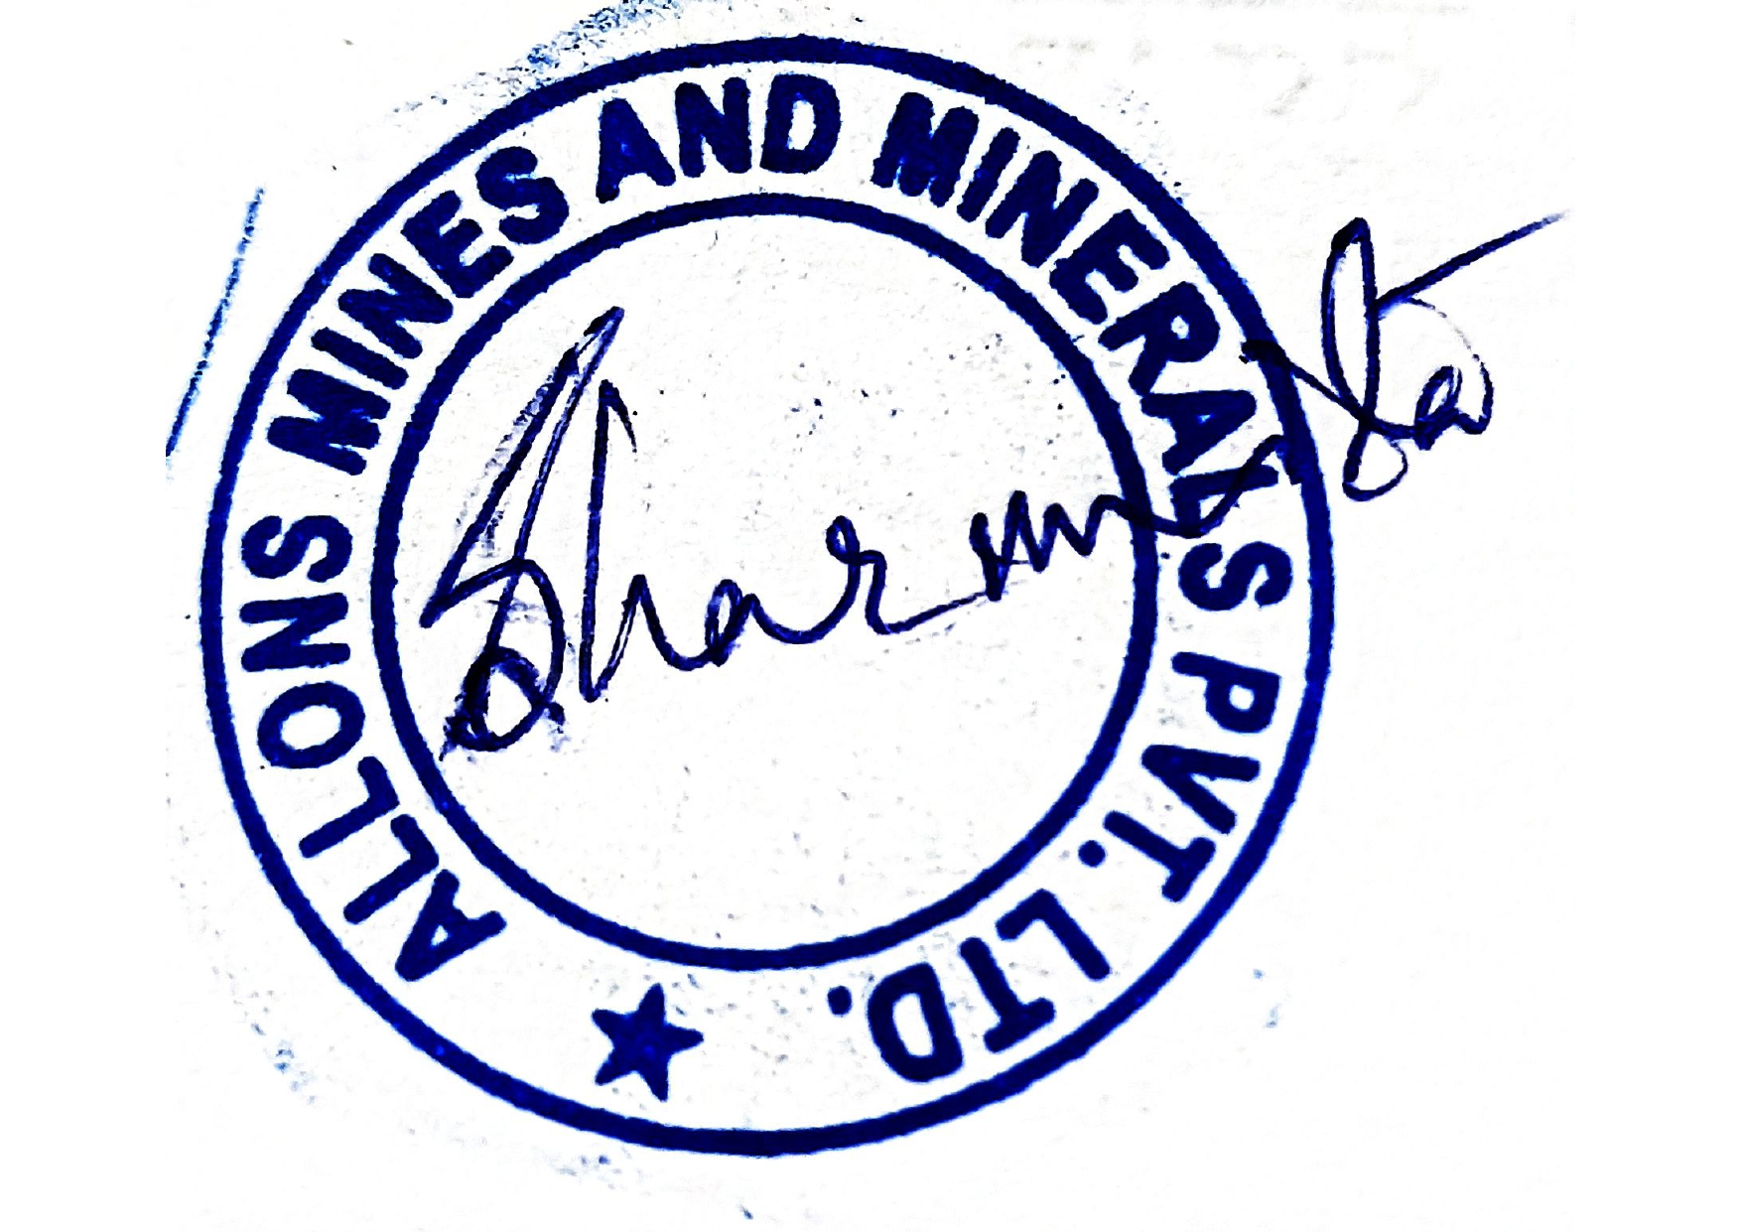  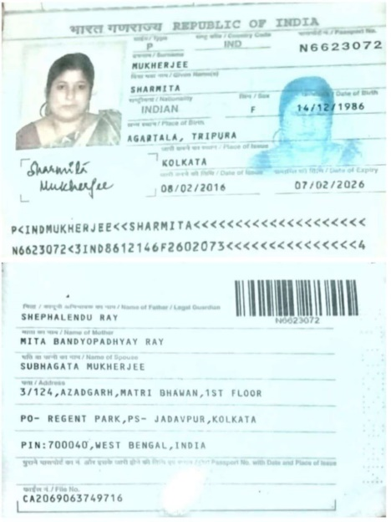

Schedule A: Discharging Conditions
Discharge Port: 1 safe berths, 1 safe port at (Actual port), CHINA.
NOTICE OF READINESS
At port of discharging notice of readiness shall be given to the Charterers or their Agents when the Vessel is in all respects ready to discharge at the discharging berth. If a discharging berth is not designated or if such designated berth is not available upon the Vessel's arrival at or off the port, notice of readiness may be given upon arrival at the waiting place at or off the port.
DISCHARGING RATE AND LAYTIME
Discharging shall be effected at the customary rate of 30,000 metric tons per weather-working day, Saturday、Sundays and holidays included.
Laytime shall commence twenty-four (24) hours after tendering Notice of Readiness, even if on demurrage, unless discharging commences sooner. If the berth is not available, vessel shall anchor as directed by the Agent and/or port authorities (as directed by receivers) and tender Notice of Readiness. Laytime then shall commence twenty-four (24) hours after tendering, unless discharging commences sooner. Laytime shall end after completion of discharge.
DEMMURAGE: Once demurrage always on demurrage.
DISCHARGE PORT AGENT: Vessels are to be consigned to the Buyer's ship agent at the Port of Discharge.
LAYTIME:
Time lost in waiting for berth shall count as laytime; time for draft survey not to count as laytime even vessel on demurrage
Time lost due to breakdown or deficiency of vessel’s equipment affecting discharging will be deducted from laytime or demurrage pro-rated.
The time used for draft survey, custom clearance will not count as laytime.

