PURCHASE LETTER OF INTENT

Issued to Seller
Seller | Al Fakhama UAE  UAE
Attention (PIC) | Ali — kumar.vaman@icloud.com
Ref | VK
LOI Issue No. and Date | IMP-BUL-1503-185 , 15 March 2026
Valid Till | 7 days
Purchase Incoterms | CIF
Issued by Buyer
Buyer | Bullfrog LLC  Dubai UAE
Attention (PIC) | VK — VK@BULLFROG.AE

Sr. No. | Parameters | Details
01 | Commodity | petcoke
02 | Origin | venino
03 | Quantity | 50000 MT
04 | Incoterms Terms | CIF
05 | Delivery period | _______________
06 | Price | USD _______________
07 | Contract Confirmation | Subject to Producer's Confirmation of cargo
08 | Commodity | S<1%
09 | Payment Terms | By DLC against 2% Performance Bond
10 | Documents for Payment | _______________
11 | Other terms & conditions | _______________
12 | Compliance | _______________

We look forward to hearing from you within the stipulated LOI Validity
and look forward to a long term and mutually fruitful association.
With warm regards,
Bullfrog LLC

Digital Signature:

Date: 15 March 2026

DIGITAL SIGNATURE
FOR & ON BEHALF OF BUYER / ISSUER
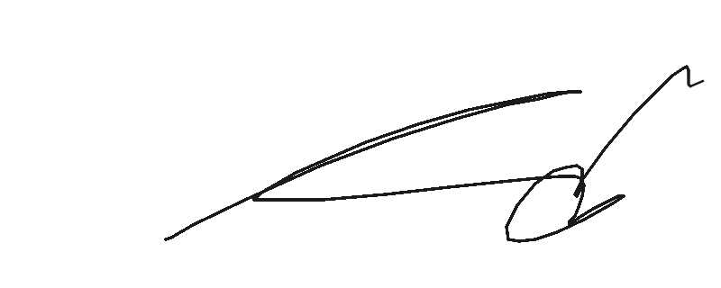
Name: VK
Date: 15 Mar 2026

Issued by Bullex Trading Platform

