FULL CORPORATE OFFER (FCO)

Date: 10 March 2026
Reference: _______________
Status: IRREVOCABLE — Binding upon Buyer's acceptance

PREAMBLE
We, the undersigned, hereby confirm and present this Full Corporate Offer for the supply of the commodity described below. This FCO is irrevocable and binding upon acceptance by the Buyer within the stipulated validity period.

PARTIES

SELLER DETAILS
Company: Al Fakhama UAE
Address: UAE
Contact: Ali — kumar.vaman@icloud.com
Bank: Hsbc Bank
SWIFT/BIC: HSBCXXXX

BUYER DETAILS
Company: Bullfrog LLC
Address: Dubai UAE
Contact: VK — VK@BULLFROG.AE
Bank: HSBC BANK
SWIFT/BIC: HSBCXXXXX

COMMODITY DETAILS
Commodity: NPK
Quantity: 50000 MT
Origin: EGYPT
Unit Price: USD _______________
Currency: USD
Incoterm: CIF
Buyer: Bullfrog LLC
Seller: Al Fakhama UAE

Quality Specifications:
N50%
P25%
K25%

DELIVERY TERMS
Loading Port: EGYPT
Discharge Port: RIZHAO
Laycan: 10
Delivery Terms: CIF

PAYMENT TERMS
Payment Terms: DLC

INSPECTION & ANALYSIS
Analysis Agency: SGS
Agency Contact: XX
Pre-shipment inspection by SGS at loading port at Seller's cost.
Discharge inspection at Buyer's cost.

DOCUMENTATION
- Full set of Bills of Lading (3/3)
- Certificate of Origin
- Certificate of Analysis / Quality
- Certificate of Weight
- Commercial Invoice
- Packing List
- Insurance Certificate (CIF terms)

VALIDITY
This FCO is valid for five (5) working days from the date of issuance.

AUTHORISED SIGNATORY
Name: _______________
Title: _______________
Company: Al Fakhama UAE
Date: 10 March 2026
Signature: _______________

DIGITAL SIGNATURE
FOR & ON BEHALF OF BUYER / ISSUER
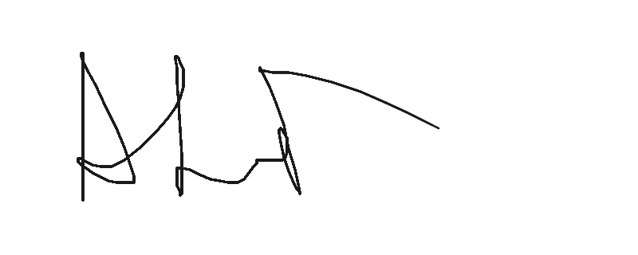
Name: ALI
Date: 10 Mar 2026

Issued by Bullex Trading Platform

