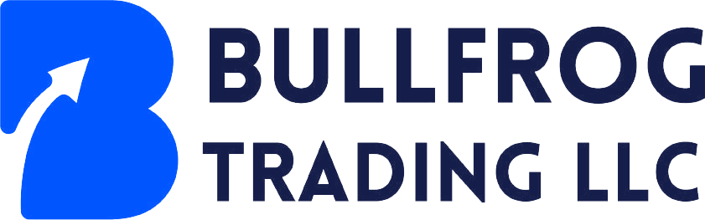
Office No.206, The Business Centre, Opp. Burjuman Mall, Al Hamriya, Bur Dubai, Dubai, United Arab Emirates E-mail : info@bullfrog.ae , Website : www.bullfrog.ae

Date of Issue: 25/10/2024

TO
ETS BAPEKE DOUDOU BUSINESS
NO. 21, AV. MUADIME, Q/METCO, C/NGALIEMA,
DEMOCRATIC REPUBLIC OF CONGO

KIND ATTN: BAPEKE KELELA DOUDOU. EXECUTIVE DIRECTOR

THRU OUR MANDATE : MR VINOD KUMAR , M/S AKSHAYA RARE EARTH MINERAL LIMITED

IRREVOCABLE CORPORATE PURCHASE ORDER

We, BULLFROG TRADING LLC, as Buyer, with full corporate responsibility hereby state and confirm that we are ready, willing and able to purchase the following commodity as per the specifications and in the quantity and for the price as specified in the terms and conditions as stated below.

Commodity: Copper Cathode
Specifications: As per your FCO dated 24/10/2024 in favour of M/s Akshaya Rare earth Mineral Limited
Qty: 2500 MT tons
Basis: FOB Dar ES Salaam Port
Price: $6500 per MT basis FOB Dae Es Salaam Port
Payment Terms: By TT basis Discharge Port SGS Inspection result

Procedure:

- Upon confirmation of contract and cargo verification, Buyer shall send Sales and Purchase agreement (SPA) and legalise the same by DRC Commerce and Trade Tribunal against payment of 3% of the value of the contract which will be equally shared by Buyer and Seller.
- Supplier shall do FOB for the cargo and Buyer shall make payment for freight.
- Once cargo arrives at discharge port, Supplier will send their authorized person to witness unloading and SGS Inspection procedure.
- Once the final results will be submitted by SGS at Discharge Port, Buyer will make payment to Supplier’s Agent Account by Telegraphic Transfer.

Documents required after ICPO is confirmed by Supplier:

- Copy Producer’s License and Mining License
- Copy of MTC ( Mill Test Certificate ) issued at the plant
- Proof of Cargo and SKR (Sake Keeping receipt) issued by the warehouse

Documents after FOB:

- Seller’s commercial Invoice for the cargo
- Export permit
- Certificate of Origin
- Bills of lading
- SGS certificates of Quality and Quantity issued at loading Port

Documents for Payment:

- Sellers Commercial invoice for cargo
- SGS certificates of Quality and Quantity issued at discharge port

Buyer’s Banking Details:

Bank Name : Abu Dhabi Islamic Bank
Bank Address : Shera Al Emarat Building, Al Buhairah Corniche, Sharjah, United Arab Emirates
Account Name : BULLFROG TRADING LLC
IBAN No. USD AE680500000000019247333
Swift ID : ABDIAEADXXX

We look forward for your confirmation on the same.

Thanks & Best regards,

_________________________________-
Vaman Kumar
CEO

