**Concierge_JG.aspx Form to enter external media references into the Concierge Catalog (Catalog.aspx). Called from Default.aspx.**

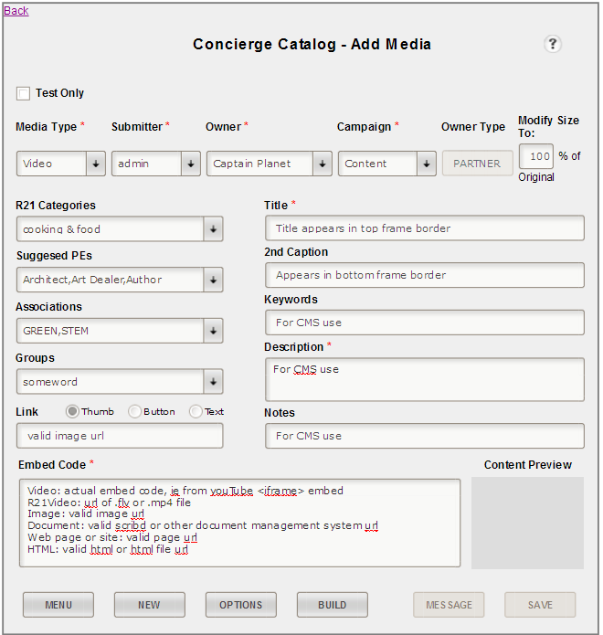

**cboOwner** – CMS use – associated entity.

Popup Help

**txtCaption** – CMS use, passed to **assembleFB()**

**btnBuild** – calls **parseContent()**, which parses **txtContent** for valid media URI & builds the Floatbox anchor string, utilizing the fb… class; returns LitPreview, to form.

**btnMsg** – duplicates **btnSave** functionality AND calls and prepopulates the send message dialog, send.aspx

**btnSave** – duplicates btnBuild functionality (calls **parseContent()**) THEN calls **postData()**, which parses out txtContent for url, size, etc, and saves all form data to **Catalog.aspx**

**txtTitle** – CMS use, passed to **assembleFB()**

**txtKeywords** – CMS use – *future use case*

**textNotes** – CMS use for identification and *future search*

**litPreview** – object literal which holds generated anchor tag from **btnBuild** routine

**textDesc** – CMS use for identification and *future search*

**ddlAssociatedPE** – CMS use – lookup

**ddnAssociations** – CMS use – lookup

**lstCategory** – CMS use – lookup

**listGroups** – CMS use – lookup

**chkTestOnly** – CMS flag

**cboSubmitted** – CMS use (*future auto populated by logged-in user*)

**txtOwnerType**.. – CMS lookup – read only

**btnPrevious** – link to default.aspx

**rbnLinkThumb, rbnLinkButton, rbnLinkText** – used to select anchor link style, process.

**cboCampaign** – CMS use, entity sub-class

**txtPct** – changes image display size

**btnNew** – clear form and link to self.

**btnOptions** – link to popup…

**txtContent** – valid url path to media object

**txtLinkInfo** – location of anchor image OR actual anchor link text.

**cboMedia** – used to select embed parse match, process path, thumbnail routine.

**home.aspx Form to enter components of feed message. Called from Default.aspx & Concierge_JG.aspx.**

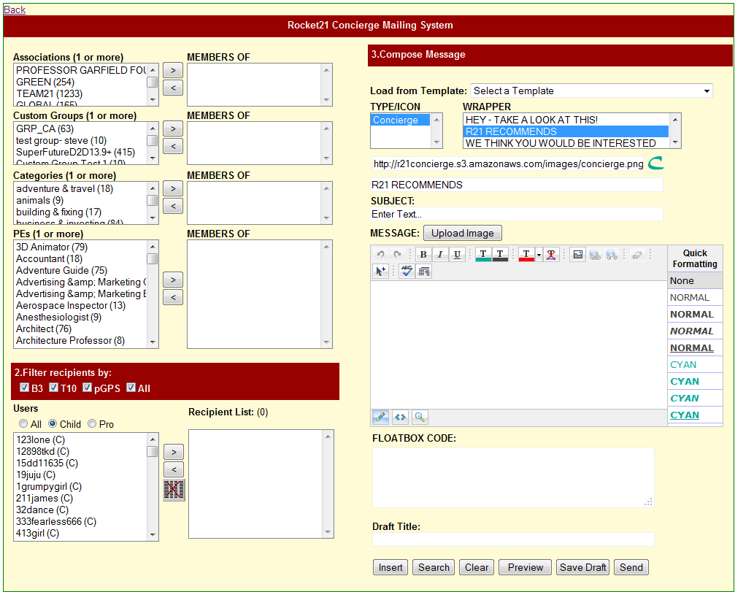

**btnPreview** – calls concierge messaging API, which sends message to Stage Child7.

**btnClear** – Clears form

**ddnTemplate** – selects custom message template…

**btnSilverLight** – calls **openSL()** which opens a Silverlight site media search page.

**btnInsertHTML** – (calls **ModalPopupExtender1**) which displays a **Catalog** picker – places floatbox anchor code in **txtMedia**, and anchor img/text in **litPreview**

**ddnTemplate** – selects custom message template…

**ddnTemplate** – selects custom message template…

**ddnTemplate** – selects custom message template…

**ddnTemplate** – selects custom message template…

**ddnTemplate** – selects custom message template…

**ddnTemplate** – selects custom message template…

**ddnTemplate** – selects custom message template…

**ddnTemplate** – selects custom message template…

**ddnTemplate** – selects custom message template…