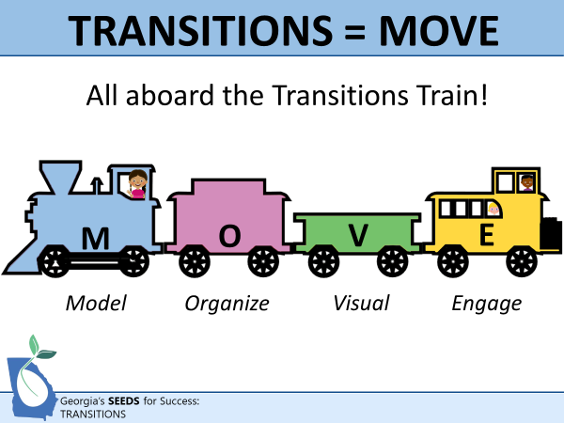 | 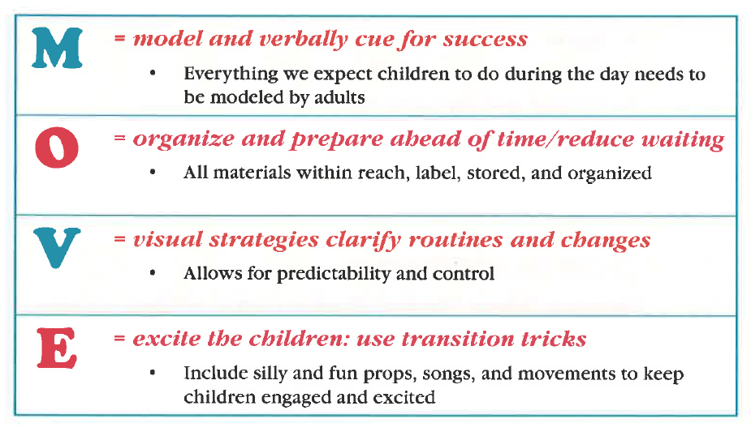
Accommodations | Tips to Support All Learners  - Use real objects instead of pictures to cue children who need extra support  - Use proximity and eye contact when giving individual cues  - Let an individual child lead the transition (e.g., start the song, point to the picture on the schedule, acknowledge other peers who transition well.  - Allow an individual child to take a toy/item from one activity to the next
Arrival/Greeting Transitions | Tips for a “great day”!  1. Every child needs a warm welcome and a smile to greet him/her. Saying a simple good morning is not enough. Walk to the child or call the child over and enthusiastically celebrate the child’s arrival.  2. Let them know the expectations for the day.  3. Do or say something related to the theme or day’s activities.  4. Use a song to assist in transitioning to the morning activity.  5. Create greeting choice chart or have a child have the job as greeter.
Check in Chart  During arrival, children can move a picture (photo, symbol, and/or name) from “home” to “school”.  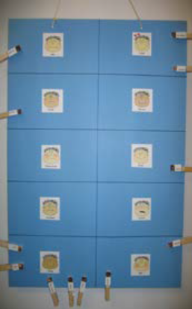  Feeling Chart Check-In  1.Use a poster board to make a grid  Square for each feeling.  2. Place a photo of each child on a  clothespin.  3. Children identify how they are  feeling as they check in by clipping  their photo to the corresponding  feeling. | Arrival Mini Schedule  Print, assemble, and sequence the visual mini-schedule.  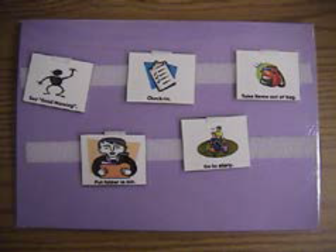  The arrival mini schedule can be used to prompt children as to the steps in the arrival routine. Once taught, this will help them self-initiate the routine steps.  For example: 1. sign in  2. put belongings in your  cubby, 3. say good morning  to your teacher, 4. play with  a table toy.
Large Group Time/Circle Transition  NOTE: Circle is a great “check the schedule” location. Go to circle between big transitions to check the visual photo schedule to see what the next expected routine will be.  Blow Bubbles  Blow some bubbles to get children to come to circle.  Surprise Sack/Magic Bag  Put a very special something in the bag and have the children guess what’s inside.  Give them little hints.  (Sing to the tune of Mary Had a Little Lamb)  Ms. _____ has a magic bag, magic bag, magic bag, Ms. _____ has a magic bag, I wonder what’s inside. | Tips for a “Great” Large Group Transition:  1. For children who will not come easily to circle, show them the “circle visual” from the visual schedule.  2. Clearly state expectations (use first/then phrases) i.e., “First sit in circle, then we can sing the monkey song.”  3. Point out something fun that is going to happen in circle. (“Ms. Rochelle’s Magic Bag has something very special inside. Come see.”)  4. Use children’s preferences to engage them  5. Use positive encouragement and comment on those who are following directions
Microphone  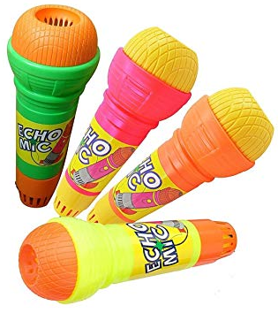  -Announce who is in the circle  (to promote others to join)  -Call children to do special jobs  - Let the children make “special  announcements”  - Announce whose turn is next  -Comment as the children  successfully transition | 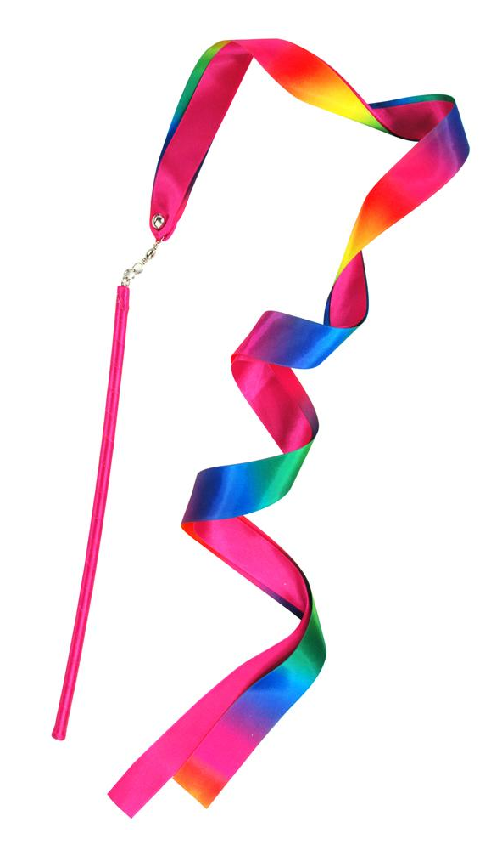  Ribbon Wand  -Point out ‘special helpers’  -Call out children’s names  -Pick an activity to do in circle  time by using it as a pointer  -Sprinkle with “magic dust”  and give a child a special way  to move from place to place  (i.e., fly like a fairy, tip toe on  a high wire, etc.)
Freddie Flea is Whispering to Me  Pretend to catch a flea between your thumb and pointer finger and bring it to your ear as if he is whispering to you. Say, “Freddie Flea is whispering to me ________________”.  Character Hat  Find (or make) an attention-grabbing hat and use it to announce story time by walking around with the hat on your head. Cut out different characters from the day’s story. Attach Velcro to the characters and place them on your ‘attention grabbing’ hat. This will catch the children’s attention and make them eager to listen and get ready for circle time. Sing a little song during clean up, while getting ready to transition to story time. | Bathroom Transitions  Note: This can take place while circle is going on (or another activity) so that children do not experience huge amounts of wait time.
Bathroom Turn-Taking Cue Card  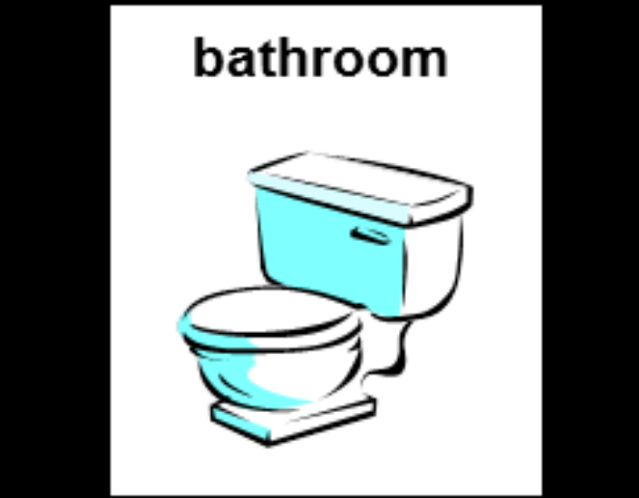  1. Place a bathroom turn-taking cue card on the door frame of the bathroom.  2. Give the first child the cue card.  3. Child goes to bathroom, places the cue card in its spot (on the outside door frame) until done.  4. Child comes out and takes cue card to the next child and then that child follows the same sequence of steps. | Potty Sequence Visuals  The “Potty Visual” is for use with children who are having difficulty with going potty independently. It is intended for use in the bathroom. Post in the bathroom, at the child’s level, for easy use and prompting.  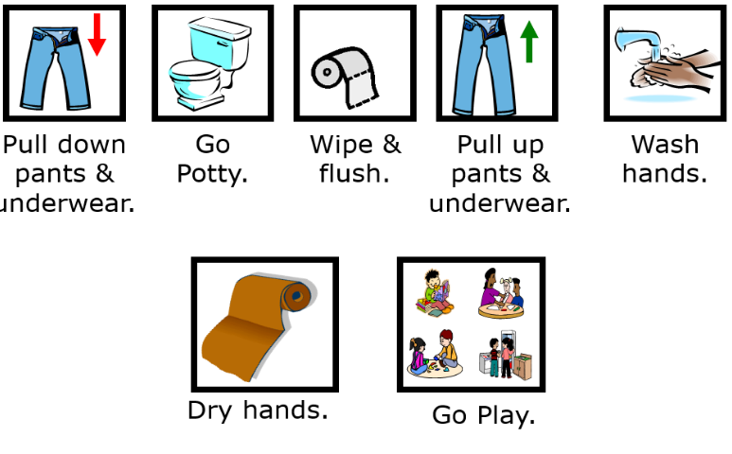
Table Activity/Meals Transitions | Wash Your Hands Song  (To the tune of “Row Row Row Your Boat”)  Wash, wash, wash your hands  get them really clean;  Get the soap and make the bubbles  Scrub them till they gleam.  Wash, wash, wash your hands  scrub them really good;  Wash the dirt and the germs  like all our friends should.
It’s in the Bag  Place pictures, to indicate a variety of movements, inside a bag. Children pull out a picture and then move to the next activity just like the picture.  This can also be done when  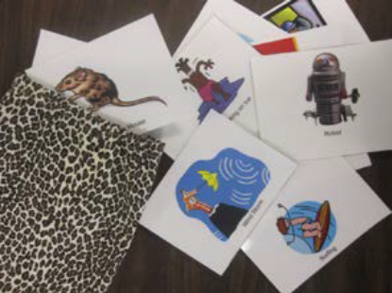  moving from place to place,  like from the playground  to the classroom. | Find Your Chair  Label each chair with a number.  Children choose a number and  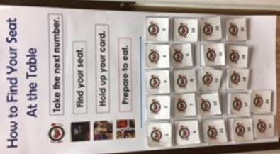  match it to the chair with the  same number. (You could also  use shapes, letters, animal  pictures, etc. . .) Each child shows  the card to indicate they are  ready to be served. The card  stays on the table until they  clean up and then it goes back  on the visual.
Center Time Transitions | Computer Turn Taking Chart  Have a chart with every child’s name (with photo if needed) on it:  1. Allow children to take their name and place it on the computer chart. The turns are in the order of the list.  2. Set a timer, the first child takes his/her turn until the timer goes off  3. When the timer goes off, move the names up and let the next child take his/her turn. Have the first child return their name to the bottom of the turn-  taking chart.
White Board Turn Taking Sign-In  Have a white board in an area or at an activity that is popular and requires waiting for a turn  1. Allow children to “sign in” on the white board for a turn  2. Set a timer and let the first child take his/her turn until the timer goes off  3. When the timer goes off, cross off the child’s name and move down the list (the child who is finished with his or her turn can go get the next child for the next turn) | Clean Up Transitions
Five Minute Glove  The teacher should first model how to use this prop as a safety signal that clean-up time will be soon. Then a child can use this prop as a “helper job” to cue his/her peers.  • The teacher/child with the glove announces to the class that there are “five more minutes left to play, and then it will be time to clean up”.  This should follow an auditory or visual cue like a bell sound or lights  flicked once.  • The teacher/child walks to each center/area in the classroom to make this announcement.  • If a particular child(ren) needs individual cueing, the teacher should go directly to that child to cue them.  This could be repeated as a count down for multiple warnings. (4 more minutes, 3 more minutes, etc... | 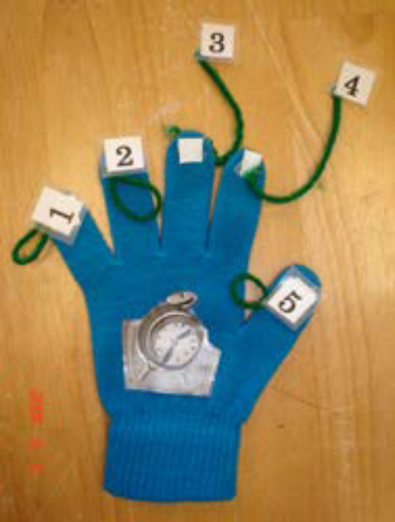
Helping Hands  When children finish cleaning up their center activity they receive a helping hands clip. They then can go and ask a peer if they can help clean up their center. This can reinforce friendship skills of helping others and working together.  1.First clean-up own center.  2. Ask teacher for helping hand clip.  3. Go to center and ask, “Can I help clean-up?”  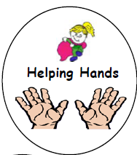  4. If they say “No”, go to another center and ask, “Can I help you clean-up?” Continue to help others until all is clean.  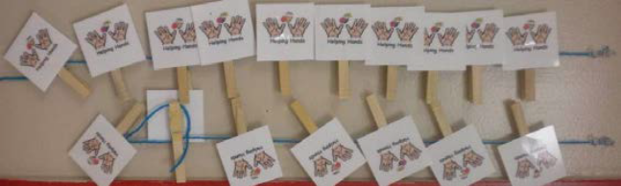  6. Celebrate the clean room! | Line-up Transition  (in classroom/on playground)
Stand on the Line  Place tape on the floor to show children where to stand when waiting in line at the door, for the bathroom, at the water fountain, etc.  Line-up Feet  Have a set of feet on the floor in a line for the children to line-up by standing on. Children can pull matching feet out of a bag and go to the line to stand on the matching feet.  Stop and Go  Hold up a stop sign and blow a horn/ring a bell to indicate that all are to stop. Then turn to “go” to indicate it’s time to line-up. | Beanbag Line Up: A way to stay!  While the children are in line waiting for the rest of their classmates to line up, have a quite game to play to keep the carefully planned line in shape! Make a beanbag and give it to the first person in line. Have them hand it to the person behind them anyway they can think of, like over their shoulder, under their legs, around their waist. Make sure the rules of the game are clearly stated: Only two people can move at a time, no one can talk, and if it drops it is brought back to the front of the line and starts all over. This will help occupy the children while the rest of the children line up.
Go Fish!  Children ‘fish’ for where they will stand in line.  1. Cut out enough paper fish for the number of children in the class, making at least 2 of each color (each child will be lining up with another child who has the matching fish)  2. Attach paperclip to the mouth of each fish  3. Make a fishing pole out of a dowel with a magnet attached to the end of the dowel (by eliminating the string, rods will not get tangled)  4. Give children turns with a magnetic fishing pole to catch their fish, once they catch it they use that fish to line up with their matching fishing buddy.  5. Children can go three at a time to keep the pace moving. By letting the children have a part in the line-up method they become engaged and eager to participate in the task at hand.  NOTE: Shapes, letter, numbers, animals, etc. can also be used | Visual Cue Cards  Choose printouts of cue cards to prompt children of where to go. This is especially powerful for children who have language processing problems or who have behavior problems around transition times. Cue cards can be placed on a cue ring and worn on a coil wrist bracelet for quick access.  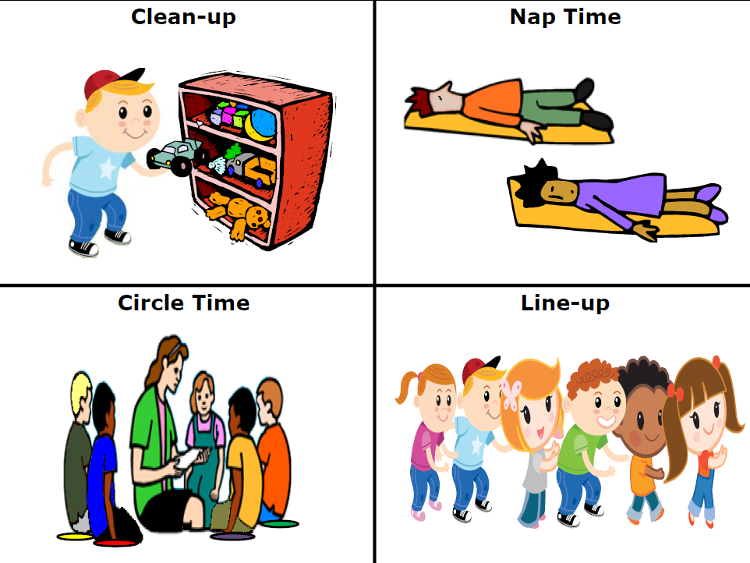
Magic Mirror
Use the “magic mirror” by looking through it and commenting on who is correctly transitioning. For example,
At circle say: I am looking through my mirror and who do I see,
I see ____ looking at me. (…sitting for me.)
At lunch say: I am looking through my mirror and who do I see,
I see ____ eating with me.
At nap say: I am looking through my mirror and who do I see,
I see ____ napping for me.
At line-up say: I am looking through my mirror and who do I see,
I see ____ lining up for me.
At clean-up say: I am looking through my mirror and who do I see,
I see ____ cleaning up for me.
When called to an area: I am looking through my mirror and who do I see, I see ____ coming over to me.
NOTE: Other options are looking through funny glasses, binoculars, a magnifying glass, telescope, etc.

Partner Sticks  (good for transitions to: Line up, Table Time, Centers)  1. Use the partner sticks to pair up the kids in going to line up.  2. Have children pull a stick out of the can  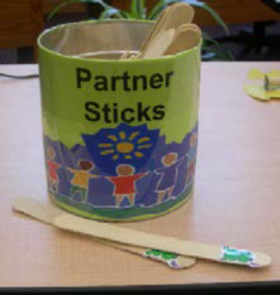  3. Then have them find a friend  with a matching stick  4. Once they find a matching stick,  they go to the line together  5. When they get to the line their  stick acts as a “ticket” to get out the door. | Transition to Resting
Let the Light Lead the Way  Use a decorated flashlight to “lead the way” to the child’s cot. Have the child “follow the light”.   | Quiet as a Mouse  Create a mouse finger puppet from felt as prop -  -tell the children to “tip toe as quiet as a mouse” to their mats  -tell the children “shhhhh, I’m trying to sleep”  -look for those who are napping quietly and give kisses from the mouse for being “quiet as a mouse”  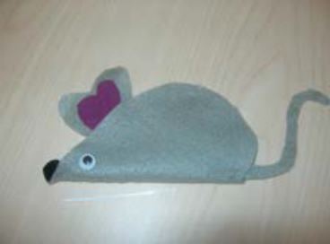
Good-Bye/Dismissal Transition | Tips for an end to a “great day”!  1. Every child needs a genuine “good” bye and a smile to send him/her on his/her way. Saying a simple good bye is not enough. Walk to the child or call the child over and enthusiastically celebrate the child’s day in the classroom.  2. Let them know how proud you are of them or what fun you had and comment on something exciting or good that they did that day.  3. Make physical contact (pat on the shoulder or head, hug, high five or a gentle loving nudge) and let them know you are looking forward to seeing them the next day of school.

