TRANSITIONS | 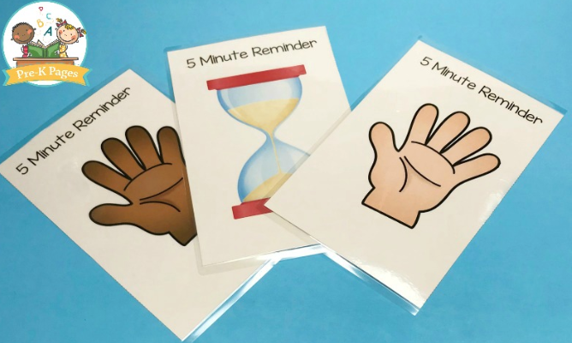
Children are actively involved when  transitioning. No long wait periods. | 
Teach children the expectation during a  transition. Use visuals to teach. | 
Create a transition ritual/game for the most  challenging transition of the day. | 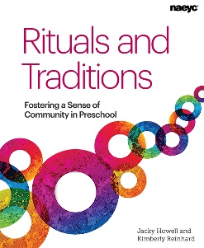
Give at least a 5-minute whole class  reminder BEFORE a transition happens,  visually and verbally. | 
Give individual reminder before transition to  students who need it…..verbally/visually. | 