Kirtan Patel

CMPSC 487W

Assignment#1

Dr. Hien

**Screenshots of Application Operations for Sun lab access**

1. Log in Basics

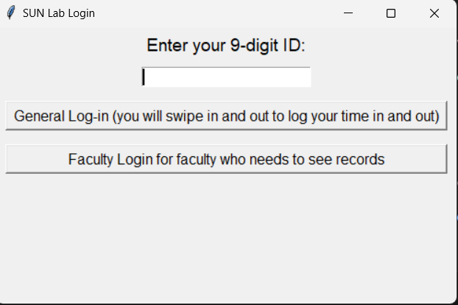

* ID input box to enter the 9-digit ID (replicating the swiping motion
* Additional faculty log in button (this is only for faculty who wants to see records)
* **STUDENTS CANNOT ACCESS IT**

1. Log in Authentication

WHEN ANYONE CLICS GENERAL LOG IN TO SWIPE IN/OUT

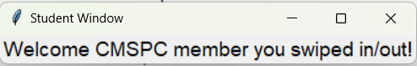

* This logs verifies that that person has been successfully timed im / time out

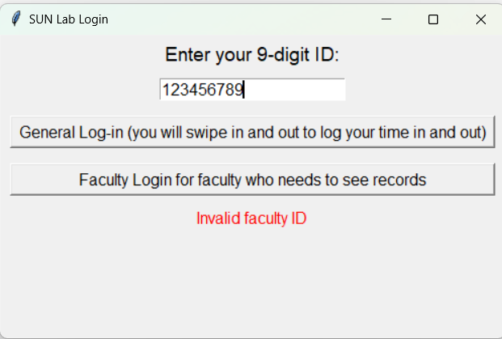

* Students cannot click the Faculty log in to see records because they are not authenticated as a faculty member

1. **Working Operations for the GUI**

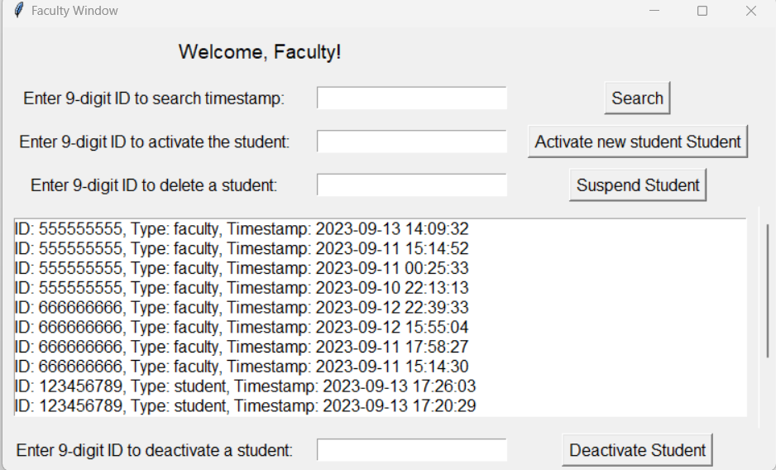

* This is the primary GUI which handles all the database interaction which deals the operation.
* In the middle you can all the screenshots of everyone who has swiped in and out of the PSU sunlabs.
* It contains both faculty and students who have accessed the room

*ALL THE SCREENSHOTS OF THE OPERATIONS*

***EXAMPLE OF A STUDENT SWIPPING IN AND OUT***

**]**

* 2 stamps are logged with the according DATE and TIME
* 2023-09-13 17:26:03 represents the TIME IN
* 2023-09-13 17:55:53 represents the TIME OUT

**The SEARCH operation example**

* This operation searches the ID of the individual, then shows all of the related attributes with them

EX:

I would input the ID of the individual



**Then**

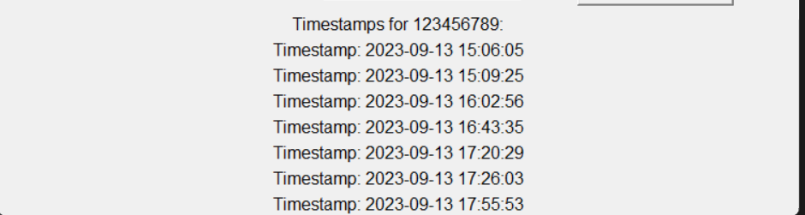

* It then queries all of the specific details regarding ‘123456789’

**Activate operation**

**Simply activates a student so they can log in again**



**Ex:**



* 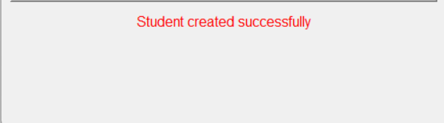
* **This is verification that the student has been activated**

**Suspend Operation**

* **Stops a user from logging in, so they lose their Sun lab access rights**



**Suspending ‘987654321’ then the authorized person would click Suspend student**

**This shows how they can no longer log in once they have been suspended**

