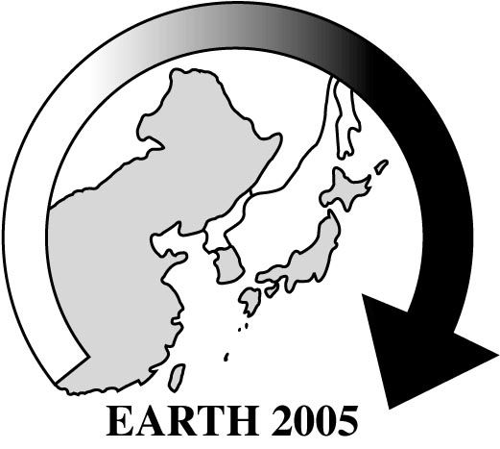
Final Registration Form
for EARTH 2005
Please complete in distinct block letter and tick ”し” in appropriate boxes
Family name Given name Male [ ]
Full name in Chinese Female [ ]
Title/Position Nationality
Passport No. Date of birth

Address _________

_ ___ Tel:
E-mail: ____ Fax:
1. Registration fee (before August 1, 2005 ) US$ 350
( after August 1, 2005 ) US$ 400
Student Registration fee (before August 1, 2005 ) US$ 180
( after August 1, 2005 ) US$ 200
Accompanying person program fee US$ 180
I will be accompanied by (please fill separate registration form)
2. Package accommodation fee/person: Days Hotel & Suites (double room) US$ 145
(Nov. 9 evening to Nov.12 morning) ( single room) US$ 250
Longtan Hotel (double room) US$ 90
(single room) US$ 135
I will share the room with

3. Optional post-conference tour fee/person
Tour 1: Beijing-Tianjin (Double room) US$ 330
(Single room) US$ 435
Tour 2: Ningbo-Hangzhou-Shanghai (Double room) US$ 475 _
(Single room) US$ 575
Tour 3: Xiamen-Guangzhou (Double room) US$ 550 __
(Single room) US$ 635
I will share the room with

Grand Total US$
I will arrive in Beijing from (place) by Flight
on (date) ; and leave for on (date) ____
Payment of the Grand Total should be made payable in US dollars and remit by telegraphic transfer to:
The Nonferrous Metals Society of China, EARTH 2005; A/C No.:809215805808094014
Bank of China, Xi-Zhan-Bei Subbranch, Beijing 100038, China; Swift Code: BKCHCNBJ110
Please return the completed Registration Form with a copy of remittance receipt to

Prof. CHU Youyi, YANG Huanwen, Secretariat of EARTH 2005
B12 Fuxing Road, Beijing 100814, CHINA

Signature __ ; Date _____

