

THE TITLE OF THE DESIGN PROJECT
GOES HERE IN ALL CAPITAL LETTERS

Senior Design Project I (or II)

Your Name Goes Here in Title Format (Only First Letters Capitalized)

2018
MEF UNIVERSITY
FACULTY OF ENGINEERING

DEPARTMENT OF COMPUTER ENGINEERING

THE TITLE OF THE DESIGN PROJECT
GOES HERE IN ALL CAPITAL LETTERS

Senior Design Project I (or II)

Your Name Goes Here in Title Format (Only First Letters Capitalized)

Advisor: Advisor’s Name (e.g. Asst. Prof., Assoc. Prof.)

2018

MEF UNIVERSITY
FACULTY OF ENGINEERING

DEPARTMENT OF COMPUTER ENGINEERING

Project Title : Your Project Title (Title Format)
Student(s) Name : Your Name (Title Format)
Date : dd/mm/yyyy

I hereby state that the design project prepared by Your Name (Title Format) has been completed under my supervision. I accept this work as a “Senior Design Project”.

dd/mm/yyyy
Advisor’s Name (Asst. Prof. ...)

I hereby state that I have examined this senior design project by Your Name (Title Format). This work is acceptable as a “Senior Design Project”.

dd/mm/yyyy
Department Chair’s Name

Head of the Department of
Computer Engineering

ACADEMIC HONESTY PLEDGE

In keeping with MEF University Student Code of Conduct, I pledge that this work is my own and that I have not received inappropriate assistance in its preparation. I further declare that all resources are explicitly cited.

NAME DATE SIGNATURE
Name Surname dd/mm/yyyy

ABSTRACT

THE TITLE OF THE DESIGN PROJECT
GOES HERE IN ALL CAPITAL LETTERS

Your Name (Title Format)

MEF UNIVERSITY
Faculty of Engineering
Department of Computer Engineering

Advisor: Your Advisor’s Name (Title Format)

MONTH (ALL CAPITAL LETTERS), Year

Your abstract goes here. All paragraphs in this section follow the format “Normal”. Make sure that the format selected is “Normal”. You can check it from the menu Format>Styles and Formatting that will be opened on the right-hand side of this document.

Keywords: Write the keywords of the project here, separated by comma.

ÖZET

TASARIM PROJESİNİN ADI (BÜYÜK HARFLERLE)

Öğrencinin Ad Soyadı (Başlık Formatında)

MEF ÜNİVERSİTESİ
Mühendislik Fakültesi
Bilgisayar Mühendisliği Bölümü

Tez Danışmanı: Danışmanın İsmi (Başlık Formatında)

AY (BÜYÜK HARFLERLE), Yıl

Projenin Türkçe Özeti.

Anahtar Kelimeler: Anahtar kelimeler virgül ile ayrılmış olarak buraya yazılır.

TABLE OF CONTENTS
ABSTRACT iii
ÖZET iv
TABLE OF CONTENTS v
LIST OF TABLES vii
LIST OF FIGURES viii
LIST OF ABBREVIATIONS ix
1. INTRODUCTION 1
1.1. Motivation 1
1.2. Broad Impact 1
1.2.1. Global Impact of the solution 1
1.2.2. Economic Impact of the solution 1
1.2.3. Environmental Impact of the solution 1
1.2.4. Societal Impacts of the solution 2
1.2.5. Legal Issues related to the project 2
2. PROJECT DEFINITION AND PLANNING 3
2.1. Project Definition 3
2.2. Project Planning 3
2.2.1 Aim of the Project 4
2.2.2 Project Coverage 4
2.2.3 Use Cases 4
2.2.4 Success Criteria 4
2.2.5 Project Time and Resource Estimation 4
2.2.6 Solution Strategies and Applicable Methods 5
2.2.7 Risk Analysis 5
2.2.8 Tools Needed 5
3. THEORETICAL BACKGROUND 6
3.1. Literature Survey 6
3.2. Solution Method (Change this title according to your solution method) 6
4. ANALYSIS AND MODELLING 7
4.1. System Factors 7
4.2. How System Works 7
4.3. Modelling 7
4.3.1. System Architecture 7
5. DESIGN, IMPLEMENTATION AND TESTING 8
5.1. Design 8
5.2. Implementation 8
5.3. Testing 8
6. RESULTS 9
7. CONCLUSION 10
7.1. Life-Long Learning 10
7.2. Professional and Ethical Responsibilities of Engineers 10
7.3. Contemporary Issues 10
7.4. Team Work 10
APPENDIX A 11
APPENDIX B 12
ACKNOWLEDGEMENTS 13
REFERENCES 14

LIST OF TABLES
Table 1. Impact dimensions of GreenChoice and the mechanisms through which they arise.

LIST OF FIGURES
Figure 1. Sample figure. Use Insert/Caption to insert figure captions. 2

LIST OF ABBREVIATIONS
Word to be defined Write the definition here. Do not put any hard carriage returns in the definition and it will wrap like this automatically. When you are done with the definition, hit one return and the appropriate space for the next definition will be inserted
Next word Remember to use a tab between the abbreviations and the definitions
SVM Support Vector Machines
PCA Principal Component Analysis
LDA Linear Discriminant Analysis

Note: The style for the list of abbreviations is “Abbreviation Style”. The paragraphs are single-spaced, and there is one empty line between paragraphs.

1. INTRODUCTION
Household appliances are usually bought on price, because price is the most visible signal at the point of sale. A refrigerator or washing machine, however, stays in service for more than a decade. Over that period, its electricity and water consumption, its reliability and the quality of after-sales service may matter more than the initial price difference between two models. Consumers rarely see these factors side by side. Energy labels, technical specifications and user reviews do exist, but they are spread across official registries and e-commerce pages, expressed in different units and, in the case of reviews, written as unstructured Turkish text.
GreenChoice addresses this fragmentation. It is an AI-based decision support prototype that evaluates refrigerators and washing machines against six criteria: energy efficiency, long-term cost of ownership, durability, service and failure experience, price advantage and overall satisfaction. Structured attributes come from Turkish e-commerce listings and from the European Product Registry for Energy Labelling (EPREL), matched through manufacturer model codes. Customer reviews provide the unstructured evidence. Aspect-level signals such as durability complaints or service problems are extracted from them with rule-based, TF-IDF and transformer-based (BERTurk) methods. Each criterion is normalised to a sub-score between 0 and 1, and the sub-scores are combined with category-specific weights into a single score that maps to one of three labels: recommended, neutral or not recommended.
A score alone is not the intended output. Every result comes with a short explanation that names the criteria that pull the product above or below its category average. Technically, the system is split into two parts. An offline batch pipeline collects, cleans, analyses and scores the data, then writes the results to a single SQLite database. A FastAPI service and a React interface read this database, and users can re-rank products by their own priorities. This separation keeps the serving layer lightweight and reproducible, which appears appropriate for a prototype whose main contribution lies in its scoring and explanation logic rather than in real-time data acquisition.

1.1. Motivation
The project starts from a gap between the information that exists and the information consumers actually use. The rescaled A–G energy label, introduced under Regulation (EU) 2017/1369 [3], states a product’s efficiency class, but it does not state that efficiency in monetary terms. A more efficient model may cost more at purchase and still be cheaper over twelve years of operation. Without a total cost of ownership (TCO) estimate, this trade-off stays hidden. The estimate is not trivial to produce, since it depends on tariffs, usage assumptions and product lifetime.
Reviews pose a different problem. They hold practical knowledge about noise, breakdowns and service quality that no specification sheet reports. Reading hundreds of them is impractical, and star ratings compress that knowledge too far: in the pilot data, 86.5% of reviews carry five stars, which might suggest that average ratings discriminate poorly between products. Aspect-based analysis of review text could recover part of the signal that ratings lose.
Explainability is the third concern. If a recommendation cannot justify itself, users either trust it blindly or ignore it. Because GreenChoice shows how each criterion contributes to the score and lets users change criterion importance, it aims to support an informed decision rather than make it for them.

1.2. Broad Impact
The broader impact of GreenChoice is expected to come less from the software itself than from the purchase decisions it might influence. A refrigerator or washing machine is a long-lived product. A choice made in a few minutes at the point of sale fixes, for roughly twelve years, the household’s electricity and water consumption, the likelihood of repairs and, eventually, part of its waste stream. A tool that shifts attention from purchase price towards lifetime criteria could therefore have effects beyond the individual buyer. Table 1 lists the impact dimensions considered in this report and the mechanism behind each. Sections 1.2.1 to 1.2.5 treat them in detail; this section outlines the overall economic and societal picture and covers health and security, which have no dedicated subsection.
Economically, the system makes visible a cost that consumers tend to estimate poorly. The total cost of ownership combines the purchase price with twelve years of electricity and, for washing machines, water consumption, priced with official Turkish tariffs. The pilot data point to a more cautious message than is often assumed. For most product pairs in the dataset, the higher price of the more efficient model is not recovered through electricity savings at current tariffs. This appears consistent with the debate on the energy efficiency gap, in which the size of profitable but neglected efficiency investments remains contested [1]. Field evidence also suggests that lifetime cost information changes purchases only modestly, and not for every product type [2]. GreenChoice is therefore positioned as a means of making trade-offs transparent, not as a promise of savings.
The societal contribution lies mainly in access to information. Specifications, EPREL records and several thousand Turkish reviews are condensed into a score with a written justification. This could narrow the gap between buyers who can interpret technical data sheets and those who cannot. Because users can change the importance of each criterion, the system does not impose a single definition of a good product. Some risk remains. A score presented with apparent precision might be trusted more than its underlying data allow, particularly near the threshold between labels, where the sensitivity analysis indicates that small weight changes can alter the outcome.
The health dimension is indirect but not negligible. Appliances operate inside living spaces, and noise is recorded both as a technical specification and as a review aspect, although it does not yet enter the score. Failure reports, such as a refrigerator that stops cooling, could also carry food safety implications for the household. The durability and failure criteria capture this signal only partially, since they depend on how often such problems are reported.
Security concerns relate to data handling rather than to physical safety. Reviews are read only from pages saved manually in a standard browser, usernames are never extracted, and review text is kept out of the version-controlled repository. The planned user study collects no personal data. This data-minimisation approach might reduce privacy risk without limiting the analysis, since the scoring logic needs review content, not reviewer identity. The legal side of these choices is discussed in Section 1.2.5.

Table 1. Impact dimensions of GreenChoice and the mechanisms through which they arise.
Dimension | Mechanism in GreenChoice | Section
Global | Scoring approach transferable to other markets; EPREL as an EU-wide data source | 1.2.1
Economic | Twelve-year total cost of ownership with official electricity and water tariffs | 1.2.2
Environmental | Energy class and annual consumption weighted in the overall score | 1.2.3
Societal | Turkish reviews and specifications condensed into explained, adjustable scores | 1.2.4
Legal | Manual collection, compliance with site terms, no personal data | 1.2.5
Health and security | Failure and noise signals; data minimisation in review handling | 1.2

1.2.1. Global Impact of the solution
GreenChoice targets the Turkish market, yet its official energy data are European. EPREL was established under the labelling framework of Regulation (EU) 2017/1369 [3], and the label rules for refrigerating appliances and household washing machines follow Delegated Regulations (EU) 2019/2016 and 2019/2014 [4], [5]. Because these rules apply across the EU single market, the structured part of the scoring model is not tied to one country. Since tariffs, lifetimes and weights sit in a configuration file, transfer to another market would mainly require new tariffs and a review model for another language.
The pilot data qualify this portability. Only 48 of the 80 products matched an EPREL record through their shop model code. Bosch and Siemens use the same codes in Türkiye and the EU, while Beko and Grundig sell under Turkish names absent from the registry. Global reach might thus depend less on the regulation than on consistent model identification across markets.

1.2.2. Economic Impact of the solution
The TCO model adds twelve years of operating cost to the purchase price. Electricity is priced at 2.919 TL/kWh, the low-tier residential tariff excluding taxes [6], and water at 65.52 TL/m³ under the 2026 İSKİ residential tariff [7]. A break-even analysis gives the clearest economic result. For each pair where the cheaper model uses more energy, the electricity price equalising both lifetime costs was computed. At the current tariff, the efficient model was already cheaper in only 1 of 76 refrigerator pairs and 7 of 104 washing machine pairs. Median break-even prices of 49.45 and 103.81 TL/kWh lie roughly 17 and 35 times above that tariff.
Price gaps in this sample thus seem to reflect brand, capacity and features rather than efficiency. For households, the practical gain may be avoiding a premium the label alone does not justify. Taxes, discounting and future tariff changes are not modelled, so these figures remain indicative.

1.2.3. Environmental Impact of the solution
If efficiency rarely pays for itself, its value in GreenChoice is mainly environmental. The energy criterion is weighted 0.25 for refrigerators and 0.15 for washing machines and uses only the energy class and declared annual consumption. A keyword search found 21 energy-related candidates in 1,460 pilot reviews, and only one of the four inspected actually concerned energy. Combining the class with kWh reflects evidence that labels may draw attention to the efficiency class at the expense of actual consumption [8].
The sample is environmentally uneven. No refrigerator reaches class A on the rescaled label, and 28 of the 39 with a known class fall into class E. A category-relative score could make such a product look sound, so energy-related explanations state the absolute EU class. Durability may add an indirect benefit by delaying replacement and the resulting waste. This link remains unquantified, since no life-cycle assessment is performed.

1.2.4. Societal Impacts of the solution
Two societal risks emerge from the pilot data. The first is false reassurance. Review-based criteria barely vary: the service sub-score averages 0.99 ± 0.03 for refrigerators, because few service complaints are detected and most reviews carry five stars. Together with the doubled service weight for washing machines, this partly explains why 37 of 40 washing machines but only 10 of 40 refrigerators were labelled “recommended”. Users could read an artefact of the weighting as a quality difference between categories.
The second risk concerns coverage. Products without a model code, mostly from domestic brands such as Arçelik, Beko and Vestel, are harder to link to official data. Imputation can distort such products in either direction. In the first full run, washing machines with imputed energy data scored slightly higher on average (85.0 against 80.5). The planned user study is meant to show whether participants grasp these limits or simply trust the label.

1.2.5. Legal Issues related to the project
The legal questions concern personal data, platform terms and official data reuse. Review texts written by identifiable users might fall within Law No. 6698 on the Protection of Personal Data [9]. GreenChoice never extracts usernames, keeps review text out of the public repository and displays only aggregated counts.
Platform terms are less clear-cut. Trendyol’s terms of use forbid copying site materials without prior permission and attribution, but do not state whether reviews are covered [10]. Hepsiburada’s agreement could not be read without logging in. Automated requests obey robots.txt and use an honest user agent, and Hepsiburada’s CAPTCHA was not bypassed. Academic, unpublished use is not treated as lifting these terms, and the question is pending with the advisor.
EPREL licenses its data for research and comparison tools, provided attribution is kept and no endorsement is implied [11]. Although these terms govern API access, each manually read record keeps its EPREL source URL. Reviews might also qualify as works under Law No. 5846 [12], which favours showing derived signals over reproducing text. No human rights issue has been identified. A negative label could also be perceived as harming a brand; every label therefore carries a written justification.

2. PROJECT DEFINITION AND PLANNING
This chapter defines what GreenChoice is expected to do and how the work was organised to deliver it. Section 2.1 sets the scope of the prototype and states its functional and non-functional requirements. Section 2.2 presents the work breakdown, the responsibilities of the two team members and the fourteen-week schedule. The subsections that follow refine the aim, coverage, use cases, success criteria, resources, methods, risks and tools.

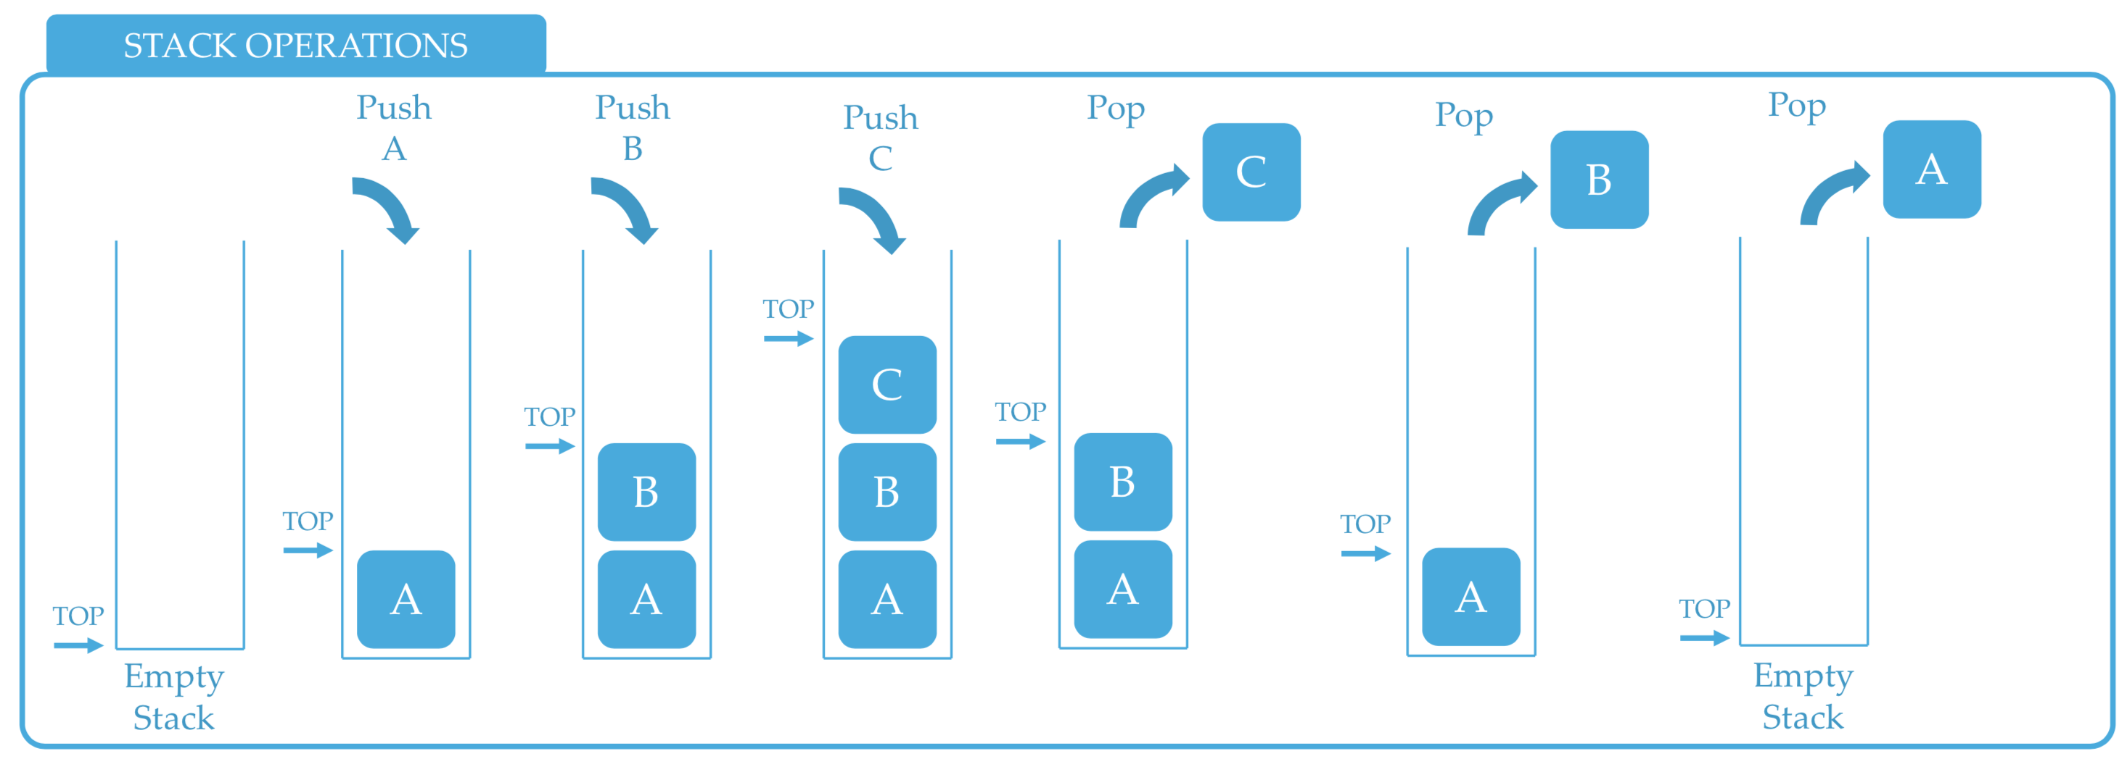
Figure 1. Sample figure. Use Insert/Caption to insert figure captions.

In one dimension, the Gaussian function is the probability density function of the normal distribution.
$f\left(x\right)=\frac{1}{σ\sqrt{2π}}e^{\frac{-{\left(x-μ\right)}^{2}}{2σ^{2}}}$ (1)

sometimes also called the frequency curve. The full width at half maximum for a Gaussian is found by finding the half-maximum points x₀.

2.1. Project Definition
GreenChoice is a decision support prototype, not a marketplace or a price-tracking service. Its scope is deliberately narrow. The intended user is a consumer comparing a shortlist of appliances before buying one. Two product categories are covered, refrigerators and washing machines, because energy use matters in both, reviews are plentiful and EPREL holds official label data for each. Product data come from Trendyol and Hepsiburada listings, and the first complete dataset contains 80 products, 40 per category, with 3,386 reviews after cleaning. All collection, analysis and scoring run offline. The serving layer reads a prepared database and performs no scraping or model inference at request time. Real-time price updates, further categories, purchase functions and user accounts lie outside the scope.
The functional requirements follow the data flow of the system. The pipeline shall import product attributes and hand-collected EPREL values, rejecting invalid rows with their row number (FR1). It shall import reviews from browser-saved pages without extracting usernames, and clean the text (FR2). It shall extract aspect-level signals through interchangeable rule-based, TF-IDF and BERTurk extractors that share one interface (FR3). For every product, it shall compute six criterion sub-scores between 0 and 1, a twelve-year TCO, a score from 0 to 100 and one of three labels (FR4). Each score shall come with Turkish explanation sentences derived from criterion contributions, and criteria filled by imputation shall never appear in them (FR5). Through the API, users shall list, filter and sort products by score, price or TCO, open product details, compare two to four products and re-score a category with their own priorities (FR6). The interface shall expose these functions and express priorities as three importance levels instead of numeric weights (FR7).
The non-functional requirements are less visible, yet they shape the design just as strongly. Transparency comes first: every score must be traceable to the weights and sub-scores that produced it (NFR1). Reproducibility follows from the offline design. Identical inputs are intended to yield an identical SQLite database, and annotated reviews are to be split with a fixed seed (NFR2). Data collection must respect robots.txt and site terms, use an honest user agent, wait at least two seconds between requests and never bypass blocks; raw and personal data stay out of the repository (NFR3). Silent data loss counts as a defect, so invalid input must fail visibly (NFR4). Maintainability rests on small modules, abstract extension points and automated checks. A GitHub Actions workflow runs ruff, pytest and the frontend build on every pull request, and the last recorded run passed 191 tests (NFR5). Responsiveness is expected because the service only computes a weighted sum, although no latency target has been measured yet (NFR6).

2.2. Project Planning
The work was decomposed into five stages that lead from decisions to delivery: discovery and source review, data collection and preprocessing, NLP and feature extraction, the scoring model, and finally explainability, interface and submission. Each stage was broken into tasks with an owner, a date range and a completion condition. Ownership follows two roles. Person A is responsible for review collection, BERTurk, SHAP-based explanations and the user study. Person B handles product and EPREL data, scoring, the machine learning comparison, the API and the interface. Shared tasks such as annotation and the final report are assigned to both. Table 2 shows the resulting schedule; week 1 starts on 22 October 2026, and submission is due on 25 January 2027. Several bars overlap on purpose. Annotation, for example, runs alongside the literature survey, since the labelling guideline and the reading on aspect-based sentiment analysis inform each other, while the user study can only start once explanations exist.
Parallel work creates dependencies, so eight hand-off dates were fixed between the two roles. Each hand-off has a date and a named sender, which keeps a delay on one side from silently blocking the other. The train, validation and test split, for instance, had to be ready by 12 November so that all three NLP methods could be evaluated on the same test set. Progress is reviewed in a fifteen-minute meeting every Monday, and each task is merged through a pull request reviewed by the other member. The plan has already shifted in places. Automated collection from Hepsiburada was replaced by browser-saved pages after the site blocked automated requests, and the sensitivity analysis, scheduled for late December, was first run on 7 November.

Table 2. Project plan and responsibilities over 14 weeks (22 October 2026 – 25 January 2027).
Task | Responsible Person | Weeks
Task | Responsible Person | 1 | 2 | 3 | 4 | 5 | 6 | 7 | 8 | 9 | 10 | 11 | 12 | 13 | 14
Decisions and source review | Person A  Person B
Product, EPREL and review data collection | Person A  Person B
Review annotation and NLP methods | Person A  Person B
Literature survey | Person A  Person B
Product labelling and AHP weights | Person A  Person B
ML scoring and sensitivity analysis | Person B
SHAP explanations and review evidence | Person A
Interface, deployment and demo | Person B
User study | Person A  Person B
Final report and presentation | Person A  Person B

2.2.1 Aim of the Project
The aim of the project is to help consumers choose refrigerators and washing machines on the basis of lifetime criteria rather than purchase price alone. GreenChoice pursues this aim by combining official energy label data, a twelve-year cost estimate and aspect-level evidence from Turkish reviews into a single score that explains itself. The intended outcome is not a verdict that replaces the buyer’s judgement. It is a transparent ranking that users can question, re-weight and compare. A secondary, academic aim is to examine whether a fine-tuned BERTurk model extracts appliance-specific review signals more reliably than rule-based and TF-IDF baselines when labelled data are scarce.

2.2.2 Project Coverage
The project covers the full path from raw sources to an interactive prototype. Data work comprises product and EPREL collection, manual reading of manufacturer labels where EPREL holds no record, review import from saved pages and text cleaning. The NLP component covers the annotation of a review sample by two annotators, the measurement of their agreement and the comparison of three aspect extraction methods on one test set. On the scoring side, the project includes criterion design, TCO computation, AHP-based weights, a comparison of logistic regression, random forest and XGBoost against the weighted baseline, and a sensitivity analysis. Explanations come from criterion contributions for the weighted model and from SHAP values for machine learning scorers. A FastAPI backend and a React interface form the service layer, and a small within-subjects user study evaluates whether the explanations are understood.
Several items are explicitly excluded. GreenChoice does not track prices over time, sell products or store user profiles. Nor does it claim to cover the whole market: its product pool reflects the saved listing pages and the selection rule, not every model on sale.

2.2.3 Use Cases
Figure 2 shows the UML use case diagram of GreenChoice. The system boundary contains eleven use cases, initiated by two primary actors. EPREL and the e-commerce sites appear as external, secondary actors.
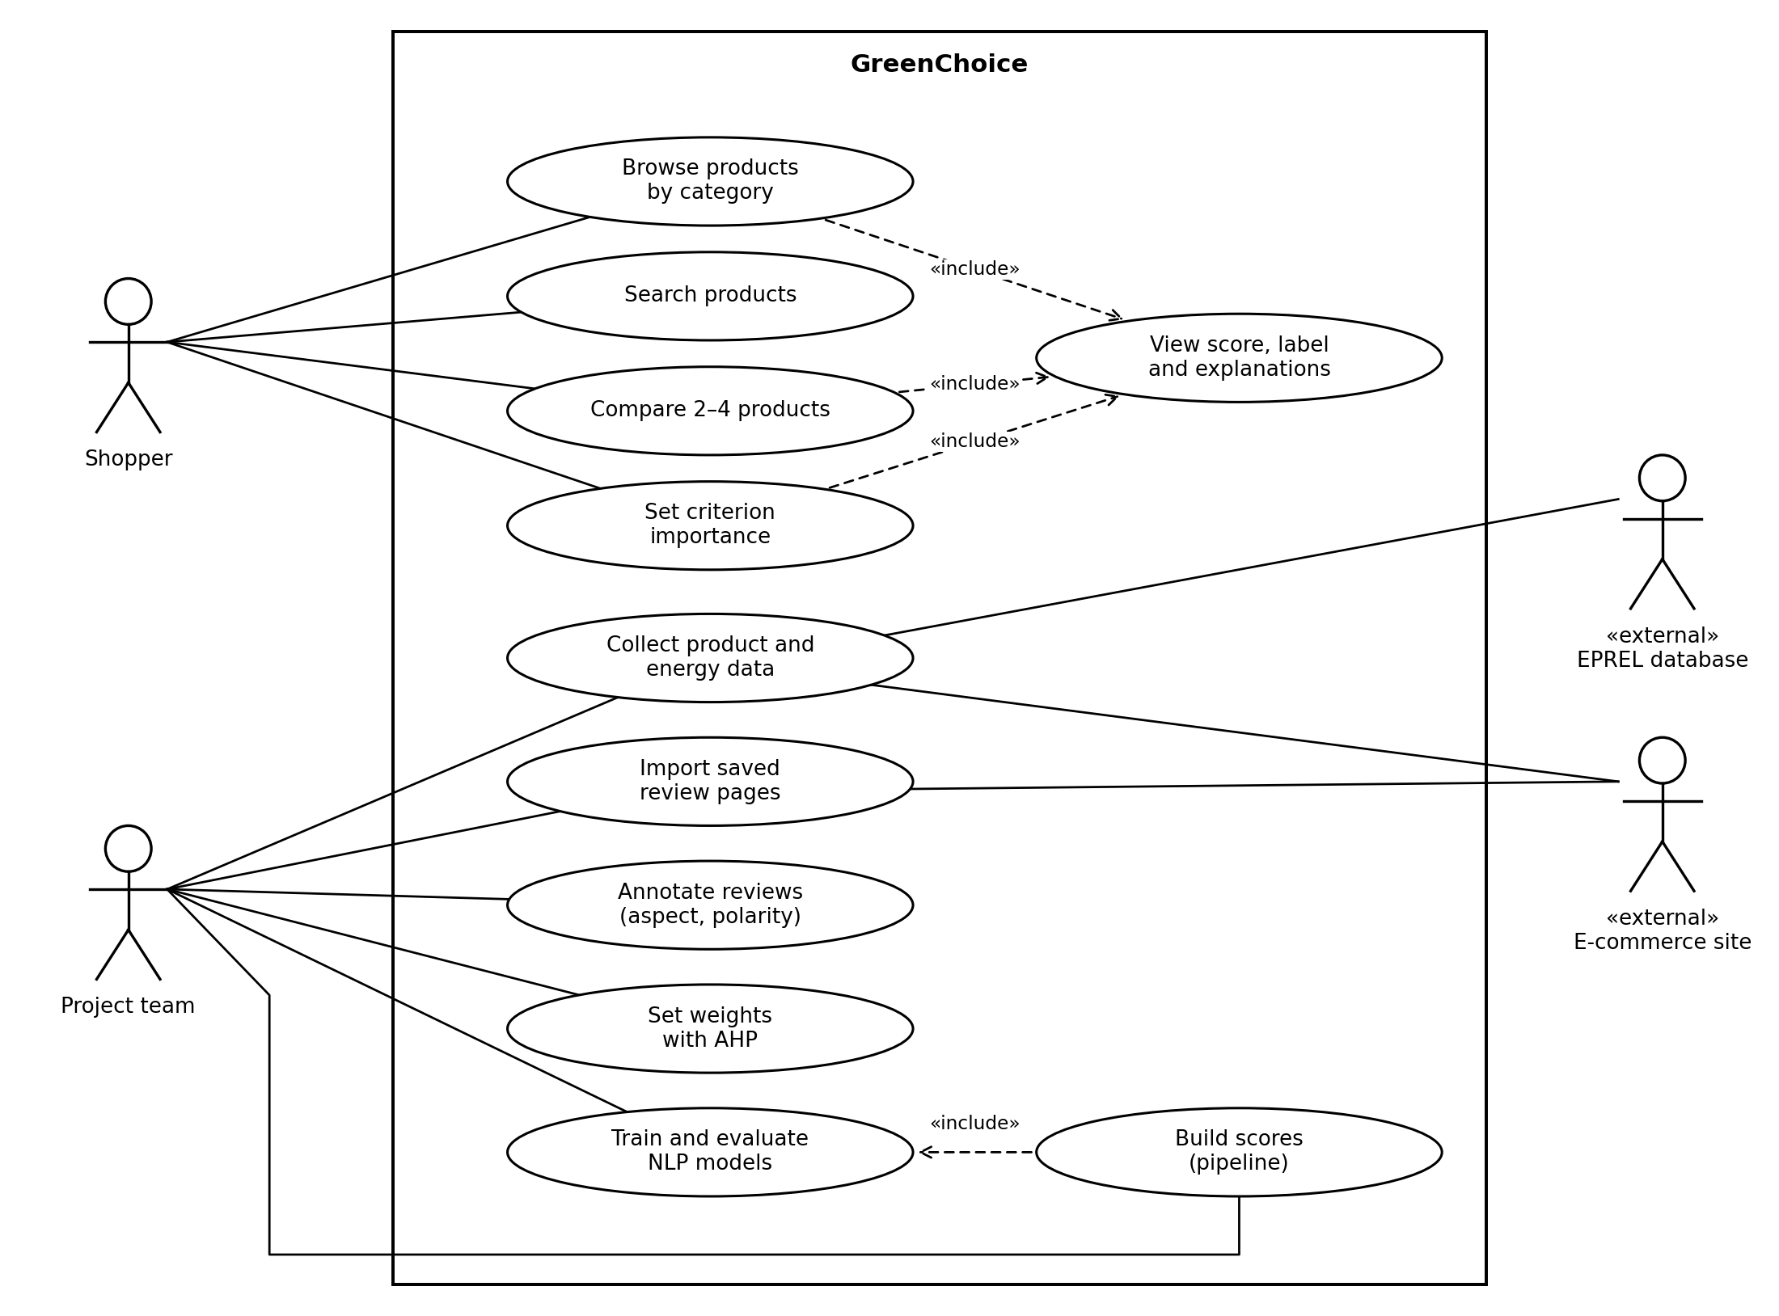
Figure 2. UML use case diagram of GreenChoice.
The Shopper interacts only with the deployed interface. Browsing a category, searching by name or brand, comparing two to four products and setting the importance of criteria are distinct goals. Three of them end in the same behaviour, namely displaying a score, a label and its explanation, so this behaviour is modelled once as the included use case View score, label and explanations. Setting importance is the only shopper action that triggers computation. Even then, the API merely re-weights stored sub-scores; no shopper request ever invokes the pipeline.
The Project team actor represents the two developers in their analyst role, and its use cases mirror the offline pipeline. Product and energy data are collected from EPREL and the e-commerce sites, and review pages saved in a browser are imported. The association between review import and the shop therefore denotes a data source, not automated access. Reviews are then annotated by aspect and polarity, criterion weights are derived with AHP, and NLP models are trained and evaluated. Building the scores includes the NLP use case, because the pipeline applies the selected extractor to every review before the criteria are computed.
Keeping the two actors apart reflects a deliberate design decision. Everything the team does happens before deployment. The shopper-facing system can thus remain read-only, which may simplify hosting and make results easier to reproduce.

2.2.4 Success Criteria
Success is judged against measurable criteria for each component, most of which were fixed before the main experiments began. At system level, the prototype counts as complete when every functional requirement in Section 2.1 can be demonstrated end to end on real data and the automated test suite passes.
Data coverage requires at least 40 products per category, each with at least 30 ratings, and EPREL energy data for at least 70% of products. The first full run reached 48 of 80 products, or 60%, through EPREL. Manufacturer labels raised energy class coverage to 78 products, yet the EPREL target itself has not been met.
Annotation quality is assessed with Cohen’s kappa per aspect on 100 shared reviews; aspects below 0.6 are discussed and the guideline revised. NLP performance is measured by precision, recall and F1 of the three extractors on the same held-out test set. The comparison itself is the criterion. Given the small training set, BERTurk is not assumed to outperform the baselines.
Scoring validity is evaluated against consensus labels for 150 to 200 products, using accuracy, macro F1 and Spearman correlation. AHP judgements are accepted only when the consistency ratio is below 0.1. Explanation quality is tested in a user study with 10 to 15 participants. Correct answers to comprehension questions and Likert ratings for understanding and trust are compared between score-only and explained conditions with the Wilcoxon signed-rank test. A non-significant difference would not be read as evidence that explanations have no effect.

2.2.5 Project Time and Resource Estimation
The project runs for fourteen weeks, from 22 October 2026 to 25 January 2027, roughly 3.1 months. Effort was estimated bottom-up. The schedule in Table 2 was combined with the weekly time each member can devote alongside other courses. Exact hours have not been logged, so the estimate assumes 8 to 10 hours per member per week. For two members over fourteen weeks, this yields 224 to 280 working hours. Taking one person-month as 160 hours of full-time work, the total effort amounts to approximately 1.4 to 1.75 person-months. The range reflects weekly variation in workload.
Direct monetary costs are near zero. Human effort, contributed as unpaid student work, is the dominant resource. Development runs on the members’ own laptops, and BERTurk is fine-tuned on the free T4 GPU tier of Google Colab. All libraries are open source, and the repository, CI and data sources are free to use. Hosting the demonstration on Render or Hugging Face Spaces is planned; whether a free tier will suffice has not yet been verified.

2.2.6 Solution Strategies and Applicable Methods
Choices for each sub-problem were guided by data access, label availability and the need for transparency.
For data acquisition, an automated scraper would scale best, but Hepsiburada answered the first honest request with a CAPTCHA, and Trendyol’s robots.txt disallows its review endpoints. Public corpora were rejected because they lack either product identifiers or energy data. Reviews are therefore read from browser-saved pages, a slower method that stays within site rules. For energy data, the EPREL API would have been ideal, yet it requires a signed declaration; values are instead read from public EPREL pages and, failing that, from manufacturer labels.
Aspect extraction offers a clear trade-off. Rule-based matching is transparent and needs no training data, but it misses paraphrases and complex negation. A TF-IDF classifier is cheap to train yet ignores word order. BERTurk [13] captures context but requires labelled data and a GPU. Instead of choosing in advance, all three are implemented behind one interface and compared on the same test set.
For scoring, supervised models such as random forest or XGBoost could learn weights from labelled products. With roughly 80 products and labels still being collected, they risk overfitting. A weighted sum is less flexible but fully interpretable, so it serves as the primary method, with weights justified through AHP pairwise comparisons [14]. ML models are compared against it once consensus labels exist.
Explanations follow from this choice. In the weighted model, each criterion’s contribution is computed exactly, and no approximation is needed. For ML scorers, SHAP [15] was preferred over LIME [16] because its additive attributions fit the same contribution format. Live scraping and on-demand inference were rejected in favour of an offline pipeline, which keeps the prototype reproducible.

2.2.7 Risk Analysis
Risks are reviewed in the weekly meetings, and two have already materialised.
Restricted data access (likelihood high, impact high) materialised when Hepsiburada blocked automated requests. Saved pages and a polite client mitigate it. If access is lost entirely, public corpora could still serve NLP training. Low EPREL coverage (high, medium) also materialised, with 60% of products matched. Manufacturer labels narrowed the gap, and imputed values are flagged and kept out of explanations.
Scarce or imbalanced labels (medium, high) threaten the NLP comparison, because energy and service complaints are rare. Class-weighted loss and threshold tuning on the validation set are planned; if BERTurk does not improve on the baselines, the stronger baseline will be used and the result reported. Low inter-annotator agreement (medium, medium) is addressed by piloting the guideline on 30 reviews and revising aspects with kappa below 0.6.
Unverified assumptions (medium, low), such as the April 2026 tariff and the unsourced refrigerator lifetime, could bias TCO. The sensitivity analysis indicates that rankings barely change under a ±50% tariff or an 8- or 15-year lifetime (Kendall’s tau ≥ 0.98). Schedule slippage and uneven workload (medium, high) are contained by fixed hand-off dates, and tasks have already been reassigned once when one member was overloaded. Ethics approval for the user study (medium, medium) remains uncertain; the study is anonymous and low-risk, and the question is with the advisor.

2.2.8 Tools Needed
The pipeline is written in Python 3.12 with pandas, NumPy, PyYAML and Pydantic. TF-IDF and logistic regression models come from scikit-learn, while XGBoost and SHAP support the ML scorers. BERTurk is fine-tuned with PyTorch and the Hugging Face Transformers and Datasets libraries. Saved pages are parsed with Beautiful Soup, and data collection workbooks are read with openpyxl. The service layer combines FastAPI and Uvicorn with SQLite storage and a React 18 interface written in TypeScript and built with Vite. Testing and linting rely on pytest, httpx and ruff, run by GitHub Actions. Exploratory analysis runs in JupyterLab with matplotlib, and reviews are annotated in shared spreadsheets.
Hardware needs are modest: two personal laptops for development and a cloud GPU for training.

3. THEORETICAL BACKGROUND
This chapter places GreenChoice within the research it draws on and describes the method that forms its solution. Section 3.1 surveys four strands of literature: consumer responses to energy information, aspect-based sentiment analysis, transformer models for Turkish text, and explainable, multi-criteria decision support. Section 3.2 then details the solution method, from review analysis to the scoring and explanation of products.

3.1. Literature Survey
The survey is organised by theme rather than chronology, because GreenChoice combines techniques that have developed in largely separate research communities. Each strand first summarises the central findings and then states what they imply for the present design.

3.1.1. Energy Information and Consumer Choice
Whether better information changes appliance purchases remains an open empirical question. Allcott and Greenstone [1] examine the claim that households systematically forgo profitable efficiency investments. After reviewing the evidence, they conclude that a large and widespread efficiency gap is difficult to demonstrate, that engineering estimates may overstate potential savings, and that policy should target specific market failures. Kallbekken et al. [2] tested one targeted intervention in a natural field experiment with an electronics retailer. Displaying lifetime energy costs and training sales staff reduced the average energy use of tumble dryers sold by 4.9%, but the effect faded over time and was not significant for fridge-freezers. Waechter et al. [8] studied attention rather than sales. In an eye-tracking experiment with 117 Swiss adults choosing among televisions and freezers, the label raised attention to energy information yet barely changed choices. It also drew attention away from annual consumption towards the efficiency class, although a better class does not guarantee lower consumption.
Taken together, these studies suggest that lifetime cost information can help, but only modestly and unevenly across product types. Two consequences follow for GreenChoice. TCO is presented as one criterion among several rather than as a promise of savings, and annual kWh is reported next to the energy class so that the class does not silently stand in for consumption.

3.1.2. Aspect-Based Sentiment Analysis
Star ratings compress a review into a single number. Aspect-based sentiment analysis (ABSA) instead asks which properties of a product are praised or criticised. The distinction matters in practice: a five-star review may still complain about a noisy spin cycle, and 86.5% of the pilot reviews carry five stars. Hu and Liu [17] laid much of the groundwork: their system identified frequently mentioned product features as noun phrases, located opinion sentences, assigned polarity through an adjective lexicon and summarised the results feature by feature. The SemEval shared tasks later standardised the problem. The 2014 edition [18] defined subtasks for aspect term extraction, aspect category detection and polarity classification on laptop and restaurant reviews. Its 2016 successor [19] extended the task to eight languages and seven domains, with 19 training and 20 test datasets. Turkish restaurant and telecommunication data were among them, annotated by two linguists and checked by an adjudicator.
GreenChoice adopts the aspect category and polarity formulation, but with a fixed set of appliance-specific aspects such as durability, service, failure and noise. Unlike the approach of Hu and Liu, it does not discover aspects from the corpus. Its annotation procedure, with two annotators and a consensus step, resembles the practice behind the SemEval-2016 datasets. No public Turkish ABSA dataset for household appliances could be found, so the project labels its own sample.

3.1.3. Transformer Models for Turkish Review Analysis
Pre-trained transformers changed how such classifiers are built. BERT [20] pre-trains a bidirectional encoder through masked language modelling and next-sentence prediction, then adapts it to a downstream task by fine-tuning with a small output layer. Sun et al. [21] recast each aspect as an auxiliary sentence, turning ABSA into sentence-pair classification; at the time, this setup achieved state-of-the-art results on SemEval-2014 and SentiHood. For Turkish, BERTurk [13] offers cased and uncased models trained on a large Turkish corpus.
Turkish e-commerce reviews have mostly been analysed at document level. Güven [22] compared classical classifiers with BERT, ELECTRA and ALBERT on Hepsiburada product reviews. Naive Bayes reached 89.95% accuracy, while ELECTRA performed best at 92.54%. The closest aspect-level work is that of Yaman and Aslan [23], who predicted speed, service and taste ratings for 676,214 Yemek Sepeti reviews. A multi-task BERTurk model with a shared encoder and class-weighted loss produced their best results. Their error analysis identified the middle rating class and reviews whose text contradicts the rating as the main sources of error.
These findings shape the NLP design in two ways. Class weighting appears useful when some aspects are rare, as energy and service complaints are in the GreenChoice data. Yet Yaman and Aslan derive labels from user ratings across hundreds of thousands of reviews, whereas GreenChoice relies on a few hundred manually labelled ones. Whether BERTurk keeps its advantage under such scarcity is therefore treated as an empirical question, not an assumption.

3.1.4. Explainable and Multi-Criteria Decision Support
Ranking appliances is, at its core, a multi-criteria decision problem. Energy use, lifetime cost, durability and price pull in different directions, and no single criterion settles the choice. The analytic hierarchy process (AHP) introduced by Saaty [14] structures such problems as a hierarchy of goal, criteria and alternatives. Decision makers compare criteria in pairs on a 1–9 scale, where 1 denotes equal importance and 9 extreme dominance, and the weights are obtained from the principal eigenvector of the resulting reciprocal matrix. Human judgements are rarely perfectly transitive. AHP therefore computes a consistency ratio that relates the observed inconsistency to that of random matrices of the same size; values below 0.10 are conventionally accepted. GreenChoice applies the procedure separately to each category, since the relative importance of energy, lifetime cost and service is unlikely to be identical for refrigerators and washing machines. Judgements from several respondents are merged through the element-wise geometric mean, which keeps the combined matrix reciprocal.
Supervised learners offer the opposite trade-off. XGBoost [24] builds gradient-boosted tree ensembles with a sparsity-aware split-finding algorithm and a weighted quantile sketch for approximate learning, and its system design targets very large datasets. Such models can capture non-linear interactions between criteria, yet they presuppose labelled examples in numbers that the pilot cannot supply. With roughly 80 products, a boosted ensemble might fit noise rather than structure. AHP weights encode stated preferences and need no labels at all. This is why they define the reference model against which learned scorers are compared once consensus labels become available.
A learned scorer, once introduced, requires explanation. LIME [16] explains a single prediction by sampling perturbed inputs around it and fitting a simple surrogate model that is faithful only in that local region. In the authors’ user experiments, such explanations helped participants decide whether to trust a prediction and which of two classifiers to prefer. SHAP [15] places LIME and several related techniques in one class of additive feature attribution methods. Building on Shapley values from cooperative game theory, Lundberg and Lee argue that only one attribution in this class satisfies local accuracy, missingness and consistency simultaneously. For a linear model with independent features, the SHAP value of a feature reduces to its weight multiplied by the deviation of the feature from its expected value. The consequence for GreenChoice is direct. The contribution reported for the weighted model, namely the weight times the distance between a product’s criterion score and the category mean, coincides with linear SHAP when the category is taken as the background distribution. Explanations from the baseline and from any learned scorer can thus share one format without a change in meaning.
Explanations also need a form that users can read. Zhang and Chen [25] organise explainable recommendation along two dimensions: the information source or display style of an explanation, such as relevant items, features, opinions or generated sentences, and the model that produces it. Within this taxonomy, GreenChoice provides feature-based textual explanations, generated from templates such as a statement that a product’s twelve-year operating cost is lower than that of similar products. Whether such sentences actually help is a separate question. Hoffman et al. [26] distinguish explanation goodness as judged by researchers, user satisfaction, the user’s mental model, curiosity, trust, and the performance of the combined human–machine system, and they propose a satisfaction scale for the second of these. Trust has its own measurement tradition. Jian et al. [27] derived a 12-item trust scale empirically, from ratings of trust-related words, rather than from theory; their results indicated that trust and distrust can be treated as opposites on a single dimension. The planned GreenChoice user study draws on both strands. Its questionnaire keeps understanding and trust apart, because a persuasive explanation might raise confidence without improving comprehension.

3.1.5. Research Gap
Read together, the four strands point to a gap that the project attempts to address. Studies of energy information [1], [2], [8] show that lifetime costs and labels influence choices only modestly and unevenly, but they leave aside the experiential evidence contained in reviews. ABSA research [17]–[19], [21] extracts aspect-level opinions, whereas Turkish datasets have covered restaurants, telecommunications and food delivery [19], [23] rather than household appliances. Document-level work on Turkish product reviews [22] does not separate aspects such as noise or service. Explanation methods [15], [16], [25] tend to be demonstrated on generic classification and recommendation tasks. No study was found that joins aspect-level Turkish appliance reviews with official energy records and lifetime cost in a single explainable score. The search relied on general web and database queries, so this absence should be read with caution. GreenChoice may therefore be described as contributing less through a new algorithm than through the integration and evaluation of established methods in a setting where, as far as could be determined, they have not yet been combined.

3.2. Aspect-Aware Multi-Criteria Scoring Method
The solution method turns three heterogeneous inputs, namely e-commerce listings, official energy records and free-text reviews, into one score per product with its reasons. All steps run in an offline pipeline that writes its results to a single SQLite database. The web service only reads this database. Its one computation at request time is a re-weighting of precomputed criterion scores when the user moves a weight slider.

3.2.1. Data Integration and Lifetime Cost
Products are first matched to EPREL records through their model codes. Codes are normalised by removing spaces, hyphens, underscores, slashes and dots and by converting them to upper case. Where a match exists, EPREL values for energy class, energy consumption, water use and noise replace those on the listing, since the registry is regarded as the more reliable source. Lifetime cost is then computed as
$TCO=P+L\left(Ec_{e}+Wc_{w}\right)$ (1)
where $P$ is the purchase price, $L$ the assumed lifetime in years, $E$ the annual electricity consumption in kWh, $W$ the annual water consumption in m³, and $c_{e}$ and $c_{w}$ the corresponding unit prices. Refrigerator labels state annual consumption directly. Washing machine labels report energy per 100 cycles and water per cycle, so both are scaled to an assumed 220 cycles per year. Electricity is priced at 2.919 TL/kWh, the low residential tier of the April 2026 tariff excluding taxes [6], and water at 65.52 TL/m³ [7]. A twelve-year lifetime is used for both categories. For refrigerators this value is an unsourced assumption, so it is varied in the sensitivity analysis.

3.2.2. Aspect Extraction from Reviews
Before analysis, Turkish-specific lowercasing maps I to ı and İ to i, URLs and punctuation are removed, and elongated letters are shortened, so that “çoook” becomes “çok”. A second filter handles a domain-specific ambiguity. Words such as “sorunsuz” (trouble-free) often describe the delivery rather than the appliance. They are dropped only when delivery or installation terms occur within four words, and they are kept when a verb of use such as “çalışıyor” follows.
Aspect extraction is cast as multi-label classification over nine aspect–polarity labels. Durability, energy, service, failure and noise each take a positive and a negative label, except failure, which is negative by definition. Three extractors share one interface. The rule-based extractor matches keyword phrases from the start of a word, which tolerates Turkish suffixes, and resolves overlaps by matching longer phrases first; “arızasız” (fault-free) is thus read as positive durability before “arıza” (fault) can be counted. The TF-IDF extractor uses character n-grams of length two to five within word boundaries and trains one logistic regression per label with balanced class weights. The BERTurk extractor fine-tunes the cased base model [13] with sigmoid outputs. For both learned models, decision thresholds are tuned per label on a validation subset to maximise F1. Precision, recall and F1 are reported once, on 100 randomly drawn test reviews that both team members label independently.
Review-level labels are then aggregated per product. For an aspect $a$ with $n_{a}^{+}$ positive and $n_{a}^{−}$ negative mentions, the aspect score is
$s_{a}=\frac{n_{a}^{+}−n_{a}^{−}}{n_{a}^{+}+n_{a}^{−}+λ}$ (2)
where $λ=2$ is a smoothing constant that pulls products with few mentions towards zero. The share of reviews that contain a service or failure complaint gives the service issue rate.

3.2.3. Criterion Scoring, Weighting and Explanation
Six criteria enter the score: energy efficiency, lifetime cost, durability, service and failure, price advantage and overall satisfaction. Each is mapped to the interval [0, 1]. Price, TCO and annual kWh are min–max scaled within the category and inverted, so that 1 marks the best product among comparable ones. Energy efficiency averages this kWh score with the energy class, mapped linearly from A = 1 to G = 0, following the observation of Waechter et al. [8] that the class alone can mislead. Durability is $(s_{d}+1)/2$, service is one minus the issue rate, and satisfaction rescales a Bayesian average rating with a prior weight of ten ratings. Missing values are filled with the category median and flagged. Flagged criteria never appear in explanations.
The score of product $i$ is
$S_{i}=100\sum_{k}{w_{k}x_{ik}}$ (3)
where $x_{ik}$ is its score on criterion $k$ and $w_{k}$ a category-specific weight, with weights summing to one. The current draft weights are to be replaced by AHP weights [14] once the pairwise judgements pass the consistency check. Scores of 70 or above are labelled Recommended, scores from 45 up to 70 Neutral, and lower scores Not recommended. Explanations derive from the contribution
$φ_{ik}=100w_{k}\left(x_{ik}−{\overline{x}}_{k}\right)$ (4)
where ${\overline{x}}_{k}$ is the category mean of criterion $k$. As argued in Section 3.1.4, $φ_{ik}$ equals the linear SHAP value, so the same template-based sentences can later describe learned scorers. The criteria with the largest absolute contributions become Turkish sentences that also state their evidence.
A final step tests how far the ranking rests on assumptions. Each scenario changes one input: the electricity price by ±50% or to the upper tariff tier, the lifetime to 8 or 15 years, or a single weight by ±50%. The new ranking is compared with the baseline through Kendall’s τ, the overlap of the top ten products and the number of changed labels. A ranking that shifts little under such perturbations might be considered stable enough to guide consumers.

4. ANALYSIS AND MODELLING
This chapter analyses GreenChoice as a working system. Section 4.1 identifies the factors that appear to shape its output, using the first end-to-end run on real data. Section 4.2 traces how a product moves from raw inputs to a score and an explanation, and how the service answers user requests. Section 4.3 models the architecture and presents its UML views.

4.1. System Factors
The analysis draws on the first full pipeline run of 7 November 2026, which used the draft weights and the rule-based extractor. It covered 80 products, 40 per category, and the 3,386 reviews that remained after cleaning out of 3,467 collected. The rule-based extractor found 1,135 aspect mentions. Under these conditions, 47 products were labelled Recommended, 33 Neutral and none Not recommended. Four groups of factors seem to explain this outcome.
Data coverage comes first. Only 48 of the 80 products matched an EPREL record, and 32 lack an energy class, 20 of them refrigerators. Their energy and lifetime cost criteria are filled with the category median. This choice has an unintended side effect. Products with missing energy data scored slightly higher on average than those with complete data, 85.0 against 80.5 for washing machines and 67.7 against 66.2 for refrigerators, because the median lies above the weakest documented products. Missing information is thus rewarded rather than penalised. A lower-quartile fill or a separate “no data” state is under consideration. No listing stated a warranty period, so warranty could not enter the model at all.
Review characteristics form the second group. With 86.5% of reviews carrying five stars and few service complaints detected, the service and satisfaction criteria barely vary; service averages 0.99 ± 0.03 for refrigerators and 0.98 ± 0.02 for washing machines. The spread of their contributions across products stays at 0.3–0.4 points, against 3.5–4.2 points for lifetime cost. The ranking is determined by lifetime cost, durability, price and energy. A transformer-based extractor that detects more complaints than keyword matching might change this picture, which is one reason the three extractors are compared.
The third group concerns weights and thresholds, which interact with these near-constant criteria. Washing machines carry a service weight of 0.20, refrigerators 0.10. Because service is almost always close to 1, washing machines gain roughly ten points from a criterion that does not separate products. Their mean score reached 82.0, against 67.0 for refrigerators, and 37 of 40 washing machines were Recommended compared with 10 of 40 refrigerators. The absolute thresholds of 70 and 45 amplify the effect; the lowest score in the sample was 50.5. Category-relative labelling is one option under discussion.
Economic assumptions form the last group, and they matter less than expected. Changing the electricity price by ±50%, switching to the upper tariff tier, or setting the lifetime to 8 or 15 years kept Kendall’s τ at 0.983 or above, and the top ten products in each category did not change. Weights are far more influential. Halving the durability weight lowered τ to 0.891 for refrigerators, and equal weights changed the labels of 19 refrigerators. Labels are therefore more fragile than rankings, since many refrigerators score just below 70. The weak role of electricity prices follows from the price structure of the sample. In 75 of 76 refrigerator pairs where the cheaper model uses more energy, the efficient model still costs more over twelve years at current prices.

4.2. How System Works
GreenChoice operates in two modes: a build mode that computes everything once, and a request mode that serves the results. Figure 3 shows the build-mode data flow.
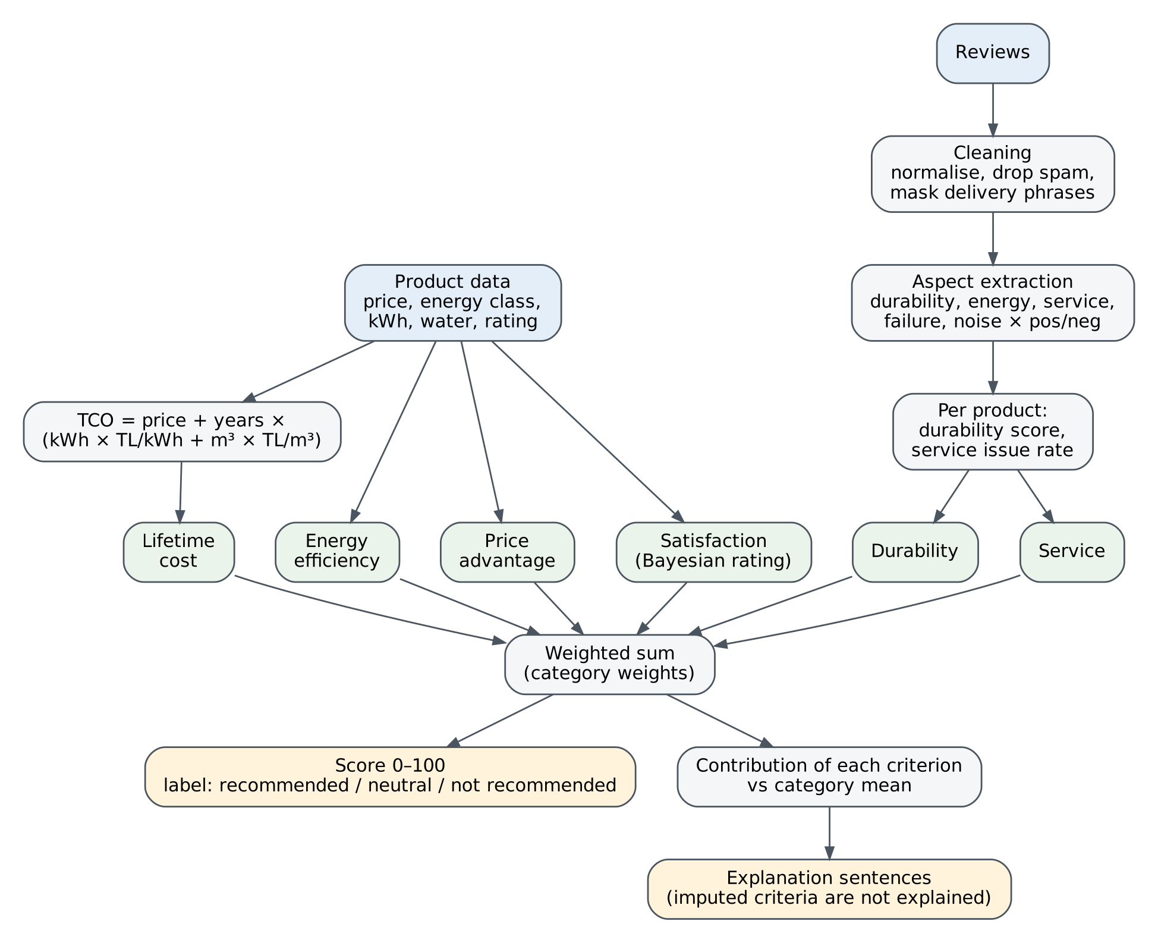
Figure 3. Data flow from product data and reviews to the score, label and explanations.
The figure has two entry points. Structured product data feed four criteria either directly or through the TCO formula of Equation (1). Reviews follow a longer path. They are cleaned, which involves discarding very short texts, repetitive spam and duplicates and masking delivery phrases, and are then passed to the selected aspect extractor. Its review-level output is condensed into a durability score and a service issue rate per product, which supply the two review-based criteria. The six criteria converge in a weighted sum. From there the flow splits: one branch yields the score and label, while the other computes each criterion’s contribution relative to the category mean and turns the largest ones into sentences. Imputed criteria are excluded at this last step, so an explanation never rests on a median value.
Request mode is deliberately thin. The React interface calls seven FastAPI endpoints under /api. Listing a category reads stored products and scores, and opening a product returns its sub-scores, TCO and explanations exactly as the pipeline wrote them. Computation occurs only when the user moves a weight slider. The interface then sends the category and the new weights to POST /api/score. Criteria left untouched keep their default weights, all weights are rescaled to sum to one, and the service recomputes scores and explanations from the stored criterion values without rerunning the pipeline. This separation keeps responses fast and results reproducible. Its cost is freshness. Prices and reviews reflect the date of collection, so the collection date should arguably be shown next to each score.

4.3. Modelling
The system is modelled at three levels of abstraction. The architecture view in Section 4.3.1 shows the deployable parts and the data passed between them. The UML views in Section 4.3.2 then describe behaviour, through the interaction of components during a user session, and structure, through the classes and tables that make the methods interchangeable. Every element in these diagrams corresponds to a module, table or endpoint in the project repository, so the models describe the implemented prototype rather than an intended design.

4.3.1. System Architecture
Figure 4 presents the architecture of GreenChoice. It separates an offline pipeline, which performs every computation, from a service that reads the results. The two parts share a single artefact, the SQLite file greenchoice.db.
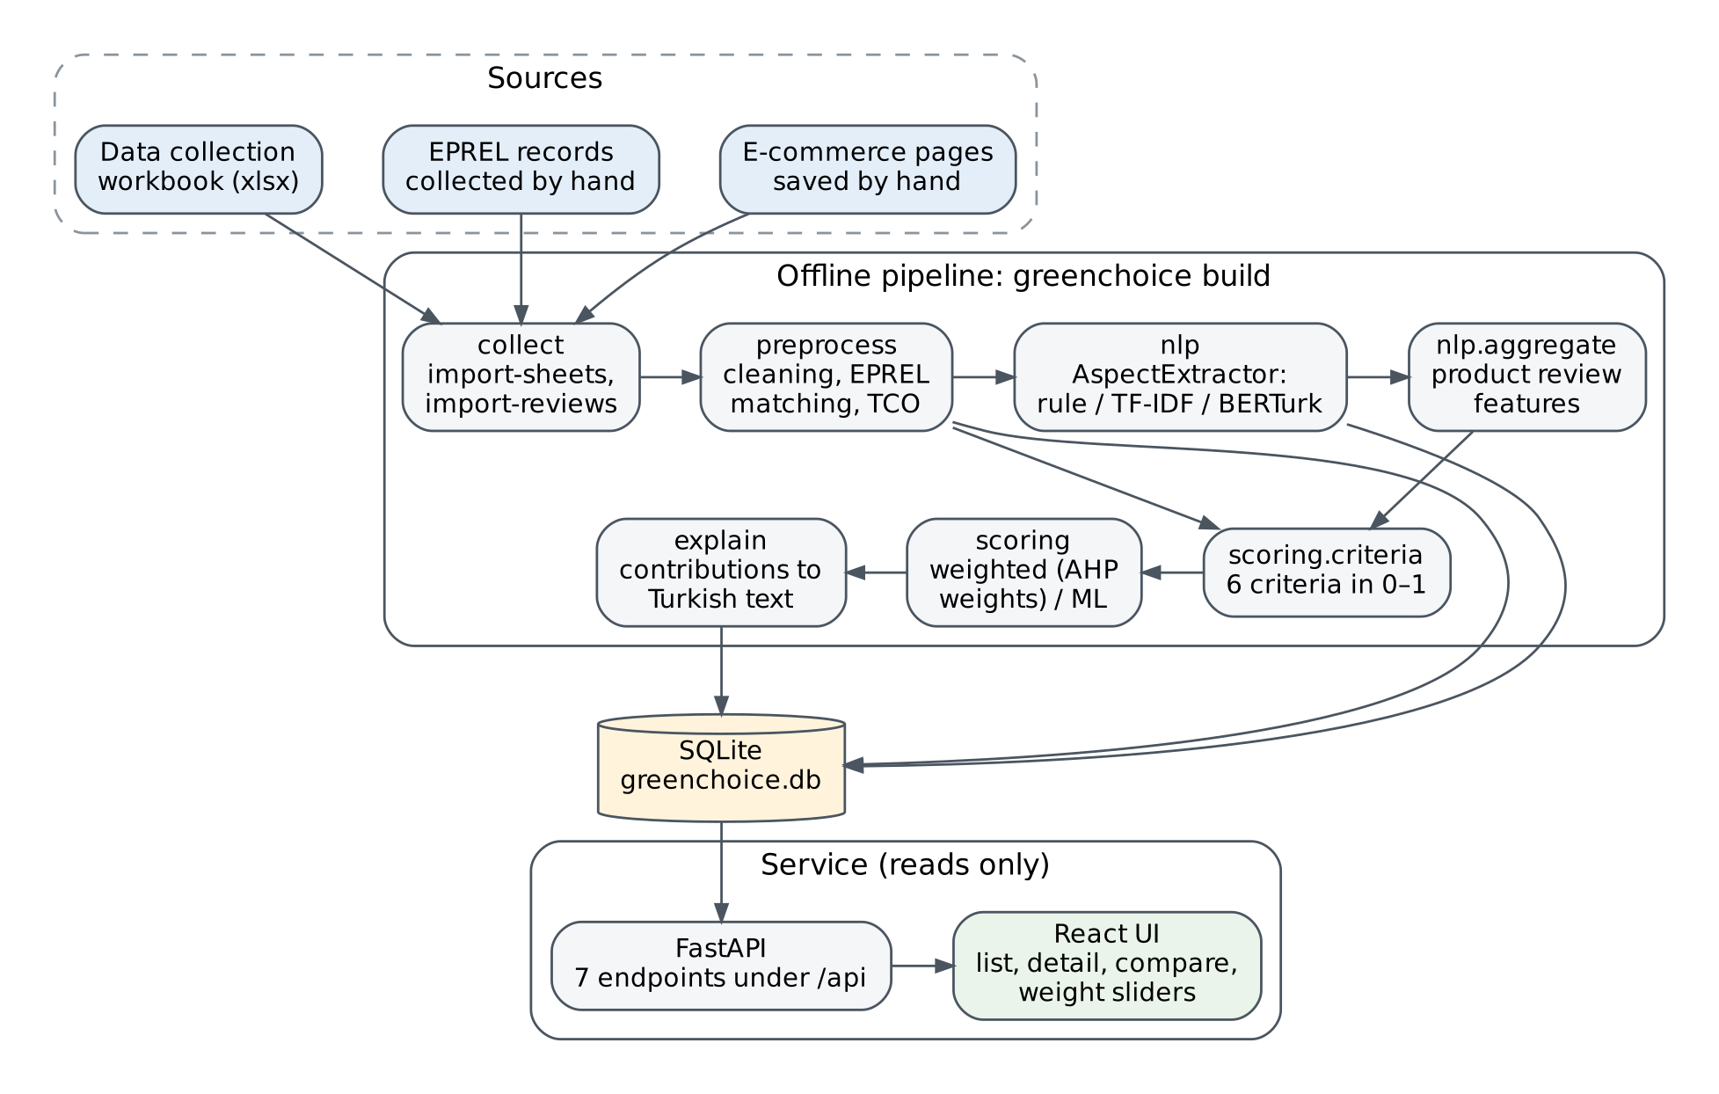
Figure 4. System architecture of GreenChoice.
All three sources enter the system by hand. E-commerce product pages are saved from the browser, EPREL values are copied from public registry pages, and product attributes are recorded in a shared data collection workbook. This manual entry point follows from the access restrictions discussed in Section 2.2.7 rather than from a design preference. It does, however, leave every record with a human-checked origin.
The pipeline is started by one command, greenchoice build, and runs its stages in a fixed order. The collect stage converts the workbook and the saved pages into tabular files. The preprocess stage cleans prices and texts, matches products with EPREL, falls back on manufacturer labels where registry data are missing and computes TCO. Two branches follow. The nlp stage runs the selected AspectExtractor over the review texts and nlp.aggregate condenses its output per product, while scoring.criteria joins these review features with the structured attributes to form six criteria. The scoring and explain stages finally produce the score, the label and the explanation sentences. Each run rewrites the five database tables from scratch: products, reviews, review_aspects, product_features and scores.
Three design decisions are visible in the figure. First, the extractor is a parameter rather than a fixed component; the --nlp option selects the rule-based, TF-IDF or BERTurk model without changes elsewhere. Second, intermediate results are stored alongside final ones, which is why arrows lead from preprocess and nlp to the database. Because review_aspects and product_features remain available, a disputed score can be traced back to the individual reviews and values behind it. Third, the service holds no state of its own. FastAPI exposes seven endpoints, six of them read-only, and the React interface renders product lists, details, comparisons of two to four products and the weight sliders. Heavy steps such as BERTurk inference thus stay out of the request path.
The interfaces between stages are fixed by explicit data contracts. Each table has a documented column set that is checked in code before a stage reads its input. Adding a column is allowed at any time, whereas removing or renaming one requires the agreement of both developers, since the two halves of the pipeline were built in parallel by different team members. This rule is meant to keep the hand-offs planned in Section 2.2 from breaking when one side changes its output.

4.3.2. UML (Unified Modeling Language) Diagrams
Two UML views complement the architecture: a sequence diagram for behaviour and a class diagram for structure. The sequence diagram in Figure 5 models a typical session of the Shopper actor introduced in Figure 2.
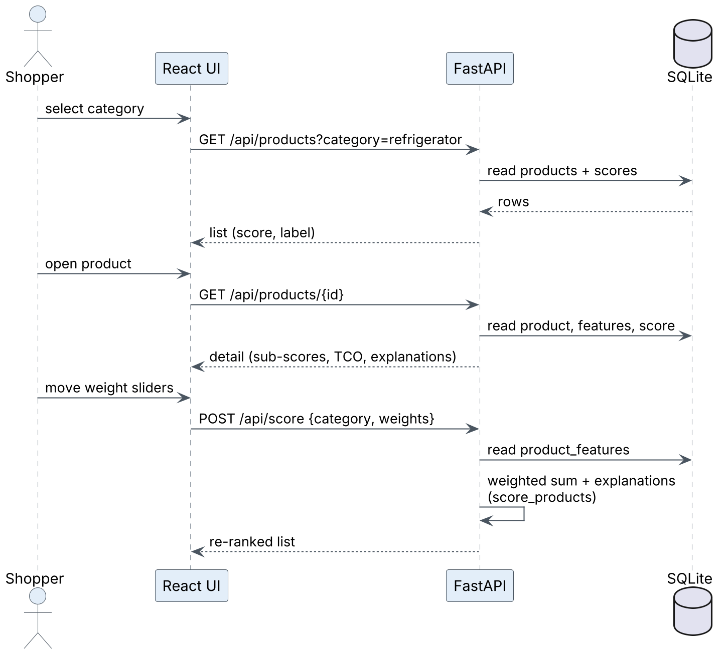
Figure 5. UML sequence diagram of a browsing session with custom weights.
The session involves four lifelines, the Shopper, the React UI, the FastAPI service and the SQLite database, and consists of three exchanges. Selecting a category triggers GET /api/products with a category filter; the service reads products and scores and returns a list with each product’s score and label. Opening a product triggers GET /api/products/{id}, for which the service reads the product, its features and its stored score and returns sub-scores, TCO and explanations. Both exchanges are pure reads. The third one is not. When the shopper moves the weight sliders, the interface posts the category and the new weights to /api/score. The service reads product_features and sends itself the message score_products, which recomputes the weighted sum and the explanations before a re-ranked list is returned. Invalid input is rejected at this boundary: an unknown category returns HTTP 404, and a weight vector that sums to zero after negative values are clipped returns HTTP 422 instead of an undefined ranking.
This self-message carries the main design decision of the diagram. score_products is the same function that the pipeline calls during a build. Custom and stored rankings are therefore produced by a single code path, so a product scored with the default weights in the interface matches the stored result. The diagram also shows what does not happen: no request reaches the e-commerce site, EPREL or a language model. Response time depends only on table size, which for 80 products appears negligible. The price of this simplicity is that custom weights are not persisted, and each new session starts from the category defaults.
The class diagram in Figure 6 turns from behaviour to structure. It shows the abstractions that keep methods interchangeable, grouped by the package in which they are implemented.
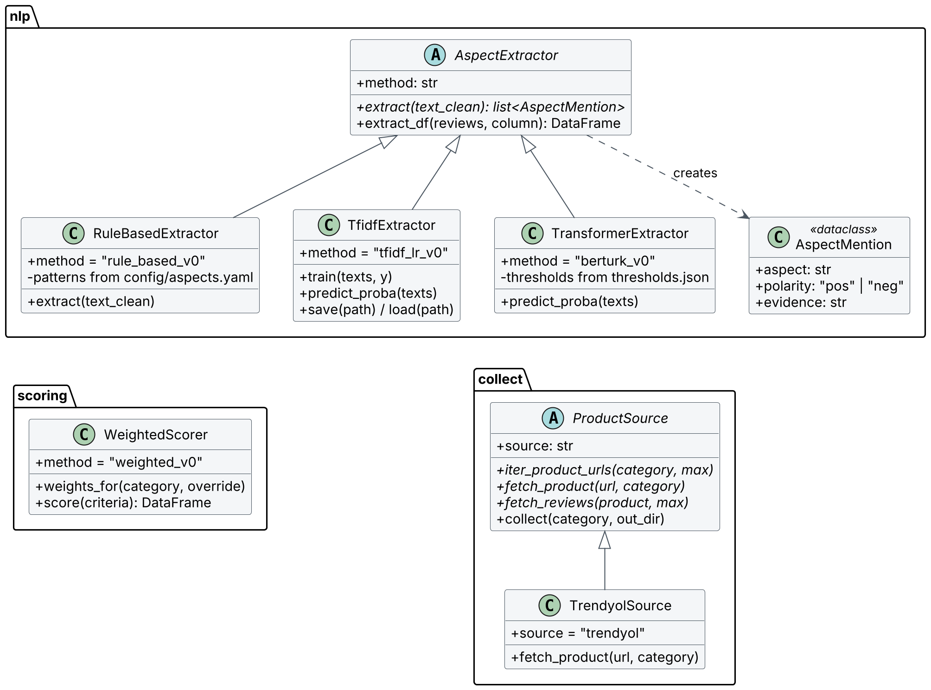
Figure 6. UML class diagram of the main extension points.
The nlp package is organised around the abstract class AspectExtractor. It declares a method identifier and one abstract operation, extract, which maps a normalised review text to a list of AspectMention objects. AspectMention is an immutable data class that holds an aspect, a polarity and, optionally, the matched evidence. The base class also implements extract_df, which applies extract to every review, drops repeated aspect–polarity pairs within a review and returns rows in the review_aspects format. RuleBasedExtractor relies on this inherited behaviour and compiles its patterns from config/aspects.yaml. TfidfExtractor adds training, probability estimation and model persistence. TransformerExtractor loads a fine-tuned BERTurk model together with per-label thresholds from thresholds.json. Both learned subclasses override extract_df to classify reviews in batches, yet they return the same table format, and every row records which extractor produced it.
This structure follows the open–closed principle in a pragmatic form. A fourth extractor, for instance the auxiliary-sentence formulation of Sun et al. [21], could be added as a new subclass without touching the evaluation or scoring code. Only the selection function behind the --nlp option would need one more branch.
WeightedScorer, the only scorer currently integrated into the pipeline, has no abstract parent. Its contract is defined by its output instead: any scorer that returns score, label, sub-scores and contributions can replace it, and the explanation module keeps working. A separate module already compares logistic regression, random forest and XGBoost [24] under stratified cross-validation, but it is not yet connected to the build. An abstract scorer class would seem justified once such a model is promoted to production use. The collect package retains the abstract class ProductSource from the original plan for automated collection. Its single implementation, TrendyolSource, reads known product pages but raises an error for listing and review retrieval, because the site’s robots.txt disallows both. The diagram thus records a deliberate restriction rather than missing functionality.
The persistent data model appears in Figure 7. It covers the five tables written by each build. Only a subset of columns is shown, since product_features alone holds 46.
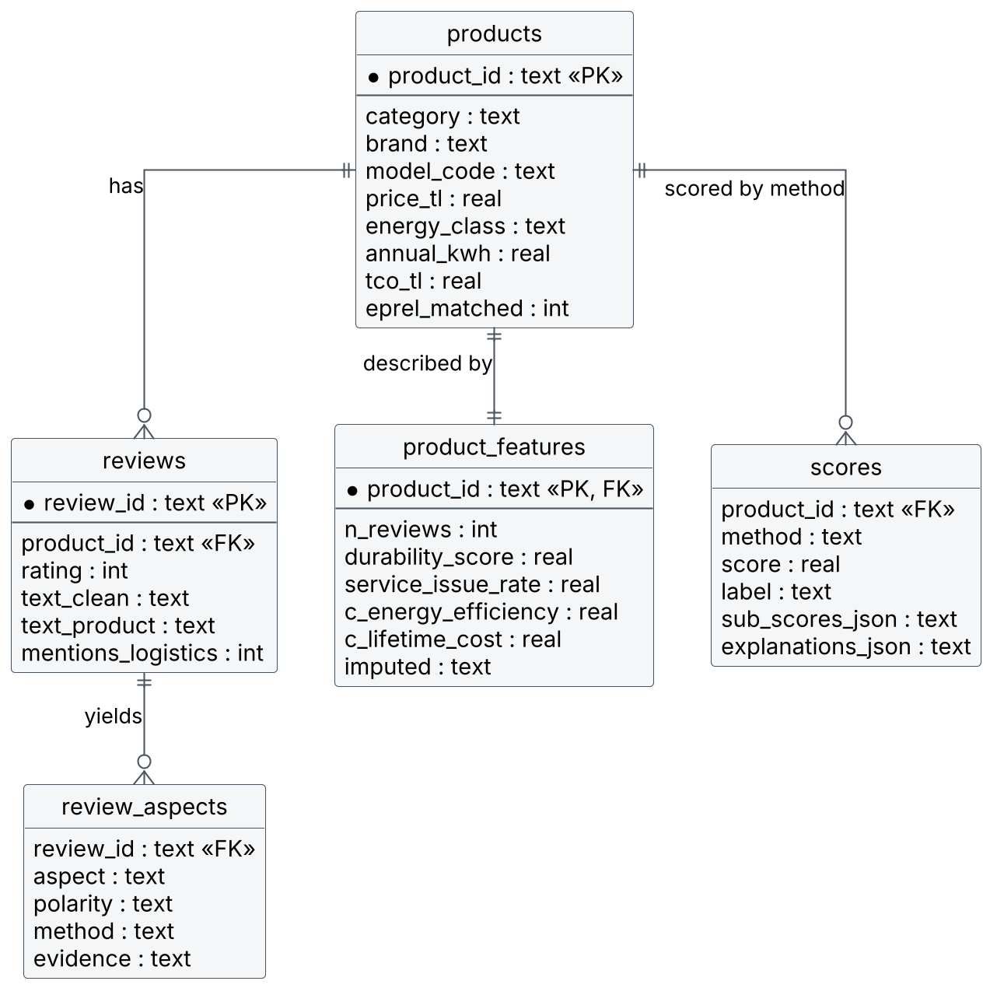
Figure 7. Entity–relationship diagram of the GreenChoice database.
The products table is the central entity. Each product has zero or more reviews, each review yields zero or more aspect rows, and each product is described by exactly one row in product_features. That row gathers its raw attributes, aggregated review features, six criterion scores and the list of imputed criteria. The scores table relates to products through product_id and method, so the schema allows results from different scoring methods to be stored side by side.
Two choices deserve comment. Sub-scores and explanations are stored as JSON text rather than in separate tables, because the service always reads them together with the score and never queries them individually. The keys, in turn, are logical rather than enforced. Tables are written from pandas data frames, which declare no primary or foreign key constraints in SQLite, so referential integrity depends on the pipeline; reviews whose product is absent, for example, are filtered out before writing. For a read-only prototype that is rebuilt from scratch on every run, this seems acceptable. A multi-user deployment with incremental updates would probably need declared constraints.
A last view, Figure 8, models the workflow that produces the labelled data on which the learned extractors depend. It is an activity view rather than a structural one, but it fixes several design decisions that the evaluation relies on.
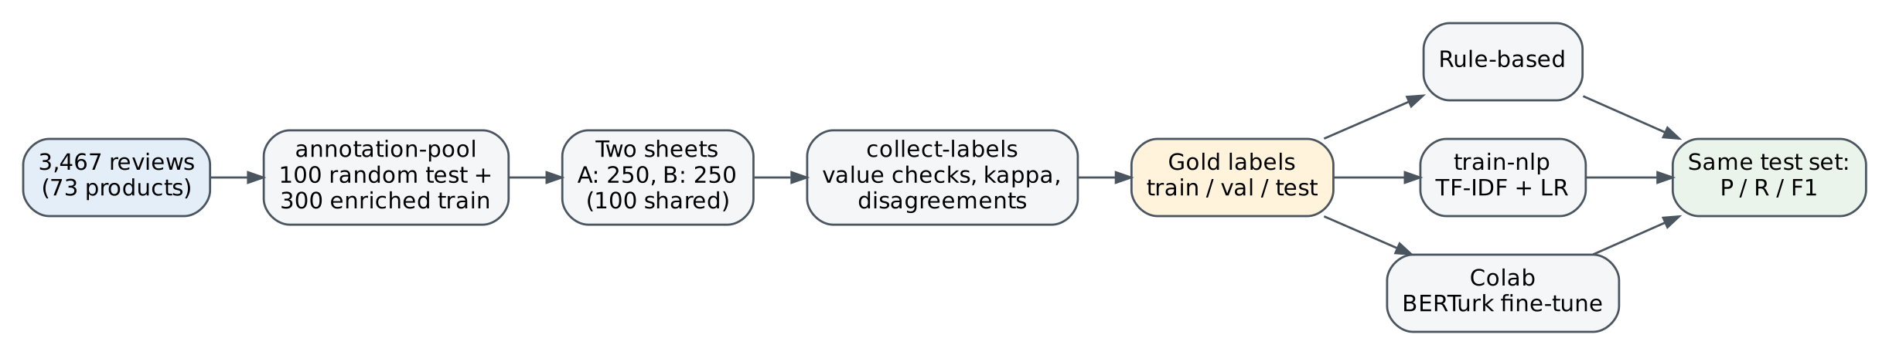
Figure 8. Annotation and evaluation workflow for aspect extraction.
The annotation-pool command draws 400 reviews with a fixed random seed. One hundred are sampled completely at random and form the test set, so that precision, recall and F1 reflect the real distribution of aspects. The other 300 are training reviews and are deliberately enriched: keyword candidates for energy, failure, noise and service, together with reviews rated three stars or lower, are taken first, with at most 30 reviews per product, and the remainder is filled at random. Each annotator receives a sheet of 250 reviews, the shared test set plus 150 training reviews of their own, shuffled and stripped of star ratings and selection reasons, so that neither can steer the label. The collect-labels command then validates the entries, computes Cohen’s kappa [28] per aspect on the shared reviews and lists disagreements for a consensus decision. Aspects with a kappa below 0.6 are redefined and the shared reviews discussed again. The resulting gold labels feed all three extractors, which are scored once on the same untouched test set.
Taken together, the architecture, the two UML diagrams, the data model and the annotation workflow describe one prototype from complementary angles. They also locate the weak points quantified in Section 4.1: sparse energy data, near-constant review criteria and weights that still await AHP justification.

5. DESIGN, IMPLEMENTATION AND TESTING
Explain design, implementation and testing of your system in detail.

5.1. Design
Explanation of the design of your system.

5.2. Implementation
Explanation of the implementation of your system.

5.3. Testing
Explanation of the testing of your system.

6. RESULTS
Explain your results.

7. CONCLUSION
Briefly explain the problem you studied, the solution method you proposed and your experience in the implementation. Then, please proceed to subsections and explain the requirements in details.

7.1. Life-Long Learning
Identify additional knowledge, skills, and attitudes that you needed to complete the project. In the context of the project, which tools and methods did you learn by yourself? From which sources did you learn them? How difficult was for you to learn these topics by yourself? How did you manage to collect the relevant information? Answer all the questions.

7.2. Professional and Ethical Responsibilities of Engineers
Define professional and ethical responsibilities you followed during your design process. What are the professional and ethical standards you used in the project? Is there an ethics code or code of conduct? Answer all the questions.

7.3. Contemporary Issues
Evaluate you project experience in terms of contemporary issues related to the problem that you studied. What kind of contemporary tools you have used throughout your project? Analyze the contemporary issues related to the future of the field that you work in this project. What will change in the products, services, or processes in the next ten, twenty, or fifty years, with emerging technologies such as 3D printers, big data analytics, nanotechnology, internet of things, quantum computing, biotechnology, artificial intelligence, cognitive science, and robotics?

7.4. Team Work
During your design project experience, describe the team work that you have participated. Give positions and majors of the people in the company that you worked with. Evaluate the composition, organization, and performance of your team. Describe how you shared the load in terms of the project tasks.

APPENDIX A
Your appendix goes here.

APPENDIX B
Your appendix goes here.

ACKNOWLEDGEMENTS
Acknowledgements.

REFERENCES
[1] H. Allcott and M. Greenstone, “Is there an energy efficiency gap?,” J. Econ. Perspect., vol. 26, no. 1, pp. 3–28, 2012, doi: 10.1257/jep.26.1.3.
[2] S. Kallbekken, H. Sælen, and E. A. T. Hermansen, “Bridging the energy efficiency gap: A field experiment on lifetime energy costs and household appliances,” J. Consum. Policy, vol. 36, no. 1, pp. 1–16, 2013, doi: 10.1007/s10603-012-9211-z.
[3] “Regulation (EU) 2017/1369 of the European Parliament and of the Council of 4 July 2017 setting a framework for energy labelling and repealing Directive 2010/30/EU,” Off. J. Eur. Union, vol. L 198, pp. 1–23, Jul. 28, 2017.
[4] “Commission Delegated Regulation (EU) 2019/2016 of 11 March 2019 supplementing Regulation (EU) 2017/1369 of the European Parliament and of the Council with regard to energy labelling of refrigerating appliances and repealing Commission Delegated Regulation (EU) No 1060/2010,” Off. J. Eur. Union, vol. L 315, pp. 102–133, Dec. 5, 2019.
[5] “Commission Delegated Regulation (EU) 2019/2014 of 11 March 2019 supplementing Regulation (EU) 2017/1369 of the European Parliament and of the Council with regard to energy labelling of household washing machines and household washer-dryers and repealing Commission Delegated Regulation (EU) No 1061/2010 and Commission Directive 96/60/EC,” Off. J. Eur. Union, vol. L 315, pp. 29–67, Dec. 5, 2019.
[6] Energy Market Regulatory Authority (EPDK), “Board Decision No. 14461 of 02/04/2026: Electricity tariffs excluding taxes valid from 4 April 2026,” Official Gazette of the Republic of Türkiye, no. 33214, Apr. 4, 2026.
[7] İstanbul Water and Sewerage Administration (İSKİ), “Su birim fiyatları [Water unit prices],” 2026. [Online]. Available: https://iski.istanbul/abone-hizmetleri/abone-rehberi/su-birim-fiyatlari/ (accessed Oct. 30, 2026).
[8] S. Waechter, B. Sütterlin, and M. Siegrist, “Desired and undesired effects of energy labels—An eye-tracking study,” PLoS ONE, vol. 10, no. 7, Art. no. e0134132, 2015, doi: 10.1371/journal.pone.0134132.
[9] Law No. 6698 on the Protection of Personal Data, Official Gazette of the Republic of Türkiye, no. 29677, Apr. 7, 2016.
[10] Trendyol, “Kullanım koşulları [Terms of use].” [Online]. Available: https://www.trendyol.com/kullanim_kosullari (accessed Nov. 1, 2026).
[11] European Commission, “EPREL Application Programming Interface (API) to access registered products public data: Terms and conditions,” in force from Jun. 3, 2024. [Online]. Available: https://ec.europa.eu/assets/move-ener/eprel/EPREL%20Public/Public%20API%20Term%20and%20Conditions/API_TERMS_AND_CONDITIONS_EN.pdf
[12] Law No. 5846 on Intellectual and Artistic Works, Official Gazette of the Republic of Türkiye, no. 7981, Dec. 13, 1951.
[13] S. Schweter, “BERTurk – BERT models for Turkish,” version 1.0.0, Zenodo, 2020, doi: 10.5281/zenodo.3770924.
[14] T. L. Saaty, “How to make a decision: The analytic hierarchy process,” Eur. J. Oper. Res., vol. 48, no. 1, pp. 9–26, 1990, doi: 10.1016/0377-2217(90)90057-I.
[15] S. M. Lundberg and S.-I. Lee, “A unified approach to interpreting model predictions,” in Adv. Neural Inf. Process. Syst. 30 (NIPS 2017), 2017, pp. 4765–4774.
[16] M. T. Ribeiro, S. Singh, and C. Guestrin, “‘Why should I trust you?’: Explaining the predictions of any classifier,” in Proc. 22nd ACM SIGKDD Int. Conf. Knowl. Discov. Data Min. (KDD ’16), 2016, pp. 1135–1144, doi: 10.1145/2939672.2939778.
[17] M. Hu and B. Liu, “Mining and summarizing customer reviews,” in Proc. 10th ACM SIGKDD Int. Conf. Knowl. Discov. Data Min. (KDD ’04), 2004, pp. 168–177, doi: 10.1145/1014052.1014073.
[18] M. Pontiki, D. Galanis, J. Pavlopoulos, H. Papageorgiou, I. Androutsopoulos, and S. Manandhar, “SemEval-2014 Task 4: Aspect based sentiment analysis,” in Proc. 8th Int. Workshop Semantic Eval. (SemEval 2014), 2014, pp. 27–35.
[19] M. Pontiki et al., “SemEval-2016 Task 5: Aspect based sentiment analysis,” in Proc. 10th Int. Workshop Semantic Eval. (SemEval-2016), 2016, pp. 19–30, doi: 10.18653/v1/S16-1002.
[20] J. Devlin, M.-W. Chang, K. Lee, and K. Toutanova, “BERT: Pre-training of deep bidirectional transformers for language understanding,” in Proc. NAACL-HLT 2019, 2019, pp. 4171–4186.
[21] C. Sun, L. Huang, and X. Qiu, “Utilizing BERT for aspect-based sentiment analysis via constructing auxiliary sentence,” in Proc. NAACL-HLT 2019, 2019, pp. 380–385, doi: 10.18653/v1/N19-1035.
[22] Z. A. Güven, “The effect of BERT, ELECTRA and ALBERT language models on sentiment analysis for Turkish product reviews,” in Proc. 6th Int. Conf. Comput. Sci. Eng. (UBMK), 2021, pp. 629–632, doi: 10.1109/UBMK52708.2021.9559007.
[23] S. Yaman and Ö. Aslan, “Multi-aspect sentiment analysis on Turkish food delivery reviews: A multi-task BERTurk approach,” Int. J. Innov. Eng. Appl., no. 1, pp. 121–130, 2026, doi: 10.46460/ijiea.1956584.
[24] T. Chen and C. Guestrin, “XGBoost: A scalable tree boosting system,” in Proc. 22nd ACM SIGKDD Int. Conf. Knowl. Discov. Data Min. (KDD ’16), 2016, pp. 785–794, doi: 10.1145/2939672.2939785.
[25] Y. Zhang and X. Chen, “Explainable recommendation: A survey and new perspectives,” Found. Trends Inf. Retr., vol. 14, no. 1, pp. 1–101, 2020, doi: 10.1561/1500000066.
[26] R. R. Hoffman, S. T. Mueller, G. Klein, and J. Litman, “Metrics for explainable AI: Challenges and prospects,” 2018, arXiv:1812.04608.
[27] J.-Y. Jian, A. M. Bisantz, and C. G. Drury, “Foundations for an empirically determined scale of trust in automated systems,” Int. J. Cogn. Ergon., vol. 4, no. 1, pp. 53–71, 2000, doi: 10.1207/s15327566ijce0401_04.
[28] J. Cohen, “A coefficient of agreement for nominal scales,” Educ. Psychol. Meas., vol. 20, no. 1, pp. 37–46, 1960, doi: 10.1177/001316446002000104.

