CRM / ERP Tool

# Users and stakeholders

## Stakeholders (names / groups)

|  |  |  |  |
| --- | --- | --- | --- |
| Stakeholder group | Stakeholder | Contact | Important! |
| User (User) | Management | Malik Gobbi | Overview |
|  | Admin | Samir Menasria | Manageable |
|  | Sales Manager | Yanik Siva | Overview |
|  | Backoffice | Aaron Gomes | Adaptability |
|  | Consultants | Yanik Siva / Malik Gobbi | Simplicity |
|  | Marketing | Samir Menasria | Interface/API options |
|  | Finance | Samir Menasria | Automatic commissions, wages, etc. |
|  |  |  |  |
| Developer (Developer) | Developer | Enis |  |
|  | IT Manager Kosovo | Enis |  |
|  | Project management | Samir Menasria | Time limitation |
|  |  |  |  |
| Authorities  (Authorities) | Finma |  | Industry agreement |
|  | Legislation Confederation |  | Insurance Act |
|  |  |  |  |
| Customers (Companies) | Health insurance | Astrid Zähner (Helsana) |  |
|  | Property insurance |  |  |
|  | Precautionary |  |  |
|  | Mortgages |  |  |
|  | Legal protection | (GM) |  |
|  |  |  |  |
| Customers (private & corporate)  Clients | Individuals |  | Individuals |
|  | Families / groups of people |  | Several persons (linked to head of family) |
|  | Corporate customers |  | SMEs for pension fund, accident insurance, vehicles etc. |
|  |  |  |  |
| Partner | SwissHome | Mire | Competion of outstanding commissions |

Currently the following systems / data are used. This is mainly relevant for the migration of the data and for the creation of the future automation processes.

|  |  |  |  |
| --- | --- | --- | --- |
| Existing systems | InsuERP |  | CRM/ ERP from SwissHome |
|  | Excel |  | Final list with numbers |
|  | Notes Yanik |  | Settlements Commissions |
|  | Helsana Portal |  | Helsana CRM and Finance Portal |
|  | GM portal |  | GM CRM Portal |
|  | Ec portal |  | ÖKK Portal |
|  | Pax Portal |  | CRM portal |
|  | Other portal |  | Open |

## User groups

|  |  |
| --- | --- |
| Name of the user group | Members |
| Consultants | All field staff   * See only the data and statistics of their own trades / customers |
| Back Office (BO) | All office staff and HR.   * See the data of all locations. * Don't see stats. |
| Team Leader | The team leaders at the various locations.   * View the data and statistics of each assigned location. * See only the commission MA and not commission Total |
| Sales Manager | The sales manager in the company   * Sees all data and statistics. * See only the commission MA and not commission Total * Can adjust the commission system. |
| Management | The manager in the company   * Views all data including the finances of the entire company. * Can switch to sales manager mode. |
| IT administrator | The sales manager in the company   * Sees all data including the finances of the company without any restrictions. * Can download the databases. * Can create new users and assign user groups. |
| IT development | The development team to test new features.   * Tests are only possible on the inactive server. No tests can be made in the active system! |
| Finance | Finance:   * Can enter the commissions and adjust the status of the customers. * Can adjust the commission system retroactively (in case of errors). * Performs automatic commission statement generation for MAs on a monthly basis. |

# Business processes

## Process Map / Process Models / Value Chains

# System scope and functionality

## Big Picture (The big picture as a sketch)

The big picture of the planned CRM / ERP is outlined below. The various access points, basic services and databases are visible. If necessary, the databases can also be designed / divided differently.



## Use case diagram (overview diagram in UML of the use cases)

The following illustration shows the different users/stakeholders and their interaction with the CRM/ERP as well as interface programs.



# Functional requirements

## Use cases (use cases with ID, trigger, standard process, etc.)

|  |  |
| --- | --- |
| **Procedure 1: Lead** | |
| **Expiry ID** | **Standard process** |
| 1.1 | Lead is generated on Facebook/ Instagram/ Google/ Platform and integrated in CRM/ERP |
|  |  |
| 1.2 | Sales manager distributes the lead to a sales representative or digital team |
|  |  |
| 1.3 | Automatic assignment of the lead to Digitalteam |
|  |  |
| 1.4 | Consultant schedules the lead (appointment / no appointment) and converts to appointment |
| 1.4.1 | System: Closing Lead, Positive: Conversion/ Duplication to Appointment |
|  |  |
| 1.5 | Digital team makes digital closure/ digital offer (incl. follow-up) |
|  |  |
| **Procedure 2: Dates** | |
| **Expiry ID** | **Standard procedure** |
| 2.1 | Sales manager receives the appointment sheets and enters the appointments in the system (manual entry or reading in using standardised appointment sheet). |
| 2.1.1 | Consultant enters new appointment or follow-up appointment him/herself |
|  |  |
| 2.2 | Sales manager assigns the appointments to the consultants (filter regional, time, languages / nationalities, quality level etc.) |
| 2.2.1 | System: Appointment is assigned to the calendar (Outlook) by the corresponding consultant |
|  |  |
| 2.3 | Consultant receives push notification of appointments assigned at short notice |
| 2.3.1 | Consultant receives push notification in the evening with number of appointments for the next day |
|  |  |
| 2.4 | Consultant checks his appointments in the morning (time?) |
| 2.4.1 | Consultant accepts or rejects the appointments |
| 2.4.2 | Rejected appointment: appointment is rescheduled by sales manager (2.2) |
|  |  |
| 2.5 | Consultant attends appointments. |
| 2.5.1 | Consultant gives feedback after the appointment |
|  |  |
| 2.6 | Positive feedback: recording of completed persons (first name, last name, date of birth) |
| 2.6.1 | System: Completion date, conversion/creation of the created persons into "open tasks MA". |
|  |  |
| 2.7 | Negative feedback: Documentation Feedback |
| 2.7.1 | System: Completion date, documentation completed |
|  |  |
| **Procedure 3: Customer acquisation** | |
| **Expiry ID** | **Standard procedure** |
| 3.1 | Consultant uploads the various closings including attachments and creates product requests for the closed individuals (open tasks). |
|  |  |
| 3.2 | Open Task MA is closed. |
| 3.2.1 | System: Saving of the data (incl. backup), conversion/continuation to the back office "Open Tasks BO", creation of the customer incl. the details/attachments made in the customer database (status: back office) |
|  |  |
| 3.3 | Back office checks the financial statement, the information provided and attachments. Enters further personal data/additions and carries out desired product enquiries. |
| 3.3.1 | System: Requests for additional products are documented. Customer is created. Status of submitted, requested products etc. in the customer data adjusted (status from Pending BO --> Submitted or Requested). |
| Procedure 3.4 | |
|  |  |
| **Procedure 4: Pending issues** | |
| **Expiry ID** | **Standard procedure** |
| 4.1 | Backoffice creates pending items when something is missing and assigns them to the employee concerned. |
| 4.1.1 | System: Pendency is created and chat is started in it. Consultant receives notification of the pending case with the customer concerned. |
|  |  |
| 4.2 | Consultant checks his open pending items daily. Processing target max. 48h! |
| 4.2.1 | System: Pending items that are unopened for more than 24 h Push notification.🡪 |
| 4.2.2 | System: Pending items that are unopened for more than 72 hours 🡪Notification to sales manager |
|  |  |
| 4.3 | Consultant responds in chat of pending and submits requested attachments, details in chat. |
| 4.3.1 | System: Rejection of the pending case to the back office |
|  |  |
| 4.4 | Backoffice processes the pending and closes it if everything is correct. PENDING ITEMS CANNOT BE CLOSED BY CONSULTANTS! |
| 4.4.1 | System: Completion of the pending task. Filing of the closed pending. |
| 4.42 | Pending cases can be opened for any customer (open, closed, etc.) even if it has already been submitted. |
|  |  |
| **Procedure 5: Processing by the different partners (Insurance/ Finance Companies)** | |
| **Expiry ID** | **Standard procedure** |
| 5.1 | Partner company processes the submitted contracts. Gives feedback to DL Finance by mail on the status, makes queries etc. |
|  |  |
| 5.2 | Queries are either answered immediately by the back office (if possible) or a pending matter is created (see "Procedure for pending matters"). |
| 5.2.1 | System: Pending is opened (see Pending). |
|  |  |
| 5.3 | Backoffice enters feedback and status changes to the corresponding customer. |
| 5.3.1 | Automation: Mails are automatically scanned (name, status changes, comments, etc.) and assigned to the corresponding customer (mail history section in the customer sheet), back office receives notification or can open the customer in CRM directly from the mail. |
| 5.3.2 | System: Adjustment of the status. Documentation from the date of the corresponding adjustment (In progress) |
|  |  |
| 5.4 | Backoffice enters the status Policed for the corresponding product. |
| 5.4.1 | System: Adjustment to Policy and entry in statistics for financial manager / business owner (expected payments) |
|  |  |
| **Procedure 6: Commissions** | |
| **Expiry ID** | **Standard process** |
| 6.1 | Financial management receives commission statements from the partner companies and checks them (checklist so that no statement is forgotten). |
|  |  |
| 6.2 | Financial management changes the status to "Internal commissioned" and changes the amounts (total) for the respective customers if required. (CHANGE OF THE AMOUNTS LEADS TO AN AUTOMATIC COMMENT). |
| 6.2.1 | System: Automatically calculates the share of employees. Influencing factors: Lead/ Own acquisition & Amounts (Total) |
| 6.2.2 | System: Status "Provided internally" does not yet lead to the sales representative seeing this. |
|  |  |
| 6.3 | Financial management receives an overview of the month's finances. Total commission, share of business, share of employees |
|  |  |
| 6.4 | Automatic creation of commission statements for all consultants |
| 6.4.1 | System: All customer names and commission amounts with the status ("Commissioned internally") and date of the status adjustment (between the first and last day of the month) are listed and totaled in the commission statement. |
|  |  |
| 6.5 | Financial management receives all commission settlements for control and approval. |
| 6.5.1 | System: Provisioned (Internal) is set to Provisioned on a standardized date (for example, the 6th of each month). |
|  |  |
| 6.6 | Consultants receive the PDFs with their commission statement in their "HR Services". |
|  |  |
| **Procedure 7: Commission regulations** | |
| **Expiry ID** | **Standard process** |
| 7.1 | Sales manager / admin / management can customize the commission system. |
| 7.1.1 | Commissions can be defined for a specific period or indefinitely from a specific date or. |
| 7.1.2 | Trades are commissioned according to the commission system that is active on the date of the trade. |
|  |  |
| 7.2 | System: Creates the commission rules for the following month on the last day of each month based on the commission system active at that time. |
| 7.2.1 | System: Sales Manager / Admin / Manager is notified to validate the new commission rules. |
| 7.2.2 | Sales Manager / Admin / Manager accepts the new commission regulations. |
| 7.2.3 | System: Consultants are notified of the new commission regulations. The new commission regulations can be found in HR Services. |
|  |  |
| **Procedure 8: Calendar** | |
| **Expiry ID** | **Standard process** |
| 8.1 | Calendar from Outlook is displayed in CRM/ERP. New appointments can be created from CRM/ERP. |
| 8.1.1 | The sales manager/ manager/ admin can also assign appointments to others. |
|  |  |
| 8.2 | System: The calendar also reflects appointments created directly in Outlook. Refreshtime 1x per hour  Consultants: Are obliged to keep your calendar up to date! |
|  |  |
| **Procedure 9: Absence** | |
| **Expiry ID** | **Standard process** |
| 9.1 | Employee enters new absence request (holidays, extended weekend, etc.) with period and reason or brief comment |
| 9.1.1 | System: Absence request is set to "open" and the sales manager is notified., periods lesser than 1 week are getting accepted instantly if they are further away than 1 week |
|  |  |
| 9.2 | Sales manager checks the absence requests and accepts or rejects them (rejection with reason). |
| 9.2.1 | System: Notification to employee (Accepted / Rejected) |
|  |  |
| **Procedure 10: Personal data** | |
| **Expiry ID** | **Standard process** |
| 10.1 | Employees can customize their personnel data, bank data, etc. in the ERP. |
| 10.1.1 | System: Mail to back office or directly to trustee with the change in personnel data |
|  |  |
| **Procedure 11: Terminations** | |
| **Expiry ID** | **Standard procedure** |
| 11.1 | On the "Terminations" page, Backoffice receives an overview of all persons who have to be terminated according to the entries made by the sales force. |
| 11.1.1 | System: Based on the different companies, they are assigned a termination date. |
| 11.1.2 | System: Notices, like contracts, have a status (In processing, To be submitted, Submitted, Withdrawn). |
|  |  |
| 11.2 | Backoffice regularly checks the site and prepares all notices to submit on the appropriate notice date. |
| 11.2.1 | System: If the notices are stored digitally, you can filter the notices (status, notice date) and then print out all selected notices using a button. |
|  |  |
| **Procedure 12: Customer Evaluations** | |
| **Expiry ID** | **Standard process** |
| 12.1 | Commissioned customers receive a mail/ SMS to evaluate the advice and quality. |
| 12.1.1 | System: Rating < 4 = Thank you mail  Rating >4 = Thank you mail with request to leave a rating on social media or Google. Possibly send small thank you gift to customers with QR code to rating |

## Statistics

The following table shows which statistics are relevant for the company and the various stakeholders. The statistics are ordered according to the different categories of statistics.

|  |  |
| --- | --- |
| **Statistics (always per sales representative, team and total)** | |
| 1 | **Leads (Basic Service Lead Management)** |
| 1.1 | Terminated / Not Terminated |
| 1.2 | Sources |
| 1.3 | Campaigns |
| 1.4 | Reasons (occurrence of individual reasons) |
| 1.5 | Duration of lead processing |
|  |  |
| 2 | **Appointments (Appointment Management Basis Service)** |
| 2.1 | Closing rate |
| 2.2 | Most frequent feedback |
| 2.3 | Held at rate |
| 2.4 | Dates per day |
| 2.5 | Number of contracts per date |
| 2.6 | Most frequent reasons "Did not take place» |
|  |  |
| 3 | **Status (Basis Service Customer / Contract Management)** |
| 3.1 | Accepted |
| 3.2 | Open |
| 3.3 | Rejected |
| 3.4 | Commisioned |
| 3.5 | Canceled |
|  |  |
| 4 | **Pending issues (basic service customer / contract management)** |
| 4.1 | Processing time |
| 4.2 | Initial opening duration (duration until the pending items are opened for the first time) |
| 4.3 | Unanswered |
| 4.4 | Total duration |
| 4.5 | Reasons of pending issues |
|  |  |
| 5 | **Calendar (Interface - Exchange)** |
| 5.1 | Workload of field staff |
| 5.2 | number of trainings |
| 5.3 | Number of appointments per day |
| 5.4 | Number of appointments per week |
|  |  |
| 6 | **Finances (Basic Service Finances)** |
| 6.1 | Profit margin |
| 6.2 | Commissions (month) |
| 6.3 | Commissions (day) |
| 6.4 | Contracts (month) |
| 6.5 | Contracts (day) |
| 6.6 | Wage total consultants |
| 6.7 | Wage Back office |
|  |  |
| 7 | **Marketing (Basic Service Lead Management))** |
| 7.1 | number of leads |
| 7.2 | Lead costs |
| 7.3 | Conversion rate |
| 7.4 | Number of appointments |
|  |  |
| 8 | **Marketing (Basis Service Appointment Management)** |
| 8.1 | Number of appointments |
| 8.2 | Costs Call Center |
| 8.3 | Cost per appointment |
|  |  |
| 9 | **Absences (HR Services Basis Service)** |
| 9.1 | Sick days |
| 9.2 | Accident reports |
| 9.3 | Vacation days |
| 9.4 | Unable to work days (money problems etc.) |
|  |  |
| 10 | **Open Tasks (Basis Service Appointment Management)** |
| 10.1 | Processing time |
| 10.2 | Opening duration |
| 10.3 | Error rate (Incomplete) |
| 10.4 | Number of product inquiries (pension plans, vehicles, etc.) |
|  |  |
| 11 | **Contracts ((Basis Service Contract Management)** |
|  |  |
| 11.1 | Basic insurances |
| 11.2 | Basic insurance amount |
| 11.3 | Supplementary insurance |
| 11.4 | Supplementary insurance amount |
| 11.5 | Vehicles (third party liability, partial cover, fully comprehensive) |
| 11.6 | Pension plan 3a |
| 11.7 | Pension plan 3b |
| 11.8 | Property insurance |
| 11.9 | Mortgages |
|  |  |
| 12 | **Customers (Basic Service Customer Management)** |
| 12.1 | Number |
| 12.2 | Satisfaction |
| 12.3 | Products per customer |
|  |  |
| 13 | Reviews |
| 13.1 | Number |
| 13.2 | Rating |
| 13.3 | Number of follow-up ratings Social Media |
| 13.4 | Number of follow-up ratings Google |

# Non-functional requirements

## Quality requirements

|  |  |  |  |
| --- | --- | --- | --- |
|  |  |  |  |
| Performance | Extensions | Fields | Fields must be expandable if new data is required. Mandatory fields can be extended. Previous data however not affected |
|  |  | CRM for other companies | Possibility to sell the CRM to other companies and accordingly the fields must remain customizable. |
|  |  |  |  |
|  |  |  |  |
| Availability | Browser types | Chrome, Edge, Firefox | Most popular browsers |
|  | Mobile | iOS, Android | IOS/ Android App |
|  | Windows | Windows Store | App for Windowsstore |
|  | Offline | App data | Certain app data also accessible offline / links (calendar / files) |
|  |  |  |  |
| Security | Risks | bruteforce attack | Protection against network attacks |
|  |  | Competitors | Protection against unauthorized login attempts |
|  |  | Data theft | Protection of databases |
|  |  | Data theft | Download of data not possible without 2FA from Malik Gobbi / Samir Menasria --> Also IT department!!! |
|  |  | Passwords | Passwords must have a high complexity. 2FA (SMS or Authentificator) mandatory for all users |
|  |  | Encryption | The data must be encrypted |
|  |  |  |  |
|  |  |  |  |
| Reliability | Data retention | 2. server | Constant access possibility by means of a backup server. |
|  |  | Patching | Monthly patching |
|  |  | Backup | Daily backup. Backup retention 90 days) |
|  |  |  |  |

# Prototype

## Sketches of the different surfaces

### Login

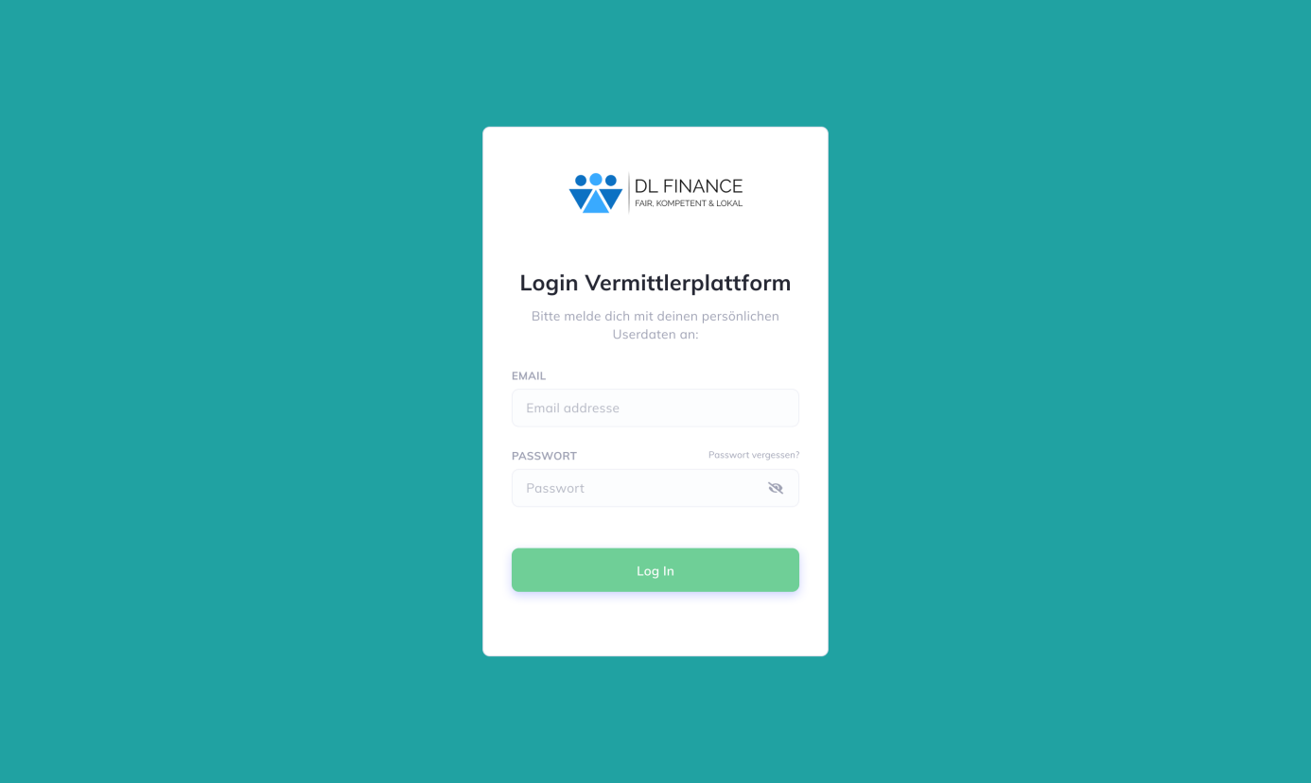

* 2 FA with sms or authenticator
* 2 Step Login for Users with multiple roles. (Step 2 is to choose the role they want to be logged in)

### Field Service

#### Home

Buttons with further news

* New leads (number) Link🡪: leads
* Open tasks (number) Link🡪: Tasks
* Pendencies (Number) = if not 0 marked red 🡪Link: Tasks
* Appointments Today(Number) 🡪Link Calendar
* HR Messages number) 🡪Link: Finance
* Individual Buttons can be added

Appointments (Personnel)

* Personal appointments and consultations

Statistic (Personal)

* 3. status
* With diagram (daily, weekly, monthly)
* Individual Stats can be added

Menu

* Home
* Calendar
* Tasks
* Customers
* Leads
* Finance

Logo DL Finance

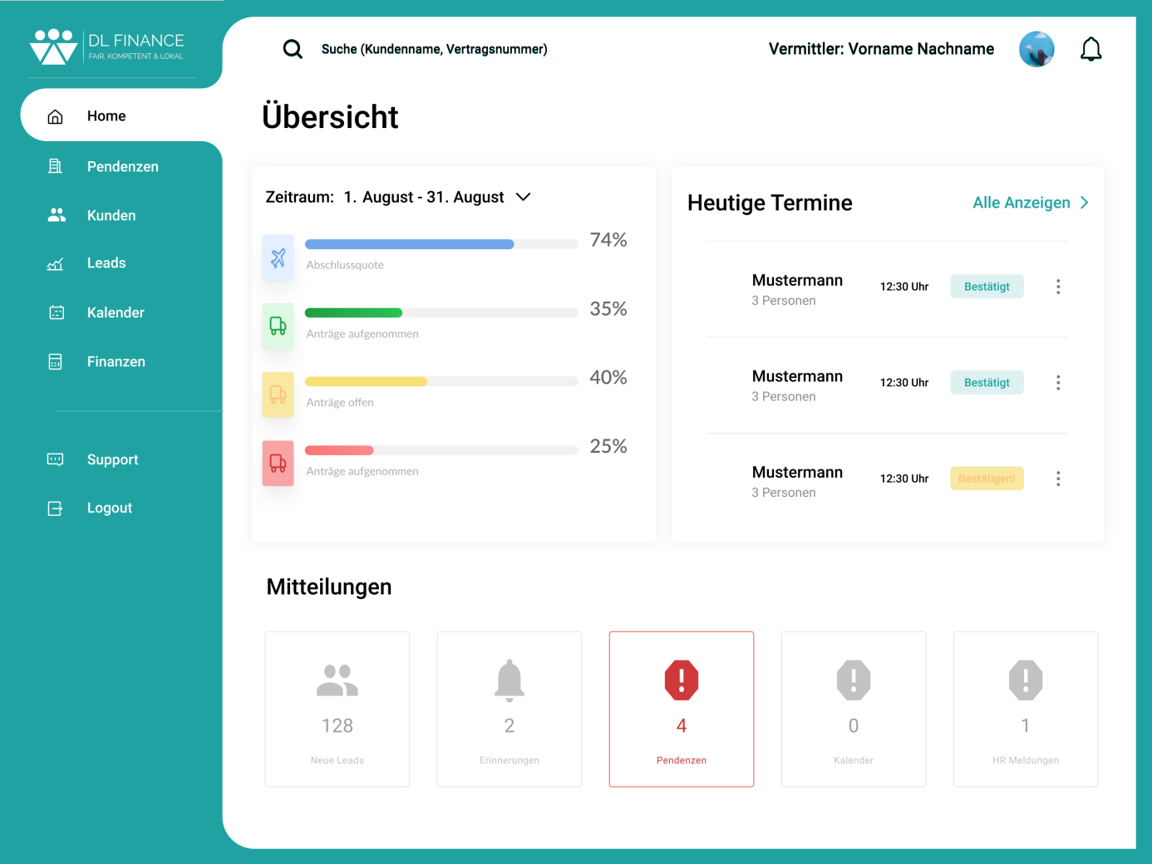

#### Kalender (calendar)

Appointments

* Filter (Day, Duration)
* All filtered appointments

Map

* Map with dots of the filtered appointments from the left side.

Menu

* Home
* Calendar
* Tasks
* Customers
* Leads
* Finance

Logo DL Finance

Important notices

* Information / training Appointments with the sales leader

#### Tasks

birthdays / anniversaries

* birthdays / anniversaries from clients

Open Tasks

* Persons captured from appointments

Menu

* Home
* Calendar
* Tasks
* Customers
* Leads
* Finance

Logo DL Finance

Pendencies

* Pending issues assigned to the consultant by the back office

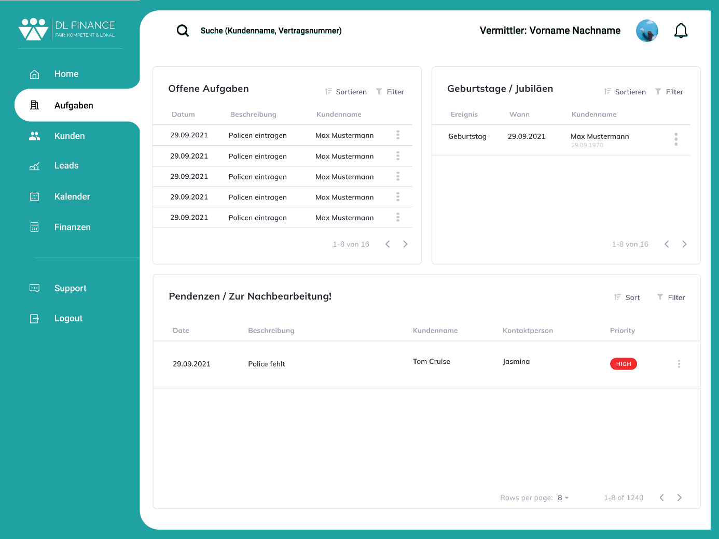

#### Clients (clients 🡪only clients from the person)

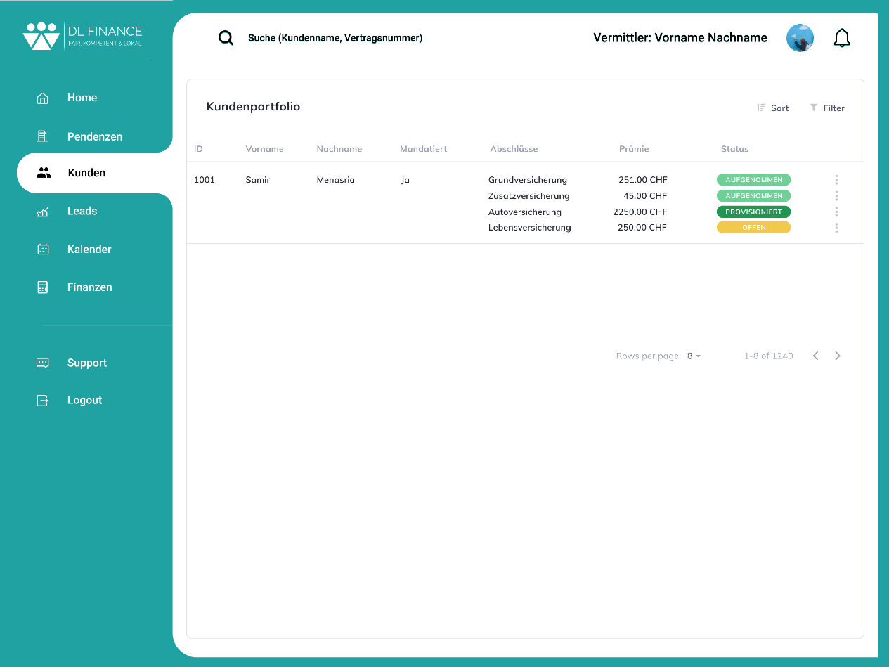

Menu

* Home
* Calendar
* Tasks
* Customers
* Leads
* Finance

Logo DL Finance

#### Leads

Statistic

* 7. marketing
* Duration per lead
* Which Platforms

Leads

* Assigned leads
* Information: name, number of people, source, campaign

Menu

* Home
* Calendar
* Tasks
* Customers
* Leads
* Finance

Logo DL Finance

#### Finance

Salaries / Commissions

* All statements pertaining to personal earnings, insurance, etc.

HR services

* Personal data
* bank details
* Accident report
* Orders

Menu

* Home
* Calendar
* Tasks
* Customers
* Leads
* Finance

Logo DL Finance

Insurances and others

* All statements about insurance, etc.

Commission regulations

* Monthly commission regulation papers

### Backoffice

#### Home

Open pendencies

* Pendencies open more than 30 days

HR tasks

* HR requests from employees

Answered pendencies

* Daily tasks

To-Do

* Daily tasks

status check

* Notification 2 times a week
* Contracts that are open more than 30 days

Informational Numbers

* Most used numbers

Menu

* Home
* Tasks
* Status
* Customers
* Cancellations
* Deposit
* Finance

Logo DL Finance

#### Tasks

Open pendencies

* Filtered by duration

Answered pendencies (Prio)

* Filter
* Daily tasks

Menu

* Home
* Tasks
* Status
* Customers
* Cancellations
* Deposit
* Finance

Logo DL Finance

#### Status

Clients (customers)

* Client Database to change their status and other changements

Mails

* Mailbox

Menu

* Home
* Tasks
* Status
* Customers
* Cancellations
* Deposit
* Finance

Logo DL Finance

#### Clients (All Clients)



Menu

* Home
* Tasks
* Status
* Customers
* Cancellations
* Deposit
* Finance

Logo DL Finance

#### Cancellations

Clients (customers)

* Client Database to change their status and other changements

Mails

* Mailbox

Menu

* Home
* Tasks
* Status
* Customers
* Cancellations
* Deposit
* Finance

Logo DL Finance

#### Deposit

Receipts

* All scanned receipts

Mail (Post)

* All scanned mail and letters

Menu

* Home
* Tasks
* Status
* Customers
* Cancellations
* Deposit
* Finance

Logo DL Finance

Scan new mail (Post)

* Scan new mails and letters
* Add Details and Assign

Scan new receipt

* Scan option with hashtags

#### Finance

Salaries / Commissions

* All statements pertaining to personal earnings, insurance, etc.

HR services

* Personal data
* bank details
* Accident report
* Orders

Menu

* Home
* Tasks
* Status
* Customers
* Cancellations
* Deposit
* Finance

Logo DL Finance

Insurances and others

* All statements about insurance, etc.

Commission regulations

* Monthly commission regulation papers

#### Sales Manager

#### Home

Statistic (Total / Teams / Personnel)

* 3. status
* 6. finances
* 11. financial statements
* Individual Stats can be added

Info (Personnel)

* Personal appointments and consultations

Buttons with further news

* New leads (number) Link🡪: leads
* Open tasks (number) Link🡪: Tasks
* Pendencies (Number) = if not 0 marked red 🡪Link: Tasks
* HR Messages number) 🡪Link: Finance
* Individual Buttons can be added

Menu

* Home
* Calendar
* Leads
* Dates
* Customers
* Prov. system
* Statistics
* Finance

Logo DL Finance

#### Calendar

Calendar (Total / Teams / Staff)

* Filterable on the day, team, region and more
* Calendar with an overview of all appointments.

Menu

* Home
* Calendar
* Leads
* Dates
* Customers
* Employees
* Prov. system
* Statistics
* Finance

Logo DL Finance

Statistic:

* 5. calendar

#### Leads

Statistic

* 7. marketing
* Duration per lead
* Which Platforms

Leads

* All leads with the option to assign them to a certain user
* Information: name, number of people, source, campaign, status

Menu

* Home
* Calendar
* Leads
* Dates
* Customers
* Employees
* Prov. system
* Statistics
* Finance

Logo DL Finance

#### Dates

Map

* Map with dots of the filtered appointments from the left side.

Appointments

* Filter (Day, Duration, status, assignment)
* Unassigned appointments on top

Important notices

* Information / training Appointments with the sales leader
* Add new

Menu

* Home
* Calendar
* Leads
* Dates
* Customers
* Employees
* Prov. system
* Statistics
* Finance

Logo DL Finance

#### Customers



Menu

* Home
* Calendar
* Leads
* Dates
* Customers
* Employees
* Prov. system
* Statistics
* Finance

Logo DL Finance

#### Employees

Commission groups

Validation of employee commissions

Menu

* Home
* Calendar
* Leads
* Dates
* Customers
* Employees
* Prov. system
* Statistics
* Finance

Logo DL Finance

Create new commission system

* Creation of a new commission system/adaptation of the current one to a selectable month

#### Prov. system

Commission groups

* Selection of the commission group
* Display of the members

Commission system

* Selection of the commission systems
* Display of the selected commission system

Menu

* Home
* Calendar
* Leads
* Dates
* Customers
* Employees
* Prov. system
* Statistics
* Finance

Logo DL Finance

Create new commission system

* Creation of a new commission system/adaptation of the current one to a selectable month

#### Statistics

Statistical menu

* Selection of the statistics to be displayed

Menu

* Home
* Calendar
* Leads
* Dates
* Customers
* Employees
* Prov. system
* Statistics
* Finance

Logo DL Finance

Statistic (Total / Teams / Personnel)

* Display of the selected statistic.
* Graphical and tabular display.
* Filterable on a chosen timeframe, person, group and more.

#### Finance

Salaries / Commissions

* All statements pertaining to personal earnings, insurance, etc.

HR services

* Personal data
* bank details
* Accident report
* Orders

Menu

* Home
* Calendar
* Leads
* Dates
* Customers
* Employees
* Prov. system
* Statistics
* Finance

Logo DL Finance

Insurances and others

* All statements about insurance, etc.

Commission regulations

* Monthly commission regulation papers

### Management

#### Home

Statistic (Total / Teams / Personnel)

* 3. status
* 6. finances
* 11. financial statements
* Individual Stats can be added

Info (Personnel)

* Personal appointments and consultations

Buttons with further news

* New leads (number) Link🡪: leads
* Open tasks (number) Link🡪: Tasks
* Pendencies (Number) = if not 0 marked red 🡪Link: Tasks
* HR Messages number) 🡪Link: Finance
* Individual Buttons can be added

Menu

* Home
* Calendar
* Leads
* Dates
* Customers
* Employees
* Prov. system
* Statistics
* Trust
* Finance

Logo DL Finance

#### Calendar

Calendar (Total / Teams / Staff)

* Filterable on the day, team, region and more
* Calendar with an overview of all appointments.

Menu

* Home
* Calendar
* Leads
* Dates
* Customers
* Employees
* Prov. system
* Statistics
* Trust
* Finance

Logo DL Finance

Statistic:

* 5. calendar

#### Customers



Menu

* Home
* Calendar
* Leads
* Dates
* Customers
* Employees
* Prov. system
* Statistics
* Trust
* Finance

Logo DL Finance

#### Employees

Commission groups

Salaries / Commissions (Wages and Commissions)

* All payrolls, filterable to individual employees

Menu

* Home
* Calendar
* Leads
* Dates
* Customers
* Employees
* Prov. system
* Statistics
* Trust
* Finance

Logo DL Finance

Statistic

* Statistics showing the income of the employees.

#### Prov. system

Commission groups

* Selection of the commission group
* Display of the members

Commission system

* Selection of the commission systems
* Display of the selected commission system

Menu

* Home
* Calendar
* Leads
* Dates
* Customers
* Employees
* Prov. system
* Statistics
* Trust
* Finance

Logo DL Finance

Create new commission system

* Creation of a new commission system/adaptation of the current one to a selectable month

#### Statistics

Statistical menu

* Selection of the statistics to be displayed

Menu

* Home
* Calendar
* Leads
* Dates
* Customers
* Employees
* Prov. system
* Statistics
* Trust
* Finance

Logo DL Finance

Statistic (Total / Teams / Personnel)

* Display of the selected statistic.
* Graphical and tabular display.
* Filterable on a chosen timeframe, person, group and more.

#### Trust

Expenditure

* Filterable on month, year, individual
* Salaries
* Provisions
* Marketing
* Rent
* Other Expenses
* Total

Revenue

* Filterable on month, year, individual
* Commissions per insurance company
* Total

Menu

* Home
* Calendar
* Leads
* Dates
* Customers
* Employees
* Prov. system
* Statistics
* Trust
* Finance

Logo DL Finance

#### Finance

Salaries / Commissions

* All statements pertaining to personal earnings, insurance, etc.

HR services

* Personal data
* bank details
* Accident report
* Orders

Menu

* Home
* Calendar
* Leads
* Dates
* Customers
* Employees
* Prov. system
* Statistics
* Trust
* Finance

Logo DL Finance

Insurances and others

* All statements about insurance, etc.

Commission regulations

* Monthly commission regulation papers

### Finance

#### Home (Finances)

Clients (customers)

* Client Database to change their status and other changements

Mails

* Mailbox

Menu

* Home
* Commissions
* Customers
* Trust
* Finance

Logo DL Finance

#### Commissions

Clients' contracts of chosen Client

* Status
* Price details
* Commission Amount

Client Database (customers)

* Filterable and searchable by names and companies

Menu

* Home
* Commissions
* Customers
* Trust
* Finance

Logo DL Finance

#### Customers



Menu

* Home
* Commissions
* Customers
* Trust
* Finance

Logo DL Finance

#### Trustee services

Expenditure

* Filterable on month, year, individual
* Salaries
* Provisions
* Marketing
* Rent
* Other Expenses
* Total

Revenue

* Filterable on month, year, individual
* Commissions per insurance company
* Total

Menu

* Home
* Commissions
* Customers
* Trust
* Finance

Logo DL Finance

#### Finance

Salaries / Commissions

* All statements pertaining to personal earnings, insurance, etc.

HR services

* Personal data
* bank details
* Accident report
* Orders

Menu

* Home
* Commissions
* Customers
* Trust
* Finance

Logo DL Finance

Insurances and others

* All statements about insurance, etc.

Commission regulations

* Monthly commission regulation papers

### Admin

Login with all user roles and as all users.