Network Traffic Data Prediction Using Deep Learning
B. Cay
Department of Research and Development, ULAK Communications Inc., Istanbul, Turkey
buminhan048@gmail.com
E. Tuna
Department of Research and Development, ULAK Communications Inc., Ankara, Turkey
evren.tuna@ulakhaberlesme.com.tr
E. Demircioglu
Department of Research and Development, ULAK Communications Inc., Istanbul, Turkey
erdem.demircioglu@ulakhaberlesme.com.tr
H. Arslan
School of Engineering and Natural Sciences, Istanbul Medipol University, Istanbul, Turkey
huseyinarslan@medipol.edu.tr

Abstract

Applying artificial intelligence (AI)and machine learning (ML) are crucial for 5G and beyond networks to meet users’ diverse service requirements autonomously and robustly. Especially, the diversity of services and the increasing device density make this problem even more complex. In this chapter, the importance of AI/ML application in the next generation mobile networks is explained with the focus areas and current literature.
In terms of experimental results, various ML models trained with user-specific measurements in an urban area is used to classify six different service types. The study utilizes an open-source dataset comprising real and live network data shared by Telecom Italia, considering both labelled and unlabelled situations in two scenarios, supervised and unsupervised learning.
In supervised learning, the CNN model, with approximately one-fifteenth the number of parameters compared to the DNN model, delivered similar performance results. Additionally, in unsupervised learning, the combination of PCA with K-means clustering resulted in a 32.76% performance improvement. Classifying different services based on user-specific measurements is critical for triggering network configurations specific to different network slices.
Keywords. Mobile networks, service classification, neural network, cognitive networks.
List of Notations and Abbreviations
5G | Fifth-Generation Technology Standard for Cellular Networks
6G | Sixth-Generation Technology Standard for Cellular Networks
AI | Artificial Intelligence
CDR | Call Detail Record
CNN | Convolutional Neural Network
DL | Deep Learning
DNN | Deep Neural Network
eMBB | Enhanced Mobile Broadband
ML | Machine Learning
mMTC | Massive machine type communication
NN | Neural Network
PCA | Principal Component Analysis
SLA | Service Level Agreement
SMS | Short Message Service
URLLC | Ultra Reliable and Low Latency Communication

Introduction
The initiation of 5G and beyond technologies is establishing new complications for mobile service providers and incorporating artificial intelligence (AI) methods into their networks is a solid approach how the industry is handling these difficulties. The ability of applying AI techniques is a major technology which is introduced with deployment of 5G [1-3].
AI is by now being combined into mobile operator networks, with a principal concentration on lowering capital expenses, improving network performance and developing additional income flows. In addition, AI will be critical for advancing customer service and experience. Also, AI can be applied to assist regain the assets communications service providers are attaining in their networks for alteration to 5G. Finally, implementing AI into network operations is establishing novel data challenges, although it answers system complexities [4].
Core sections, in which the biggest potential for AI investments returns, are listed below [4];
- Network planning,
- Network performance management,
- SLA management,
- Product lifecycle management,
- Network operations & management,
- Revenue management.

Figure 1.1. depicts the generic applications of 5G and beyond communication technologies. Enhanced mobile broadband (eMBB) describes the need for increased spectrum bands. For instance, high-definition videos, online gaming can be described as the major source for eMBB applications. Ultra reliable and low latency communication (URLLC) is needed for very fast responding applications such as V2X applications and autonomous transportation and platforms.
Finally, massive machine type communication (mMTC) is associated with widening sensor communication between machine-machine and human-machine. Among these application scenarios, three technologies are becoming increasingly important, and AI/ML can be shown as the most distinguishing technology for 6G [5-7].
Since the data load for the operator networks are getting larger, novel methods and tools are highly essential to handle these data loads. Besides, AI tools are essential for generating cost efficient solutions. The tremendous evolution of neural networks through the last decade enables researchers to implement their solutions to complicated problems [8].
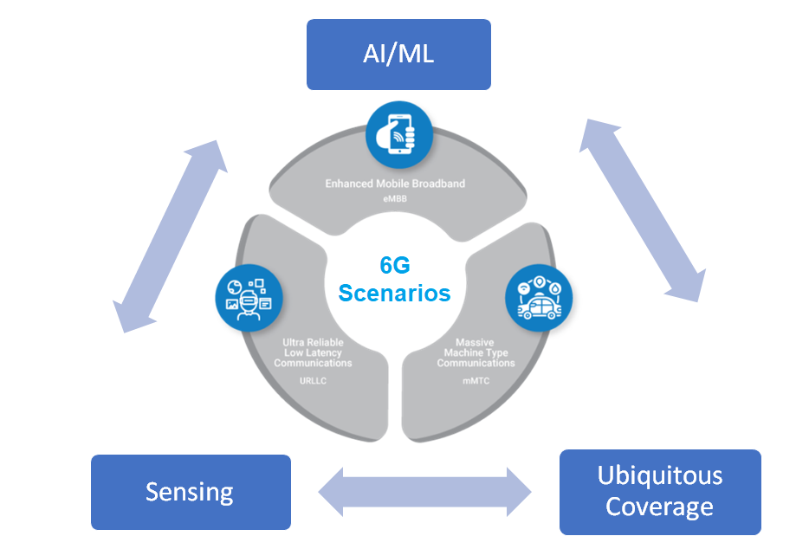

Figure 1.1. 6G Applications Scenarios with Distinguishing Technologies

ML is extensively applied across a wide range of domains, including the fields of communication and networking. This technology, anticipated to gain even more significance, is aimed at achieving heightened levels of inter-device communication, optimizing network performance, and improving the efficiency of cellular networks [9].
As ML becomes increasingly integrated within the realm of 5G and gains prominence within the evolving landscape of 6G, its potential expands beyond mere efficiency, encompassing a multitude of benefits across various sectors. A pivotal aspect of leveraging neural network (NN) is its capability to establish intricate connections within complex datasets. The ease of establishing these connections not only facilitates efficient data classification and forecasting but also contributes to time and energy savings [10].
Figure 1.2 illustrates the aspects of AI/ML improving the 6G network performance management. As the AI tools are used to manage mobility and user behaviour for localization and traffic, better network performance can be generated as an output. In addition, network efficiency can be enhanced by resource utilization, admission and congestion controlling. In terms of network security, analysing massive data can enforce threat detection and better user behaviour localization. Finally, small cells and various network topologies can be used for better 6G deployment [4].

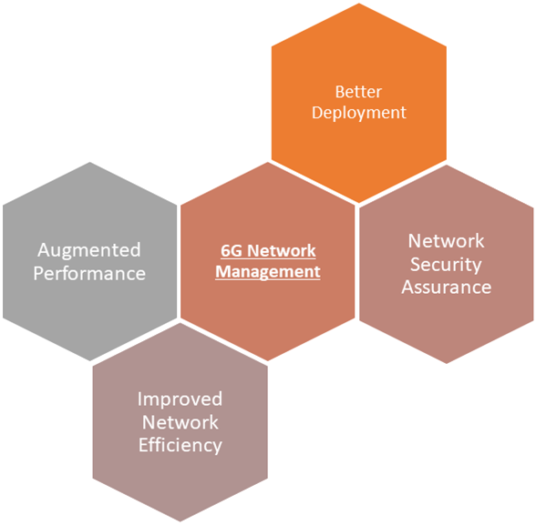
Figure 1.2. 6G Network Performance Management via AI/ML Tools [4]

Deep learning (DL) offers an impressive ability to discover and learn patterns among data using multi-layered NNs. The application of DL on large datasets has achieved remarkable success in many areas, such as image recognition, natural language processing, gaming, and autonomous driving. With its flexible structure and broad application areas, DL constitutes one of our most important artificial intelligence research areas.
While internet, call, and short message service (SMS) services remain fundamental pillars of mobile networks, as we delve into more complex services, such as extended reality and remote control, it's easy to assume that the requirements for these services may not be as demanding. However, the dynamic nature of modern society, which includes unexpected events like natural disasters or sudden surges in crowd movement in any location, underscores the critical need for machine learning-driven predictions. Furthermore, the classification of services tailored to different user device types and capabilities becomes increasingly pivotal in meeting diverse service requirements effectively. This multifaceted landscape underscores the ever-evolving challenges and opportunities within the realm of mobile network services. We need accurate DL-based models to classify them and make accurate predictions [11].
There are numerous studies on traffic classification problems. [12] investigates each traffic type's random entropy and conditional entropy based on temporal, geographical, and service-related information, classifying by text and dataset containing voice, SMS, and internet traffic logs. In [13], recurrent NN, long short-term memory and gated recurrent unit, and OS-ELM were used to predict network traffic data and compared these different techniques for determining the best network in terms of prediction accuracy and computational time. By looking at the results obtained, a 12.2% energy saving was observed by using the OS-ELM method, and it was revealed that it is the most suitable network for making faster and more accurate predictions compared to other networks. In [14], they present a high-level overview of these techniques and discuss their applications in local and wide area networks. Moreover, they explore the applicability of various machine learning and statistical models, including NNs, linear regression, support vector machines, principal component analysis (PCA), statistical models, and linear time series models, to determine their suitability for specific applications. Another critical issue in DL is data management. Dataset collection and preprocessing stages are critical steps for efficient training and validation. It should be noted that the statistical analysis of the dataset needs to be done carefully to divide the dataset into train, validation, and test sets.
In this study, supervised and unsupervised learning techniques are utilized to classify different network types and benchmark the performance of techniques such as convolutional neural network (CNN), deep neural network (DNN), and K-means clustering. The book chapter is structured as follows. Firstly, Section 2 presents a comprehensive description of the utilized dataset. Secondly, Section 3 provides the architecture of different models with their hyperparameters. Thirdly, Section 4 benchmarks the performances of different models. Finally, Section 5 concludes the book chapter.

Dataset Descrıptıon
In this study, we utilize a dataset collected from a real and live mobile network operated by Telecom Italia. The dataset comprises the call detail records (CDRs) of the cellular network within the urban area. These CDRs serve the dual purpose of tracking user behaviour for invoicing and network management. The dataset includes the user-based activities such as received SMS, sent SMS, incoming calls, outgoing calls, and internet usage. The dataset contains network traffic information for the period between 11.04.2013 and 11.10.2013. Table 2.1 illustrates the features of the dataset. For more detailed information about these features, please refer to [15].
We investigated that some parts of the dataset need to be pre-processed, so that we removed rows with null elements, considering not affecting the statistics of the feature set. Then it is guaranteed that only SMS-in, SMS-out, Callin, Call-out, and internet activities are stored. After all these processes, a new feature called 'total activity' is generated. This feature consists of the SMS-in, SMS-out, Call-in, Call-out, and internet traffic logs. Also, this step dataset is divided into three parts training, validation, and testing.
Table 2.1. Features
Name | Description
Square ID | Represents a part of the grid
Start time | Start time of the period
Country code | Represents the country code
SMS-In | Received SMS within the square ID
SMS-Out | Sent SMS within the square ID
Call-In | Received call activity within the square ID
Call-Out | Initiated call activity within the square ID
Internet | Internet connection within the square ID

Model Archıtectures
In this section, we present the different ML models we employed in our study, considering both supervised and unsupervised learning.

DNN
We have developed a DNN-based model, which places a particular emphasis on leveraging Dense layers to assess performance outcomes. The DNN architecture is characterized by its depth, comprising multiple successive Dense layers. By focusing on Dense layers, we aim to scrutinize the model's capability to capture intricate patterns and relationships within the dataset. As shown in Figure 3.1, the model consists of six hidden layers. The model employs ReLU activation with 200 perceptrons in each layer, as specified in [11]. The training epoch is set to 30, the batch size is 10⁴, and the total number of parameters amounts to 243606. We use the Adam optimizer and employ categorical cross-entropy as the loss function.

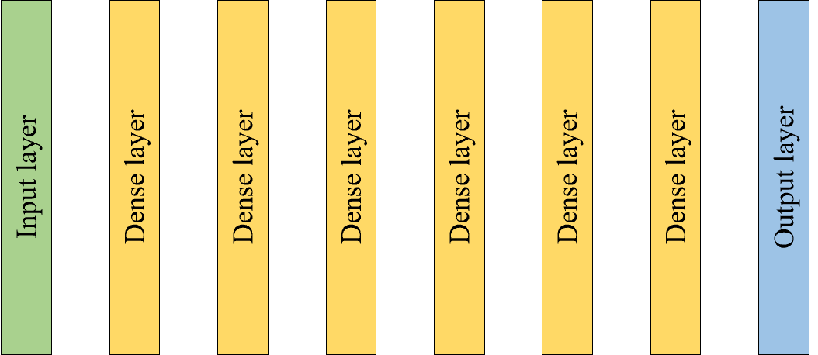
Figure 3.2. DNN Model Architecture

CNN
We have developed a CNN-based model to investigate its performance and effectiveness. Comprising multiple convolutional and pooling layers, the CNN is well-suited to capture intricate features and patterns within the data. Its unique ability to automatically learn spatial hierarchies of information makes it a powerful tool. By employing a CNN, our objective is to explore the model's capacity to extract meaningful features from the data and assess its performance in tasks that require spatial understanding, ultimately providing valuable insights into its suitability for our specific application. As shown in Figure 3.2, the model consists of a total of five hidden layers, including two convolutional layers, one flatten layer, and two dense layers. The purpose of using this model is to determine whether learning spatial hierarchies of information provides an advantage compared to the DNN model. In this model, we set the epoch to 30, the batch size to 10⁴, use categorical cross-entropy as the loss function, and employ the Adam optimizer. The total number of parameters in this model is 15430.
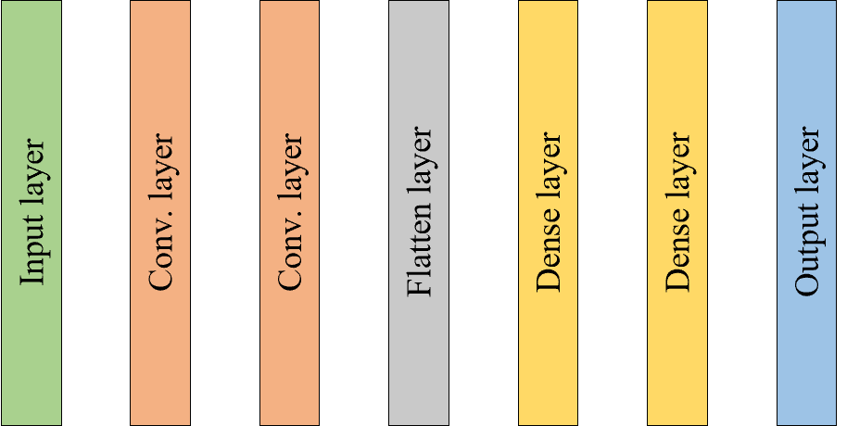
Figure 3.2. CNN Model Architecture

K-Means Clusterıng
In this study, following an initial exploration using supervised learning models, specifically DNN and CNN, the focus of our investigation shifts to the domain of unsupervised learning. Our primary aim is to unveil latent structures within the data without relying on pre-existing labels. To achieve this, we employ the powerful unsupervised machine learning technique known as K-means clustering, which groups data points based on their similarity. This approach offers the opportunity to reveal hidden patterns, relationships, and inherent groupings within the dataset. Through the application of K-means clustering, we intend to gain fresh insights and a novel perspective on the data, potentially uncovering valuable information that may have been previously overlooked within the context of supervised learning. Utilizing K-means clustering, data points are grouped into K clusters, each representing similar data samples, thereby facilitating the discovery of structures and patterns within the dataset [16]. Figure 3.3 illustrates our use of K, which has been set to 6.
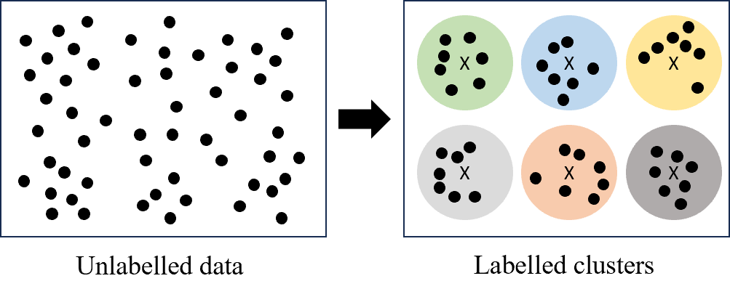
Figure 3.3. K-Means Clustering (K=6)

PCA
In our pursuit of enhancing data analysis and gaining deeper insights, we have extended our approach to incorporate PCA in conjunction with K-Means clustering. While K-Means clustering serves as a powerful technique for uncovering inherent data structures, PCA complements this process by reducing dimensionality and capturing essential features within the data [16]. The amalgamation of these methods offers the potential to not only identify data clusters but also improve the quality of the information used for clustering. Our objective is to explore the combined approach to determine whether it yields more robust results, enhances clustering accuracy, and contributes to a more comprehensive understanding of the underlying patterns and structures within the dataset.

Results
In this section, we provide the performance results of network traffic classification using different ML models. Initially, we demonstrate the change in the accuracy of DNN and CNN models for supervised learning. Then, we present the performance results of K-Means clustering and K-Means clustering with PCA for unsupervised learning.
For supervised learning, both the DNN and CNN models have produced notably similar accuracy results. As illustrated in Figure 4.1, the DNN model's accuracy commences at 95% and steadily ascends to reach a peak of 99.5%. Simultaneously, the model's loss remains consistently below 0.1, approaching nearly 0. These exceptional training outcomes are substantiated by test results, which also demonstrate an impressive accuracy of 99.5%. Figure 4.2 depicts the performance results of the CNN model. Accuracy reaches an impressive 99%, while the loss decreases to under 0.1%. These findings are highly accurate, and the test results also confirm an accuracy level of 99%. When comparing these results with those of the DNN model, they exhibit a remarkable degree of similarity and reliability. Furthermore, the DNN model we employed boasts approximately 15 times the number of parameters compared to the CNN model. From the perspective of model complexity, the utilization of the CNN model proves to be more computationally efficient in terms of training load.
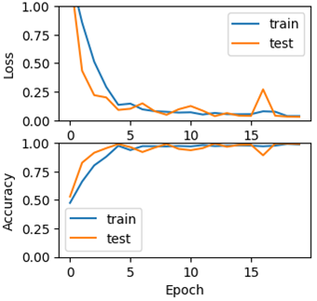
Figure 4.3. Loss and Accuracy Results for DNN Model
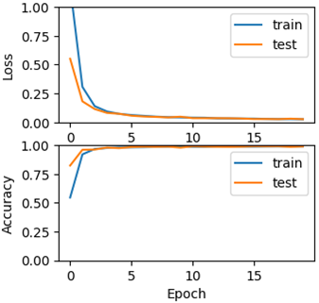
Figure 4.4. Loss and Accuracy Results for CNN Model
For unsupervised learning, we observe that the combination of K-Means clustering and PCA has a significantly positive impact on performance. Figure 4.3 depicts the performance results of K-means clustering. The test result is only 58%. While a decrease in accuracy compared to supervised learning was expected, we have observed that the dataset's existing dimensionality significantly impairs performance [16].
Hence, to mitigate this issue, we apply PCA to reduce the dimensionality of the additional feature set. Figure 4.4 shows that the test result is 77%. This model has more accurate results than the K-Means clustering model but still lags far behind the DNN and CNN models. In a mobile network, there may be a need to employ unsupervised learning under certain conditions. In such cases, it is crucial for operators or vendors to carefully determine performance thresholds. This is essential to select the most suitable model that achieves the desired performance rate while optimizing model complexity and computational load.
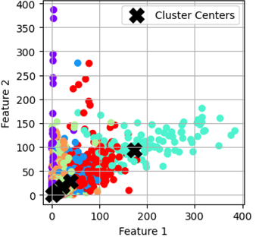
Figure 4.5. K-Means Clustering

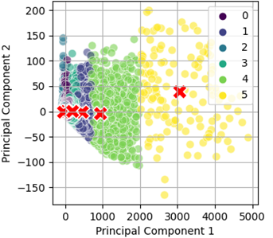
Figure 4.6. K-Means Clustering with PCA

Conclusion
Due to the increasing device density and the diversity of network traffic types in 5G and beyond networks, it is important to classify the different traffic levels to make networks more dynamic and robust. In this study, we benchmarked and evaluated the classification results of different models for supervised and unsupervised learning scenarios. For supervised learning, the DNN model, which has approximately one-fifteenth the number of parameters as the CNN model, has yielded performance results similar to that of the DNN model. Consequently, in terms of model complexity, the CNN model's ability to learn spatial hierarchies of the data has led to improved performance. Additionally, for unsupervised learning, the use of PCA in conjunction with K-means clustering has resulted in a 32.76% performance enhancement. We can say that the unsupervised models are inefficient compared to the supervised models for traffic prediction applications. On the other hand, it is important to utilize well-defined thresholds for performance, model complexity, and computational load when designing a model specific to traffic classification in mobile networks. It is evident that the classification of different types of traffic in a mobile network and the triggering of optimization actions based on traffic type will be critical in 5G and beyond networks.

Figures and Tables Caption List
Figure 1.7 | 6G Applications Scenarios with Distinguishing Technologies
Figure 1.2. | 6G Network Performance Management via AI/ML Tools
Figure 3.1 | DNN Model Architecture
Figure 3.2 | CNN Model Architecture
Figure 3.3 | K-Means Clustering (K=6)
Figure 4.1 | Loss and Accuracy Results for DNN Model
Figure 4.2 | Loss and Accuracy Results for CNN Model
Figure 4.3 | K-Means Clustering
Figure 4.4 | K-Means Clustering with PCA
Table 2.1 | Features

References
[1] W. Saad, M. Bennis, and M. Chen, “A vision of 6G wireless systems: Applications, trends, technologies, and open research problems,” IEEE Networks., vol. 34, no. 3, pp. 134-142, May 2020.
[2] F. Tariq, M. R. A. Khandaker, K.-K. Wong, M. A. Imran, M. Bennis, and M. Debbah, “A speculative study on 6G,” IEEE Wireless Communications, vol. 27, no. 4, pp. 118-125, Aug. 2020.
[3] M. Z. Chowdhury, M. Shahjalal, S. Ahmed, and Y. M. Jang, “6G wireless communication systems: Applications, requirements, technologies, challenges, and research directions,'' IEEE Open J. Communications Society, vol. 1, pp. 957-975, 2020.
[4] Ericsson Technical Report “What role will 5G and AI have in the mobile networks of the future?” Available at: https://www.ericsson.com/en/network-services/ai-5g-networks.
[5] B. Li, Z. Fei, and Y. Zhang, “UAV communications for 5G and beyond: Recent advances and future trends”, IEEE Internet Things Journal, vol. 6, no. 2, pp. 2241- 2263, Apr. 2019.
[6] S. Chen, Y.-C. Liang, S. Sun, S. Kang, W. Cheng, and M. Peng, “Vision, requirements, and technology trend of 6G: How to tackle the challenges of system coverage, capacity, user data-rate and movement speed,” IEEE Wireless Communication, vol. 27, no. 2, pp. 218-228, Apr. 2020.
[7] Y. Yuan, Y. Zhao, B. Zong, and S. Parolari, “Potential key technologies for 6G mobile communications,” Sci. China Inf. Sci., vol. 63, pp. 1-19, May 2020.
[8] J. Kaur, M. A. Khan, M. Iftikhar, M. Imran and Q. Emad Ul Haq, "Machine Learning Techniques for 5G and Beyond," in IEEE Access, vol. 9, pp. 23472-23488, 2021, doi: 10.1109/ACCESS.2021.3051557.
[9] C. Jiang et al., “Machine learning paradigms for next-generation wireless networks,” IEEE Wireless Communication, vol. 24, no. 2, pp. 98–105, Apr. 2017.
[10] K. Aykurt and W. Kellerer, "Autonomous Network Management in Multi-Domain 6G Networks based on Graph Neural Networks," 2023 IEEE 9th International Conference on Network Softwarization (NetSoft), Madrid, Spain, 2023, pp. 338-341, doi: 10.1109/NetSoft57336.2023.10175480.
[11] P. Kaushik, S. S. Singh, and P. K. Yadav, “Traffic prediction in telecom systems using deep learning,” 2018 7th International Conference on Reliability, Infocom Technologies and Optimization (Trends and Future Directions) (ICRITO), pp. 302–307, 2018. [Online]. Available: https://api.semanticscholar.org/CorpusID:195774672.
[12] X. Zhou, Z. Zhao, R. Li, Y. Zhou, and H. Zhang, “The predictability of cellular networks traffic,” in 2012 International Symposium on Communications and Information Technologies (ISCIT), 2012, pp. 973–978.
[13] F. Rau, I. Soto, D. Zabala-Blanco, C. Azurdia-Meza, M. Ijaz, S. Ekpo, and S. Gutierrez, “A novel traffic prediction method using machine learning for energy efficiency in service provider networks,” Sensors, vol. 23, no. 11, 2023. [Online]. Available: https://www.mdpi.com/1424-8220/23/11/4997.
[14] A. Chen, J. Law, and M. Aibin, “A survey on traffic prediction techniques using artificial intelligence for communication networks,” Telecom, vol. 2, no. 4, pp. 518–535, 2021. [Online]. Available: https://www.mdpi.com/2673-4001/2/4/29
[15] C.-W. Huang, C.-T. Chiang, and Q. Li, “A study of deep learning networks on mobile traffic forecasting,” in 2017 IEEE 28th Annual International Symposium on Personal, Indoor, and Mobile Radio Communications (PIMRC), 2017, pp. 1–6.
[16] E. Alpaydin, Introduction to Machine Learning, 2nd ed. The MIT Press, 2010.

