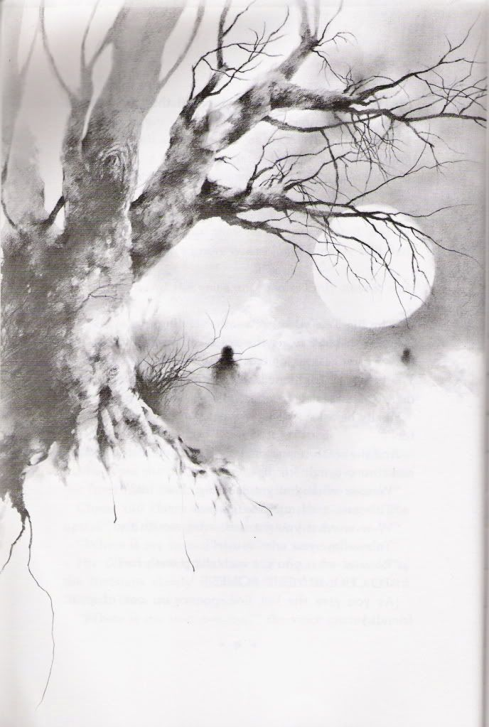

Before Treetrover crashed and burned,

Treetrover Trevor turned and turned.

First, he was a cowboy tall and alone,

Then he played on the end zone,

The bears past the rams was a common sight,

But he didn’t go down raiders without a fight.

2

The Song of Treetrover Trevor

Treetrover Trevor took his trove,

Treetrover Trevor was very old,

Treetrover Trevor heard a sound,

Treetrover Trevor hit the ground.

Treetrover Trevor took his trove,

Treetrover Trevor was very old,

Treetrover Trevor heard a sound,

Treetrover Trevor hit the ground.

1

When he reached the spire view,

He laughed at the swan that he didn’t choose,

At the strait of the floral hall,

He was raised in Loudoun in the fall.

At the end of this long drawn-out path,

Treetrover Trevor took a nap,

He laid right next to the grass and mold,

Then his body was dead and cold.

Treetrover Trevor took his trove,

Treetrover Trevor was very old,

Treetrover Trevor heard a sound,

Treetrover Trevor hit the ground.

3