Charging the Corridors: A Distance-Weighted Difference-in-Differences Analysis of NEVI Interstate Fast-Charging Deployment, Gasoline Consumption, and Air Quality Across California Counties
Khoi Van
Summer Research 2026
Project Advisor: Dr. Alexandre Scarcioffolo
Department: Data Analytics Program
Denison University
2026

Abstract
California's 2022 National Electric Vehicle Infrastructure (NEVI) Formula Program directs federal funds through the state to build direct-current fast-charging along designated Interstate Alternative-Fuel Corridors before any other spending. Because corridor placement is fixed by the federal interstate network and administered by the state rather than chosen by counties, it offers a plausibly exogenous shock with which to ask whether public fast-charging deployment reduces gasoline use and improves local air quality. Using a California county-year panel (58 counties, 2010–2025) assembled from the California Energy Commission, U.S. Department of Energy Alternative Fuels Data Center, U.S. Environmental Protection Agency Air Quality System, U.S. Census Bureau American Community Survey, and the state's NEVI corridor GIS layer, we estimate a canonical two-way fixed-effects difference-in-differences (DiD) model comparing corridor counties (treated, n = 23) with off-corridor counties (control, n = 35) around a 2023 treatment onset, controlling for log median household income and the share of commuters driving alone. We then sharpen identification with a distance-weighted DiD that measures each county's centroid distance to the interstate corridor and up-weights counties nearest the threshold, using both an exponential-decay kernel and an inverse-distance (1/d) weight. Across specifications, the estimated effect on log per-capita gasoline is negative and grows stronger as weight is concentrated on corridor-adjacent counties (unweighted -0.048, p = 0.24; exponential h = 50 km -0.064, p = 0.25; inverse-distance -0.089, p = 0.10), with an event-study point estimate of -0.17 by 2024 (p = 0.055). Median Air Quality Index shows no detectable effect under any weighting. All estimates are directionally consistent but statistically insignificant at conventional levels, which is expected given only two post-treatment years and a small cross-section. We interpret the pattern as suggestive evidence that fuel displacement is concentrated near state-built charging corridors, and we outline how continuous-dose and causal-machine-learning designs could formalize the result.

1 Introduction
Electric vehicle (EV) adoption in California has surged, positioning the state as a national leader in the transition away from gasoline-powered transportation. By 2023 California recorded roughly 1.26 million light-duty EV registrations, and by late 2025 the state surpassed 200,000 public and shared chargers (California Energy Commission, 2025b). Yet rapid adoption has not translated into proportional reductions in gasoline consumption, and transportation remains the largest source of the state's greenhouse-gas emissions and a persistent contributor to local air pollution (California Air Resources Board, 2024). A prior county-level study established that within-county growth in everyday Level 2 charging is associated with lower per-capita gasoline use, while raw counts of direct-current fast chargers (DCFC) can display a counterintuitive positive association tied to corridor clustering and inequitable deployment (Van, 2025). That work, however, relied on associational two-way fixed-effects regressions of charger counts and could not isolate a policy-driven infrastructure shock.
This paper advances that agenda by exploiting a concrete, external policy shock: the 2022 National Electric Vehicle Infrastructure (NEVI) Formula Program. Created by the 2021 Bipartisan Infrastructure Law, NEVI apportions federal funds to states and requires each state department of transportation to first build out fast-charging along the Federal Highway Administration's designated Interstate Alternative-Fuel Corridors before spending elsewhere (Federal Highway Administration, 2023). Two features make this a useful research design. First, treatment is geographic and state-administered: which counties receive the first wave of corridor charging is determined by the federal interstate network and a state build-out rule, not by county wealth, politics, or local demand. Counties neither nominate nor fund the corridor segments, which mitigates self-selection into treatment. Second, the program turned on at a common date, allowing a canonical before/after comparison with treatment onset in 2023.
We ask whether the NEVI corridor build-out reduced per-capita gasoline consumption and improved local air quality in the counties it crosses, relative to comparable off-corridor counties. Because the credible counterfactual for a corridor county is a nearby off-corridor county that shares the same regional shocks, we go beyond a binary treated/control split and measure each county's distance to the interstate corridor, then weight the difference-in-differences so that counties closest to the threshold count most. We compare an unweighted DiD with two distance-weighting schemes—an exponential-decay kernel and an inverse-distance (1/d) weight—and trace the dynamic response with weighted event studies. This distance-weighted framing connects the applied question to the spatial logic of boundary-discontinuity designs while retaining the transparency of a two-way fixed-effects panel model.
Our contribution is threefold. We reframe the charging-and-gasoline question around an exogenous, state-administered infrastructure shock rather than endogenous charger counts; we introduce an explicit distance-to-corridor running variable and a distance-weighted DiD that concentrates identification near the treatment threshold; and we report a transparent robustness surface across weighting schemes and bandwidths. The results are directionally consistent—gasoline effects are negative and strengthen as weight moves toward corridor-adjacent counties—though they remain statistically insignificant given the short post-treatment window, a limitation we take seriously in interpreting the findings.

2 Literature Review

2.1 Theoretical framework
The relationship between charging infrastructure, fuel displacement, and local environmental co-benefits rests on microeconomic consumer-choice theory, public economics, and the economics of infrastructure reliability. Transportation economics conceptualizes vehicle adoption and fuel substitution through McFadden's random-utility framework (McFadden, 1973, 1974): consumers choose between internal-combustion-engine (ICE) and alternative-fuel vehicles by maximizing a multi-attribute utility function in which adoption trades off upfront capital cost against operational shadow costs. Financial subsidies—such as the federal clean-vehicle tax credits—lower the nominal purchase price, while public charging serves as a complementary good that reduces the operational shadow cost of EV ownership by mitigating range anxiety and refueling search costs. When demand-side incentives are removed, the spatial density and reliability of charging becomes the primary structural variable able to sustain substitution away from retail gasoline.
In public economics, ICE tailpipe emissions are a classic negative externality: private vehicle operation releases criteria pollutants—fine particulate matter (PM2.5) and tropospheric-ozone precursors—that impose unpriced public-health costs. Electrification internalizes these costs by shifting emissions from decentralized tailpipes to regulated grids, with the size of the environmental benefit depending on grid intensity. Finally, service-reliability economics warns that nominal access is an insufficient metric when product performance is stochastic: if public connectors fail frequently, the effective cost of EV use rises through search friction and travel disruption, dampening the expected substitution effect. Operational uptime therefore functions as a first-order modifier of raw infrastructure density.

2.2 Methodological review
Evaluating regional infrastructure policies requires panel designs that control for unobserved spatial and temporal confounding. The workhorse has been the linear two-way fixed-effects (TWFE) model with a continuous treatment intensity, Y_ct = γ_c + δ_t + β(D_c × Post_t) + X_ct′Γ + ε_ct, where γ_c and δ_t are county and year fixed effects. A large econometrics literature shows that the TWFE coefficient is vulnerable to bias when treatment timing is staggered or effects are heterogeneous, because already-treated units can act as effective controls for later-treated units—the problem of forbidden comparisons (Baker et al., 2022; Goodman-Bacon, 2021; Roth et al., 2023). With continuous treatments, Callaway, Goodman-Bacon, and Sant'Anna (2024) show that comparing across dose intensities can be contaminated by selection bias and that linear TWFE imposes restrictive functional-form assumptions, applying negative weights to below-average-dose units.
To resolve these issues, modern estimators isolate clean 2×2 comparisons. Callaway and Sant'Anna (2021) decompose staggered panels into group-time average treatment effects estimated against never-treated or not-yet-treated units, and Sun and Abraham (2021) provide a cohort-robust event-study estimator. For continuous settings, Callaway et al. (2024) define average causal responses as nonparametric functions of the dose. Beyond DiD, causal machine learning—double/debiased machine learning (Chernozhukov et al., 2018) and causal forests (Wager & Athey, 2018)—recovers low-dimensional treatment parameters and heterogeneous effects while flexibly controlling high-dimensional nuisance variation. The present study adopts the transparent end of this spectrum: because the NEVI corridor shock has a single common onset (2023) and a binary geographic assignment, a canonical TWFE DiD is well specified, and we address the spatial-selection concern directly by weighting on distance to the treatment threshold. We treat the staggered/continuous-dose and causal-forest extensions as the natural next step rather than the current design.

2.3 Current empirical findings
A central driver of substitution is the relative price of competing energy sources. EV adoption is four to six times more responsive to gasoline prices than to electricity tariffs (Bushnell et al., 2022), so sustained high gasoline prices act as a demand-side catalyst; once EVs enter the fleet they displace petroleum demand. These dynamics are shaped by federal fiscal policy: the 2025 One Big Beautiful Bill Act abruptly terminated the consumer clean-vehicle tax credits on September 30, 2025, generating a sharp pricing shock (One Big Beautiful Bill Act, 2025; U.S. Department of the Treasury, IRS, 2025). On the supply side, nominal deployment often diverges from operational access: an audit of Bay Area DCFC found roughly 73% of connectors fully operational, with 27% impaired by hardware, software, or payment failures (Rempel et al., 2024), implying that charger counts overstate effective access.
The environmental co-benefits of electrification are well documented but spatially heterogeneous. Vehicle electrification reduces localized NO2 and PM2.5 and improves child-health outcomes (Baran et al., 2025), and during winter inversion events high electrification can prevent severe pollutant spikes, improving the Air Quality Index by tens of points (Christensen & Salmon, 2021). Yet access is unequal: below-median-income and higher-minority areas have systematically lower charging access (Hsu & Fingerman, 2021; Lou et al., 2024), even as zero-emission-vehicle adoption has begun to narrow ambient PM2.5 disparities (Skipper et al., 2023; Yu et al., 2023; Lau, 2024). This equity dimension motivates our attention to which counties the state-built corridor actually reaches.

2.4 Research gap
Three gaps motivate this study. First, most prior work treats charging as a static aggregate count and studies its association with adoption or fuel use, rather than exploiting a discrete, externally assigned infrastructure shock; this leaves the causal question of whether public deployment displaces gasoline underidentified. Second, evaluations of infrastructure rollouts have rarely used spatially explicit comparison strategies: even when a treated/control contrast is available, the analyst typically weights all controls equally, ignoring that a corridor county's credible counterfactual is a nearby off-corridor county. Third, the NEVI corridor program—federally funded, state-administered, and geographically assigned—has not been used as the quasi-experiment it naturally provides. We address these gaps with a corridor-based DiD that (a) defines treatment by federally designated interstate corridor geography, (b) measures each county's distance to that corridor and weights the estimator toward the threshold, and (c) reports the full robustness surface across weighting schemes and bandwidths. In doing so we build directly on the associational county-level evidence in Van (2025) and translate it into a design with a plausibly exogenous treatment.

3 Methodology

3.1 Data preparation
We assemble a balanced California county-year panel covering all 58 counties from 2010 through 2025 (928 county-years). Per-capita gasoline consumption is built from California Energy Commission taxable-gallons data, with the aggregated “other counties” row split by American Community Survey population share and 2025 values scaled by the statewide CDTFA fuel-tax distribution ratio; the outcome enters in logs. Air quality is summarized by the county median Air Quality Index (AQI) constructed from U.S. EPA Air Quality System monitor records; county-years without a monitor receive a leave-one-out inverse-distance-weighted (power-2, centroid) estimate that is flagged so it can be excluded in observed-only checks. Time-varying controls are the log of median household income and the share of commuters who drive alone, both from the American Community Survey. Following the advisor-approved specification, the analysis focuses on two outcomes—log per-capita gasoline and median AQI—so that the fuel-displacement and air-quality channels are examined with a common design.

3.2 Treatment assignment and distance to the threshold
Treatment is defined by NEVI-designated Interstate Alternative-Fuel Corridors. Using the state's NEVI corridor GIS layer and U.S. Census TIGER county boundaries, we intersect each county polygon with the twelve interstate corridor segments and classify a county as treated if an interstate corridor crosses it for at least 5 km—a floor that removes boundary-clip artifacts. This yields 23 treated (corridor) counties and 35 control (off-corridor) counties. For each county we also compute the straight-line distance from its centroid to the nearest interstate corridor (dist_centroid_km) in an equirectangular projection centered on California; this continuous distance is the running variable for weighting. To make the treated/control contrast transparent we grade controls into distance rings—adjacent (0–25 km), near (25–75 km), and far (> 75 km)—while retaining all controls in estimation.

3.3 Empirical models
The baseline is a canonical two-way fixed-effects difference-in-differences model estimated by panel OLS with the within transformation:
Y_ct = β (Treated_c × Post_t) + X_ct γ + α_c + δ_t + ε_ct,
where Y_ct is the outcome in county c and year t, Treated_c indicates a corridor county, Post_t indicates years from 2023 onward, X_ct contains log median household income and the share driving alone, and α_c and δ_t are county and year fixed effects. The coefficient β on the Treated×Post interaction is the DiD estimate. County fixed effects absorb persistent cross-county differences (geography, urban form, baseline fuel dependence); year fixed effects absorb statewide shocks common to all counties, including the state-level administration of the program itself. Standard errors are clustered by county, because the state assigns the shock at the county level and county outcomes are serially correlated. Gasoline is observed through 2024 and AQI through 2025.
The distance-weighted DiD estimates the same equation by weighted panel OLS, assigning each county a weight that decreases with its distance to the corridor so that counties near the threshold dominate identification. We use two schemes. The exponential-decay kernel sets w_c = exp(−dist_centroid_km / h), with bandwidth h (in km) controlling how quickly far counties fade out; the headline bandwidth is h = 50 km, and we report h ∈ {15, 25, 50, 100, 250}. The inverse-distance scheme sets w_c = 1 / dist_centroid_km, a heavier-tailed weight that still concentrates influence on corridor-adjacent counties. Both weights are constant within a county over time (a county-level design weight) and are normalized to mean one, so they do not disturb the within transformation and leave the coefficient scale interpretable. Comparing the unweighted estimate with the two weighted estimates shows how the effect moves as identification is concentrated near the treatment threshold.
Finally, we trace dynamics with event studies that replace Treated×Post with a full set of Treated×year interactions (2022 omitted as the reference), estimated under each weighting scheme. Flat, near-zero pre-2023 coefficients support parallel pre-trends between corridor counties and their nearer controls; movement from 2023 onward is the dynamic treatment effect.

4 Data
The panel merges authoritative federal and California state sources; each variable is preprocessed for consistency across the 2010–2025 window, and derived fields carry provenance flags so that observed values are never overwritten by imputed ones. Table 1 lists the variables used in the analysis, their measurement, and their sources.
Table 1: Variable definitions, measurement, and sources
Variable | Description | Measurement | Source
Log gasoline per capita | Outcome: county per-capita gasoline consumption (log) | log(total taxable gasoline gallons / population) | California Energy Commission (2025a); CDTFA (2025)
Median AQI | Outcome: county median Air Quality Index | Median of daily AQI; IDW-filled where unmonitored | U.S. EPA (2025)
Treated (corridor) | County crossed by a NEVI interstate corridor (≥5 km) | Indicator from corridor × county intersection | CEC NEVI corridor GIS (2025c); U.S. Census Bureau TIGER (2023)
Distance to corridor | Centroid distance to nearest interstate corridor | Straight-line km (equirectangular, CA-centered) | CEC NEVI corridor GIS (2025c); U.S. Census Bureau TIGER (2023)
Post | Post-treatment period (NEVI onset) | Indicator for year ≥ 2023 | Federal Highway Administration (2023)
Log median hh income | Control: county median household income (log) | log(ACS median household income, Table B19013) | U.S. Census Bureau (2024)
Share drove alone | Control: commuters driving alone | ACS drove-alone share (Table B08301) | U.S. Census Bureau (2024)
Population | Denominator for per-capita measures | ACS total population (Table B01003) | U.S. Census Bureau (2024)
Rurality (RUCC) | Rural–urban continuum classification | USDA Rural-Urban Continuum Code (2023) | USDA Economic Research Service (2025)
EV / charger context | Fleet and charger counts (descriptive context) | ZEV registrations; AFDC station locations | CEC (n.d.); U.S. DOE AFDC (n.d.)
The analysis considers 58 counties over 2010–2025. Because NEVI's first-phase priority is the interstate network, a pure on/off split over the full corridor network would touch nearly every county; restricting treatment to interstate corridors yields the usable 23-treated / 35-control contrast used throughout.

5 Results

5.1 Baseline two-way fixed-effects DiD
Table 2 reports the canonical DiD estimate for each outcome. For log per-capita gasoline, the corridor treatment is associated with a change of −0.048 (SE 0.041, p = 0.24), i.e., roughly a 4.8% lower per-capita gasoline level in corridor counties after 2023, though the estimate is not statistically significant. For median AQI the point estimate is +0.98 points (SE 1.49, p = 0.51), effectively a null. The within-R² values are small, as expected when county and year fixed effects absorb most of the variation and only two post-treatment years are available. Figure 1 plots the DiD coefficients with 95% confidence intervals alongside the raw treated-versus-control gasoline trend, which move together through the pre-period and diverge only slightly at the end of the sample.
Table 2: Two-way fixed-effects DiD estimates (β on Treated × Post)
Outcome | β (Treat×Post) | SE | p | N | Within R²
Gasoline per capita (log) | -0.0480 | 0.0410 | 0.241 | 870 | 0.017
Median AQI | +0.9813 | 1.4866 | 0.509 | 844 | 0.062
Notes: County and year fixed effects; standard errors clustered by county. Controls: log median household income, share driving alone. Gasoline observed through 2024; AQI through 2025.
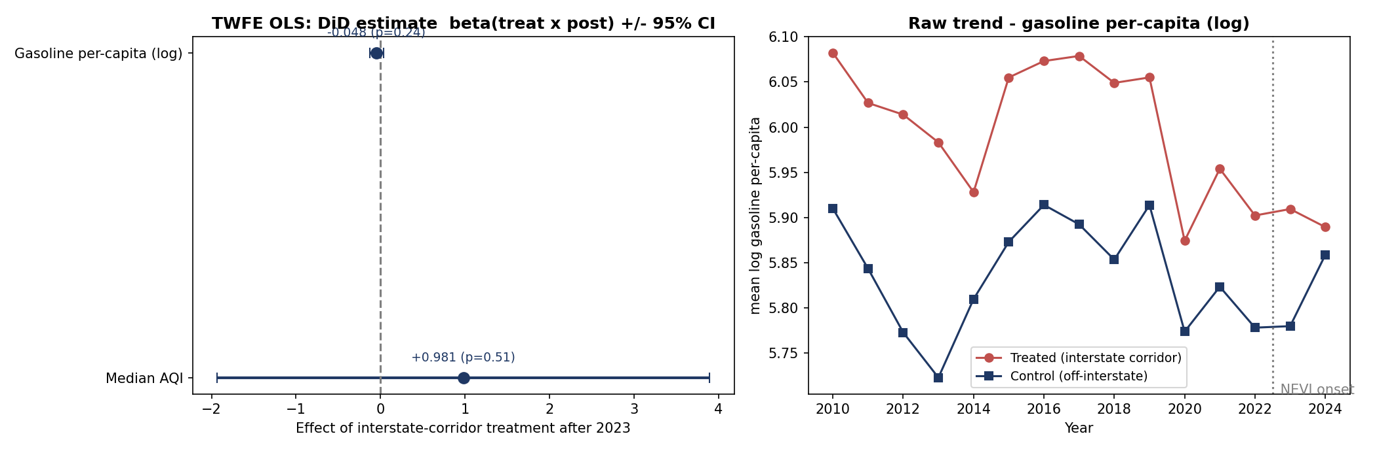
Figure 1: DiD coefficient estimates with 95% confidence intervals (left) and raw treated-versus-control trend in log per-capita gasoline (right).

5.2 Separating treated and control counties by distance
Figure 2 maps the treated corridor counties and grades controls by centroid distance to the interstate corridor, alongside the distribution of those distances. A notable feature is that no control county falls within 25 km of the corridor: the treated group (23 counties, mean centroid distance ≈ 17 km) is separated from the nearest controls by a visible gap, with 14 near controls (25–75 km) and 21 far controls (> 75 km). This spatial structure is exactly what the distance weighting is designed to exploit—near controls are the credible counterfactual and should count most, while remote interior counties should count little. Figure 3 shows the exponential-decay weight as a function of distance for several bandwidths: a county on the corridor receives weight near one, and the weight falls to about 37% of that value at a distance equal to the bandwidth.
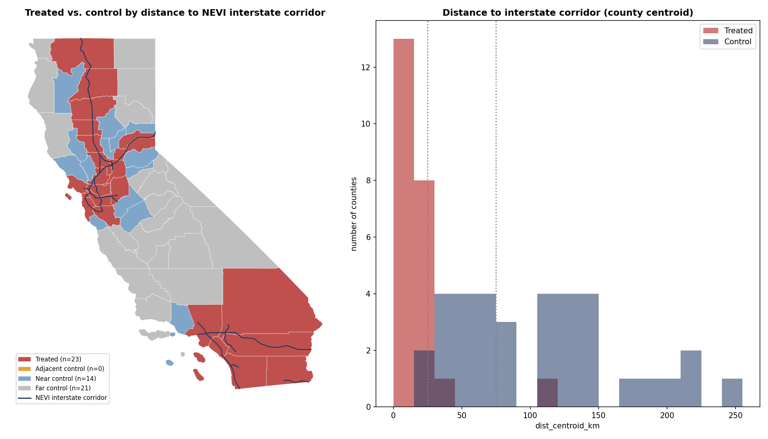
Figure 2: Treated versus control counties by distance to the NEVI interstate corridor (left) and the distribution of county-centroid distances (right).
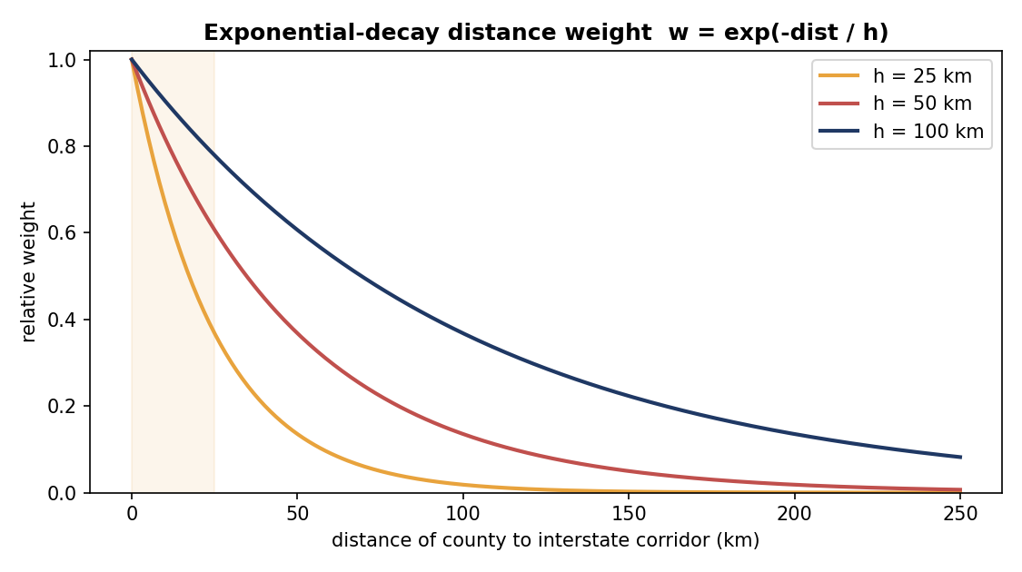
Figure 3: Exponential-decay distance weight w = exp(−dist / h) for bandwidths h = 25, 50, and 100 km.

5.3 Distance-weighted DiD and weighting-scheme comparison
Table 3 and Figure 4 compare the DiD estimate under three weighting schemes. For gasoline, tilting weight toward corridor-adjacent counties makes the effect progressively more negative: from −0.048 (unweighted) to −0.064 under the exponential kernel (h = 50 km) to −0.089 under inverse-distance weighting, the last of which is roughly double the unweighted estimate and the closest to conventional significance (p = 0.10). This monotone pattern is consistent with a treatment that operates through proximity to the state-built corridor: counties nearest the charging investment show the largest post-2023 reduction in per-capita gasoline. Median AQI, by contrast, is null and sign-unstable across schemes (unweighted +0.98, exponential +0.72, inverse-distance −0.08; all p ≥ 0.51), providing no evidence of a corridor effect on air quality over this short window.
Table 3: DiD under three weighting schemes (β on Treated × Post)
Outcome | Weighting scheme | β | SE | p | N
Gasoline per capita (log) | Unweighted | -0.0480 | 0.0410 | 0.241 | 870
Gasoline per capita (log) | Inverse-distance (1/d) | -0.0895 | 0.0544 | 0.101 | 870
Gasoline per capita (log) | Exponential (h = 50 km) | -0.0638 | 0.0560 | 0.254 | 870
Median AQI | Unweighted | +0.9813 | 1.4866 | 0.509 | 844
Median AQI | Inverse-distance (1/d) | -0.0833 | 1.3303 | 0.950 | 844
Median AQI | Exponential (h = 50 km) | +0.7223 | 1.4795 | 0.626 | 844
Notes: Weighted panel OLS with county-level distance weights normalized to mean one; county and year fixed effects; SEs clustered by county.
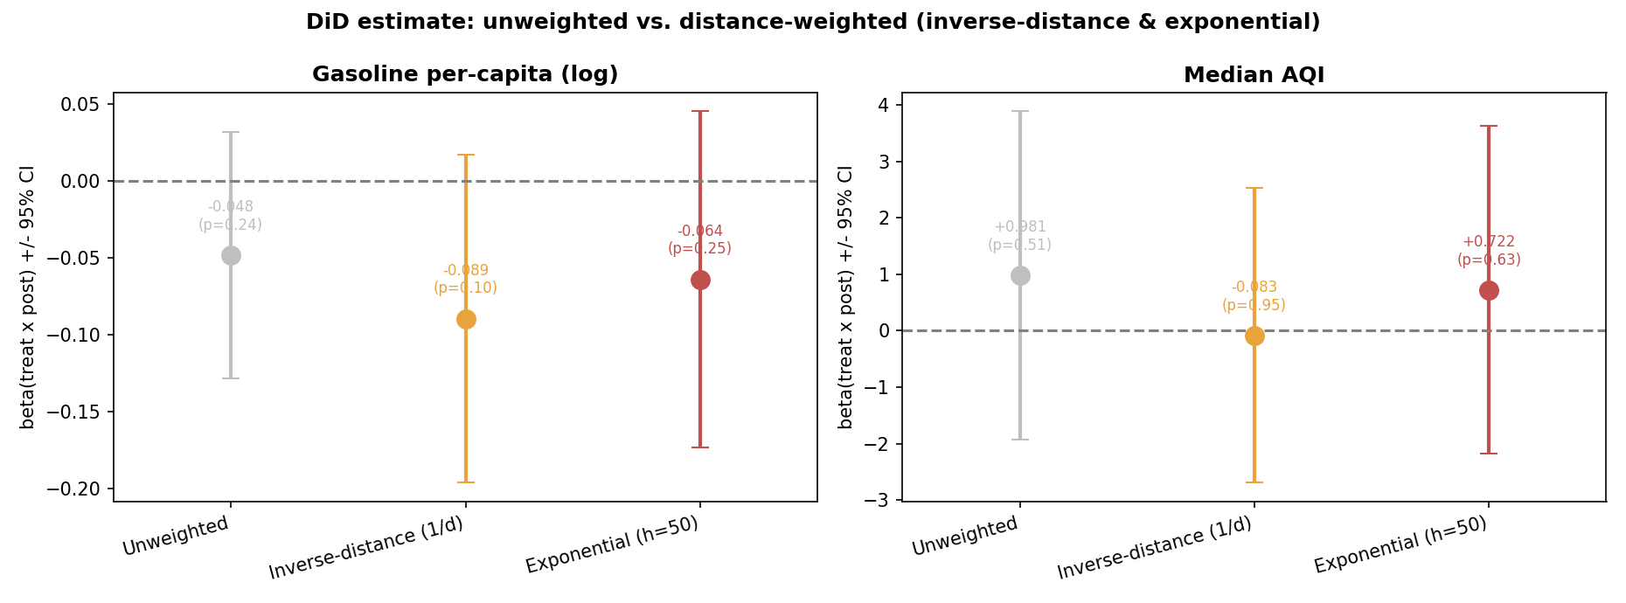
Figure 4: DiD estimate under unweighted, inverse-distance, and exponential (h = 50 km) weighting, with 95% confidence intervals.

5.4 Bandwidth robustness
Because the exponential kernel requires a bandwidth choice, Figure 5 and Table 4 re-estimate the weighted DiD across h ∈ {15, 25, 50, 100, 250} km. The gasoline estimate is stable in sign and strengthens smoothly as the bandwidth narrows—from −0.048 at h = 250 km (essentially the unweighted value) to −0.130 at h = 15 km—mirroring the inverse-distance result and confirming that the more the estimator concentrates on corridor-adjacent counties, the larger the estimated fuel reduction. Median AQI is flat and small across all bandwidths. No estimate reaches significance at the 5% level, but the coherence of the gasoline gradient across independent weighting choices is reassuring.
Table 4: Exponential-kernel bandwidth robustness (β on Treated × Post)
Bandwidth h (km) | Gasoline β | Gasoline p | AQI β | AQI p
15 | -0.1304 | 0.189 | +0.751 | 0.686
25 | -0.0933 | 0.223 | +0.723 | 0.653
50 | -0.0638 | 0.254 | +0.722 | 0.626
100 | -0.0517 | 0.265 | +0.782 | 0.590
250 | -0.0481 | 0.256 | +0.887 | 0.541
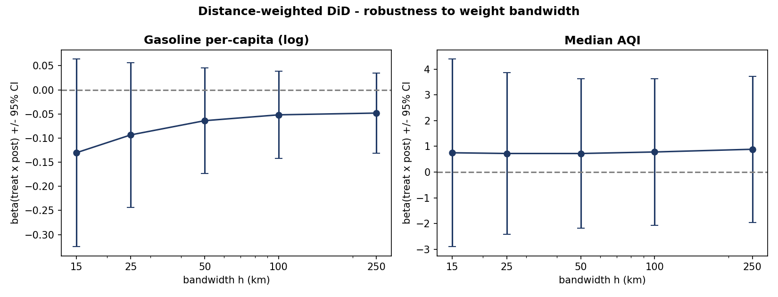
Figure 5: Distance-weighted DiD estimate versus bandwidth h, with 95% confidence intervals, for each outcome.

5.5 Event studies
Figures 6 and 7 present event studies under the exponential (h = 50 km) and inverse-distance weights. For gasoline, the pre-2023 coefficients are small and statistically indistinguishable from zero, supporting parallel pre-trends between corridor counties and their nearer controls. The dynamic response then turns negative after onset and is largest in 2024: the exponential-weighted estimate reaches −0.156 (p = 0.098) and the inverse-distance estimate −0.170 (p = 0.055) by 2024, the latter approaching conventional significance. Because gasoline is observed only through 2024, this leaves a single fully post-treatment year with a monitored fuel figure, which is why the estimate is suggestive rather than conclusive. The AQI event studies are noisy and show no systematic post-2023 movement under either weighting, consistent with the null static estimates.
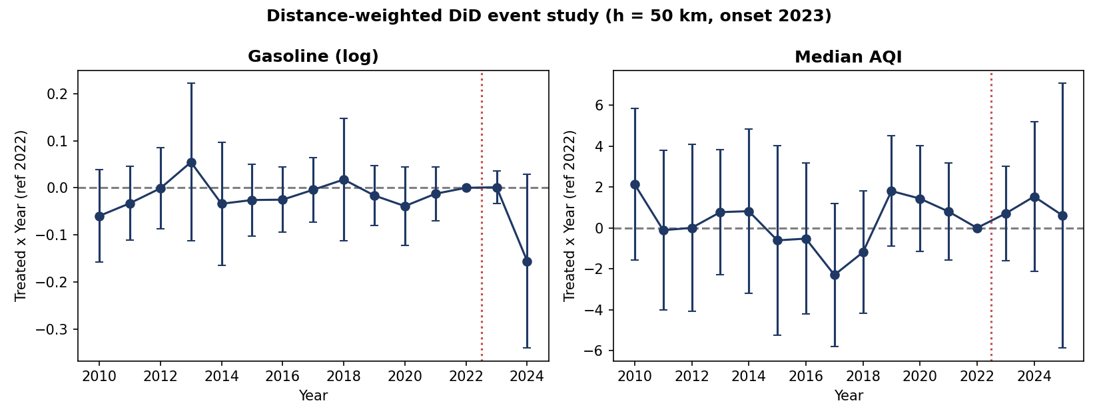
Figure 6: Exponential-weighted (h = 50 km) DiD event study, reference year 2022, treatment onset 2023.
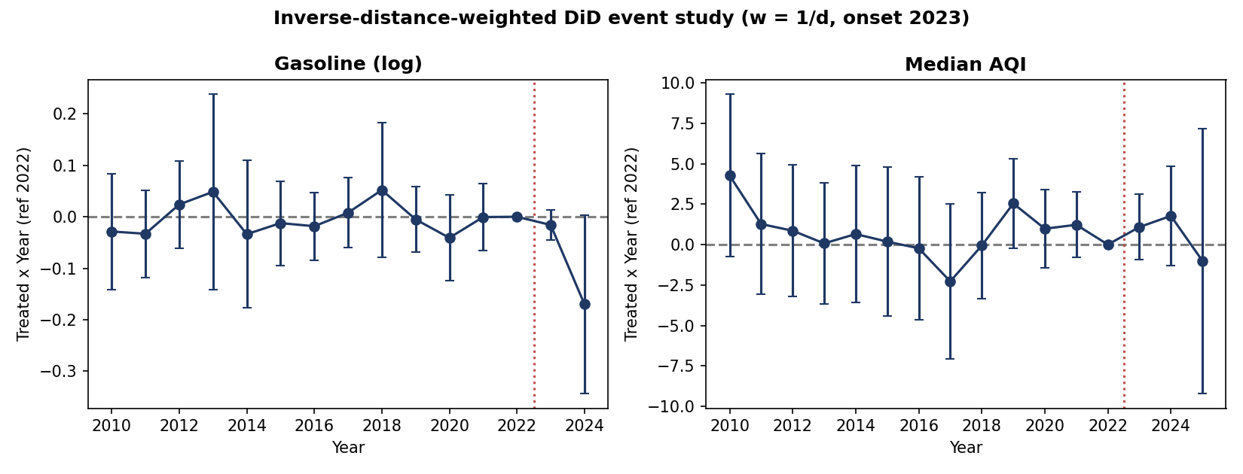
Figure 7: Inverse-distance-weighted (w = 1/d) DiD event study, reference year 2022, treatment onset 2023.

6 Conclusion
This study asked whether California's NEVI interstate charging build-out reduced per-capita gasoline consumption and improved local air quality in the counties it crosses. Using a corridor-based difference-in-differences design with a 2023 onset, and sharpening identification by weighting counties on their distance to the interstate corridor, we find a consistent pattern for gasoline: the estimated effect is negative and grows stronger as weight is concentrated on corridor-adjacent counties, from −0.048 unweighted to −0.089 under inverse-distance weighting, with an event-study point estimate of about −0.17 by 2024. The bandwidth surface reinforces this gradient. Median AQI shows no detectable effect under any specification. Read together, the results are suggestive evidence that fuel displacement is concentrated near the state-built charging corridors—precisely where a proximity mechanism would predict—while stopping short of statistical significance at conventional levels.
The central limitation is the short post-treatment window. With treatment onset in 2023 and gasoline observed only through 2024, identification rests on one to two post-period years, so confidence intervals are wide and the estimates should be read as directional. Two features nonetheless strengthen the design relative to charger-count regressions: treatment is assigned by federal corridor geography and administered by the state rather than chosen by counties, mitigating self-selection; and the distance weighting makes explicit that a corridor county's credible counterfactual is a nearby off-corridor county.
Several extensions follow directly. As more post-2023 fuel and air-quality data accumulate, the same design will gain power and can be re-estimated. The corridor build-out is naturally a continuous, staggered dose—kilometers of corridor, number of NEVI ports, or fast-charging share—so the continuous-treatment and staggered-DiD estimators of Callaway and Sant'Anna (2021) and Callaway, Goodman-Bacon, and Sant'Anna (2024) would relax the functional-form and forbidden-comparison concerns of linear TWFE. Double machine learning and causal forests (Chernozhukov et al., 2018; Wager & Athey, 2018) could then map how the fuel-displacement response varies with income, rurality, and baseline gasoline dependence, and the September 2025 sunset of the federal clean-vehicle tax credits offers a demand-side shock with which to test whether the marginal value of corridor charging rises once purchase subsidies disappear. Together these steps would move the corridor-and-gasoline question from the suggestive spatial evidence reported here toward a fully identified, policy-relevant estimate.

References
Baker, A. C., Larcker, D. F., & Wang, C. C. Y. (2022). How much should we trust staggered difference-in-differences estimates? Journal of Financial Economics, 144(2), 370–395. https://doi.org/10.1016/j.jfineco.2022.01.004
Baran, C., Currie, J., Dursun, B., & Tekin, E. (2025). Clean rides, healthy lives: The impact of electric vehicle adoption on air quality and infant health (NBER Working Paper No. 34278). National Bureau of Economic Research.
Bushnell, J. B., Muehlegger, E., & Rapson, D. S. (2022). Energy prices and electric vehicle adoption (NBER Working Paper No. 29842). National Bureau of Economic Research. https://www.nber.org/papers/w29842
California Air Resources Board. (2022). Advanced Clean Cars II (ACC II): Rulemaking materials and environmental analysis. https://ww2.arb.ca.gov/sites/default/files/barcu/regact/2022/accii/acciirtc1.pdf
California Air Resources Board. (2024, September). California greenhouse gas emissions from 2000 to 2022: Trends of emissions and other indicators. https://ww2.arb.ca.gov/sites/default/files/2024-09/nc-2000_2022_ghg_inventory_trends.pdf
California Department of Tax and Fee Administration. (2025). Fuel taxes statistics and reports [Data set]. https://www.cdtfa.ca.gov/dataportal/dataset.htm?url=FuelGasJetStats
California Energy Commission. (n.d.). Zero-emission vehicle and infrastructure statistics collection [Data set]. https://www.energy.ca.gov/data-reports/energy-almanac/zero-emission-vehicle-and-infrastructure-statistics-collection
California Energy Commission. (2024). Assembly Bill 2061 EV charging reliability reporting regulations (CEC-200-2024-002).
California Energy Commission. (2025a). CEC-A15 gasoline consumption results and analysis (2010–2024) [Data set]. https://www.energy.ca.gov/media/3874
California Energy Commission. (2025b, September 24). California exceeds 200,000 electric vehicle chargers [Press release]. https://www.energy.ca.gov/news/2025-09/california-exceeds-200000-electric-vehicle-chargers
California Energy Commission. (2025c, December). NEVI 2 corridor groups [GIS layer]. https://cecgis-caenergy.opendata.arcgis.com/
California Open Data Portal. (n.d.). Vehicle fuel type count by ZIP code [Data set]. https://data.ca.gov/dataset/vehicle-fuel-type-count-by-zip-code
Callaway, B., Goodman-Bacon, A., & Sant'Anna, P. H. C. (2024). Difference-in-differences with a continuous treatment. SSRN Electronic Journal. https://doi.org/10.2139/ssrn.4716682
Callaway, B., & Sant'Anna, P. H. C. (2021). Difference-in-differences with multiple time periods. Journal of Econometrics, 225(2), 200–230. https://doi.org/10.1016/j.jeconom.2020.12.001
Chernozhukov, V., Chetverikov, D., Demirer, M., Duflo, E., Hansen, C., Newey, W., & Robins, J. (2018). Double/debiased machine learning for treatment and structural parameters. The Econometrics Journal, 21(1), C1–C68. https://doi.org/10.1111/ectj.12097
Christensen, C., & Salmon, J. (2021). EV adoption influence on air quality and associated infrastructure costs. World Electric Vehicle Journal, 12(4), 207. https://doi.org/10.3390/wevj12040207
Federal Highway Administration. (2023). National Electric Vehicle Infrastructure Formula Program final rule (23 CFR Part 680). Federal Register, 88(39), 12724–12759.
Goodman-Bacon, A. (2021). Difference-in-differences with variation in treatment timing. Journal of Econometrics, 225(2), 254–277. https://doi.org/10.1016/j.jeconom.2021.03.014
Hsu, C.-W., & Fingerman, K. (2021). Public electric vehicle charging infrastructure equity in California. Transportation Research Part D: Transport and Environment, 99, 102991. https://doi.org/10.1016/j.trd.2021.102991
Lau, Y. H. (2024). Comparative analysis of gasoline and electric vehicles: Economic, environmental, and consumer perspectives. Finance & Economics, 1, 1–15. https://doi.org/10.61173/psdxq366
Lou, X., et al. (2024). Spatial heterogeneity and equity considerations in national public electric vehicle charging infrastructure [Working paper].
McFadden, D. (1973). Conditional logit analysis of qualitative choice behavior. In P. Zarembka (Ed.), Frontiers in econometrics (pp. 105–142). Academic Press.
McFadden, D. (1974). The measurement of urban travel demand. Journal of Public Economics, 3(4), 303–328. https://doi.org/10.1016/0047-2727(74)90003-6
One Big Beautiful Bill Act of 2025, Pub. L. No. 119-21, 139 Stat. 44 (2025).
Rempel, D., Cullen, C., Matteson Bryan, M., & Vianna Cezar, G. (2024). Reliability of open public electric-vehicle direct-current fast chargers. Human Factors, 66(11), 2528–2538. https://doi.org/10.1177/00187208231217034
Roth, J., Sant'Anna, P. H. C., Bilinski, A., & Poe, J. (2023). What's trending in difference-in-differences? A synthesis of the recent econometrics literature. Journal of Econometrics, 235(1), 2218–2244. https://doi.org/10.1016/j.jeconom.2023.03.008
Skipper, A., et al. (2023). Air quality impacts of electric vehicle adoption in California [Working paper].
Sun, L., & Abraham, S. (2021). Estimating dynamic treatment effects in event studies with heterogeneous treatment effects. Journal of Econometrics, 225(2), 175–199. https://doi.org/10.1016/j.jeconom.2020.09.006
U.S. Census Bureau. (2023). TIGER/Line shapefiles: Counties (2023) [Data set]. https://www2.census.gov/geo/tiger/TIGER2023/COUNTY/
U.S. Census Bureau. (2024). American Community Survey 5-year estimates (Tables B19013, B01003, B03002, B25003, B08301, B19001) [Data set]. https://api.census.gov/data/2024/acs/acs5
U.S. Department of Energy, Alternative Fuels Data Center. (n.d.). Alternative fueling station locator data [Data set]. https://afdc.energy.gov/data_download
U.S. Department of the Treasury, Internal Revenue Service. (2025). Clean vehicle credit termination guidance under the One Big Beautiful Bill Act of 2025 (IRS Notice 2025-54).
U.S. Department of Transportation, Bureau of Transportation Statistics. (n.d.). Alternative fueling stations (national dataset mirror, updated from NREL/AFDC) [Data set]. https://data-usdot.opendata.arcgis.com/datasets/usdot::alternative-fueling-stations/about
U.S. Energy Information Administration. (n.d.). State Energy Data System (SEDS): Motor gasoline, California [Data set]. https://www.eia.gov/state/seds/
U.S. Environmental Protection Agency. (2024). California State Motor Vehicle Pollution Control Standards; Advanced Clean Cars II Regulations; Request for Waiver of Clean Air Act Preemption (EPA-HQ-OAR-2023-0292).
U.S. Environmental Protection Agency. (2025). Download daily data (AQS daily summaries) [Data set]. https://www.epa.gov/outdoor-air-quality-data/download-daily-data
USDA Economic Research Service. (2025). Rural-Urban Continuum Codes: Documentation and data (2023 classification). https://www.ers.usda.gov/data-products/rural-urban-continuum-codes/documentation
Van, K. (2025). Driving change: Assessing the impact of electric vehicle charging infrastructure on gasoline consumption across California counties (Summer Lisska Scholar Research Paper). Denison University.
Wager, S., & Athey, S. (2018). Estimation and inference of heterogeneous treatment effects using random forests. Journal of the American Statistical Association, 113(523), 1228–1242. https://doi.org/10.1080/01621459.2017.1319839
Yu, Z., et al. (2023). Zero-emission vehicle adoption narrows PM2.5 exposure disparities in California. Nature Communications, 14, 6712. https://doi.org/10.1038/s41467-023-42435-y

