300 points for 3 problems, 100 points for each problem
- Virgo Cluster

- From table above, we have 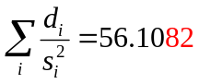 and 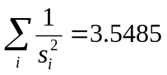, so:
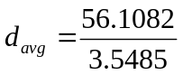 Mpc = 15.81 Mpc (30%)

- The uncertainty (rms):
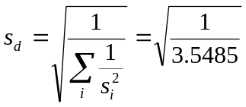 Mpc = 0.53 Mpc
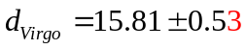 Mpc (10%)
- Hubble constant
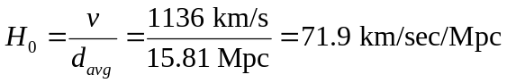 (15%)
Uncertainty:
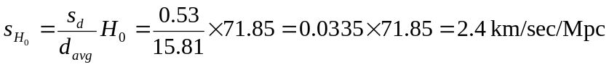 (15%)
Hubble constant: 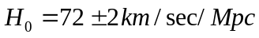 (5%)

- Hubble time:
(20%)
Uncertainty is 3.35% which is 0.45 Gyr. (5%)

II. Determination of stellar masses in a visual binary system

1 | 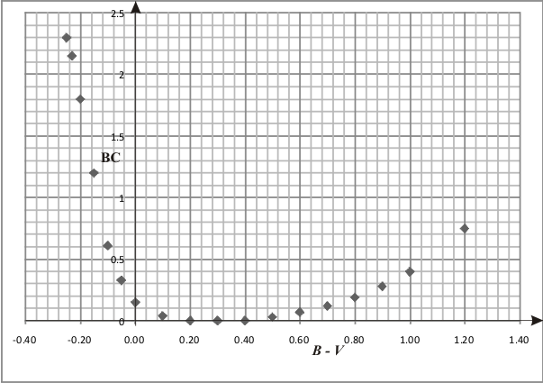 | (20%)

2. | 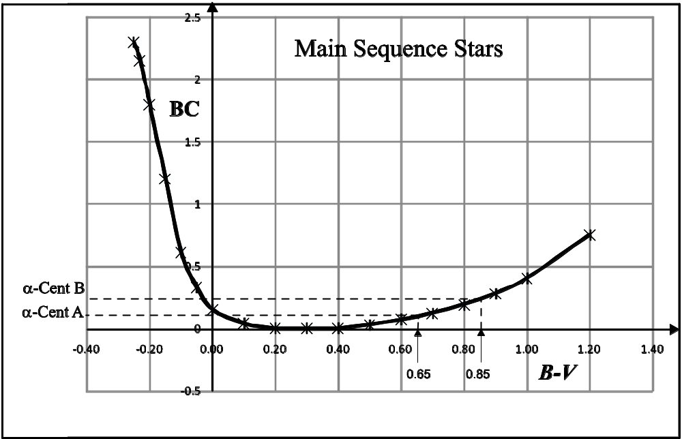
 | - For α Cen. A. , its colour index is given by B - V = 0.65. Then, by taking the line that intersecting the above curve we find BC = 0.10.  - For α Cen. B. , its colour index is given by B - V = 0.85. Then, by taking the line that intersecting the above curve we find BC = 0.25.  From the relation m_{v} – m_{bol} = BC it is then obtained,  - For α Cen. A, m_{v} = -0.01 , we get m_{bol} = -0.01 – 0.10 = -0.11  - For α Cen. B, m_{v} = 1.34, we get m_{bol} = 1.34 – 0.25 = 1.09 | (10%)  (10%)  (10%)  (10%)
3. | Periodic orbit of α Centauri star is P =79.24 years and its angle of semi major axis is α = 17.59”. From the result 2a we find that the apparent bolometric magnitude of α Centauri A is m_{bolA} = -0.11, while the apparent bolometric magnitude of α Centauri B is m_{bolB} = 1.09. (two decimal places)
1st iteration :
 | Step 1 : | Let M_{A} and M_{B} be the mass of Centauri A and Centauri B stars, respectively. Then, we firstly take M_{A} + M_{B} = 2
 | Step 2 : | Inserting the values of M_{A} + M_{B}, P, and α to the third Kepler equation namely,  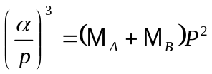  One gets p , that is  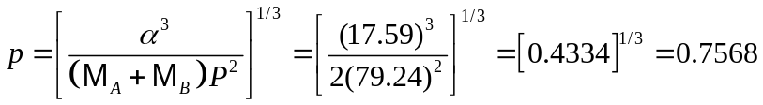″
 | Step 3 : | We determine the magnitude of absolute bolometric using Pogson equation,  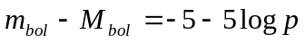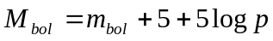  For α Centauri A:  For α Centauri B :  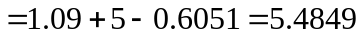
 | Step 4 : | We determine the mass of both stars using luminosity mass relation,  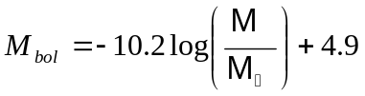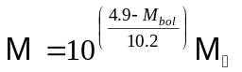  For α Centauri A:  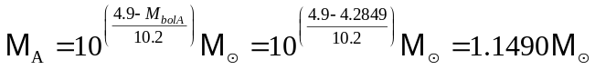  For α Centauri B:  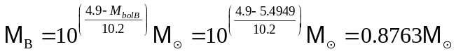 | (30%)
 | 2nd iteration | Repeating the step 1 until 4 and using the previous resulting mass in the first iteration:
 | Step 1 : | M_{A} + M_{B} = 1.1490 + 0.8763 = 2.0253
 | Step 2 : | 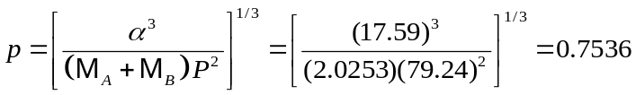
 | Step 3 : | For α Centauri A:  For α Centauri B :
 | Step 4 : | For α Centauri A:  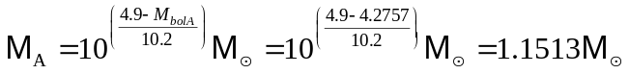  For α Centauri B:  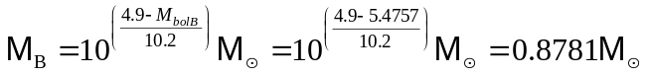 | (10%)
 | 3 ^{rd} Iteration | Repeating the step 1 until 4 and using the previous resulting mass in the second iteration:
 | Step 1 : | M_{A} + M_{B} = 1.1513 + 0.8781 = 2.0294
 | Step 2 : | 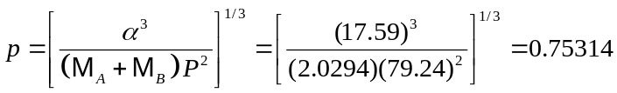
 | Step 3 : | For α Centauri A:  For α Centauri B :
 | Step 4 : | For α Centauri A:  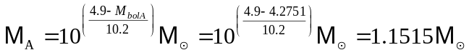  For α Centauri B:  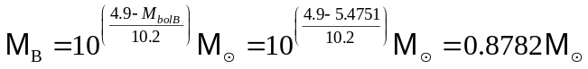 | (0%)
 | 4 ^{th} Iteration | Repeating the step 1 until 4 and using the previous resulting mass in the third iteration:
 | Step 1 : | M_{A} + M_{B} = 1.1515 + 0.8782 = 2.0297
 | Step 2 : | 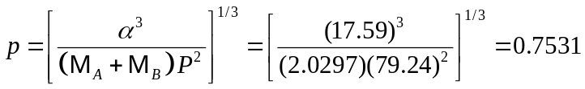
 | Step 3 : | For α Centauri A:  For α Centauri B :
 | Step 4 : | For α Centauri A:  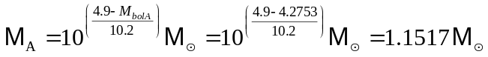  For α Centauri B:  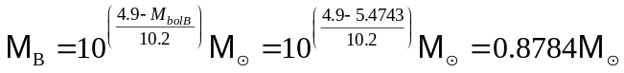 | (0%)
 | 5 ^{th} Iteration | Repeating the step 1 until 4 and using the previous resulting mass in the fourth iteration:
 | Step 1 : | M_{A} + M_{B} = 1.1517 + 0.8784 = 2.0301
 | Step 2 : | 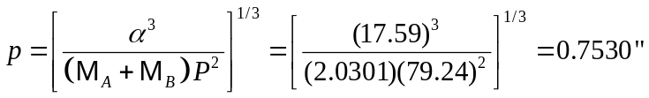
 | Step 3 : | For α Centauri A:  For α Centauri B :
 | Step 4 : | For α Centauri A:  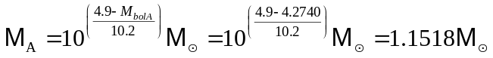  For α Centauri B:  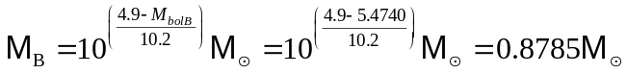 | (0%)

The results of the fifth iteration equal the results of the fourth iteration, so
The mass of α Centauri A : M_{A} = 1.1518 M
The mass of α Centauri B : M_{B} = 0.8785 M

III. The Age of Meteorite

- From N(t) = N₀ exp (-λt) and D(t) = N₀ - N(t), then we have

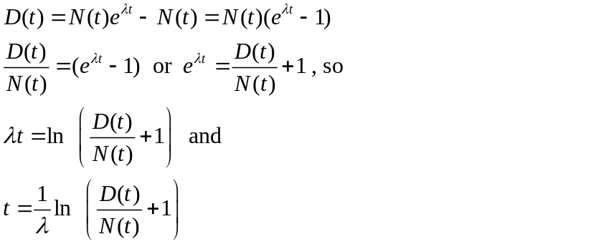(10%)

- Setting N(t) = N₀, we get:

t_{1/2} = ln 2/λ = 48.8 × 10⁹ year = 48.8 Gyr
(5%)

3. We know that 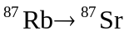, and taking the ratios 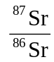 as y (dependent variable) and 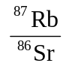as x (independent variable), we can use a simple linier regression equation:

y = a + bx

Taking into account the initial strontium, the corresponding equation is

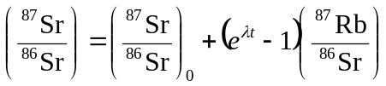
where the intercept a =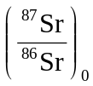;
and the slope b = 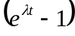 (20%)

4. First, take the ratios:

Sample No | Meteorite type | ⁸⁶Sr (ppm) | ⁸⁷Rb (ppm) | ⁸⁷Sr (ppm) | ⁸⁷Rb/⁸⁶Sr | ⁸⁷Sr/⁸⁶Sr
1 | A | 29.6 | 0.3 | 20.7 | 0.0101351 | 0.6993243
2 | B | 58.7 | 68.5 | 44.7 | 1.1669506 | 0.7614991
3 | B | 74.2 | 14.4 | 52.9 | 0.1940701 | 0.712938
4 | A | 40.2 | 7.0 | 28.6 | 0.1741294 | 0.7114428
5 | A | 19.7 | 0.4 | 13.8 | 0.0203046 | 0.7005076
6 | B | 37.9 | 31.6 | 28.4 | 0.8337731 | 0.7493404
7 | A | 33.4 | 4.0 | 23.6 | 0.1197605 | 0.7065868
8 | B | 29.8 | 105.0 | 26.4 | 3.5234899 | 0.885906
9 | A | 9.8 | 0.8 | 6.9 | 0.0816327 | 0.7040816
10 | B | 18.5 | 44.0 | 15.4 | 2.3783784 | 0.8324324
And we compile the data into Type A and B:

Type A

Sample No | ⁸⁷Rb/⁸⁶Sr (X) | ⁸⁷Sr/⁸⁶Sr (Y) | XY | X² | Y²
1 | 0.0101351 | 0.6993243 | 0.0070877 | 0.0001027 | 0.4890545
4 | 0.1741294 | 0.7114428 | 0.1238831 | 0.030321 | 0.5061509
5 | 0.0203046 | 0.7005076 | 0.0142235 | 0.0004123 | 0.4907109
7 | 0.1197605 | 0.7065868 | 0.0846212 | 0.0143426 | 0.4992649
9 | 0.0816327 | 0.7040816 | 0.0574761 | 0.0066639 | 0.4957309
Sum: | 0.4059623 | 3.5219431 | 0.2872916 | 0.0518425 | 2.4809121

Λ | 1.42E-11
 | 0.0811925
 | 0.7043886
SS_{xx} | 0.0188814
SS_{yy} | 9.54601E-05
SS_{xy} | 0.0013364
b_{A} | 0.0707786
a_{A} | 0.6986419

where,
SS_{xx} : sum of square for X = 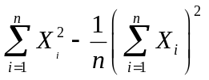
SS_{yy} : sum of square for Y = 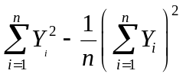

SS_{xy} : sum of square for both X and Y =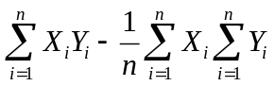

and the slope
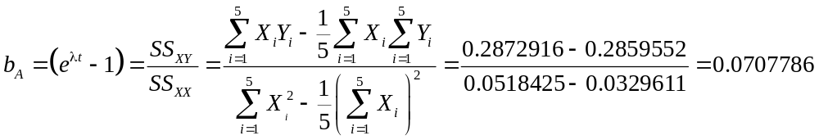 (*)
and the intercept
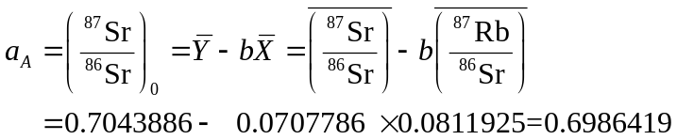

The scatter plot and linier regression line for Type A is:
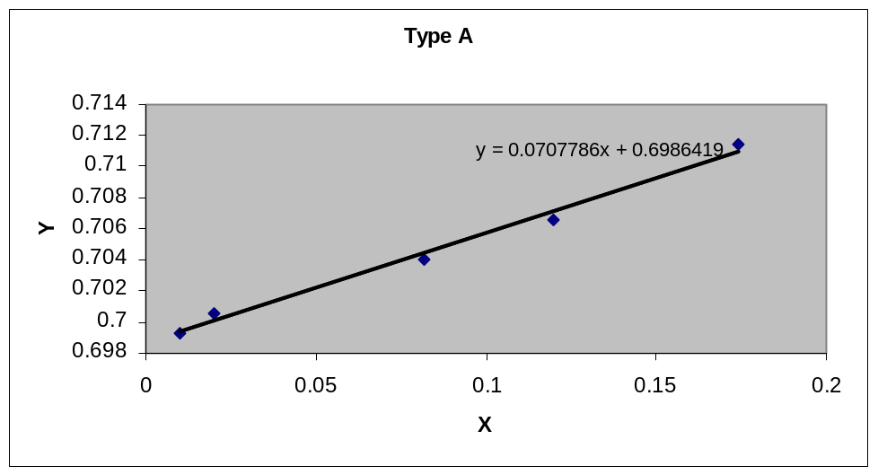
(20%)

Type B

Sampel No | ⁸⁷Rb/⁸⁶Sr (X) | ⁸⁷Sr/⁸⁶Sr (Y) | XY | X² | Y²
2 | 1.1669506 | 0.7614991 | 0.8886318 | 1.3617737 | 0.5798809
3 | 0.1940701 | 0.7129380 | 0.1383599 | 0.0376632 | 0.5082806
6 | 0.8337731 | 0.7493404 | 0.6247799 | 0.6951776 | 0.561511
8 | 3.5234899 | 0.8859060 | 3.1214808 | 12.4149811 | 0.7848294
10 | 2.3783784 | 0.8324324 | 1.9798392 | 5.6566838 | 0.6929437
Sum: | 8.0966621 | 3.9421159 | 6.7530916 | 20.1662794 | 3.1274456

λ | 1.42E-11
 | 1.6193324
 | 0.7884232
SS_{xx} | 7.0550920
SS_{yy} | 0.019390046
SS_{xy} | 0.3694955
b_{B} | 0.0523729
a_{B} | 0.7036141

and the slope b_{B} = =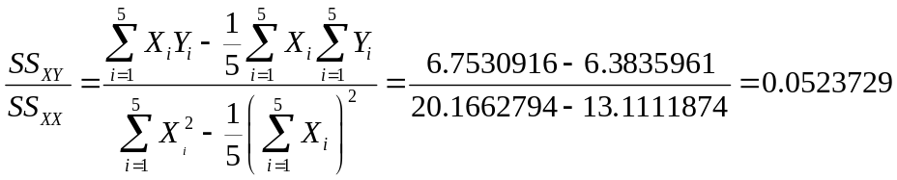
and the intercept
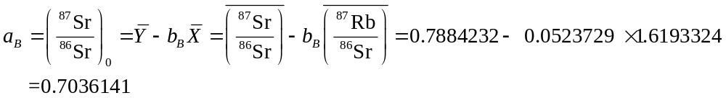

The scatter plot and linier regression line for Type B is:

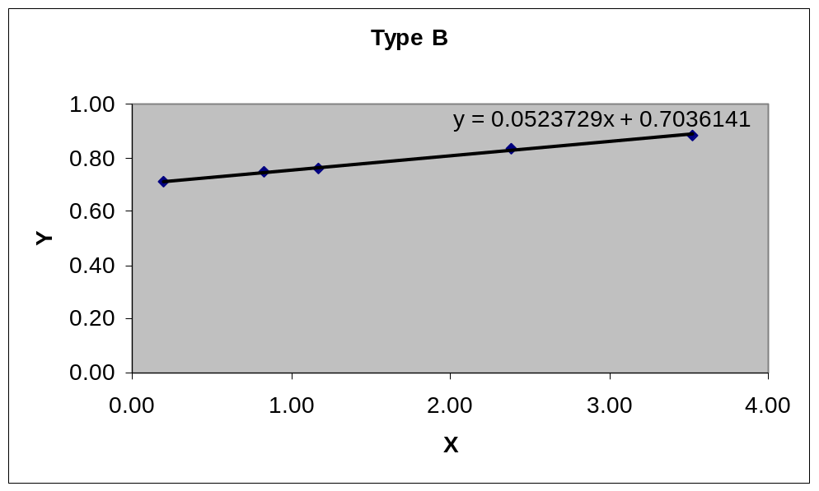

(20%)
Note: Until this point (of part III) needs 78 minutes

5. Since we have 2 types of meteorites, then we have to calculate their ages separately, and λ = 1.42 × 10⁻¹¹. As b = , then e^{λt} = b+1.
After we get a and b then
which is 4.81592 × 10⁹ year

From (*), we obtain

s_{b} | 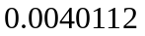
s_{a} | 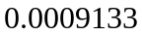
e_{t} | 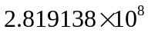
sigma-b :
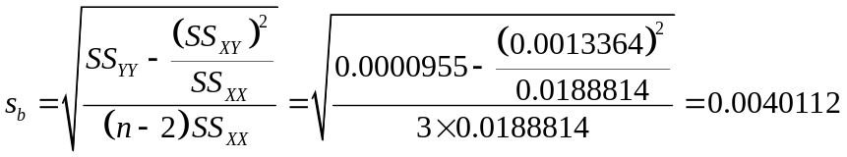
error on t : 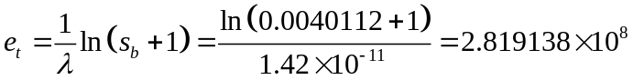

sigma-a (error on initial) :
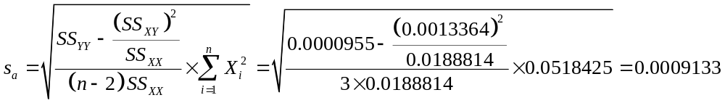

Type B

Similar as in Type A, we obtain for Type B, in which t = 3.595×10⁹ year.

s_{b} | 0.0013487
s_{a} | 0.0060566
e_{t} | 94915372.7530205
sigma-b :
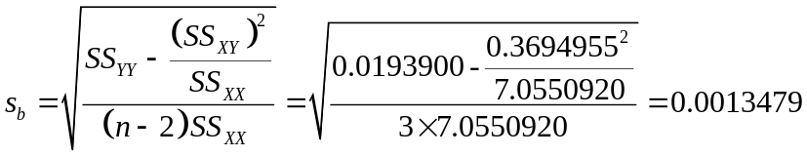
error on t : 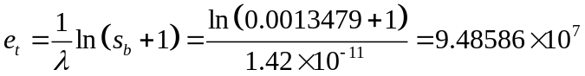
sigma-a (error on initial) :
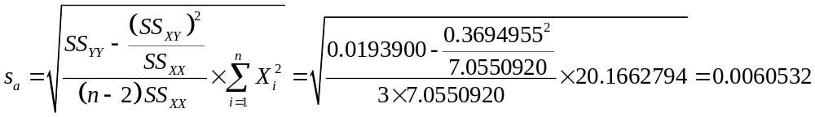

The Age of type A = (4.816 ± 0.282) × 10⁹ year = 4.816 ± 0.282 Gyr
The Age of type B = (3.595 ± 0.095) × 10⁹ year = 3.595 ± 0.435 Gyr
Hence, the type A is much older than the type B.
(20%)

6. The initial value of type A (⁸⁷Sr/⁸⁶Sr)₀ = 0.6986419 ± 0.0009133
The initial value of type B (⁸⁷Sr/⁸⁶Sr)₀ = 0.7036141 ± 0.0060532 (5%)

