**UNIVERSITY OF DAR-ES-SALAAM**



COLLEGE OF INFORMATION AND COMMUNICATION TECHNOLOGY

(COICT)

DEPARTMENT OF COMPUTER SCIENCE AND ENGINEERING

IS 335: FINAL YEAR PROJECT 2019/2020

MID-SEMISTER PROJECT REPORT

**PROJECT TITLE: CDE INFORMATION MANAGEMENT SYSTEM**

**NAME: SIMON ELIZABETH E**

**REGISTRATION NUMBER: 2017-04-07373**

**DEGREE PROGRAMME: BSC WTH COMPUTER SCIENCE**

**SUPERVISOR: Ms. ZAITUNI KAIJAGE**

**SIGNATURE: ………………**

**DATE: AUGUST 7, 2020**

# **DECLARATION**

I SIMON ELIZABETH E with registration number 2017-04-07373. I declare that, this report is the outcome of my own work that I undertake at CDE and has been prepared by myself to fulfill the curricular requirements accordance with the Regulations of the University of Dar-es-Salaam and has not been presented to any other University for examination either in Tanzania or overseas.

**STUDENT NAME: ………………………………………………**

**SIGNATURE: …………………**

**SUPERVISOR’S NAME: ……………………………………….**

**SIGNATURE: …………………**

# **ACKNOWLEDGEMENT**

I would like to thanks my almighty God, who giving me power and energy from the start up to the end of this report.

I would like to thank my supervisor Ms. Zaituni Kaijage for the guidance throughout the project progress, I am really grateful for her support and encouragement towards me.

Also, more thanks to Ms. Merina Marcelino to take a time to explain me more about CDE, guidelines and data collection so as to accomplish this report.

Moreover, I do appreciate the effort made by CDE students including Laura Mandari, Salmon Nicholas and ticky Marcus but few to mention for their explanation during my research so as to fulfill this report.

Also, more thanks to Mr. Robin Kalimwenjuma and Mr. Henry for their technical support.

Thanks all.

# **ABSTRACT**

Challenge driven education (CDE) is an education method which intends to enable university students to identify problems in the communities and find different solutions, aimed at enhancing a scalable working skills such as problem solving and team collaboration skills. Globally it started in Sweden at KHT Royal Institute of Technology School of Engineering and Management and later spread to different countries including Tanzania in different universities such as University of Dar es Salaam at college of information and communication technology (COICT).

Along of good work done by CDE in college of information and communication technology (COICT), there is no platform for an awareness of CDE, also there is no place to keep their records of their projects reports, attendance reports, also there is no area for challenge owner to put or upload their challenges, no place to facilitate communication for challenge owner who works with CDE, currently they still use the paperwork and social media to conduct their processes which is traditional way of doing management processes.

In this period of advancement of science and technology, development of web based application is needed, so as to keep track of all CDE information management processes, the system module is made of the combination of four modules, which work with collaboration with each other and make it beneficial to accomplish the main scheme. There are students, supervisors, challenge owners and coordinator modules. Firstly the system offer management of student reports, storage for projects reports, area for students to confirm of FYP, formulates a team for CDE students, student attendance and publications such as news, events.

Secondly, a system provides the chance for different challenge owners or companies to do registration and submitting their challenges. Also provide interface of challenge owner who’s willing to work with CDE so as to facilitate communicating toward each other, and also for challenge owner to view status of their projects.

Lastly system provides means that will store records of organizations and CDE organization visitors for future use. This is having an interface of registering visitors or sponsors, their details will be stored directly in the database, for easy accessibility once the information is needed.

**TABLE OF CONTENTS**

**DECLARATION** i

**ACKNOWLEDGEMENT** ii

**ABSTRACT** iii

**LIST OF FIGURES** vii

**LIST OF TABLES** viii

**CHAPTER ONE: INTRODUCTION** 1

1.0: GENERAL INTRODUCTION 1

1.1: STATEMENT OF THE PROBLEM 2

1.2: PROJECT OBJECTIVES 2

1.2.1: MAIN OBJECTIVE; 2

1.2.2: SPECIFIC OBJECTIVES 3

1.3: SIGNIFICANCE OF THE PROJECT 3

1.4: SCOPE AND LIMITATION OF THE PROJECT 3

1.5: ORGANIZATION OF THE REPORT 3

**CHAPTER TWO: LITERATURE REVIEW** 5

**CHAPTER 3: METHODOLOGIES** 6

**CHAPTER 4: SYSTEM ANALYSIS AND DESIGN** 8

4.1: REQUIREMENT SPECIFICATIONS 8

4.1.1: FUNCTIONAL REQUIREMENTS 8

4.1.2: NON-FUNCTIONAL REQUIREMENTS 8

4.1.3: DOMAIN REQUIREMENTS 9

4.2: SYSTEM DESIGN 9

4.2.1: USE CASE DIAGRAM 9

4.2.2: CLASS DIAGRAM 16

4.2.3: DATA FLOW DIAGRAMS 17

4.2.4: SEQUENCE DIAGRAM 18

4.2.5: ENTITY RELATION DIAGRAM 19

**CHAPTER 5: IMPLEMENTATION AND TESTING** 20

5.1: SYSTEM IMPLEMENTATION 20

5.2: SYSTEM TESTING 28

**CHAPTER 6: CONCLUSION AND RECOMMENDATION** 31

6.1: CONCLUSION 31

6.2: MAPPING ON HOW IMPLEMENTATION SATISFIES PROJECT SPECIFIC OBJECTIVES 31

6.3: RECOMMENDATION 31

REFFERENCES 32

APPENDICES 33

**LIST OF ABBREVIATIONS**

|  |  |
| --- | --- |
| COICT | College of Information and Communication Technology |
| CDE | Challenge Driven Education |
| HTTP | Hypertext Transfer Protocol |
| PC | Personal Computer |
| SIDA | Swedish international development cooperation agency |
| UDSM | University of Dar-es-salaam |
| ERD | Entity relationship diagram |
| PT | Practical training |
| FYP | Final year project |
| LMS | Learning management system |
| DLAB | Data lab |
| ERD | Entity relationship diagram |
| DFD | Data flow diagram |

# **LIST OF FIGURES**

Figure 1: Agile Development Software Model 7

Figure 2: use case diagram of coordinator and supervisor modules. 9

Figure 3: Class diagram of coordinator and supervisor module for CDE management platform. 16

Figure 4: DFD Diagram context level for supervisor and coordinator module of CDE management platform. 17

Figure 5: DFD Diagram 0 level for supervisor and coordinator module. 17

Figure 6: sequence diagram for CDE information management system. 18

Figure 7: sequence diagram for generate attendance report process in CDE information management system. 18

Figure 8: ERD for CDE information management system. 19

Figure 9: CDE information management system database implementation. 20

Figure 10: snapshot of user table with attributes. 20

Figure 11: login interface of CDE information management system. 21

Figure 12: coordinator homepage interface. 22

Figure 13: snapshot of coordinator to view projects progress. 22

Figure 14: snapshot of coordinator to fill schedule. 23

Figure 15: supervisor homepage interface. 24

Figure 16: snapshot of supervisor view a team. 24

Figure 17: snapshot of supervisor to view report and leave comment. 25

Figure 18: snapshot of supervisor to fill project’s progress. 25

Figure 19: snapshot of student attendance report. 26

Figure 20: snapshot of user controller. 27

Figure 21: snapshot of user table. 27

Figure 22: snapshot of user model. 28

Figure 23: snapshot of view to create new user in code. 28

Figure 24: snapshot of testing login page. 29

Figure 25: testing create user interface in coordinator module. 30

Figure 26: snapshot for testing add challenge interface. 30

Figure 27: Gantt chart for the CDE information management system. 33

# **LIST OF TABLES**

Table 1: use case description for authenticate users. 11

Table 2: case description for create, edit and delete users. 11

Table 3: use case description for view and send comments. 12

Table 4: use case description for formulate a team. 12

Table 5: use case description for student’s attendance. 13

Table 6: use case description for view weekly and final report. 13

Table 7: use case description for plan and schedule. 14

Table 8: use case description for attendance report. 14

Table 9: use case description for display uploaded challenge. 15

Table 10: use case description for view project status and completion rate. 15

Table 11: use case description for Register and view challenge and sub challenge. 16

Table 12: table for project budget. 33

# **CHAPTER ONE: INTRODUCTION**

## 1.0: GENERAL INTRODUCTION

Challenge Driven Education (CDE) is an area where university graduates can contribute so as to come up with different solutions to societal problems that are trans-disciplinary. The role of the university in society development is creation of new knowledge.CDE started in Sweden at KHT Royal Institute of Technology School Of Engineering and Management. It was started in 1827 and later introduced into different countries around the world at different universities including University of Dar es salaam (COICT) in Tanzania. Tanzania and Sweden have a far-reaching collaboration within research through funding from the Swedish international development cooperation agency (SIDA), UDSM and KTH have been collaborating for many years, and from 2016 CDE has been one of the joint areas of research (kht.diva-portal.org)

CDE involve four entities, firstly students who brainstorm to get solutions of a certain problem, secondly challenge owner who own a challenge, thirdly supervisor that is a teacher who supervises students until tackle a different perfect solutions, and lastly is coordinator who monitor all activities at CDE. Paper work is not efficient way to organize the documents because data may be lost, also tend to Lack of Bridge to facilitating communication. Up to now CDE encounters challenge to find a challenge owner which is costful, and leads to getting challenge owners who are not fully interested to work together with them, so can make complication in collaboration so as to get a solution, for instance last year DAWASA gave CDE difficulties.

Solution is development of web based application to handle different activities done at CDE also create awareness so as people to know about CDE and will facilitate for challenge owners to mention their challenges and which is like request to work with CDE and this will make easier for CDE rather than before, and also system will manage all paperwork process of CDE such as formulate team and perform student attendance.

CDE information management system after completion of its development will serve the following issues: -

1. Reduce cost associated with paper work.
2. It will increase and facilitate to get challenge owner
3. Less time consuming compared to traditional way because having records stored in the databases will make it easier whenever we need a backup from the previous executed documents.

## 1.1: STATEMENT OF THE PROBLEM

CDE has been facing the challenge of lack of awareness, not all people know about CDE, they have to seek for challenge owners or companies to work with. There is no efficient way to backup their records, for instance if there is a project done by previous students and it came up to current students want to continue with that project, a backup is an issue. Also there is no public area to facilitate communication between CDE stakeholders. Currently they still use the paperwork and social media to conduct their process which is traditional way of doing management processes.

This system comprises with four modules and solved as a team, according division of work as a team my modules is coordinator and supervisor.

The problems which face CDE at COICT according to supervisor and coordinator modules are;

1. Lack of awareness about CDE.
2. Lack of centralized reports tends to missing of backward reports.
3. Lack of efficient way to handle all activities done in CDE such as performing CDE student attendance, forming groups according a certain challenge, project status completion.
4. Lack of record’s storage of challenge owners, sponsors, students, supervisors and coordinators.
5. Lack of public area to facilitate communication.

## 1.2: PROJECT OBJECTIVES

This project has a main objective which is also divided into a couple of specific objectives

### 1.2.1: MAIN OBJECTIVE;

The main objective of this project is to eliminate paper work based on CDE activities by designing and implementing a web based application to manage all activities done at CDE and provide an awareness of CDE.

### 1.2.2: SPECIFIC OBJECTIVES

The following are the specific objectives according to my module;

1. To specify requirements of the system.
2. To design and implement the database system.
3. To design and develop a CDE coordinator and supervisor module.
4. To integrate modules to form one system.
5. Testing the implemented system.

## 1.3: SIGNIFICANCE OF THE PROJECT

A supervisor and coordinator modules has the following significances;

1. Help to create awareness about CDE.
2. It helps to increase efficient of CDE activities such as tracking of project status and completion rate, performing attendance and stored on the database.
3. Facilitates the communication between coordinator and challenge owner, likewise between student and supervisor.
4. The supervisor will be able to monitor what the students have been done and their progress on project.
5. The projects will altogether be managed centrally.

## 1.4: SCOPE AND LIMITATION OF THE PROJECT

Since, this project will be accessible to all CDE stakeholders through mobile and web interfaces, therefore internet connection will be necessary for it to work.

The project will enable implementation of software projects but not hardware projects. The hardware projects will be able to use the platform when simulating the hardware components by use of simulation software or visualization software but then the actual implementation is physically on the components.

## 1.5: ORGANIZATION OF THE REPORT

This report is divided into four major sections that include introduction, literature review, methodologies, system analysis and design and implementation and testing.

The Introduction chapter is further divided into general introduction, problem statement, objectives, and significance of the project and scope of the project.

In the general introduction of this report, the important things behind the need for the project are explained and the current situation is discussed. The problem is defined in the problem statement section. In this section, it is shown that this project solves a problem that is important for the CDE coordination team. The objectives of this project both main and specific objectives are stated in the objectives section. The impact of the project is discussed in the significance of the project section. In the scope section deliverables, features, functions, tasks and deadlines of the project are discussed.

In the Literature review chapter, there are more information about existing related systems that have been proposed and developed, were discussed and the need for this project is established.

In the Methodologies chapter, explain the methods used and to be used to collect the requirements. The Software Development Life Cycle is also discussed explaining how this system will be created.

In the analysis and design chapter, explanation about system requirements analysis and show how users can interact with system by using use case diagram and sequence diagram. Show interaction between entity and processes by using DFD as well as well diagram of class diagram and ERD for database purpose.

And finally in implementation and testing chapter, shows how the system works and system testing.

# **CHAPTER TWO: LITERATURE REVIEW**

This chapter consist different reviews on the concept of this project topic. The literature review is done to strengthen the documentation and the guide to challenge driven education. The following section is about the guide concept related in this project.

Today our societies face range of complex challenges, from sustainable development to high population and the well-being in our societies, prior the KHT Royal Institute of Technology believed that universities around the world can share a large pool of young, creative, curious students that can make impact within the societies university and can contributes solutions to societal problems for sustainable development, so along of all that came with challenge driven education,(kht.diva-portal.org).

Although there is no existing system but there some related system as CDE work such as DLAB and LMS UDSM which work the same like this project for some parts, also there are related guides about CDE which help me to know more about CDE and how to implement this platform.

DLAB is a center of activity, connecting data revolution to national priorities, global commitment and diverse programs and investments. It allows community engagement in their system likewise in CDE; it allows challenge owners to engage in the system. Also publications about the projects, goals, updating news and events so as students and challenge owners can see, so as to know more about CDE before joining or start working with CDE, also store projects and have more details about that projects and all this is done at DLAB center.

LMS UDSM it is learning management system that makes easily communication between lectures and students, lectures can upload notes and other learning materials, calendar and schedules about his or her course and students can down­­­load notes and other learning materials and view calendar and schedules, likewise to this system but in different way.

CHALLENGE DRIVEN EDUCATION guide it explains more details about CDE from when it started and how widely used internationally. This guide includes the objectives of this CDE organization, ambition, role of CDE, also a fully history about CDE and how the CDE organization works, so this guide provides more knowledge about this field.

# **CHAPTER 3: METHODOLOGIES**

Methodologies used in CDE management system are:

1. Data collection

During requirement gathering, I conducted data collection through interviewing CDE students, CDE coordinator. The main case study area for this project is the CDE at College of Information and Communication technology (COICT), UDSM.

The aim of interviewing students is to obtain information about CDE and specifically what they do. Also aim that researching on what are the expectations of the students in order to incorporate them in the design of the system.

Interviews to CDE coordinator aim to obtain more information about CDE and understanding the technology in deep as it is a new technology.

Also the data collection through reading different documentations which guide about challenge driven education (CDE)

1. Agile Methodology

In this project Agile methodology is used, this methodology will help the CDE team to add some increment to the project because this methodology allows the customers, developers and testers to constantly interact with each other.

The reason for choosing Agile Methodology is to breakdown the big project into small parts of user functionalities, prioritizing them and then continuously delivering them in couples of week cycle called iterations. The performance is measured by customer at the end of iteration, the lessons learned in iterations are captured back and used in future iteration, in this way the CDE platform is constantly improved and the process of the developing are also improved.

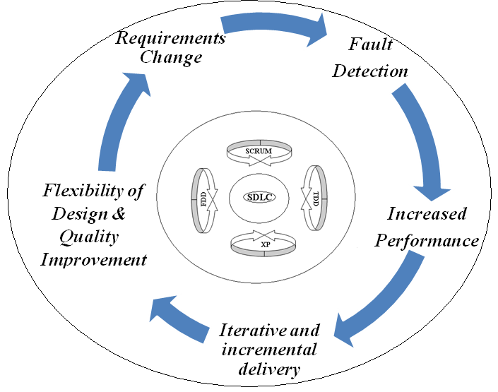

Figure 1: Agile Development Software Model

1. Visual studio code tool

Another tool used in implementation as text editor for running codes. It is cross platform which work on different operating systems but for me I am going to use it on windows operating system.

The advantages of using this text editor are;

1. It is intelliSense for programming language, it provide JavaScript, blade, HTML, CSS and sass and all of this language are used.
2. Integrated version control (Built-in-Git) which makes easily to commit work into repository after debugging.
3. Side by side editing on different files sometimes I need to refer one file’s code for another file, it makes easily by allowing opening side by side editor.

# **CHAPTER 4: SYSTEM ANALYSIS AND DESIGN**

## 4.1: REQUIREMENT SPECIFICATIONS

This section explains the system more on the requirements analysis which include functional and non functional requirements as well as domain requirements

### 4.1.1: FUNCTIONAL REQUIREMENTS

1. Authenticate users
2. Register and view identified challenge
3. Send and view comments
4. Create and view plans/schedule
5. Create/add and remove system users
6. Fill attendance and generate report
7. Display attendance reports
8. Display weekly and final reports
9. Formulate team
10. Display project status and completion rate
11. Display uploaded challenge

### 4.1.2: NON-FUNCTIONAL REQUIREMENTS

1. Security:

The system will provide security of data and privacy of information.

1. Performance:

System will allow ensuring an output in time, time from task started to task ended, hence high performance to keep track different activities.

1. Usability:

System will be easy to use, learn, adapt and become skillful while using it.

1. Reliability:

The system will be available and guarantee no inconvenient waiting time.

### 4.1.3: DOMAIN REQUIREMENTS

1. User of the system must first log in the system in order to perform all operations
2. Since CDE management platform is the web system, the server must be set up to host a database. Also, the system must be able to be accessed in all devices without deteriorating user experience.
3. The database must be backed up every time to ensure the safety of data store in case the original database gets failures.
4. The system must be able to be accessed in all web browsers without changing the appearance of some features.
5. The system must be able to adapt update capabilities for the future technology changes.
6. More than one user will be able to access system simultaneously without any contradiction.
7. Users must have an internet connection in order to access the contents of the system.

## 4.2: SYSTEM DESIGN

This section shows design of the system. It also explains the functionalities of the system that interact with the user as well as processes within a system and database architecture.

### 4.2.1: USE CASE DIAGRAM

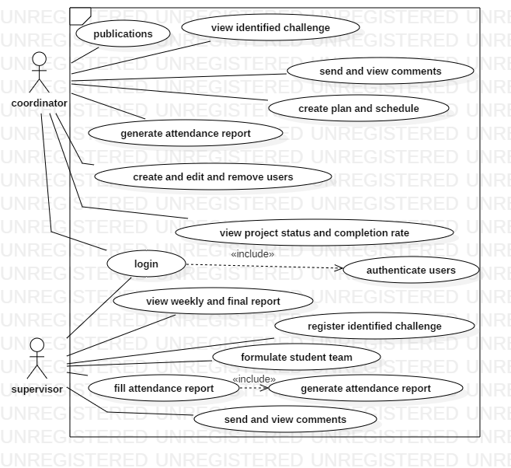

Figure 2: use case diagram of coordinator and supervisor modules.

|  |  |
| --- | --- |
| USE CASE No. | 1 |
| USE CASE TITLE | Authenticate users |
| ACTOR | Coordinator and Supervisor |
| INITIAL ASSUMPTIONS | * Users of the system must have username and password. * Users must supply their credentials to the system so that they can be authenticated. |
| SUCCESS CRITERIA | * Users will successfully have logged in. |
| WHEN SOMETHING GOES WRONG | * In case the something goes wrong; the supervisor and coordinator will be notified to check if he or she is connected to the internet and refresh the browser. * Also, users will be notified to recheck their login credential if are correct and re-type again. * If the problems persist, users will be notified to recover their password and logging again. |

Table 1: use case description for authenticate users.

|  |  |
| --- | --- |
| USE CASE NO. | 2 |
| USE CASE TITLE | Create ,Edit and remove user |
| ACTOR | Coordinator |
| INITIAL ASSUMPTION | * A coordinator able to create a new user and assign default password, also user can be edited incase some information is wrong and user can be removed |
| SUCCESS CRITERIA | * Coordinator successfully create user, edit and delete a certain user |
| WHEN SOMETHING GOES WRONG | * In case user failed to be added, edited, removed check if connected to the internet and refresh the browser. |

Table 2: case description for create, edit and delete users.

|  |  |
| --- | --- |
| USE CASE NO. | 3 |
| USE CASE TITLE | View and send comments |
| ACTOR | Supervisor and Coordinator |
| INITIAL ASSUMPTION | * A Supervisor has to view and send comments according student’s team report * Coordinator has to view and send comments from different CDE stakeholders |
| SUCCESS CRITERIA | * A coordinator and supervisor will view and send the comments |
| WHEN SOMETHING GOES WRONG | * In case the system fails to view and send the comment he or she supposed to check if connected to the internet and refresh the browser. |

Table 3: use case description for view and send comments.

|  |  |
| --- | --- |
| USE CASE NO. | 4 |
| USE CASE TITLE | Formulate Team |
| ACTOR | Supervisor |
| INITIAL ASSUMPTION | * The Supervisor has to formulate a group of students as team |
| SUCCESS CRITERIA | * The students will be formulated into several groups in which they will work as a Team. |
| WHEN SOMETHING GOES WRONG | * In case the Supervisor fail to Formulate a team, he or she must check if that student is registered as CDE students in coordinator module |

Table 4: use case description for formulate a team.

|  |  |
| --- | --- |
| USE CASE No. | 5 |
| USE CASE TITLE | Fill and view student attendance |
| ACTOR | Supervisor and Coordinator |
| INITIAL ASSUMPTIONS | * An attendance will be added to the system so as supervisor to fill the punctuality of the students * And generated by coordinator |
| SUCCESS CRITERIA | * Attendance will be successfully displayed to the system. |
| WHEN SOMETHING GOES WRONG | * In case the something goes wrong; the supervisor will be notified to check if he/she is connected to the internet and refresh the browser. |

Table 5: use case description for student’s attendance.

|  |  |
| --- | --- |
| USE CASE No. | 6 |
| USE CASE TITLE | view weekly and final report |
| ACTOR | Supervisor |
| INITIAL ASSUMPTIONS | * A weekly and final reports uploaded by student will be viewed by a supervisor in the system |
| SUCCESS CRITERIA | * All this reports will be viewed in the supervisor module in the system. |
| WHEN SOMETHING GOES WRONG | * In case the something goes wrong; the student will be notified to check if he/she uploads a formatted file. |

Table 6: use case description for view weekly and final report.

|  |  |
| --- | --- |
| USE CASE No. | 7 |
| USE CASE TITLE | Create plan and schedule |
| ACTOR | Coordinator |
| INITIAL ASSUMPTIONS | * A coordinator create or upload a plans or schedule of activities in the system |
| SUCCESS CRITERIA | * Coordinator will create plans successfully and viewed by students and supervisor in the system. |
| WHEN SOMETHING GOES WRONG | * In case the something goes wrong; the coordinator will be notified to check if he/she is connected to the internet and refresh the browser. |

Table 7: use case description for plan and schedule.

|  |  |
| --- | --- |
| USE CASE No. | 8 |
| USE CASE TITLE | attendance report |
| ACTOR | System |
| INITIAL ASSUMPTIONS | * A system should track attendance filled by supervisor and list of students with their status will be displayed to the system. |
| SUCCESS CRITERIA | * Attendance report will be successfully displayed to the system. |
| WHEN SOMETHING GOES WRONG | * In case the system failed to generate attendance report, the system will set timeout in case a generate attendance report failed for the particular range of time, then the system will resend it again. |

Table 8: use case description for attendance report.

|  |  |
| --- | --- |
| USE CASE No. | 9 |
| USE CASE TITLE | Display uploaded challenge |
| ACTOR | coordinator |
| INITIAL ASSUMPTIONS | * After challenge uploaded to the system a coordinator will be able to see and approve if accepted or rejected. |
| SUCCESS CRITERIA | * Challenge will be displayed successful to the system and approved by coordinator |
| WHEN SOMETHING GOES WRONG | * In case the something goes wrong; a coordinator will be notified to check if he/she is connected to the internet and refresh the browser. |

Table 9: use case description for display uploaded challenge.

|  |  |
| --- | --- |
| USE CASE No. | 10 |
| USE CASE TITLE | View project status and completion rate |
| ACTOR | Coordinator |
| INITIAL ASSUMPTIONS | * A coordinator should see an project status and completion rate of the projects within a system in his/her user interface |
| SUCCESS CRITERIA | * A project status charts will be shown and capture the rate completion of the projects |
| WHEN SOMETHING GOES WRONG | * In case the something goes wrong; a coordinator will be notified to check if he/she is connected to the internet and refresh the browser. |

Table 10: use case description for view project status and completion rate.

|  |  |
| --- | --- |
| USE CASE No. | 11 |
| USE CASE TITLE | Register and view challenge and sub challenge |
| ACTOR | Supervisor |
| INITIAL ASSUMPTIONS | * A Supervisor should able to register challenge and sub challenge in the system |
| SUCCESS CRITERIA | * Challenges and sub challenges will be successfully displayed to the system and stored on database. |
| WHEN SOMETHING GOES WRONG | * In case the something goes wrong; a supervisor will be notified to check if he/she is connected to the internet and refresh the browser. |

Table 11: use case description for Register and view challenge and sub challenge.

### 4.2.2: CLASS DIAGRAM

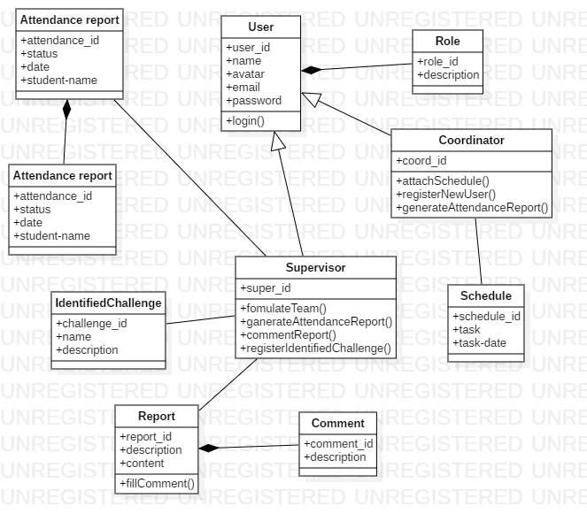

Figure 3: Class diagram of coordinator and supervisor module for CDE management platform.

### 4.2.3: DATA FLOW DIAGRAMS

* **Context level diagram**

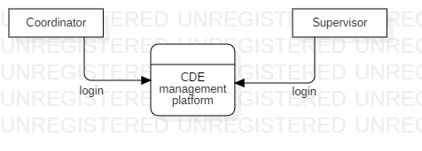

Figure 4: DFD Diagram context level for supervisor and coordinator module of CDE management platform.

**Level 0 diagram**

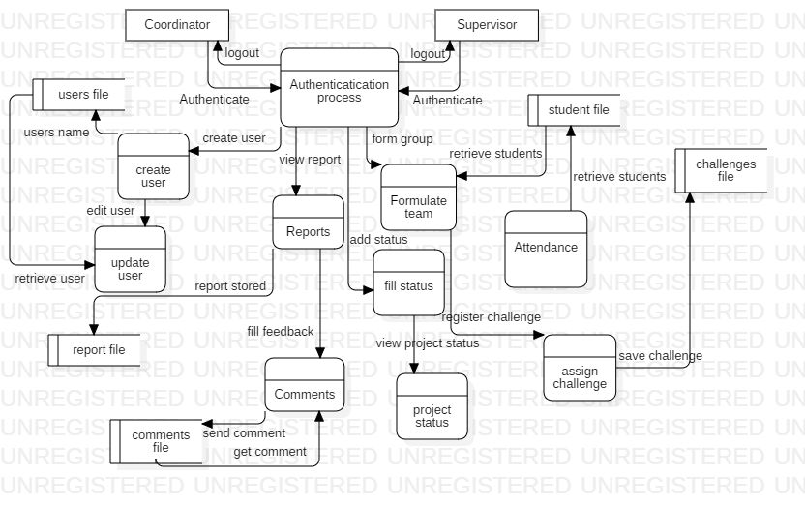

Figure 5: DFD Diagram 0 level for supervisor and coordinator module.

### 4.2.4: SEQUENCE DIAGRAM

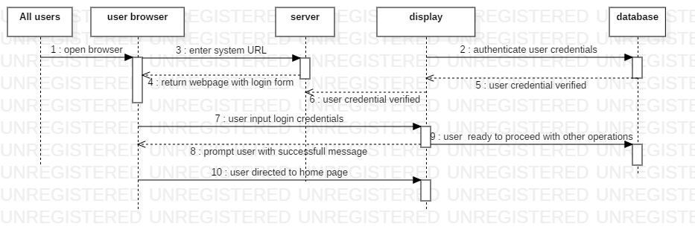

Figure 6: sequence diagram for CDE information management system.

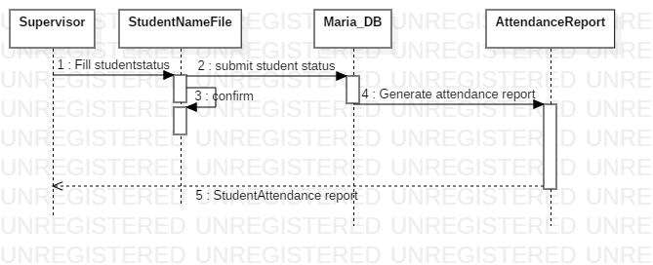

Figure 7: sequence diagram for generate attendance report process in CDE information management system.

### 4.2.5: ENTITY RELATION DIAGRAM

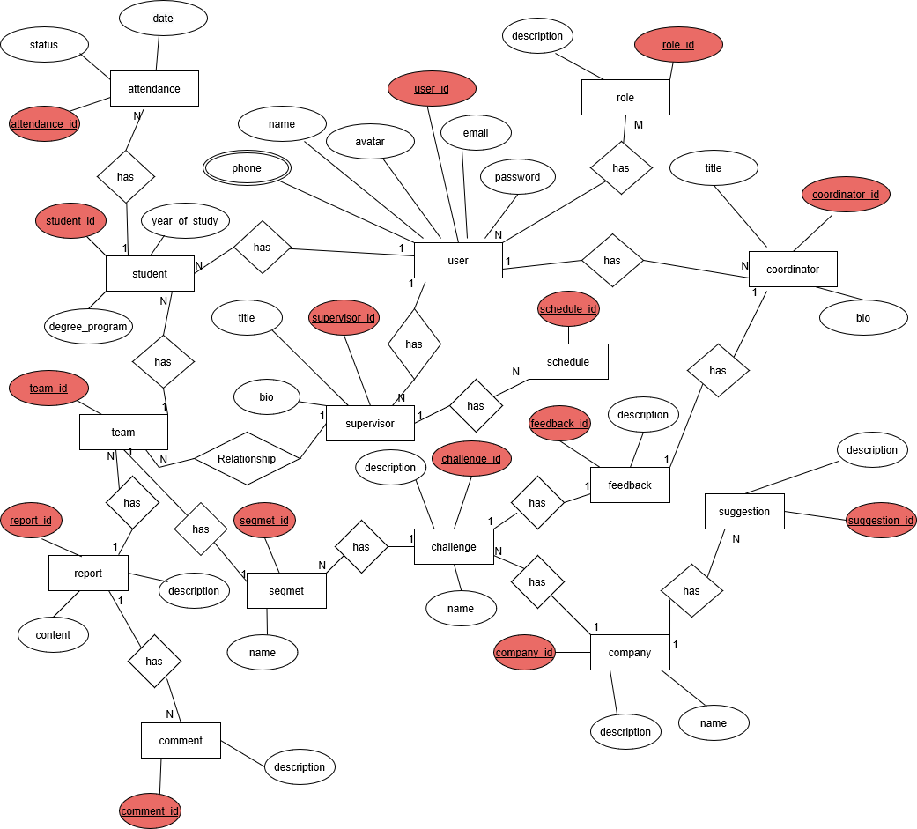

Figure 8: ERD for CDE information management system.

# **CHAPTER 5: IMPLEMENTATION AND TESTING**

In this chapter describes implementation and testing done so far to coordinator and supervisor modules in CDE information management system.

## 5.1: SYSTEM IMPLEMENTATION

After database design here is the snapshot of database implementation of whole CDE information management system corresponding tables with attributes inside.

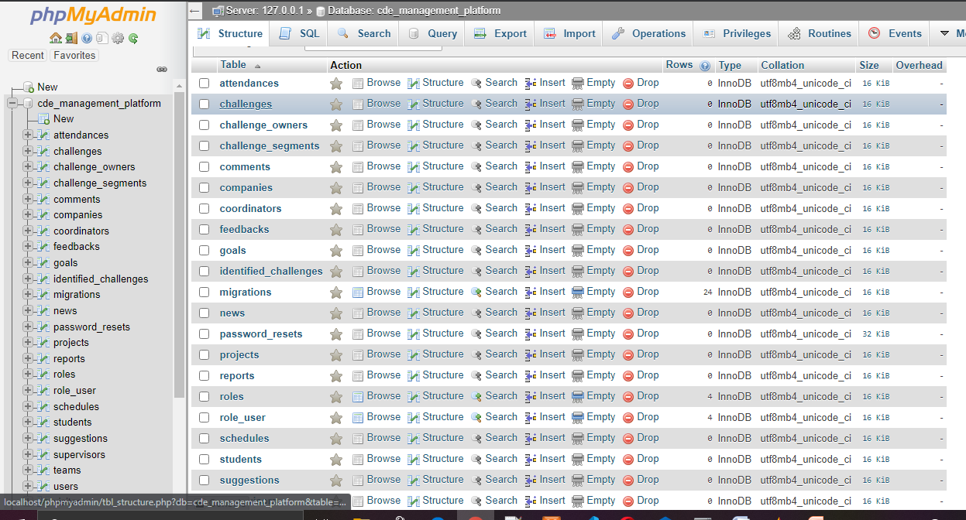

Figure 9: CDE information management system database implementation.

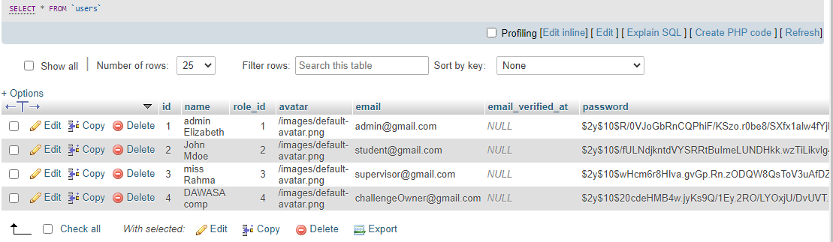

Figure 10: snapshot of user table with attributes.

A login page capable to make authentication if user have right access in the system through it credentials. If a user is already registered, the system will direct the user to specific home page according his or her role and permissions given.

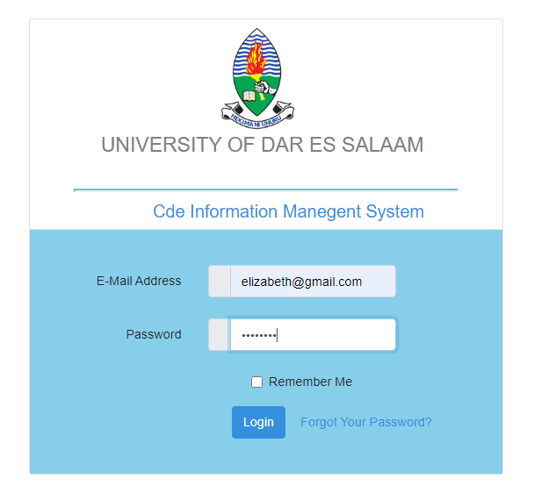

Figure 11: login interface of CDE information management system.

Coordinator user interface shows the users who are registered in the database, also show a registration of new user, also this module see details about registered user, coordinator can delete or edit registered user, another parts in this module there is interface for viewing progress of the projects, module can add schedule or plans in weekly and can update every week, also can view registered challenges, new incoming challenge uploaded by challenge owner and can receive notifications after challenge owner upload a challenge. Coordinator can see attendance of students and preview his or her profile.

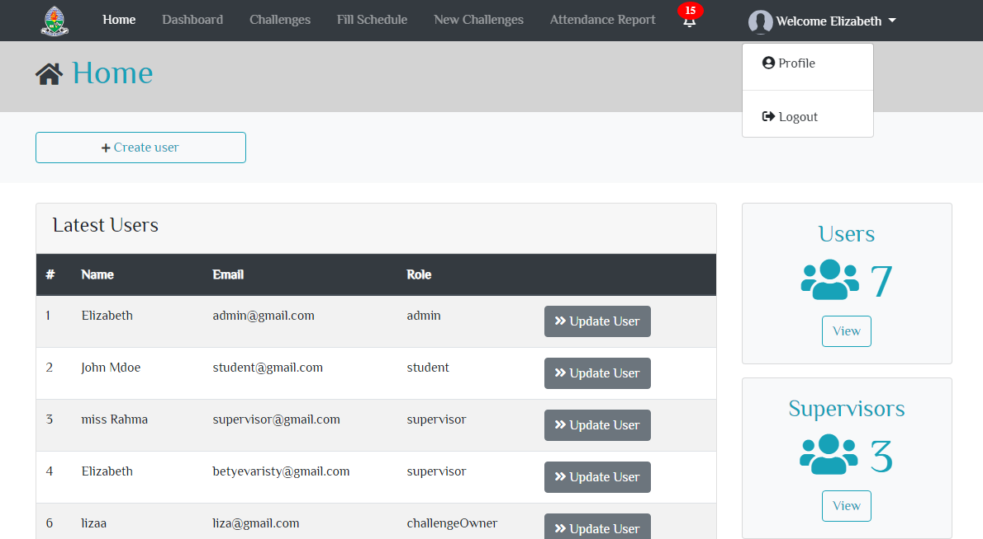

Figure 12: coordinator homepage interface.

A snapshot of dashboard interface capture the progress of the projects done by CDE, the chart shows a task with status and percentage of that status.

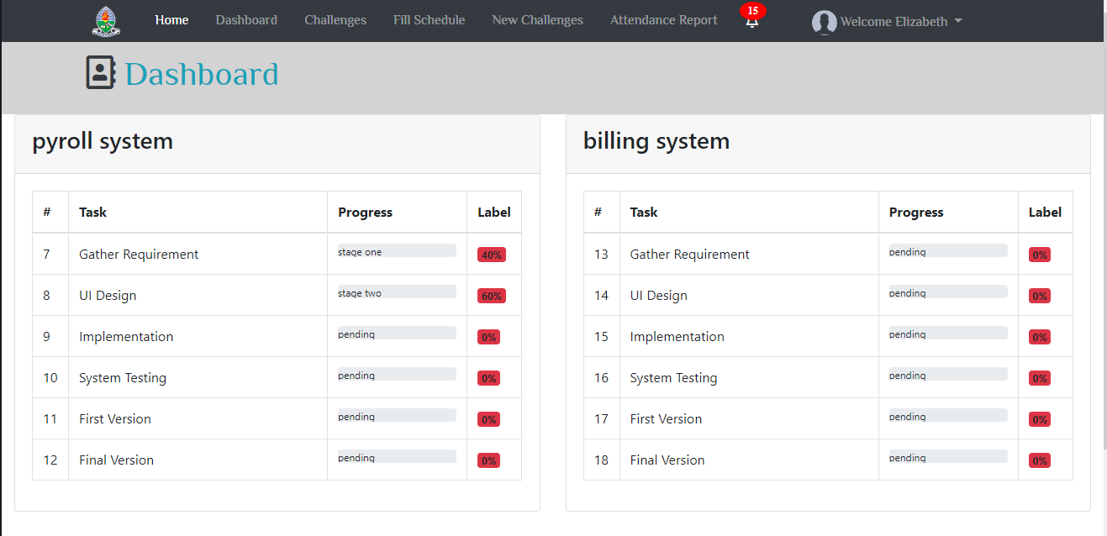

Figure 13: snapshot of coordinator to view projects progress.

Below is the time schedule which coordinator fills for the plans or schedule or timetable of events of CDE per day.

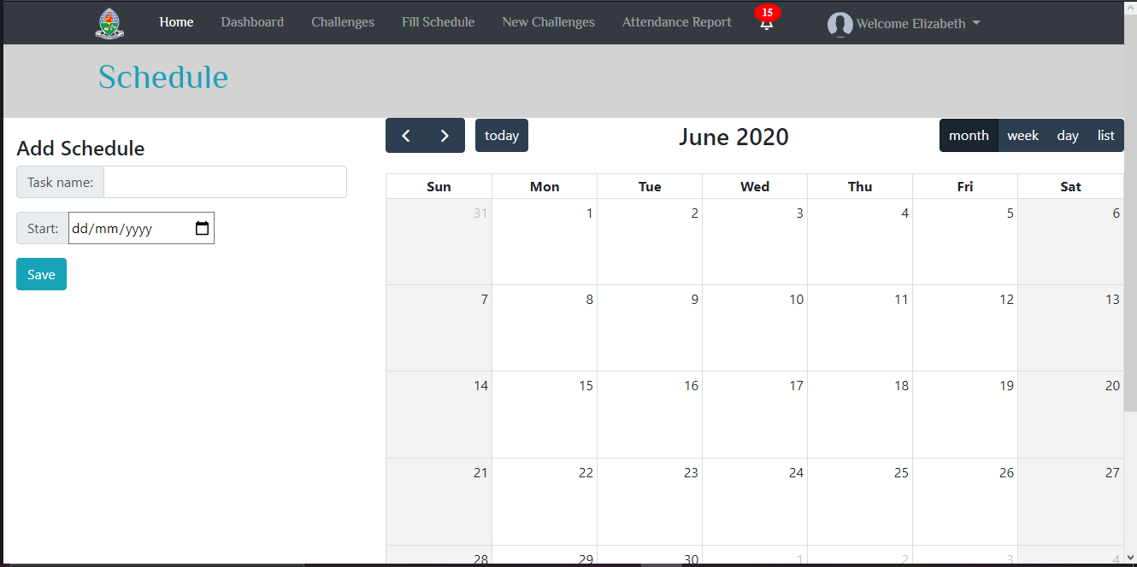

Figure 14: snapshot of coordinator to fill schedule.

Supervisor interface includes home page interface which register a challenge and sub challenge. Also supervisor create teams of the students and add sub challenge to a certain team.

Supervisor can view students reports and make a comments on a report, also can fill students attendance to be captured to the database, lastly supervisor fill performance or progress of the projects according reports so as coordinator to capture projects status.

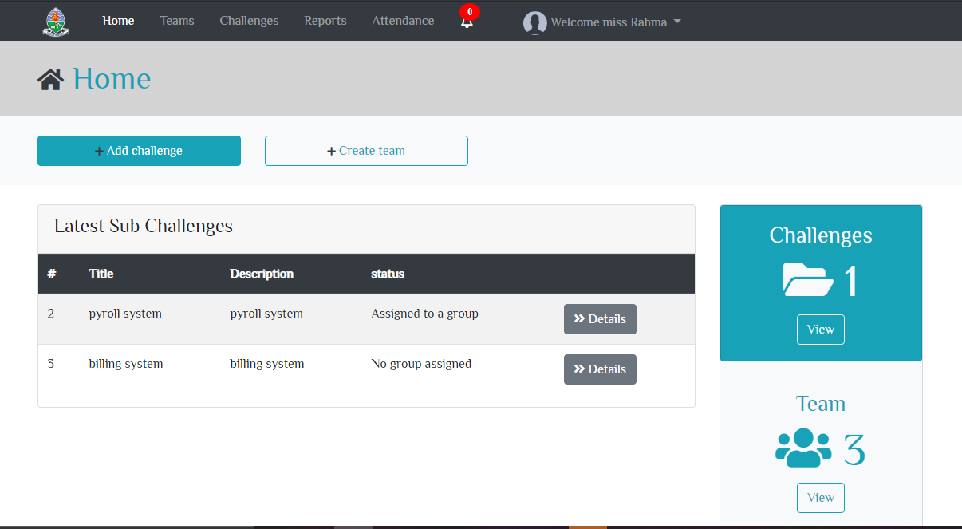

Figure 15: supervisor homepage interface.

A snapshot which shows lists of team registered in the database with team name and supervisor name, a supervisor can add students to a certain team and also can view more details about that team, also there an interface show incoming notification for alert that there is a new report uploaded by a student.

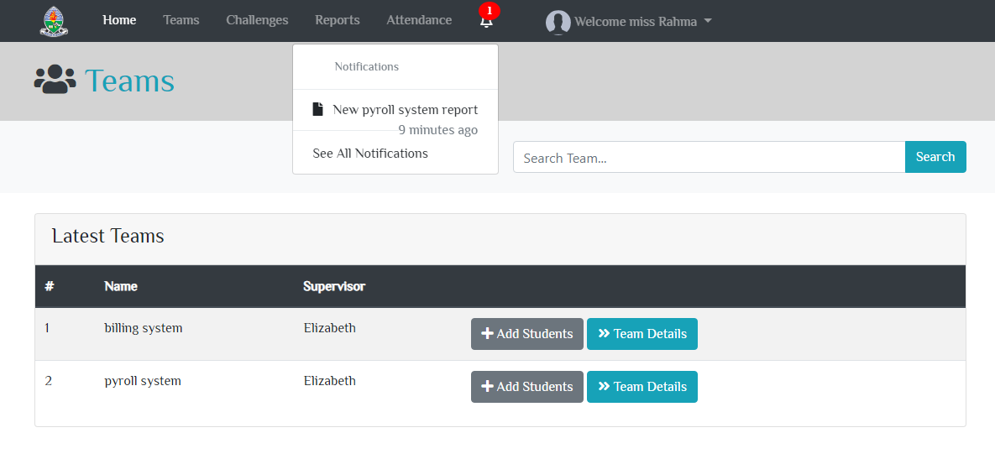

Figure 16: snapshot of supervisor view a team.

Below is another snapshot which shows an interface of incoming report from students, a supervisor can add comments to that report.

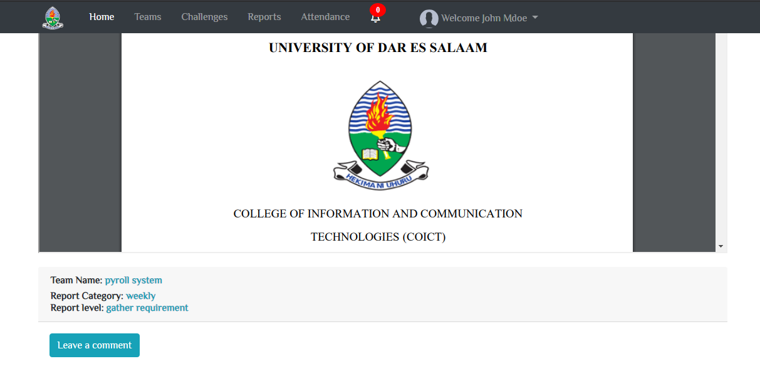

Figure 17: snapshot of supervisor to view report and leave comment.

Below is the snapshot which allow a supervisor to fill a progress of different projects according tasks which have many status, a project task status can be pending, stage one, stage two, stage three and completed.

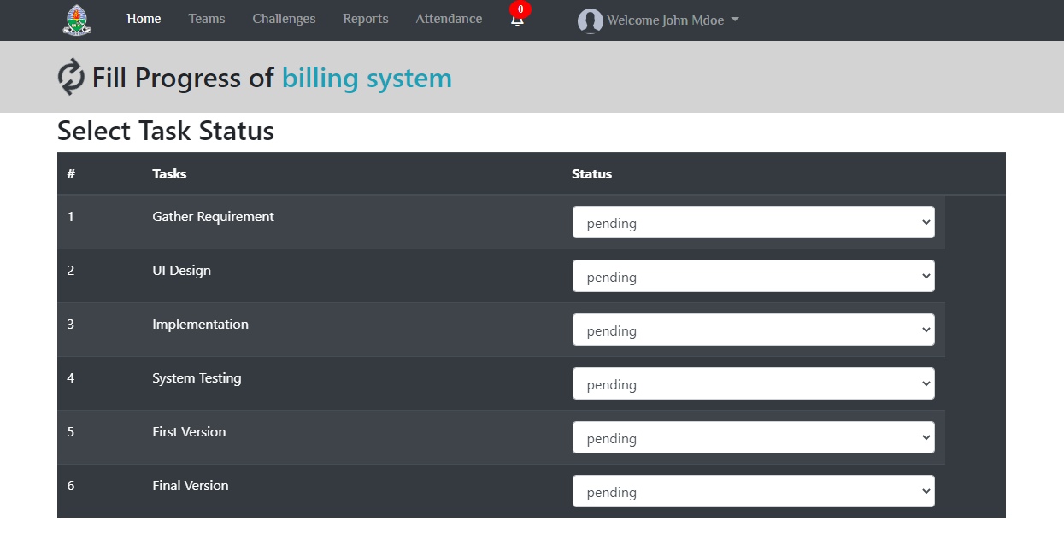

Figure 18: snapshot of supervisor to fill project’s progress.

Also this system generate different reports for instance project’s progress report which can be generated per day, also registered user report for the whole year as well as attendance student report per date.

The following below is the snapshot of student attendance report

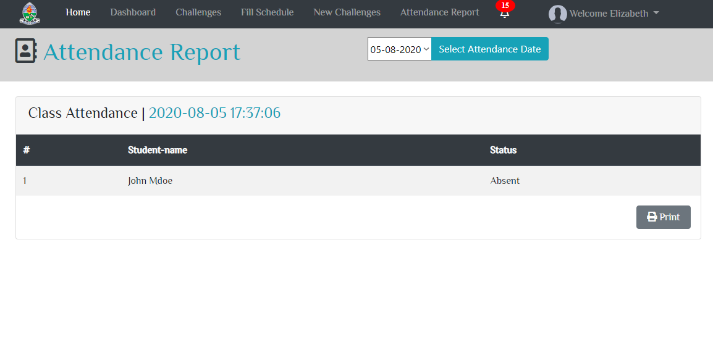

Figure 19: snapshot of student attendance report.

In coding section the MVC architecture used; model, view, controller for connecting frontend and backend, here user implementation in frontend and backend of this module.

Below is a snapshot of user Controller which includes all logic of user and makes connection between user view and model. First function is post user function which is capable to create or add user to the database with fields of name, email and role of the user, after user created returns successful message.

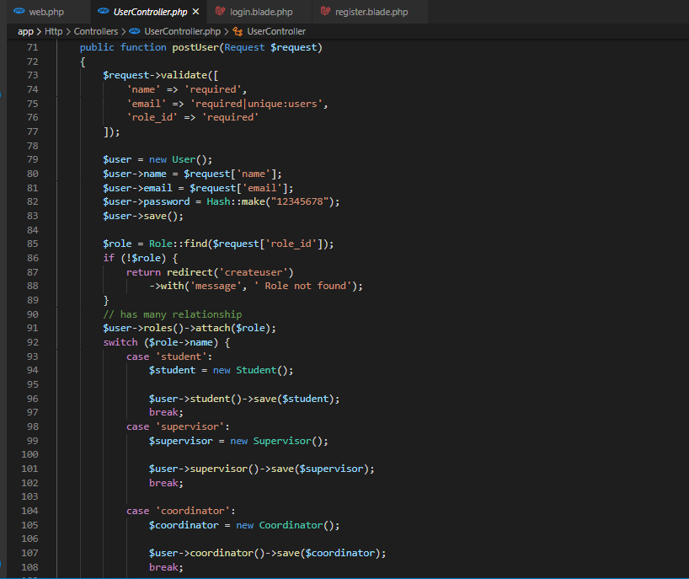

Figure 20: snapshot of user controller.

The following below is the snapshot of user migration or table which includes it attributes.

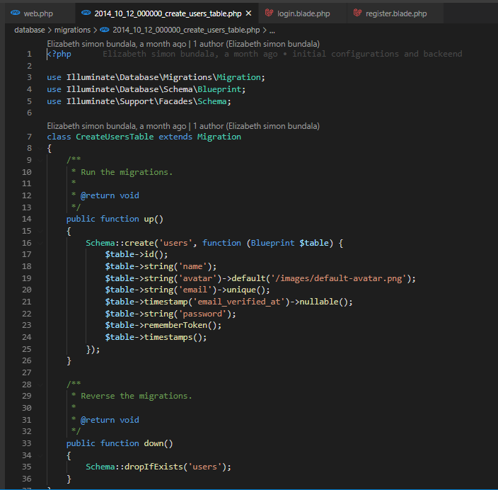

Figure 21: snapshot of user table.

The following below show a model which path our user data from user migration to a database and vice versa

## C:\Users\Eliza\Desktop\Capture.PNG

Figure 22: snapshot of user model.

The following below is the snapshot of view which shows code to create new user into a database

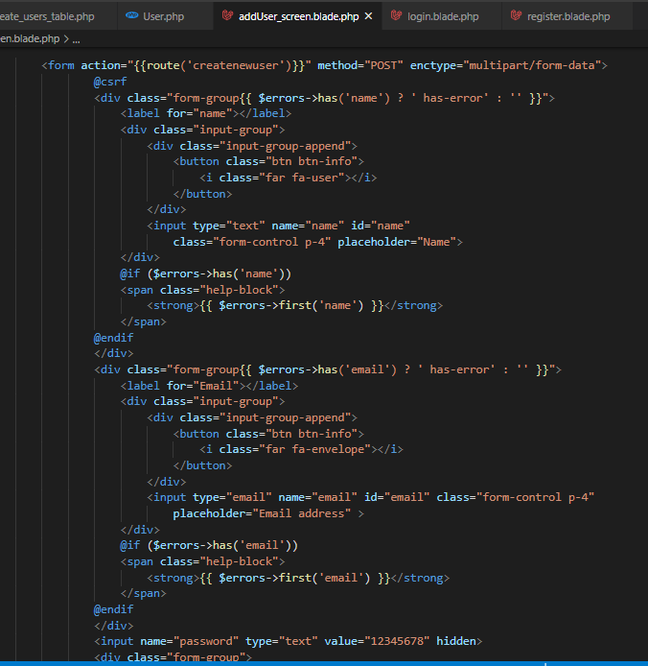

Figure 23: snapshot of view to create new user in code.

## 5.2: SYSTEM TESTING

A testing done in different area in the system, the following below are some of them.

Demonstration of the system prompts a user to enter the correct fields again in case the entry is invalid. This goes for emails and passwords. The login button will respond only after all fields are valid.

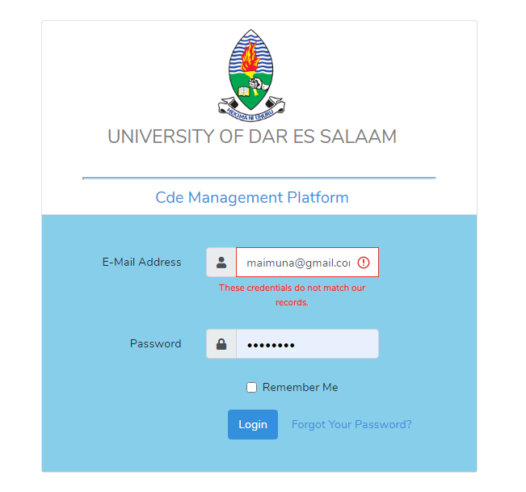

Figure 24: snapshot of testing login page.

Also testing done if coordinator tries to add a new user to database and if the user is stored successful in the database, a popup menu of successful message will appear after submitting a form.

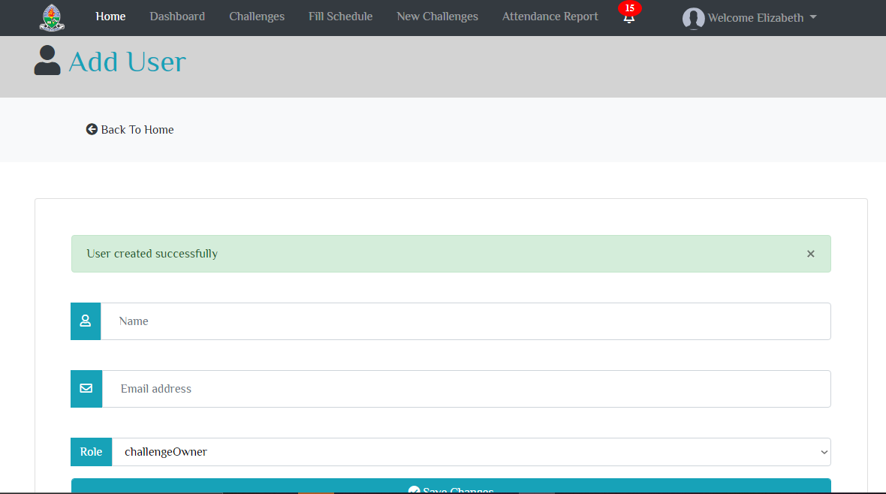

Figure 25: testing create user interface in coordinator module.

Also testing done, if a supervisor tries to delete a sub challenge to a system and when a supervisor click a delete button, a popup menu with caution message will appear to allow either deleting a sub challenge or canceling delete action.

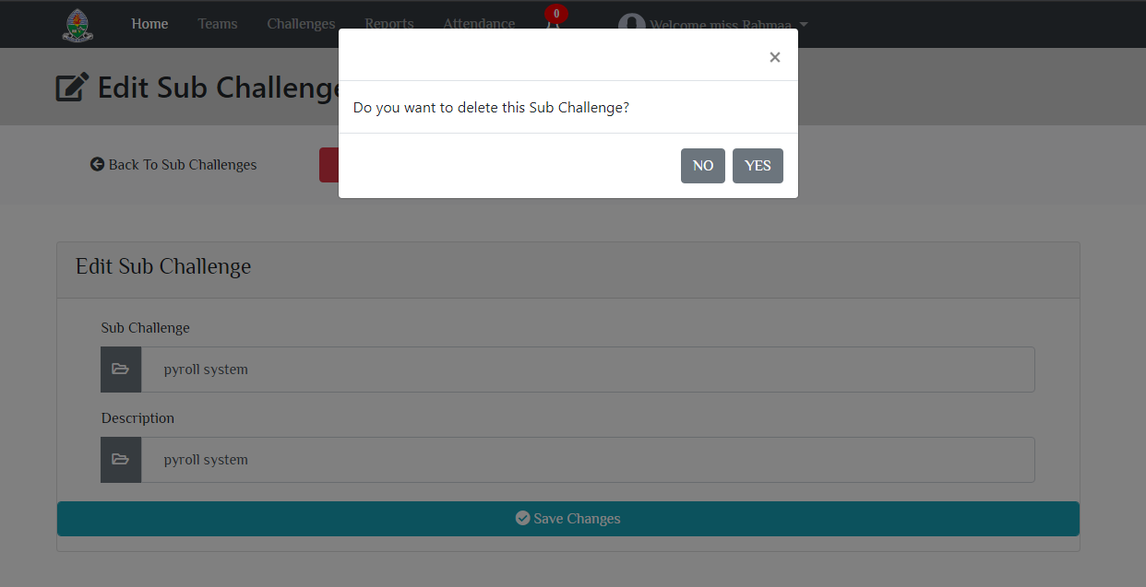

Figure 26: snapshot for testing add challenge interface.

# 

# **CHAPTER 6: CONCLUSION AND RECOMMENDATION**

## 6.1: CONCLUSION

Generally, this project came as glory for CDE stakeholders, this will manage all processes done by CDE, for instance in this module between CDE coordinator and supervisor a system generate reports, keep track reports, attach schedules, formulation of team and make attendance for CDE students as well as track project status, thus it is a useful project and I hope it is going to be applicable.

**Challenges**

1. The project required too much knowledge which i have never come across practically before. The project scope was also big to mine so as to get something usable.
2. No more existing CDE systems in locally and globally, it consume time to explore.
3. Integration of the project with my other project members made many completions.

## 6.2: MAPPING ON HOW IMPLEMENTATION SATISFIES PROJECT SPECIFIC OBJECTIVES

In implementation I archive some field of specific objectives starting from data gathering and analysis, also I already design and implemented CDE management database system, and analysis of requirements and designing, also finally end up with system implementation and system testing.

## 6.3: RECOMMENDATION

The core subjects that reflect about project management and programming which will be applied with the finalist students in the implementations of the projects should be emphasized on earlier levels of undergraduate studies, so as to make easy for the students in the implementations of their final year projects.

# REFFERENCES

Ian Sommerville. (2006). Software Engineering (8th ed.) .Addison-Wesley Longman, Incorporated.

Kht.diva-portal.org

Web version of this guide:https://www.kth.se/social/group-to-challenge-d/

<https://www.researchgate.net/publication/309423487_Guide_to_challenge_driven_education>

<https://www.kth.se/social/group/guide-to-challenge-d/>

<https://www.draw.io/>

<https://lms.udsm.ac.tz>

<https://dlab.or.tz>

# APPENDICES

APPENDEX A: PROJECT BUDGET

|  |  |  |  |  |
| --- | --- | --- | --- | --- |
| **S/N** | **ITEM QUANTITY** | **UNIT COST** | | **COST** |
| 1 | Internet bundles | 2,000 | | 30,000 |
| 2 | Printing and binding | 4,000 | | 8,000 |
| 3 | others | |  | 10,000 |
| TOTAL | | | | 48,000 |

Table 12 : table for project budget.

APPENDEX B: TIME SCHEDULE

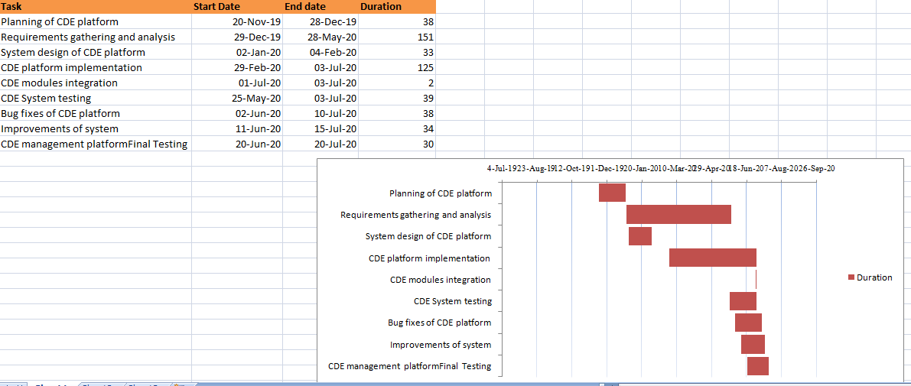

Figure 27: Gantt chart for the CDE information management system.