**UNIVERSITY OF DAR ES SALAAM**



**COLLEGE OF INFORMATION AND COMMUNICATION TECHNOLOGIES**

**(CoICT)**

**DEPARTMENT OF COMPUTER SCIENCE AND ENGINEERING**

**IS 335: FINAL YEAR PROJECT 2019/2020**

**SEMESTER II FINAL PROJECT REPORT**

**PROJECT TITLE**: CDE INFORMATION MANAGEMENT SYSTEM

**Student Name: Weston, Baraka (2017-04-07311)- Bsc. In computer science**

**Lead supervisor’s Name: Ms. Zaituni, Kaijage signature……………….**

**Date…………………….**

**August, 2020**

# **Declaration**

I hereby declare that the project report entitled **“**CDE INFORMATION MANAGEMENT SYSTEM**”** submitted to the University of Dar es salaam, College of Information and Communication Technologies, is a record of original work done by me under the guidance and supervision of Ms. Zaituni Kaijage, Assistant Lecturer department of computer science and engineering, and this project work is submitted in the partial fulfillment of the requirements for the award of **bachelor of science in computer science** and has not been presented to this university or any other University for the examination or award of any degree or other similar title to any candidate of any University.

**Weston, Baraka** 2017-04-07311

**Signature…………………….**

**Date………………………….**

# **Acknowledgements**

My gratitude goes to the almighty God who made it possible for me come up with this report from the beginning to the mid of semester 2 in my academic pursuit.

I would like to appreciate my supervisor Ms. Zaituni Kaijage for the guidance, support and encouragements towards me, throughout the progress of this project.

Also, I would like to express my sincere thanks to Ms. Merina Marcelino who is one of the coordinators of the CDE for taking her time to explain more about the CDE and giving opportunity to ask questions for more clarification and obtained data so as to accomplish this project.

Moreover, I would like to appreciate the cooperation shown by CDE students including Laura Mandari, Salmon Nicholous and Ticky Malcus but few to mention for their explanation during research so as to fulfill this project.

I would also like to thank Dr. Joseph Mushi the undergraduate final year project coordinator, Department of Computer Science and Engineering for the help rendered and all his advice to the final year students since the project problem title formed.

# **Abstract**

The Challenge Driven Education (CDE) is a new education method which intends to enable students to identify problems in the communities and find concrete solutions, Aimed at enhancing a scalable working skills such as problem solving and team collaboration skills, globally it started in Sweden at KHT Royal Institute of Technology School of Engineering and Management and later spread to different countries include Tanzania in different universities including University of Dar es Salaam at college of information and communication technology (COICT),

Along of good work done by CDE at college of information and communication technology (COICT) there is no platform for an awareness of CDE, also there is no place to keep their records of their projects, visitors, sponsors, attendance report, events done as well as area for suggestions, feedbacks for an external organization and students, Currently they still use the paperwork and social media to conduct their activities which is tradition way of doing management process.

So in this age of science and technology a development of web based application is needed so as to keep track all CDE processes, the system module is made of the combination of three modules which work with collaboration with each other and make it beneficial to accomplish the main scheme, firstly the system offer management of student reports, events, storage for projects, news as well as formulating a team for CDE students, Secondly provide the chance for the customer to register their challenges and give suggestions about the service provided at CDE, Also, the students who participate in this Organization they can give suggestions due to dissatisfaction or improvement of this organization therefore the CDE coordinator should be aware of the challenges and suggestions received and act to ensure a timely resolution, lastly system provide means that will keep records of those organizations or ordinary people visiting the CDE organization in order to express their challenges or others may be partners for future use.

# Table of Contents

Declaration i

Acknowledgements ii

Abstract iii

List of Abbreviations vi

List of figures vii

List of Tables viii

CHAPTER ONE 1

1.1 BACKGROUND 1

1.2. STATEMENT OF THE PROBLEM 1

1.3. OBJECTIVES OF THE PROJECT 2

1.4. SIGNIFICANCE OF THE PROJECT 2

1.5. SCOPE AND LIMITATION OF THE PROJECT 3

1.6. ORGANIZATION OF THE PROJECT 3

CHAPTER TWO 4

LITERATURE REVIEW 4

CHAPTER THREE 5

METHODOLOGY 6

3.1. OVERVIEW 6

3.2. DATA COLLECTION 6

3.3. SOFTWARE DEVELOPMENT METHODOLOGY 7

3.4. SYSTEM MODULE………………………………………………………………………………………………………………7

CHAPTER FOUR 9

SYSTEM ANALYSIS AND DESIGN 9

4.1. REQUIREMENT ANALYSIS 9

4.1.1. FUNCTIONAL REQUIREMENTS 9

4.1.2.NON-FUNCTIONAL REQUIREMENTS 9

4.2.USE CASE ANALYSIS 10

4.3. SYSTEM DESIGN 12

CHAPTER FIVE 17

SYSTEM IMPLEMENTATION 17

5.1. OVERVIEW 17

5.2. IMPLEMENTATION STRATEGY 17

5.3. SYSTEM COMPONENTS 18

5.4. SYSTEM TESTING…………………………………………………………………………………………………………….25

CHAPTER SIX 27

6.1 CONCLUSION 27

6.2 CHALLENGES…………………………………………………………………………………………………………………………27

6.3 FUTURE WORK TO BE DONE…………………………………………………………………27

REFERENCES 28

APPENDIX 2929

# **List of Abbreviations**

|  |  |
| --- | --- |
| CDE | Challenge Driven Education |
| COICT | College of Information and Communication Technologies |
| DFD | Data flow diagram |
| DLAB | Data Lab |
| ERD | Entity Relationship Diagram |
| FYP | Final Year Project |
| LMS | Learning Management System |
| PC | Personal Computer |
| PT | Practical Training |
| SIDA | Swedish International Development Agency |
| UDSM | University of Dar es salaam |

# 

# **List of figures**

Fig 1. Agile software development methodology ...................................................................6

Fig 2. System modules...............................................................................................................7

Fig 3. use case diagram showing an actor student ...................................................................10

Fig 4. Entity relationship diagram ..........................................................................................14

Fig 5. Diagram showing level 0 or context data flow diagram .............................................. 15

Fig 6. Showing sequence diagram.............................................................................................15

Fig 7. showing the flowchart of the student module…………………………………………17 Fig 8. Login page for student module of the system………………………………………….19

Fig 9. Home page of student module of the system………………………………...................20

Fig 10. Upload report page of student module of the system………………………………….21

Fig 11. Schedule page of student module of the system………………………………………22

Fig 12. Team page of student module of the system…………………………………………23

Fig 13. Challenge page of student module of the system……………………………………23

Fig 14. Profile page of student module of the system…………………………………………24

Fig 15. Change password page of student module of the system…………………………….25

Fig 16. Integration testing of student module and with other modules of the system…………26

# **List of Tables**

Table 1. Showing description of use case upload report………………………………….11

Table 2. showing description of use case view schedule………………………………….11

Table 3. showing description of use case view challenge…………………………………12

Table 4. showing description of use case view team………………………………………12

Table 5. showing description of use case login…………………………………………….12

Table 2. showing description of use case view challenge…………………………………..29

# CHAPTER ONE

INTRODUCTION

## 1.1 BACKGROUND

Challenge Driven Education (CDE) is an area which contribute to come up with different solutions to societal problems that are trans-disciplinary, CDE started in Sweden at KHT Royal Institute of Technology School of Engineering and Management and later introduce into different areas around the world in universities including COICT at University of Dar es salaam in Tanzania and The university of Rwanda college of science and technology.

Tanzania and Sweden have a far-reaching collaboration within research through funding from the Swedish international development cooperation agency (SIDA), UDSM and KHT have been collaborated for many years, and since 2016 CDE has been one of the joint areas of research.

According to CDE they believe that sustainable development is one of the greatest challenges in this present, so to eliminate this we suppose to educate and foster the professionals of tomorrow so as to solve their societal problems,

The CDE at COICT includes teachers or supervisors, Students and stakeholders, the role in universities play is societal development, new knowledge created and gaining increase attention for the students, also for teachers engaging in project driven learning also encounter a new dimension for interaction with society and engaging with student teams so as to assure that the student group develop into high-performance teams and to avoid team failures, The stakeholders are the challenge owners can be company or organization providing challenges to university and also takes an active role in students path to tackle them.

The goals of CDE management platform at COICT one among of them is to provide storage for projects done by CDE, also to provide an awareness of CDE organization, keep track reports, facilitate the bridge between challenge owner and solution maker (CDE).

## 1.2. STATEMENT OF THE PROBLEM

Along of good work done by CDE in college of information and communication technology (COICT) there is no platform that may help them to communicate, currently they still use the paperwork and social media to conduct their process which is tradition way of doing management process, There are many problems which face CDE at COICT and among of them are;

1. Lack of storage to keep documents such as projects and other records
2. Lack of awareness about Challenge-Driven Education to internal and external entities
3. Lack of a centralized reports tend to missing of backward reports
4. No platform handles all process in CDE such as upload report

## 1.3. OBJECTIVES OF THE PROJECT

This project aims to develop a web-based system to help managing different activities including staffs, students and challenge owners or stakeholders, for Challenge Driven Education (CDE) at college of ICT university of Dar es salaam.

1.3.2 SPECIFIC OBJECTIVES

1. To perform requirement gathering and analyse them to get the project requirements
2. To design and implement the database system.
3. To design and implement a student system part module

## 1.4. SIGNIFICANCE OF THE PROJECT

1. Help to create awareness about and what things done in CDE from the external organization or challenge owner because not all know about CDE at COICT
2. It helps to increase efficiency of activities such as upload of reports
3. Help to provide storage for the data needed to be stored for easy retrieval once are needed in future.
4. Facilitate the bridge between challenge owner and solution maker (CDE).
5. It helps to keep tracks of progress of CDE project reports

## 1.5. SCOPE AND LIMITATION OF THE PROJECT

CDE management platform is a web-based system that will be easily accessed and increase efficiency of different activities done by CDE and the case study of this project will be Challenge Driven Education of university of Dar es salaam, college of Information and Communication Technologies.

## 1.6. ORGANIZATION OF THE PROJECT

The work or material presented in this project is organized into six chapters. After this introductory **chapter one** which gives description about the background of the project, showing the problem of statement, for clear understanding of the problem, **chapter two** describes the literature review of the project by analysing the similar existing system and related works to this project, **Chapter three** will critically analyse the methodologies that is used in this project, and **chapter four** describes the analysis and design of the project, **and chapter five** will describe and show clearly the implementation and testing of the system and **chapter six** clearly gives the conclusion and recommendation of the project.

# CHAPTER TWO

## LITERATURE REVIEW

This chapter consists different reviews on the concept of this project topic. The literature review is done to strengthen the knowledge base, interview through CDE coordinator as well as students and it compares the guide to challenge driven education because there are no current CDE systems. The following section is about the guide concept of the related works in this project.

KHT Royal Institute of Technology School of Engineering and management in Sweden.

Today our societies face range of complex challenges, from sustainable development to high population and the well-being in our societies, prior the KHT Royal Institute of Technology School Of Engineering and management in Sweden starting from 2016 believed that the university can contributes solutions to societal problems and came with challenge driven education, also universities around the world can share a large pool of young, creative, curious students that can make impact within the societies.

Also, ambition is development of CDE as a meeting place of universities and their teachers as well as those stakeholders that want to engage with young graduates for the benefit of societal development,

There some related system to CDE management platform as management systems such as DLAB and LMS udsm which work the same as our project for some parts,

**Tanzania Data Lab** is a centre of activity, connecting data revolution to national priorities, global commitment and diverse programs and investments, it allow community engagement in their system but in CDE it allow challenge owners or stakeholders to be engaged in the system, Also there is publications about their projects, goals, updating news and events and in our system there is storage for CDE projects, publications of goals, news as well as events

**Learning Management System, udsm** it is learning management system that make easily communication between teachers and students, teachers can upload notes and other learning materials, calendar and schedules about his or her subject and student can download notes and other learning materials and view calendar and schedules, likewise our system but in different manner.

# CHAPTER THREE

METHODOLOGY

## 3.1. OVERVIEW

Methodology is a branch of knowledge that works with the general principles or truism of the integration or generation of new knowledge (McGrego and Murnane, 2013). It could also be defined as a system of methods used in a particular area of study. In addition, the fact-finding technique that is being used, will be discussed in this chapter, this will give concrete reason of all the choices made in the suggested technique to be used in this project.

## 3.2. DATA COLLECTION

Data collection is a process of collecting information from all the relevant sources to find answers to the research problem, test the hypothesis and evaluate the outcomes. Through the Human centred design approach to understand the requirement necessary to complete this project the following methodology were used.

**Interview**

The interview was conducted by interviewing students, 2 to 4 students and one of the coordinator or staff member of CDE from where data and information to assist the design of this project were obtained. Firstly, Interview conducted to students aimed to get in-depth information about Challenge-Driven Education team, and their expectations in order to incorporate them in the design. Also, Interview conducted to one of the coordinators aimed to obtain more information and understanding the general structure of CDE, in order to establish functional and non-functional requirements of the project. In this project both interviews to students and one of the coordinators were conducted at College of information and communication technologies at university of Dar es salaam. The reason for the use of this method for collecting data is that in an interview, there is a leeway for a respondent to describe what is important to them, and from their responses useful quotes and stories can also be collected and its capability to offer a complete description and analysis of a research subject.

**study of relevant works**

Also, the data gathered through reading different relevant documents which guide and understanding about Challenge-Driven Education from KHT Royal Institute of Technology school of engineering and management that give more understanding about the problem topic.

## 3.3. SOFTWARE DEVELOPMENT METHODOLOGY

For a successful development of any system, there must be a set of methods, principles, procedures and techniques that must be undergone by the developer or analyst which all will help the analyst to understand. In this project agile software development model is going to be used, this methodology allows the customers, developers and testers to constantly interact with each other. The reason for choosing this methodology is due to the fact that agile method anticipates change and allows for much more flexibility than traditional methods and clients can make small objective changes without huge amendments to the budget or schedule.

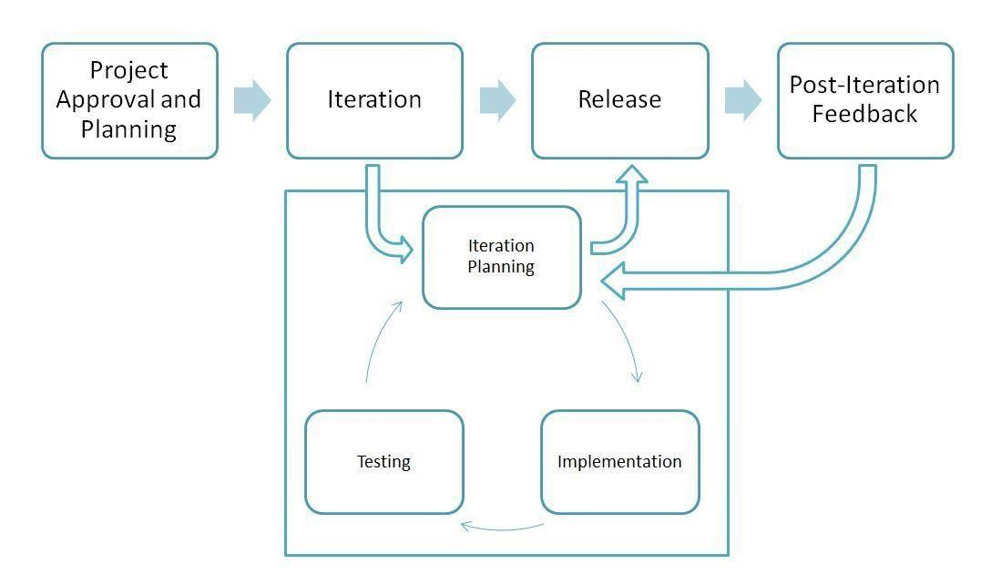

***Fig 1. Agile software development methodology***

## 3.4. SYSTEM MODULE

This project is divided into different modules which will be integrated to work as a single system as follows, this report will be describing the student module.

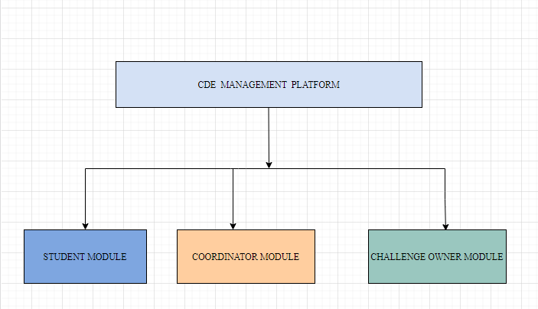

***Fig 2. System modules***

# CHAPTER FOUR

SYSTEM ANALYSIS AND DESIGN

## 4.1. REQUIREMENT ANALYSIS

The aim of this part is to describe the requirement specification (a description of needs or desires for a successful project). It involves the description of what the system should do or functional requirements and the constraints or characteristics that system should have or non-functional requirements. The following are functional and non-functional requirements identified in this project.

### 4.1.1. FUNCTIONAL REQUIREMENTS

The functional requirements relate directly to the functioning of the system, including all observable processes that must be performed by the system in order to achieve the expected goals. The following are functional requirements of this project based on the student module.

* The system must allow students to upload their particularly project reports.
* The system must allow students to view the schedule of different activities or tasks.
* The system must allow students to view challenges identified obtained during data collection.
* The system must allow users/students to login and logout of the system
* The system must allow students to view their teams.

### 4.1.2.NON-FUNCTIONAL REQUIREMENTS

Non-functional requirements define or describe how a system is supposed to behave and they are also named as the qualities of a system, the following are non-functional requirements that the expected system under this project must have;

* A system must be secure to protect the user’s data and information
* The system must provide higher performance such as fast response to requests
* A system must be simple and easy to use
* A system must support working with all web browsers

### 4.2.USE CASE ANALYSIS

This section mainly describes the interaction between a user and the system and use cases are diagrams to show the interaction between user and the system. In this project based on student module the following is a use case according to user role, is going to deal with one user who will interact with other modules after integration.

**4.2.1. STUDENT**

This category of user is also when the user is registered into the system be able to log into the system and perform the specified activities and be able to logout.

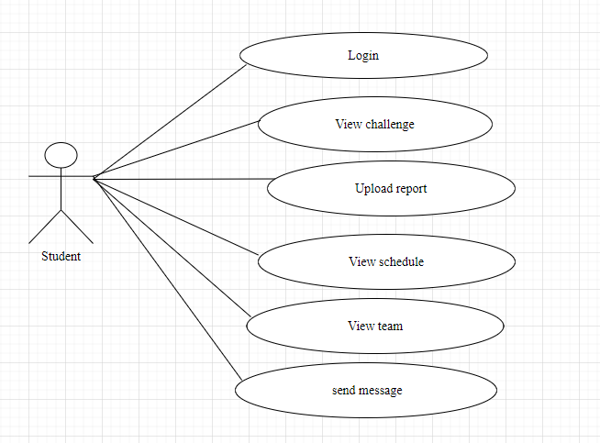

***Fig 3. use case diagram showing an actor student***

**4.2.2. USE CASE DESCRIPTION**

|  |  |
| --- | --- |
| use case | Upload report |
| actor | Student |
| Description and success criteria | student will successfully have logged in the system and report will be successfully uploaded |
| when something goes wrong | In case user entered the wrong logging credentials the system will give him/her an option to recover password and add new password |

***Table 1. showing description of use case upload report***

|  |  |
| --- | --- |
| use case | View schedule |
| actor | Student |
| success criteria | User will be successfully logged in and be able to view or navigate to schedule |
| when something goes wrong | In case user/student user entered wrong logging credentials he/she will be directed the recover password option |

***Table 2. showing description of use case view schedule***

|  |  |
| --- | --- |
| use case | View challenge |
| actor | Student |
| success criteria | User will be successfully logged in and view or navigate to challenge |
| when something goes wrong | In case user/student user entered wrong logging credentials he/she will be directed the recover password option |

***Table 3. showing description of use case view challenge***

|  |  |
| --- | --- |
| use case | View Team |
| actor | Student |
| success criteria | User will be successfully logged in and view or navigate to team |
| when something goes wrong | In case user/student user entered wrong logging credentials he/she will be directed the recover password option. |

***Table 4. showing description of use case view team***

|  |  |
| --- | --- |
| use case | Login |
| actor | Student |
| success criteria | student will enter his or her credentials and and will be authenticated if the credentials are correct then student will be successfully logged in. |
| when something goes wrong | In case a student entered wrong logging credentials he/she will be directed the recover password option or re-enter his/her credentials |

***Table 5. showing description of use case login***

## 4.3. SYSTEM DESIGN

This chapter explains the design process of this project, system design is the process of designing the elements of a system such as the architecture, modules and components, the different interfaces of those components and the data that goes through that system. It includes the following parts:

### **4.3.1 Database design**

For a system to support the applications that the end-users want, requires a well-structured database. This part describes the database expressed by using ERD that shows relationships among entities. 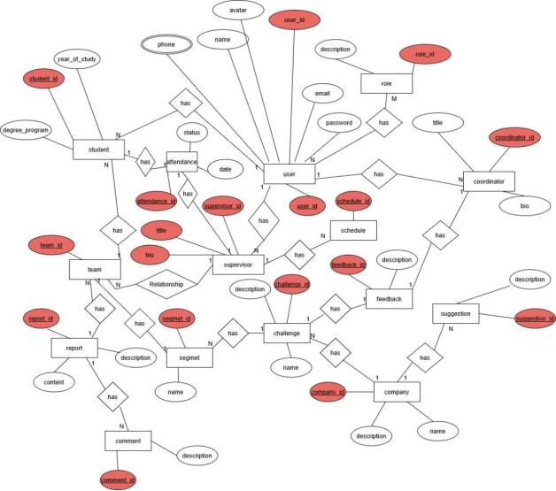

***Fig 4. Entity relationship diagram***

### **4.3.2 Process flow modelling**

This part shows the flow of different processes and data within the system, process flow modelling refers to technique designed to describe and understand process. In this project the following diagram shows data flow diagram context level.

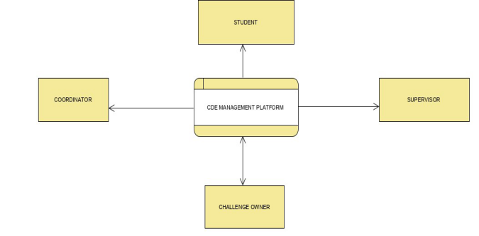

***Fig 5. Diagram showing level 0 or context data flow diagram***

### **4.3.3. Sequence Diagram**

This part describes the interaction between the objects within the system in sequential order, the following is a sequence diagram that shown interaction of some objects.

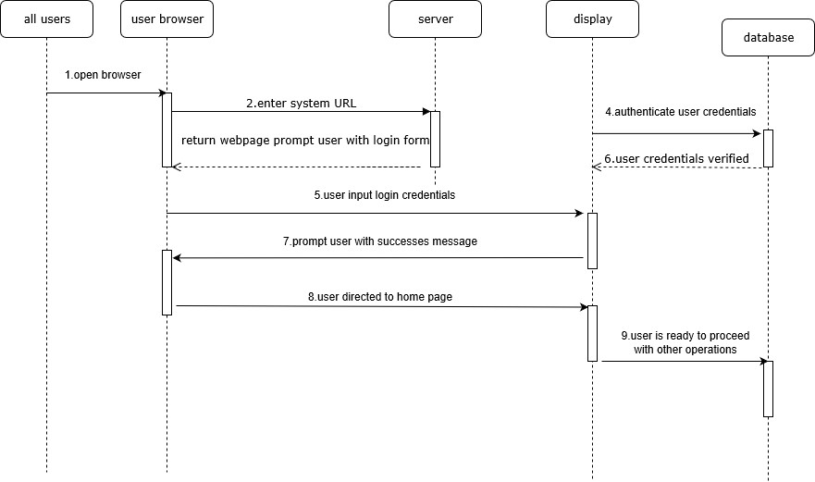

***Fig 6. Showing sequence diagram***

# CHAPTER FIVE

# SYSTEM IMPLEMENTATION AND TESTING

## 5.1. OVERVIEW OF SYSTEM IMPLEMENTATION

The implementation of this project is entirely divided into two parts, the front-end development and a back-end development, the front-end development is mainly implemented using HTML, CSS and javaScript and the back-end is implemented using Laravel framework which is a framework based on PHP. The database is implemented using mySQL database which is a database management system and the xampp with apache local server. This part of the part of the project implementation is dealing with the implementation of student module which is one of the modules that forms this project.

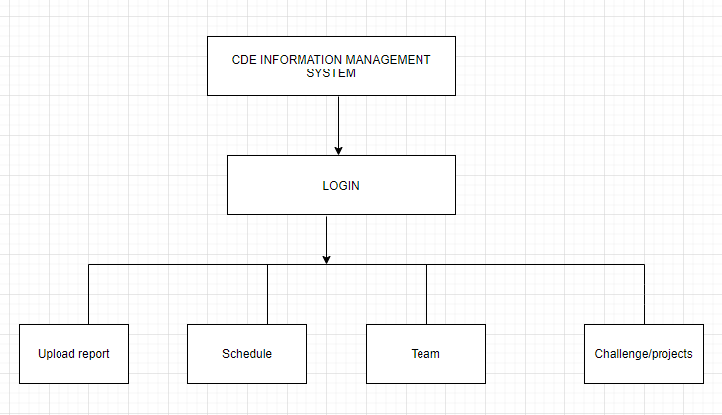

***Figure 7. showing the flowchart of the student module***

## 5.2. IMPLEMENTATION STRATEGY

The user must be able to enter the homepage and be able to navigate to different functionalities to do so a user must be logged in. when the user enters homepage, he/she will be able to browse different functions and perform specified tasks.

## 5.3. SYSTEM COMPONENTS

The student module of this system contains different components that work together to achieve the project specific objectives. The following are the components of this module:

### **5.3.1 Login page**

This page will appear to the user first that will allow the user/student to enter its credentials to ensures that he/she is the right person logging into the system. After the user enters credentials and authenticated, then the user will be directed to the student page.

**Algorithm for login Page**

Step 1: Start

Step 2: Declare a variable username and password

Step 3: Read variable username and password

Step 4: if username= password

Open a new page

Else

Display error message

step 5: stop

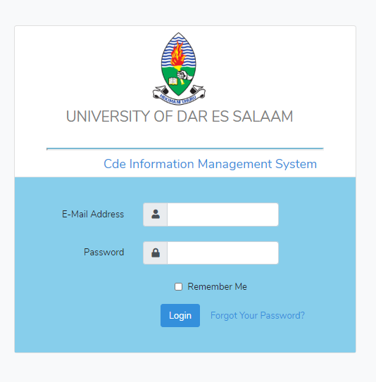

***Fig 8. Login page for student module of the system***

### **5.3.2 Home page**

This page will appear to the user after logged into the system and be able to see the welcoming contents and navigation of different directories.

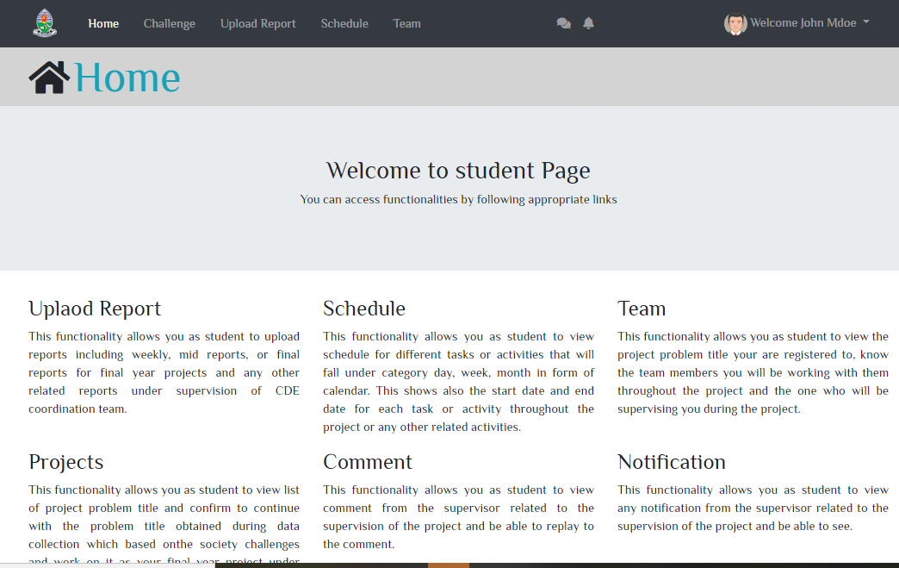

***Fig 9. Home page for student module of the system***

### **5.3.3 Upload report page**

This page will enable student to upload their reports, particularly weekly and final reports during data collection and final year projects under CDE supervision that is needed for assessment and evaluation of the progress. He/she will be able to choose a file to upload or submit.

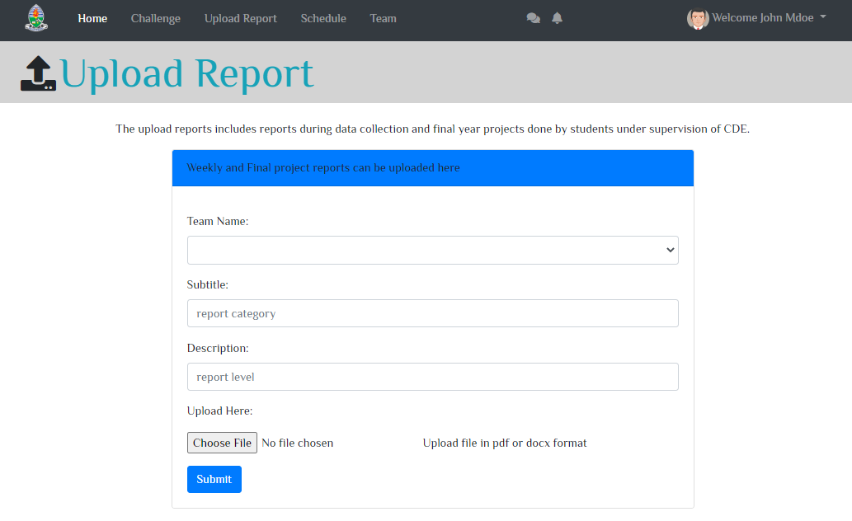

***Fig 10. upload report page of student module of the system***

### **5.3.4 Schedule page**

This page will enable student to view the schedule daily, weekly, monthly for different activities or tasks assigned to students during data collection and final year project. He/she can easily navigate to month, day, week and list of all activities that shows the start date and time of each activity.

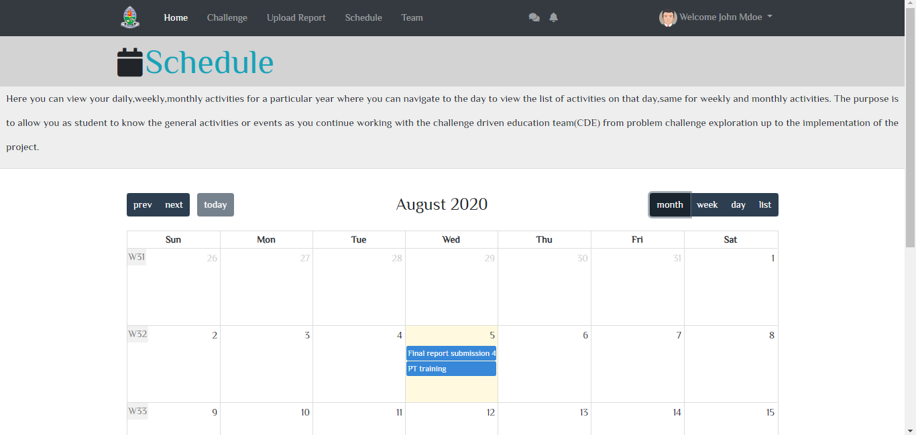

***Fig 11. schedule page of student module of the system***

### **5.3.5 Team page**

This page will enable student to view the project team that includes the project name, team members, and supervisor name to work together on the project.

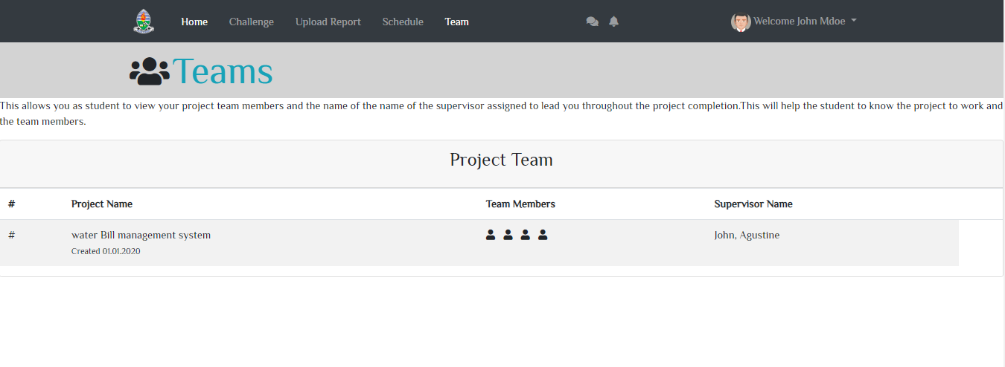

***Fig 12. schedule page of student module of the system***

### **5.3.6 Challenge page**

This page will enable students to view the challenges or problem identified during data collection from stakeholders and needs solutions.

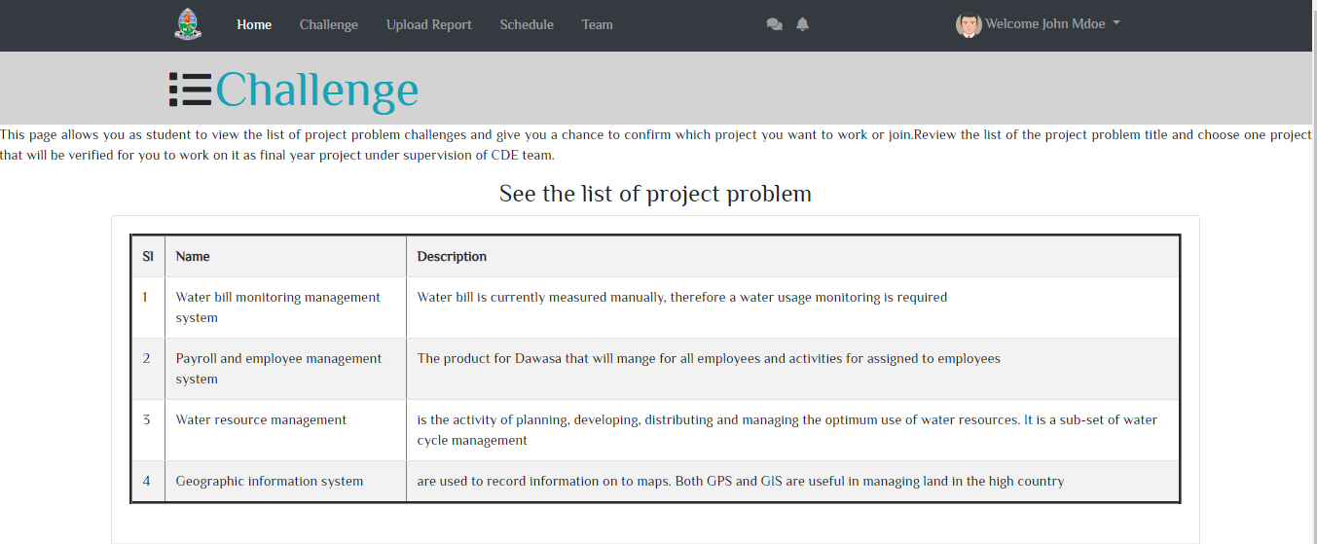

***Fig 13. Screenshot for challenge of student module of the system***

### **5.3.6 Profile page**

This page will enable students to view and update their profile after logged into the system and also, they will be to navigate to navigate to change password.

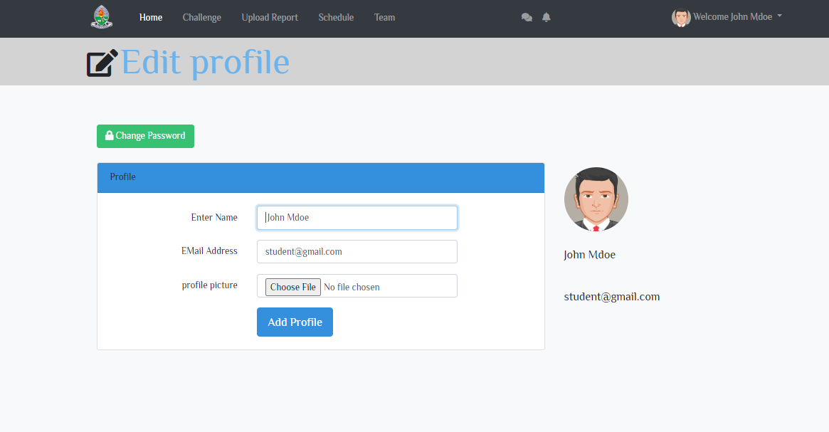

***Fig 14. Screenshot for profile of student module of the system***

### **5.3.7 Change password page**

This page will enable students to change password after logged into the system and the password will changed by using the current password and then creating the new password.

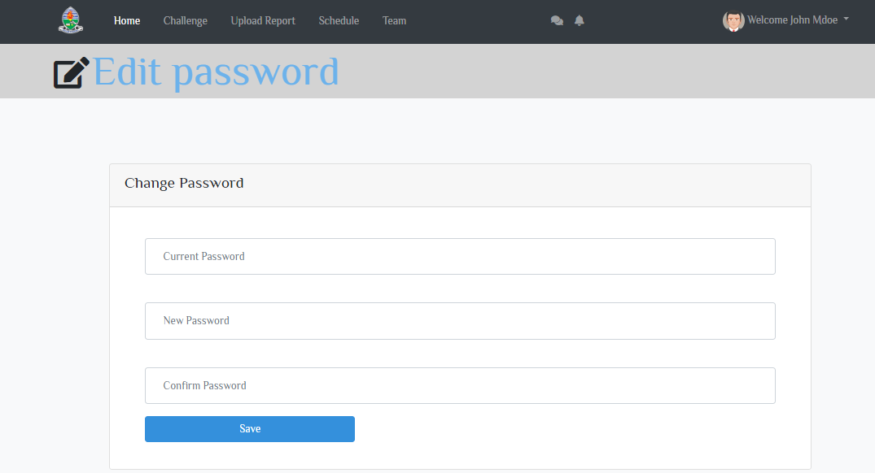

***Fig 15. Screenshot for profile of student module of the system***

## 5.4. SYSTEM TESTING

System testing is a level of software testing where a complete and integrated software is tested. The purpose of a system testing is to evaluate the end-to-end system specifications. During the development of the system, the application undergoes two phases of testing:

### **5.4.1 Unit testing**

This testing done during development phase; the testing done involved each part of the program to ensure that the individual parts are correct. This testing includes;

**Syntax error testing**: this method of testing is used to check all the syntax errors during the development. It also checks the programming pattern of the language, for instance dollar ($) is used to donate variable name in php while in JavaScript it will use the name “var” to show variable name.

**Compatibility testing**: this testing is used to test if all the languages used during the programming were compatible with each other.

**Logical testing**: this is the argument involved during the programming. This checks whether the argument is accepted by the system or not.

### **5.4.2 Integration Testing**

Integration testing done to test the components when integrated to verify that they work as expected. For example, the test of components which are working fine individually does not have issue when integrated. In this project student module were integrated with other modules of the system and the test of each component done to ensure they work as expected. The following screenshot shows integration of student module with other modules.

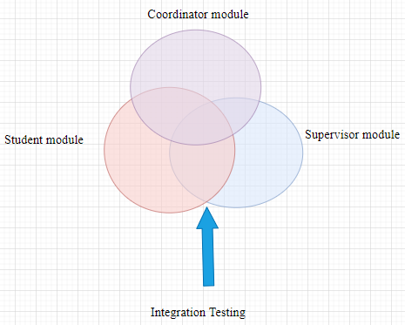

***Fig 16. Integration testing of student module with other module of the system***

### **5.4.3 Running the software on realistic data samples**

This testing includes:

Running the application in its fullness using a local server such as xampp server that have local host which is using Apache as engine and MySQL as the database. Also, browser testing used to test the appearance on the browser.

# CHAPTER SIX

CONCLUSION AND RECOMMENDATION

## **6.1 CONCLUSION**

This project report gives a detail of the problem definition, description of methodologies, system analysis and design, and the work done so far in implementation is based on the student module which is one of the modules which is integrated with other modules that together will form the system. The implementation so far has covered some components within student module as part of user interface and performing the initial integration of the student module with other modules of the system such as admin module and supervisor module, because, they depend on each other, hence the single system.

## **6.2 CHALLENGES**

During the implementation of this project, I encountered different challenges which includes, limited time, the semester schedule was limited and as a result time to perform more research and add more features was minimal.

## **6.3 RECOMMENDATION**

This project is the web-based system, that will be used as means of improving efficiency of activities particularly in the world of growing of computer technology. Hence, I recommend that this system will be better to enhance the communication between students and the coordination team and to help on performing different activities.

## **6.4 FUTURE WORK TO BE DONE**

From where I have ended the work can be further improved by adding more features that will enable students to apply for practical training under CDE for specified qualification and confirm to work with CDE for final year projects.

**REFERENCES**

1. Ian Sommerville. (2016). *Software Engineering* (10th ed.) Global edition. Addison Wesley Longman, Incorporated.
2. John Wiley and Sons, (2016) Systems*_Analysis_Design_UML*_5th ed
3. McGregor, S.L.T. & Murnane, J.A. (2013), *methodology Paradigm and method: intellectual integrity in consumer*
4. https://www.researchgate.net/publication/309423487*_Guide_to_challenge_drive n_ed*[*ucation*.](https://www.researchgate.net/publication/309423487_Guide_to_challenge_driven_education)

# **APPENDIX**

**BUDGET**

|  |  |  |
| --- | --- | --- |
| RESOURCE | COST | TOTAL |
| Stationary | 5000/= @4 reports | 20000/= |
| internet | 3000/= | 40000/= |
| others |  | 10000/= |
| Total 70000/= | | |

***Table 6 showing the budget***

GHANTT CHART TABLE

