1st section

How to SAVE UP to 30% in construction Process with NANO TECHNOLOGY ISOLATION? (ке ти пратам линк од кое видео да се искористи - https://artlist.io/stock-footage/clip/construction-site-sign-infographic-city/578589)

NANOBLOCK insulation in 3 layers with a thickness of 2mm replaces approximately up to **50mm** of classic insulation!

High Performance in EVERY CONDITION >>> Check Effectiveness! (ова линк)

(Тоа што е напишано сега под делот на About Nanoblock да се префрли на делот effectivness до експериментите,а тука да се даде акцент на CHECK EFFECTIVNESS BUTTON)

2nd section

OUR WAY OF BUSINESS

B2B (Business to Business) is our way of business **ONLY**. We provide CERTIFICAED & UNUQUE PRODUCT to companies that are established in their own country markets by giving them the unique right for distribution.

We provide live presentations and couching for companies that are going to present, sell and distribute Nanoblock and every other logistic that is needed to present the real power of NANOBLOCK isolation.

For minimum order and price depends of the country of distribution.

Check your country >>> MAP

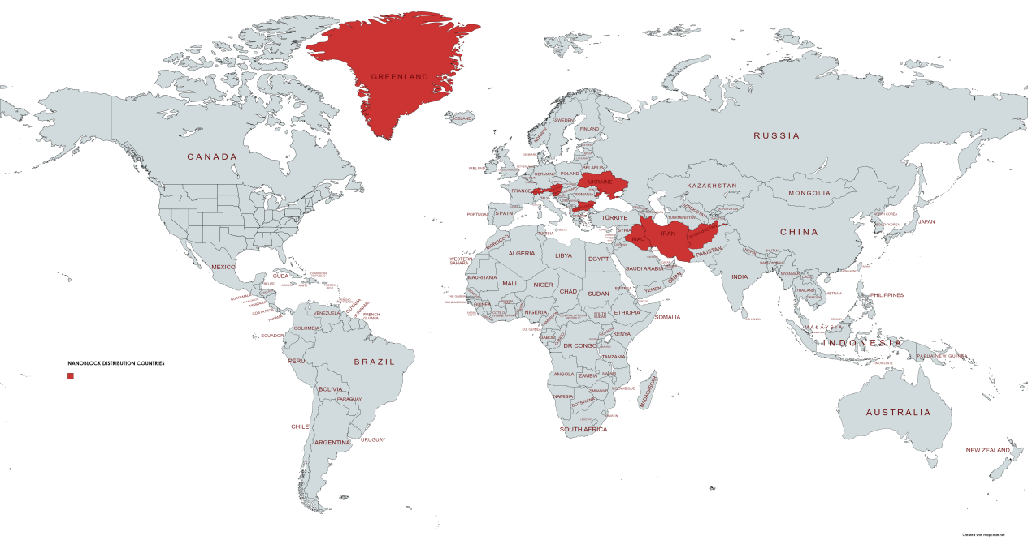

For more information you can CONTACT US or visit our OFFICE Departments

(Monday - Friday 09:00 - 17:00 Central European TIME)

(секција со видео од канцелариите)

PACKAGING (делот кај што се сликите - 3та секција моментално на сајтот и да се додаде слика од материјалот не само до кантите)

16 LITRE

Coverage with 2 Layers - 20m2 - 25m2 (Interior/Inside usage)

Coverage with 3 Layers - 15m2 (This applies for outside usage)