The Crystal or Foxhole radio

# Introduction

One of the coolest and particularly useful skill is to build something. If you are happened to be stranded on some unknown place or after a natural catastrophe. Especially as this may happen more frequently in the wake of the global climate crisis. To put together from scraps anything useful to help you out of your situation might be worth to learn about. On the field of radio technology, complex circuits and sophisticated components often dominate contemporary discussions. However, there exists a simple and very fascinating realm within the radio reception: the crystal. This rudimentary device, often associated with wartime ingenuity of handy soldiers, demonstrates the principles of radio reception using minimal components. Let’s see the scientific principles behind the so-called foxhole radio.

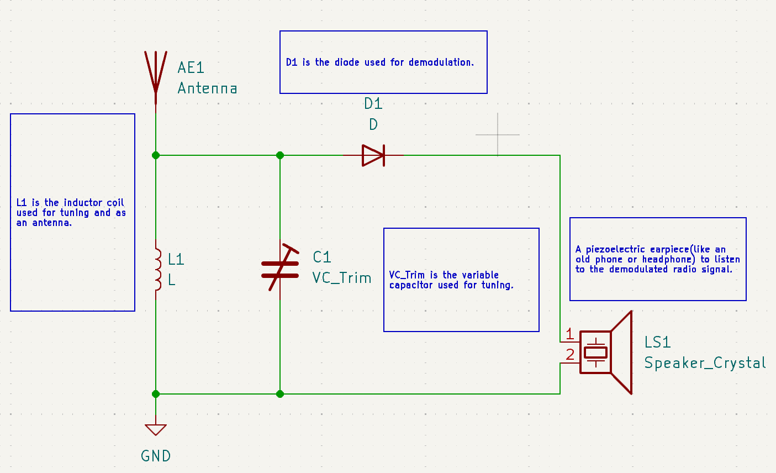

KiCad Schematic of the basic crystal radio.

# Understanding the concept

At its core, this radio operates on the principle of diode rectification, using the physical properties of certain crystals to demodulate radio signals. Semiconductor crystals, such as germanium and silicon (mostly used in diodes and transistors), exhibit asymmetric electrical behavior when properly doped (added/mixed) with impurities (certain other materials). This doping introduces an excess of charge carriers (either electrons or holes) into the crystal lattice. One called the n the other the p kind material. With that creating regions with differing electrical conductivity. A crystal diode, formed by joining two different semiconductor materials (like germanium with different impurity levels).

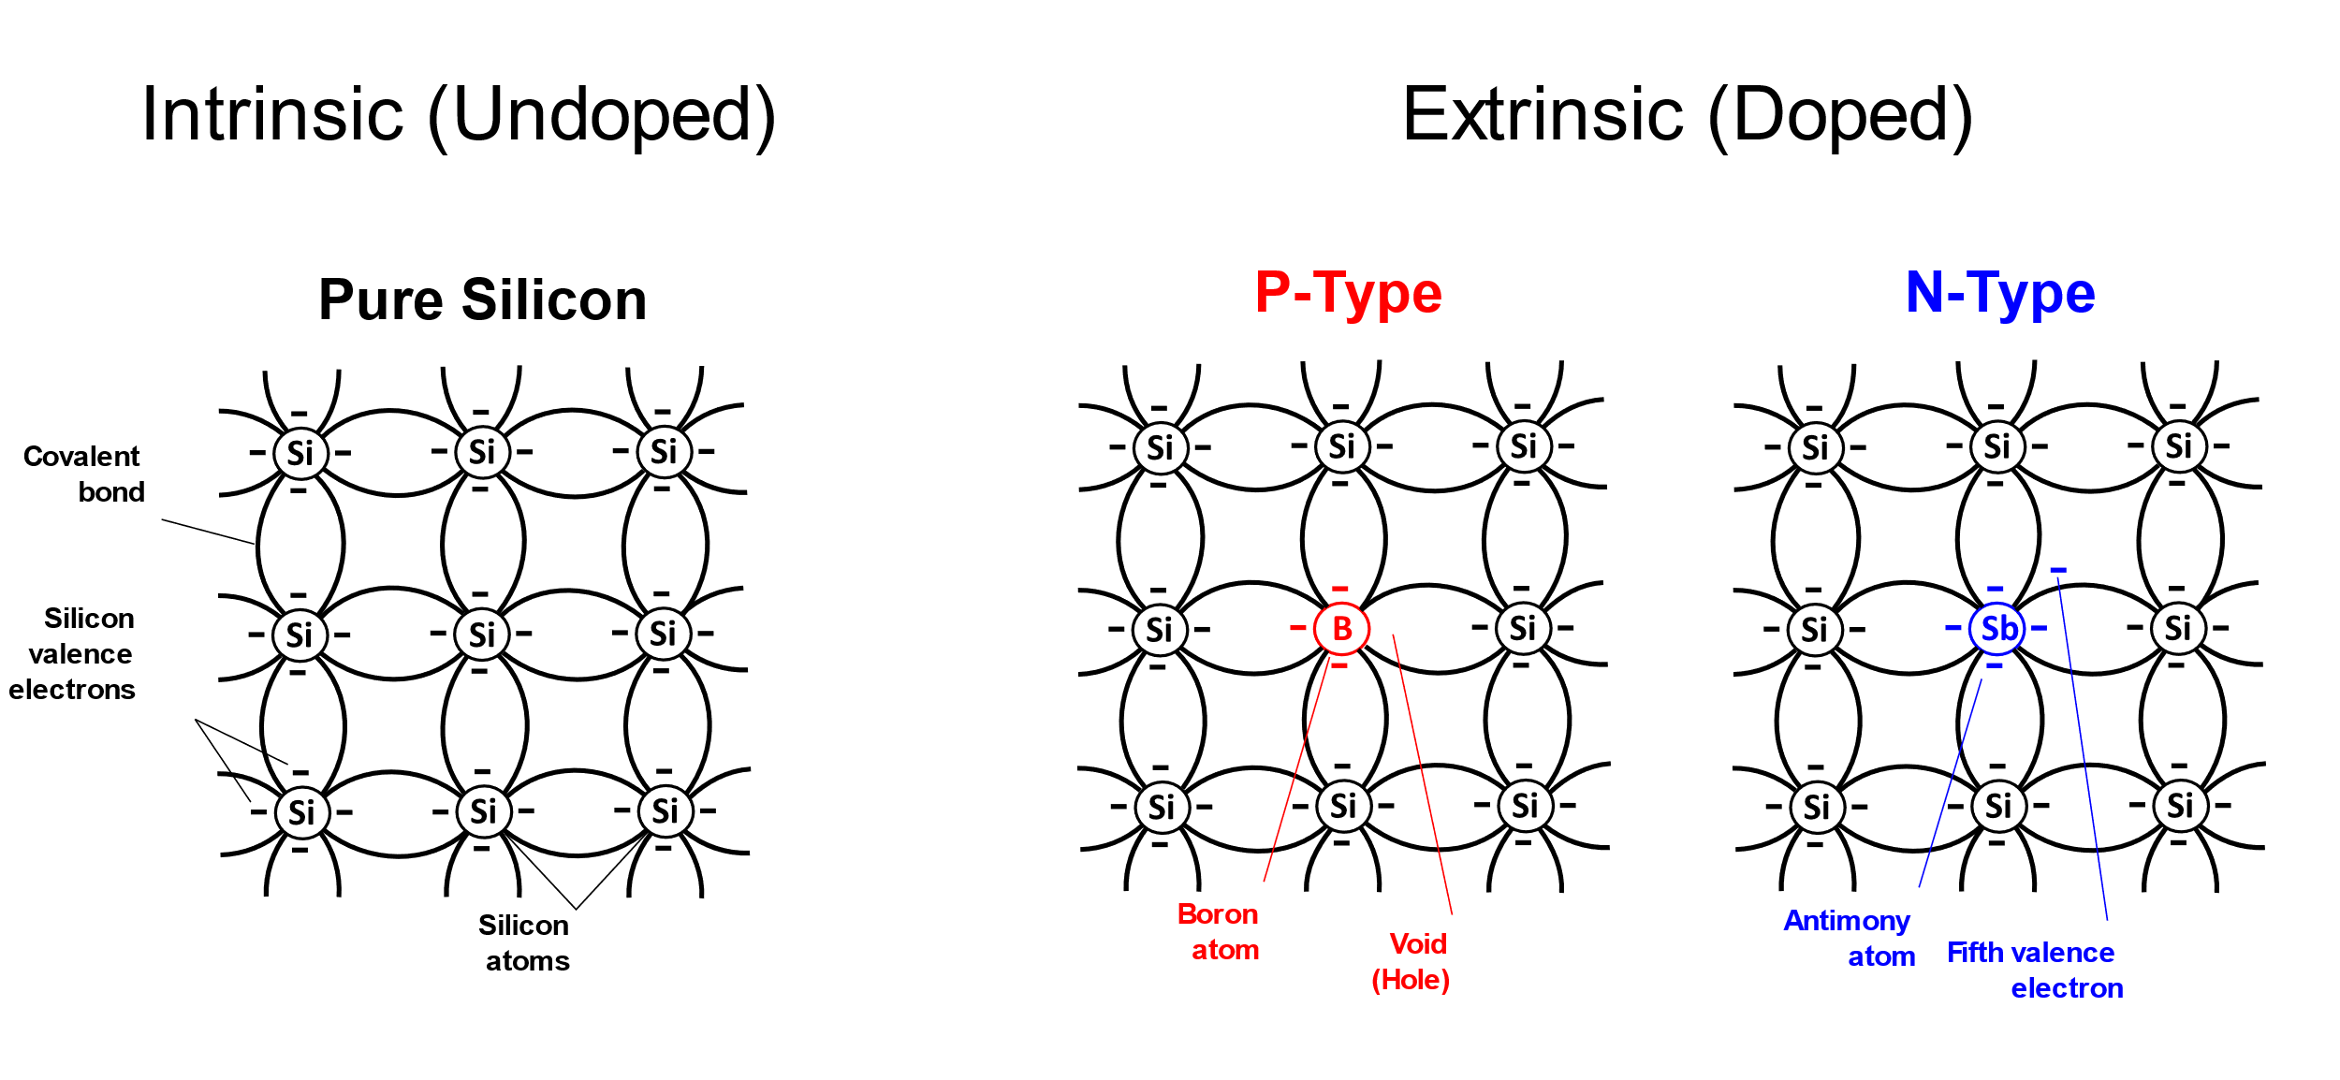

Source: https://commons.wikimedia.org/wiki/File:Silicon_doping_-_Type_P_and_N.svg#/media/File:Silicon_doping_-_Type_P_and_N.svg

This creates a junction known as a p-n junction. This junction allows the flow of electric current in one direction (from the p-type material to the n-type material) while inhibiting current flow in the opposite direction due to the so-called depletion region formed at the junction. Historically diodes made of Germanium were historically favored for crystal radio applications due to their lower forward voltage drop and higher sensitivity compared to modern silicon diodes.

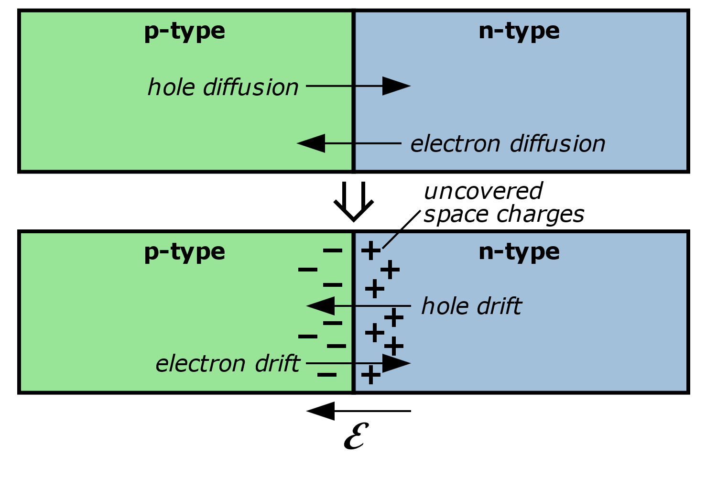

Source: https://commons.wikimedia.org/wiki/File:Pn_Junction_Diffusion_and_Drift.svg#/media/File:Pn_Junction_Diffusion_and_Drift.svg

Here comes our application. When an alternating current (AC) signal from the antenna goes to the crystal diode, it behaves as a rectifier. During the positive half-cycle of the AC signal, the diode conducts, allowing current to flow through the circuit. However, during the negative half-cycle, the diode becomes reverse-biased meaning it is blocking the current flow due to the depletion region's widening. This is the rectification process, that effectively converts the AC, amplitude modulated (AM) radio signal into a pulsating direct current (DC) signal. The DC signal contains the audio information modulated onto the radio carrier wave.

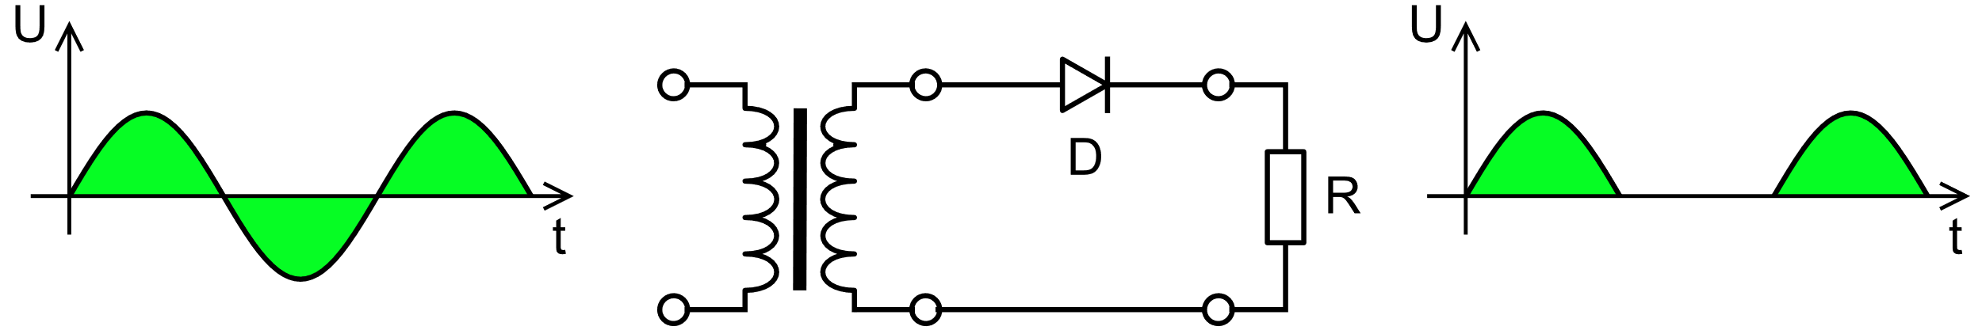

Source: https://commons.wikimedia.org/wiki/File:Halfwave.rectifier.en.svg#/media/File:Halfwave.rectifier.en.svg

By passing this rectified signal through a filtering circuit (forming a parallel oscillating circuit), typically consisting of a capacitor and a load (for us a piezoelectric speaker or similar), the high-frequency carrier wave component is removed, leaving behind our needed low-frequency audio signal. Certain ceramics and crystals, exhibit the property of generating mechanical vibrations in response to an applied electric field. Here, the fluctuating voltage from the rectified AM signal causes the piezoelectric material in the speaker to vibrate, producing sound we can hear that corresponds to the original broadcasted audio signal.

This complete device typically consists of an antenna (a long enough wire), an inductor coil (coiled up wire), a variable capacitor (possibly scavenged from old devices) for tuning, a crystal diode, and speaker or phone to hear potential broadcasts. The antenna serves to capture radio frequency (RF) signals from the airwaves. These signals induce an AC in the antenna, which is then fed into the inductor coil. The inductor, often wound around a ferrite core (or just a broken pencil), further enhances the signal by resonating at the desired frequency, thereby amplifying the amplitude of the received signal.

# The tuning

The variable capacitor is the primary component responsible for tuning our radio. It consists of two parallel plates separated by a dielectric material, allowing the capacitance to be adjusted by varying the distance between the plates. By changing the capacitance, the resonant frequency of the LC circuit (inductor coil and variable capacitor in parallel as we mentioned before) is altered, enabling tuning to different radio frequencies. The different lengths of antenna wire we use may resonate at different frequencies, affecting the overall tuning range and sensitivity. Longer antennas usually resonate at lower frequencies, while shorter antennas resonate at higher frequencies.

This process relies on the principle of resonance, where the LC circuit resonates at a specific frequency determined by its inductance and capacitance values. When the resonant frequency of the LC circuit matches the frequency of the incoming radio signal, the circuit becomes highly responsive to that frequency. Tuning this radio is typically achieved manually by rotating a knob connected to the variable capacitor. As the capacitance changes, the resonant frequency of the LC circuit shifts, enabling the user to tune to different radio broadcasts in the area.

# Demodulation

Once the RF signal is tuned to the desired frequency, it passes through the diode. Effectively demodulating the audio signal embedded within the RF carrier wave. The demodulation is the process of extracting the original audio signal from the modulated radio frequency carrier wave. This process relies on the principle of rectification, facilitated by the nonlinear behavior of semiconductor diodes.

Source: https://commons.wikimedia.org/wiki/File:Illustration_of_Amplitude_Modulation.png#/media/File:Illustration_of_Amplitude_Modulation.png

In AM, the radio signal is modulated by varying the amplitude of a high-frequency carrier wave according to the amplitude of the audio signal. To see the whole picture, the modulated signal $S\left(t\right)$ can be represented:

$$S\left(t\right)=A_{c}*[1+k*m(t)]*cos⁡(2πf_{c}t)$$

Where:

$A_{c}$ is the amplitude of the carrier wave.

*k* is the modulation index, representing the extent of modulation.

*m(t)* is the time-varying audio signal.

$f_{c}$ is the frequency of the carrier wave.

When the modulated signal reaches the diode, the rectification occurs, converting the AC signal into a pulsating direct current DC signal. Rectification can be described as a nonlinear operation:

$$I\left(t\right)=|S\left(t\right)|*sgn(S\left(t\right))$$

Where:

$I\left(t\right)$ is the rectified current.

$I\left(t\right)$ represents the absolute value of the modulated signal.

$sgn(S\left(t\right))$ is the sign function, determining the direction of the rectified current.

After the rectification process, the pulsating DC signal contains both the original audio signal and components at twice the carrier frequency. To extract the audio signal from that, a low-pass filter could be used to attenuate the high-frequency carrier components while passing the lower-frequency audio signal. Mathematically, the filtering process can be represented using basic Fourier analysis:

$$V_{out}\left(t\right)=V_{in}\left(t\right)*h(t)$$

Where:

$V_{out}\left(t\right)$ is the filtered output voltage.

$V_{in}\left(t\right)$ is the rectified input voltage.

$h(t)$ is the impulse response of the low-pass filter.

This filtered $V_{out}\left(t\right)$ represents the demodulated signal, ready for amplification and conversion into audible sound waves by our piezoelectric speaker. Just to see it the demodulated output can be expressed:

$$V_{audio}\left(t\right)=k*V_{out}\left(t\right)$$

Where:

$V_{audio}\left(t\right)$ is the demodulated audio voltage.

$k$ is the amplification factor.

# Conclusion

The crystal radio stands as a testament to engineering ingenuity. Basic principles of electromagnetism and semiconductor physics, you too can construct functional a radio using minimal scavenged components. Good luck with building something!