Guidelines for
“ICT Strategic Planning in Parliaments”
Executive Summary 5
Introduction 7
The ICT strategy document vs. programme and project documents 8
About these Guidelines 10
Purpose 10
Target audience 10
Structure 10
Format 11
STEP 1: The present: where are we - analysis of the current state 12
Gathering information 13
Structuring the gathered information 14
Additional resources 16
Step 1 - The present: where are we, analysis of the current state 17
Step 2 - The future: where do we want to go, envisioned state and choices 18
Step 3 - The challenges: what do we need, the gap analysis 19
What do we need get there: defining requirements 19
Step 4 - The strategy: how do we get there, the plan of actions 20
How do we get there: defining the action plan 20
Technical options 20
Implementation, Support Services 20
Have we achieved our objectives: monitoring and evaluation (4-6 pages) 22
Introduction: components and tools 22
How to monitor the implementation 22
How to evaluate the achievements 22
Appendices 23

Executive Summary

1-2 pages

Introduction

To support Parliaments to become more representative, engaged and transparent, and in order for parliaments to better support its legislative and oversight work all relevant parties involved in the respective legislative and oversight processes (such as MPs, Committees, Speaker, citizens) should ideally be given access to accurate, complete and updated documentation.
ICT offers very effective tools to achieve this. The main challenges are how to incorporate the necessary ICT capacity, infrastructure, processes and solutions into the Parliaments, and from there how to conceptualize, develop and implement a further integration of ICT in support of the work and responsibilities of Parliaments.
At the cornerstone of this integration of ICT and the development of information systems in support of its work is a sound ICT strategy to provide vision and direction for the development of ICT in the Parliament .

The strategic planning process

The World e-Parliament Report 2008 highlights that the “management (of ICT) encompasses the entire parliament and can be a special challenge because of the political nature of legislative bodies, their complex organizations, and sometimes subtle decision-making processes. Planning (of ICT) builds on the vision statement and establishes projects, timelines, and resources for achieving the goals and objectives of the parliament. It includes the ongoing process of strategic planning and utilizes procedures such as project management and tools such as enterprise architecture to achieve its ends.”

In addition the Report underlines that “strategic planning is not a one-time single document or product. It rather is a holistic process that provides for the review, revision, and updating of plans on a continuing basis as goals, objectives, technologies, projects, and resources change. It is a means for ensuring that ICT initiatives remain focused on the goals of the parliament, and that they occur on an appropriate schedule and with the appropriate resources.”

From this perspective and in more concrete terms the strategic planning process and the resulting (not one-time) strategic document should be seen in the following context (figure 1).

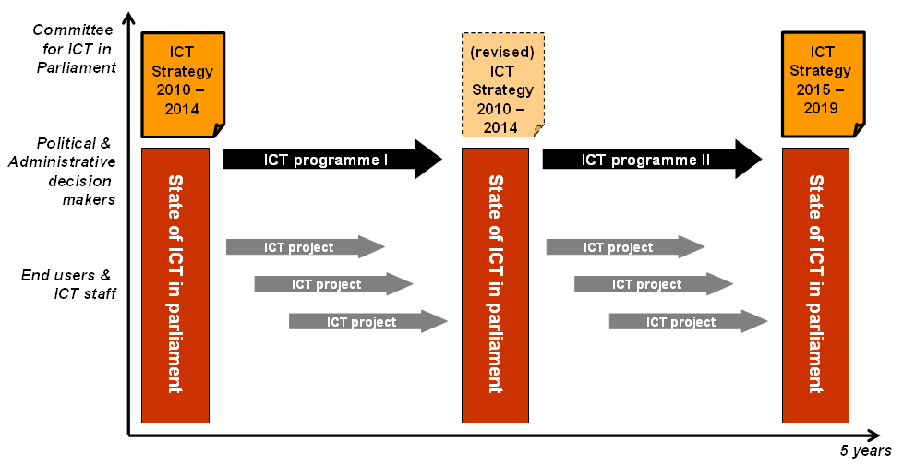
Fig. 1: Strategic planning process and its context

Strategic plans are there to provide direction on how to develop or alter the state of ICT in parliaments to better serve the institutional responsibilities and functions. Most strategic plans have a time span of five years, and are subject to mid-term reviews in the second or third year. Strategic plans in parliaments are formulated by political and senior administrative decision makers, and once endorsed form the basis for further ICT programmatic planning that sees the formulation of ICT projects, aimed at sensibly and effectively altering the state of ICT. At this programme / project level the specific needs and requirements of end-users in the context of their work are formulated and together with input from IT staff appropriate technological solutions are defined and implemented.

Depending on the success of implementing ICT projects and programmes the state of ICT in parliaments may or may not alter. For this reason evaluations and mid-term reviews are needed to revise the original ICT strategy giving new inputs to ICT programming and project planning.
As figure 1 shows there are different levels of managing and planning ICT in parliament, each of them involving different stakeholders i.e. from political and administrative to more technical and end-user level. And for each level a different “planning documents” can be distinguished:
- ICT strategy document (mostly 5 years)
- ICT programme document (mostly 2-3 years)
- ICT project document (mostly up to 1 year)

The ICT strategy document vs. programme and project documents
You must first login before you may access this page. Your Gandi handle (which looks like XX123-GANDI) was sent to you during the creation of your account. Your handle is also available in all the e-mails sent to you by Gandi. If you forget your password, please click on the "Don't remember your ID or password?" link below.An ICT strategy document within the parliamentary context defines the vision, strategic direction and framework for leveraging ICT in Parliament. It identifies the services and initiatives that overarch decision-making, planning, and deployment of ICT services and systems across Parliament. More over it is an outline of Parliaments future aspirations and direction for the use of ICT, to sustain and grow Parliament together with a strategy and action plan to realise them.
The ICT strategy document also brings the issue of resources and demands into sharp focus and provides the key decision makers in the parliament with an overall picture that will enable it to understand the scope of the investments it is making and the effort in time and money that will be required. With this knowledge, the parliament can determine the priority of each requirement and the impact of making those choices.

Strategic planning, based on an established vision, helps a parliament decide where to allocate its funds and its staff, and the likely impact of those decisions. It does this by requiring a decision not on the technology itself, but on the larger goals and objectives of the parliament.

The ICT strategy document also formulates the criteria for the evaluation of results. To successfully manage the introduction of new technologies and systems, a legislature must determine the effectiveness of the ICT projects undertaken to achieve its goals. This requires establishing in advance the measurable outcomes expected from the investment of resources (for example, faster availability of draft bills, savings from printing, access to more information about the budget), and an objective method for quantifying the results.

The ICT strategic document focuses on “what” a parliamFFFFFents needs to achieve terms of changes to citizens, MPs and administration and “how” these services are going to delivered in terms of strategical and technological optiopnal.

What an ICT Strategy document is not intended for is for describing in detail “how to” exactly deliver on strategic objectives. This (“how to”) is reserved for the ICT Programme Document that is intended to describe how the ICT strategy will be implemented and as such it covers issues such as project planning, governance, management; it also describes how projects are aligned, integrated and how programme resources are allocated among projects. The Programme Document also defines the rules for maintaining conformity of technological standards and compatibility within the parliamentary ICT infrastructure.

About these Guidelines

Purpose
The purpose of these Guidelines is to present good practices on how to conduct the ICT strategic planning process and author an ICT Strategy Document in a parliament, presentable and readable by all stakeholders in the parliament, including the lesser technical audiences like the Speaker, SG/Clerk, and Head of Departments.
Specifically this document intends to present approaches on how to systemically gather information from all the stakeholders on the current and the envisioned state of ICT in the parliament, supporting the different parliamentary processes and the work of specialized departments and offices, such as the legislative drafting office or library and research department.
Ultimately these Guidelines are meant to provide the reader with methods and techniques on how to structurally gather information, rank and order this information and conduct analyses in order to identify needs, priorities, challenges and gaps, and to come up with strategic recommendations and measurable objectives for the future development of ICT in parliaments.

Target audience
The target audience of these guidelines is ICT staff from the parliament that will be tasked with authoring ICT strategy documents in close coordination and collaboration with key stakeholders from the different parliamentary departments and offices that also represent groups to be affected by the introduction of ICT i.e. the future producers and consumers of information using ICT tools. Senior management both You must first login before you may access this page. Your Gandi handle (which looks like XX123-GANDI) was sent to you during the
Alpha | Beta
Gama | Delta

creation of your account. Your handle is also available in all the e-mails sent to you by Gandi. If you forget your password, please click on the "Don't remember your ID or password?" link below.a political and administrative level may also be interested in better understanding the process of development of a “ICT Strategic Planning in Parliaments”.

Structure
Part II of these Guidelines will describe the main steps to develop an ICT strategy within the parliamentary context, that can be divided into “information gathering” and “analysis”:
- Information gathering of:
  - the current state of ICT, that includes looking at the dimensions of organization, services, processes and people´s skills and assessing the integration of ICT within these;
  - the envisaged state of ICT that describes how technology is to be used within the parliament, again viewed from the above mentioned dimensions;
- analysis of:
- the challenges and the gaps to further develop ICT;
- strategiy , goals and objectives for the future development of ICT and making sure that it all “fits together”.
Finally guidelines are provided on defining recommendations, goals and objectives in measurable criteria and on how to ensure monitoring and evaluation (as an ICT strategy document is worthless if it does not allow for measurement and possible revision during review phases)

Format
In describing each step (and sub-steps) insight will be provided into the rationale of the step and methods will be presented on how to collect information including through the use of sample questions, forms and templates.
In addition for each step links will be provided to additional online resources where the readers can find more detailed information on the different issues and view different methods and techniques. Regarding the latter, there are many ways to conduct ICT strategic planning; there are different schools and providers of methodologies. These Guidelines present a methodology and techniques that are both practical and straightforward, and that have been applied in the field at parliaments, and also borrow from good practices presented by parliaments.

STEP 1: The present: where are we - analysis of the current state

As mentioned the ICT strategy document is the result of a four steps process that deals with:
- The present: where are we - analysis of the current state
- The future: where do we want to go - envisioned state and choices
- The challenges: what do we need - gap analysis
- The strategy: how do we get there - the plan of actions

In the figure 2 a schematic overview is provided of these steps and the areas for information gathering and analysis.

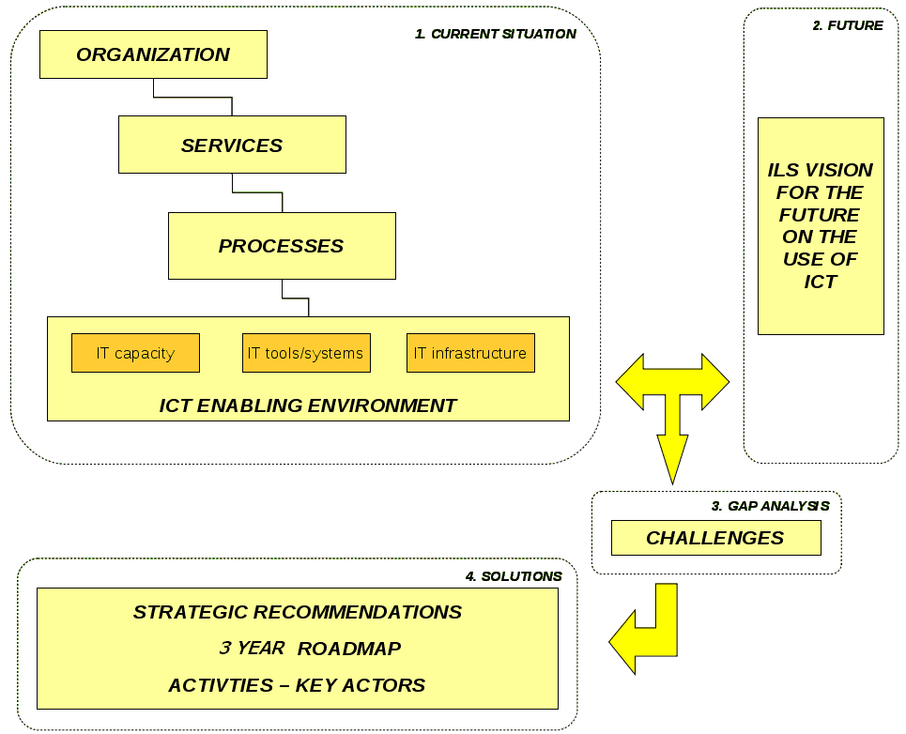

Figure 2: four steps of strategic planning
In this section we describe how to make an “analysis of the current state”. How to describe the organizational setup in terms of structure, which departments and offices exist, what their specific functions are and which services they intend to offer to “clients” such as MPs, staff, users, researchers, drafters etc.

To deliver these services and carry out their functions a number of existing processes are distinguishable, which in turn may or may not be supported by an enabling ICT environment. By

first describing the organizational setup, its services and processes we can better ensure that ICT is viewed as an enabler and in support of these services and processes.

Gathering information
Below are the types of questions that may have to be posed to political and administrative leadership gain an understanding of the context in which ICT solutions have been (or are to be) implemented. Some of these questions will not all necessarily pertain to the context of a particular parliament; they are presented here as examples of the kind of information needed and to facilitate discussion of the political and technical environment. This list of questions may seem very extensive but it should be taken into account is that the parliament´s ICT strategy may also be shared with external parties e.g. donor community, and be communicated to the public. Besides ICT related initiatives in parliaments take place in a complex environment of political and administrative decision making that requires providing some contextual overview.

Parliamentary roles and responsibilities
- What are the legal/constitutional roles and responsibilities of each chamber?
- How does each chamber fulfill its roles and responsibilities?
- What is the composition of the national parliament?
- What is the budget and staffing of the parliament?
- What are the Presiding Officer’s powers and prerogatives?
- What is the role of committees and commissions?
- What are the duties and functions of members?
- How are members elected?
- What are the duties and functions of the Secretariat of Parliament?

Parliamentary goals
- What are the goals of the parliament in the following areas?
  - Transparency
  - Openness
  - Accountability
  - Inclusiveness
  - Accessibility
  - Efficiency of core operations
  - Effectiveness of core operations
- Are there written statements regarding the goals for ICT?

Processes and activities
Legislation
- What is the legislative process, including the relationship among the legislature’s constituent bodies and between the legislature and the government and other national and sub-national bodies?
- What documentation is produced during the legislative process?
  - What is its purpose?
  - Who produces it?
  - How is it produced?
  - Who uses it?

Oversight
- What is the oversight process, including the responsibilities and activities of the bodies responsible for conducting oversight of the government
- What documentation is produced during the oversight process?
- What is its purpose?
- Who produces it?
- How is it produced?
- Who uses it?

Budget
- What the responsibilities and processes of parliament for the national budget and public financing?
- What documentation is produced during these processes?
- What is its purpose?
- Who produces it?
- How is it produced?
- Who uses it?

Non-plenary bodies
- What is the mandate and terms of reference of committees, commissions, and other official groups?
- What are their primary activities
- How do they use ICT?
- What documentation is produced by these groups?
  - What is its purpose?
  - Who produces it?
  - How is it produced?
  - Who uses it?

Plenary
- What is the mandate and terms of reference of the plenary?
- What are the primary activities of the plenary?
- How is ICT used in plenary?
- What documentation is produced by the plenary?
  - What is its purpose?
  - Who produces it?
  - How is it produced?
  - Who uses it?

Library and research services
- Describe the role, responsibilities, and activities of the library and research group
- What services are provided?
- How do they use ICT?

Communication with citizens
- What methods are used to communicate with citizens?
- Websites
- Email
- Other media – examples: radio, TV, video, webcast
- Methods for citizens to express their views

Members
- What are the roles and responsibilities of members?
- What are their duties and activities?
- How do they use ICT?
Box 1: Sample questions for better understanding the parliamentary organization, services, processes and enabling ICT environment.

Information Gathering Methods and Techniques
As mentioned the information listed in box 1 would have to be retrieved from sources such as the (Deputy) Speaker, (Deputy) SG/Clerk, and Heads of Departments and Offices. The authors could start first by collecting existing documentation on these topics including parliamentary resolutions on departmental functions and procedures to get a firsthand understanding of the environment. In addition previous ICT strategy documents or other reports regarding the parliament can be consulted.

The actual information gathering can take place through Questions and Answer sessions (Q&A sessions) during which authors conduct one-on-one interviews with the mentioned stakeholders, and go through the questions and answers to get a deeper understanding of the organizational setup, departmental functions etc. Q&A sessions may be prepared by listing questions and submitting these to the stakeholders.

This information gathering through Q&A is an iterative process, that is often concluded by a review round by the stakeholders of the first drafts i.e. the facts are checked and verified.

A note on dealing with hierarchies within parliaments: in some parliaments strict hierarchies and organizational culture may greatly influence the way how staff can interact with superiors such as the (Deputy) Speaker or (Deputy) SG/Clerk. In such cases “lower ranked staff” that are tasked with authoring a ICT strategy document are not in a position to freely pose questions to superiors. To overcome this situation the earlier mentioned committee for ICT in parliament could facilitate this freer interaction by communicating to all parties, including senior officials and departmental heads on the process of information gathering through Q&A, and fact checking through review rounds, and explain how everyone involved can lend their support.

Structuring the gathered information
Below a sample index is provided of the chapter on the “current situation” of the ICT strategy document (for a complete sample index see annex 1)

PART I: CURRENT SITUATION
1. PARLIAMENT INSTITUTIONAL CONTEXT
- Mandate & Responsibilities
- Functional bodies
- Governance structure
- Organizational structure
  - Organigramme, departments, offices
  - Number of staff

2. SERVICES & PROCESSES
- Department for Legislative Drafting & Legislative Document Management
  - Delivery of services
  - Processes & ICT Systems
- Office for Public and Media Relations
  - Delivery of services
  - Processes & ICT Systems
- Parliamentary Library
  - Delivery of services
  - Processes & ICT Systems
- Department for Parliamentary Research
  - Delivery of services
  - Processes & ICT Systems

3. CURRENT STATE OF ICT IN PARLIAMENT
- ICT Department
- ICT Infrastructure
- Systems & Applications
- Governance, policies and standards

For mapping the processes within a specific parliamentary department and existing ICT systems the following type of sample table can be used. In this example the processes of a legislative research department are described, listed vertically (↓) in the first column. On the first role, horizontally (→) all the ICT tools (or systems) are listed.

ICT Tools ► | Office productivity tools | E-mail | Internet | Content Management System | Document Management System
▼Processes
Dissemination of Information | ✓ | ✓ |  | ✓ | ✓
Acquisition and Management of Research Resources |  | ✓ | ✓
Production of Research Bulletins | ✓ | ✓ | ✓ | ✓ | ✓
Production of On-Demand Research | ✓ | ✓ | ✓ | ✓ | ✓
Systemization of legal normative analysis | ✓
Mobilizing Scientific Research | ✓ | ✓ | ✓
✓: existing and operational
✓: existing but not fully operational
Table 1. Mapping of Processes and ICT tools in the area of Legislative Research

Additional resources
- Business Process Reengineering Assessment Guide, United States General Accounting Office, May 1997 http://www.gao.gov/special.pubs/bprag/bprag.pdf
- Enterprise Architecture: An Overview (Paper): http://www.brint.com/papers/enterarch.htm
- Business Process Reengineering: A Consolidated Methodology http://webs.twsu.edu/whitman/papers/ijii99muthu.pdf

///////////////////////////////////////////////////////////////////////////////////

Step 1 - The present: where are we, analysis of the current state
  - Parliamentary Organisation and Services -
What is the organizational mandate and what services does it need to provide? Who are its clients and what are its “information products”?
  - Processes
what are the main processes?
      - What type of systems are currently used to support the processes.
      - From a high-level point of view, what do these systems do? Very general description...
      - How does the current Enterprise Architecture support the processes, information management etc?
1.3 - Human Resources
- what are the required skills?
- Application
- Infrastructure
Data

1.4 – IT Organization within parliament
    - structure of IT organization
      - roles and responsibilities
      - provision of IT services to the parliamentary organisation
      - SLAs

IT governance
      - coordination & collaboration with departments
      - role of political organ or body within parliament to promote development of IT (e.g. advisory group or committee on IT developments in parliament)

Step 2 - The future: where do we want to go, envisioned state and choices
  - - Setting vision and objectives
What are the objectives that need to be achieved within the vision while adhering to the value system. What are the expected milestones and the relative time frames for this.

This is followed by a description of the “future state of ICT” i.e. envisioned state of information management that describes how the introduction or integration of IT skills, tools, systems, infrastructure will support better processes and services, and that also makes long terms assumptions and conditions, states strategic choices with regard to technological options and compliance with technical and non-technical standards

Step 3 - The challenges: what do we need, the gap analysis
3.1 Defining requirements

What do we need get there: defining requirements
How can the current Enterprise Architecture relate / support the envisaged future?

What needs to be deployed/done/upgraded in order to …. (of course each level will have different 'strategies/approaches”
- Application requirements (here we could have >>definition of requirements, then … internal development or outsourcing, etc.)
- Infrastructure requirements
- Data management requirements
- Supporting IT organisation
- IT service delivery
- Roles and responsibilities
- SLAs
- IT skills
- IT governance, policies, procedures
- Human Resources
NB: Each of the area above will also be addressed in the next section i.e. requirements for each of the areas.

Step 4 - The strategy: how do we get there, the plan of actions
  - Strategic recommendations
  - Roadmap- Strategic goals, priorities and dependencies
  - Activities and key actors
  - Stakeholders/champions: who will pull the implementation of strategic recommendations from political point of view / leadership? Who will oversee this entire process?

How do we get there: defining the action plan
- Implementation approach – use of best practices / methodologies etc

- Procurement process – guidelines
- In-house skills vs. outsourcing
- Organisational changes
- Project activities:

      - IT Programme Development
      - IT Project Planning
      - Cost analysis / budgeting
      - Risk analysis
      - Project activities
      - Project Management
      - Project evaluation & lessons learned

Technical options
- Alignment of technical options / solutions with Enterprise Architecture
- Coherence of standards to ensure technical compatibility and interoperability with other future or existing systems
- Scalability / sharing of resources & infrastructure
- Performance
- Reliability (continuity of business ensured through disaster and recovery procedures)
- ......

Implementation, Support Services
This section deals with the future development / support of the system(s) and looks into the following:
- SLA’s / support partnerships
- Costs analysis / Budgeting
- Continuous improvements / training
- Best practices such as ITIL / COBBIT / PRINCE2 etc
- Skills / HR issues
- Extending the information use towards the public through the website

Then under each Step we would give the prescriptions , the hows and samples and tools where appropriate

Have we achieved our objectives: monitoring and evaluation (4-6 pages)

Introduction: components and tools
- IT strategy review: within a 5 year IT strategy plan, a mid-term review (e.g. after 2.5 years) should take place during which the “envisioned state of information management” is evaluated I.e. whether it still holds.
This “envisioned state” should be assessed against the “current state” that in the mean time has undergone a 2 year development. And from there a new fit-gap analysis should be made that clarifies whether priorities are shifting and whether projects need to be brought forward or postponed, or additional resources need to be made available etc.
- IT programme reformulation & evaluating priority of IT projects: based on the outcome of the IT strategy review
- This is a multi-stakeholder exercise

(here we have to deal with “objectives” but that in turn are made up of the components below … more or less )

How to monitor the implementation
- Application
- Infrastructure
- Data
- Organisation and procedures
- Human Resources

To monitor / measure the above, at the beginning of each IT project a number of technical and non-technical acceptance criteria should be drawn up, that will indicate whether a certain product (or portion of that product) has been delivered.

The number (or %) of successfully delivered IT projects within a IT Programme indicate the progress of implementation.

This type of monitoring is responsibility of the IT programme / project management and is carried out with the available project management tools

How to evaluate the achievements
- Application
- Infrastructure
- Data
- Organisation and procedures
- Human Resources

This requires more measurement at the stakeholder level I.e. MPs, Committees, Speaker, Citizens, and all other users of the parliamentary information systems would have to indicate on the above listed levels what their perception is of the quality of information services I.e. that systems are “user friendly”, or that information is always “available, updated, complete” etc etc; or that the parliament has become more transparent, open, and engages more with the public.

This type of monitoring is carried out in close collaboration with the stakeholders and could be done by a parliamentary study group, academics, citizen panels etc using tools such as interviews, questionnaires etc.

Appendices
- Digital Preservation
- Guideline to website
- Sample templates
- Etc

Below a sample (and most often used) outline of an ICT strategy document is given

EXECUTIVE SUMMARY

BACKGROUND
- About this ICT strategy document
- Methodology applied

PART I: FINDINGS AND OBSERVATIONS
1. PARLIAMENT INSTITUTIONAL CONTEXT
- Mandate
- Governance
- Housing and location

2. ORGANIZATION
- Department for Legislative Drafting & Document Management
  - Delivery of services
  - Processes , Systems, ICT capacity
- Department for Parliamentary Research
  - Delivery of services
  - Processes , Systems, ICT capacity
- Parliamentary Library
  - Delivery of services
  - Processes , Systems, ICT capacity

3. PARLIAMENTARY ICT SERVICES AND SUPPORT
- ICT Department
- ICT Infrastructure
- Systems & Applications
- Governance, policies and standards

4. VISION FOR THE USE OF ICT

5. CHALLENGES
- Governance, planning and coordination
- ICT development programme
- ICT structure, roles and responsibilities
- Infrastructure
- Capacity
- Access to systematized legislative information
- Systems for managing resources and productivity
- Regional and international networking

PART II: ICT STRATEGY
6. STRATEGIC RECOMMENDATIONS FOR THE DEVELOPMENT OF ICT
- Planning and coordination
- ICT Development Programme
- ICT organization
- ICT infrastructure
- ICT capacity
- Systems for ……….
- Systems to manage …….
- Regional and international networking

ANNEX 1: MAPPING OF CHALLENGES AND STRATEGIC RECOMMENDATIONS
ANNEX 2: MAPPING OF STRATEGIC GOALS, STAKEHOLDERS AND PRIORITIES

Estimated size of document excluding appendices: ??? pages

The 1st and 2nd steps as described above involve a lot of information gathering, meaning that the author (or authoring team) of the strategy document will need to conduct interviews with stakeholders within the parliament to find out more about the organization, mandate, processes, existing systems and how these stakeholders view the future of ICT in terms of what kind of systems they would like to see implemented, for what purpose and services.
For example one such stakeholder might be the Head of the Parliamentary Research Department who provides an overview of his/her organization, the number of people that work there, the services delivered to clients such as MPs and their staff. He/She ideally also provides information to the author on whether they make use of ICT and to what extend, and how they see the use of ICT within the next five years. And all of this information for the 1st and 2nd step could be gathered through interviews with the respective heads, but also through workshops and meetings.
The next steps of analysing the challenges and gaps, and formulating solutions and strategic recommendations involve less information gathering and is rather about synthesizing and analysing the information gathered.
In analyzing the challenges and gaps questions are asked such as: where do we want to go and what do we already have, what is missing and what stands in the way of getting there in terms of skills, tools, systems and infrastructure. Also what stands in the way for making long term (strategic) choices, opting for certain technologies and incorporating certain standards.
And in formulating solutions and strategic recommendations we clearly state: what needs to be done to get there (strategic objectives) and what are the concrete actions and their (measurable) outputs; what needs to be specifically done and who is responsible; and how urgent this is (priority) and the interdependencies between strategic objectives and actions. In this sense also a roadmap of specific activities with expected outcomes should be provided, including schematic overviews (e.g. Gantt chart) to clarify the sequence of activities, their interdependencies and critical path

The methods and techniques developed have been applied during ICT strategy assessments conducted by the Global Centre for ICT in Parliament. In addition parliaments have shared and exchanged good practices on strategic planning during the World e-Parliament Conferences of 2007, 2008 and 2009, organized by the United Nations Department of Economic and Social Affairs and the Inter-Parliamentary Union, through the Global Centre for ICT in Parliament

