UNDESA
Bungeni - eXist Architecture

26th March 2008

Authors

Adam Retter
adam.retter@googlemail.com

Ashok Hariharan
ashok@parliaments.info

Copyright and Disclaimer
Material appearing in this study constitutes copyright of the UNDESA otherwise endorsed. The study is intended for your general use and information. You may distribute any copies of the study, in unaltered, complete form only, for your personal, non-commercial use subject to proper attribution of UNDESA. All other rights are reserved.
The views expressed in this document are purely those of the authors and may not, in any circumstances, be interpreted as stating an official position of the UNDESA. UNDESA does not guarantee the accuracy of the information included in this study, nor it accepts any responsibility for any use thereof. Reference herein to any specific products, specifications, process, or service by trade name, trademark, manufacturer, or otherwise, does not necessarily constitute or imply its endorsement, recommendation, or favouring by UNDESA.
UNDESA accepts no responsibility for the content, accuracy or completeness of any material contained on this study and recommend that users exercise their own skill and care with respect to its use and should obtain any expert advice they consider necessary. The responsibility for opinions expressed in signed articles, studies and other contributions rests solely with their authors, and publication does not constitute an endorsement by UNDESA of the opinions expressed in them.

Contents
Abbreviations 4
1. Overview 5
2. Akoma Ntoso URI's 5
2.1 Formal Definition Syntax 5
2.2 URI of a Work 6
2.3 URI of an Expression 6
2.3.1 URI of an Expression Component 7
2.4 URI of a Manifestation 8
2.4.1 URI of a Manifestation Component 8
3. Considerations 9
3.1 Accessibility 9
3.2 Document Volume 9
3.3 Performance 10
3.4 Conclusion 10
4. Collection Hierarchy 11
4.1 Document Naming Convention 11
4.2 Example Mappings 12
5. eXist Configuration 13
5.1 Deployment 13
5.1.2 Memory Considerations 13
5.1.3 Automatic Validation 14
5.1.4 Full Text Indexing 14
5.2 Collection Configuration (collection.xconf) 14
6. Akoma Ntoso URI Handler 16
6.1 XQuery 16
6.1.1 Expressions of a Work 16
6.1.2 Manifestations of an Expression 17
6.1.3 Manifestations 17
6.1.4 Screen shots 19
7. XQuery REST API 20
7.1 Creating a new document 20
7.2 Editing an existing document 20
7.3 Saving an edited document 20
Appendix A – catalog.xml 22
Appendix B – Akoma Ntoso URI Handler XQuery 23
AkomaNtosoURIHandler.xql 23
Appendix C – XQuery REST API 28
edit.xql 28
config.xqm 34
db.xqm 35
error.xqm 35
uri.xqm 36
Appendix C.1 – Process Diagram for New 37
Appendix C.2 – Process Diagram for Edit 38
Appendix C.3 – Process Diagram for Save 39
Appendix D – XQuery REST API Unit Tests 40
Running the Unit tests 45
Appendix E – XQuery REST API XHTML 1.1 Transformations 46
AkomaNtosoURIHandler_results.xslt 46
error.xslt 47
Appendix F – Updating eXist to XSLT 2.0 48
1.2 eXist Configuration 48
1.3 Cocoon Changes (Optional) 48
1.3.1 cocoon.xconf 48
1.3.2 sitemap.xmap 50

Abbreviations

AMD | Advanced Micro Devices
API | Application Programmers Interface
FQHN | Fully Qualified Host Name
GB | Gigabyte
JDK | Java Development Kit
PDF | Portable Document Format
REST | Representational State Transfer
ToR | Terms of Reference (between UN DESA / Bungeni and Adam Retter)
URI | Unique Resource Identifier
WebDAV | Web Distributed Authoring and Versioning
XML | eXtensible Mark-up Language
XQuery | XML Query Language
XSL | XML Style-sheet Language

1. Overview
This report details the a recommended Architecture for using eXist for resource storage within the Bungeni system. Details of the configuration of eXist along with the definition of a suitable Collection hierarchy will be discussed. The key to this is understanding the Akoma Ntoso URI structure and balancing that with concerns of accessibility and performance with regards to querying the dataset.

2. Akoma Ntoso URI's
A formal definition of the Akoma Ntoso URI scheme syntax will be detailed below. This is needed to understand the storage and retrieval requirements of the Bungeni system. Only full URIs will be considered here, as relative URIs can be easily derived from the base URI once the full URI is understood.
All legal resources to be stored in the Bungeni system can be categorized as one of:
- Work – an original document
- Expression – a derivative of a Work, differentiated by Language or Version
- Manifestation – a manifestation of an Expression in a particular format (e.g. Word/PDF)
- Item – a physical copy either on-line or off-line of a Manifestation

2.1 Formal Definition Syntax

Syntax | Definition
<field> | Mandatory component
[field] | Optional component
/ | Path separator
uriScheme | The scheme for the URI, typically http
FQHN | A Fully Qualified Host Name i.e. The host and domain – myhost.dom.tld
countyCode | A three letter country code as defined by ISO 3166-1 alpha-3
documentType | The type of the document. Either , “act”, “bill”, “debaterecord”, “minutes”, “tabled”
date | Date in the format YYYY-MM-DD
number | A number relevant to the resource itself
humanLanguage | A three letter language code as defined by ISO 639-3
@ | Version separator. If a version is omitted it implies the original version.
version | Version of the resource in the format YYYY-MM-DD or “first” to indicate a draft version
* | Cardinality indicator of zero-or-more
componentName | A unique Expression Component name
. | Data Format separator.
dataFormat | The requested data format for the resource. Either “xml”, “pdf”, “doc”, “akn”

2.2 URI of a Work
The URI of a Work is the base of all other URI's.
<uriScheme>://<FQHN>/<countryCode>/<documentType>/<date>[/number]

Examples
http://www.authority.org/dza/debaterecord/2004-12-21 | Algerian parliamentary debate record, 21st December 2004
http://www.authority.org/sle/act/2004-02-13/2 | Sierra Leone enacted legislation, Act number 2 of 13th February 2004
http://www.authority.org/nam/bill/2003-05-14/19 | Namibia, Bill number 19 of 14th May 2003
http://www.authority.org/mdg/act/2003-03-12/3 | Madagascar enacted legislation, Act number 3 of 12th March 2003

2.3 URI of an Expression
The URI of an Expression extends the URI of a Work by including details of the Human Language and an optional Version identifier. If there are versions of a document, but the Version is omitted from the URI, then the current version in-force is expected. The original version is retrieved by setting the version to the same value as the date, or just using the version separator character '@' without a version.

<uriScheme>://<FQHN>/<countryCode>/<documentType>/<date>[/number]/<humanLanguage>[@version]

Examples
http://www.authority.org/dza/minutes/2004-12-21/fra | Algerian parliamentary Minutes, 21st December 2004, French current version
http://www.authority.org/sle/act/2004-02-13/2/eng | Sierra Leone enacted legislation, Act number 2 of 13th February 2004, English current version
http://www.authority.org/sle/act/2004-02-03/2/eng@2004-02-03 | Sierra Leone enacted legislation, Act number 2 of 13th February 2004, English original version
http://www.authority.org/sle/act/2004-02-03/2/eng@ | Sierra Leone enacted legislation, Act number 2 of 13th February 2004, English original version
http://www.authority.org/sle/act/2004-02-13/2/eng@2004-07-21 | Sierra Leone enacted leigslation Act number 2 of 13th February 2004, English version as amended on 21st July 2004.
http://www.authority.org/mdg/act/2003-03-12/3/mul | Madagascar, Act number 3 from 12th March 2003 in Multiple Languages

2.3.1 URI of an Expression Component
Some Expressions consist of several Components, these Components need to be addressable themselves by URI. Expressions that only consist of one Component consider the URI of the Expression and the Component identical and will be considered no further here. Logically the URI of an Expression Component extends the URI of the Expression by including a component name.
Each component may consist of other components, and so a recursive relationship is established. Note that the word “main” is reserved for the main Component of an Expression, as are “main1”, “main2”, “main3”, etc...

<uriScheme>://<FQHN>/<countryCode>/<documentType>/<date>[/number]/<humanLanguage>[@version]/<componentName>[*/componentName]

Examples
http://www.authority.org/dza/minutes/2004-12-21/fra/main | Algerian parliamentary Minutes, 21st December 2004, French version, main body
http://www.authority.org/sle/act/2004-02-13/2/eng/main | Sierra Leone enacted legislation, Act number 2 of 13th February 2004, English current version, main body
http://www.authority.org/sle/act/2004-02-13/2/eng@2004-07-21/schedule01 | Sierra Leone enacted legislation, Act number 2 of 13th February 2004, English version as amended on 21st July 2004, attachment “schedule01”
http://www.authority.org/sle/act/2004-02-13/2/eng@2004-07-21/schedule01/tableA | Sierra Leone enacted legislation, Act number 2 of 13th February 2004, English version as amended on 21st July 2004, attachment “tableA” of attachment “schedule01”

2.4 URI of a Manifestation
Due to the closely coupled nature of an Expression and its manifestation the URI of a Manifestation is a very simple extension to the URI of a Expression, which mainly describes the desired format.

<uriScheme>://<FQHN>/<countryCode>/<documentType>/<date>[/number]/<humanLanguage>[@version].<dataFormat>

Examples
http://www.authority.org/dza/minutes/2004-12-21/fra.doc | Algerian parliamentary Minutes, 21st December 2004, French version, Microsoft Word Manifestation
http://www.authority.org/sle/act/2004-02-13/2/eng.pdf | Sierra Leone enacted legislation, Act number 2 of 13th February 2004, English current version, PDF Manifestation
http://www.authority.org/sle/act/2004-02-13/2/eng@2004-07-21.akn | Sierra Leone enacted legislation, Act number 2 of 13th February 2004, English version as amended on 21st July 2004, Manifestation of all documents

2.4.1 URI of a Manifestation Component
Relates to an Expression Component in the same way that a Manifestation relates to an Expression.

<uriScheme>://<FQHN>/<countryCode>/<documentType>/<date>[/number]/<humanLanguage>[@version]/<componentName>[*/componentName].<dataFormat>

3. Considerations
Other considerations that must be taken into account when considering a collection hierarchy for eXist within the Bungeni system are detailed below.

3.1 Accessibility
All resources that make up the eXist portion of the Bungeni system, should themselves be stored in the database as this makes backup, restoration and portability of the application much easier.
It has been recognised that for best practice compliance with regards to archiving, a copy of the dataset should also be available in a file system like hierarchy that would follow the structure of the Akoma Ntoso URI hierarchy as closely as possible. This would also enable easy access to the data by third-party applications or systems. Apart from the fact that eXist itself stores the XML data in a series of binary tree files, it is recognised that storing data in eXist based on the full Akoma Ntoso URI path may not be suitable for exploiting the best performance and full feature set of eXist.
At present there is no scope in the ToR for this, however several possible approaches are briefly outlined:

- Maintaining a file-system synchronised with eXist. In this way when a collection/document is added, deleted or updated in the eXist database, the folder/file on the file-system could also be added, deleted or updated. The difference being in the collection to folder hierarchy between the database and the file-system. eXist supports Triggers and this could be implemented through development of a custom trigger. The disadvantage of this approach is that if the file-system is manually modified synchronisation is lost, also there are two copies of the data.
- Creation of a small custom application that will 'dump' the database to the file-system. This is similar to the above approach but does not have the synchronisation issue. The disadvantage of this approach is that write access to the database has to be suspended whilst the 'dump' is in progress, although this could be mitigated by performing it against an off-line instance of the database.
- Implementation of a custom WebDAV view could be created that would show the database through WebDAV as though it were a hierarchy similar to that of the Akoma Ntoso URI. This has the advantage of only having one atomic version of the data, no synchronisation issues and no write access down time needed for accessing the data in this way. This could be perhaps implemented by creating a new Servlet that uses the existing WebDAV Servlet in eXist as a base, or by creating a ServletFilter to work with eXist's WebDAV Servlet.

3.2 Document Volume

Document Type | Frequency | Annual Estimate
Debate Record | Daily | 200-300 documents
Ancillary documents for debate records (attachments, tabled documents etc.) | Daily * 10 | 2000-3000 documents
Bills | Annual / Sessional (parliament can have multiple sessions in a year) | 100-200
Acts / Amendments | Annual / Sessional | 100-200
Ancillary documents for bills / acts / amendments |  | 1000-2000
Other legislative documents – decrees, tablings, statutes | Annual / Sessional | 500-1000
Gazette | Weekly | 52
TOTAL |  | 3952 - 6752

Note that these are current estimates, in the future the volume of legislation, document outputs could increase. Statistics provided by Ashok Hariharan.

3.3 Performance
During performance testing (performed as the first part of the Bungeni/eXist project and described as the first deliverable in the ToR), it was discovered that there can be a significant impact on query performance in eXist when documents are split across many small collections.
Whilst it is believed that this will have less of an impact here, as the data hierarchy is not quite as extreme as in the Cassazione test dataset, it should never-the-less be kept in mind when considering a suitable collection hierarchy for the Bungeni/eXist project.

3.4 Conclusion
Based on the known performance concerns and the volume of documents that are going to be generated, it would be inadvisable to create a Collection for each set of documents that represent a Manifestation of a Work as this would have an adverse affect on performance.
Instead it is suggested that grouping documents by type and year would be a suitable division. This will still enable us to restrict the amount of documents under scrutiny in a query enabling fast query times and also provide us with a logical method of separation that partially maps to the Akoma Ntoso URI.

4. Collection Hierarchy

- XML and binary data belonging to the legislative process itself will be kept in /db/bungeni/documents organisation under this will be country, the document type, then the year.
- XML Schema will be stored in /db/bungeni/grammar
- XSL Transformations will be stored in /db/bungeni/transformation
- XQuery and XQuery Modules will be stored in /db/bungeni/query
/db
/bungeni
/documents
/sle
/act
/bill
/debaterecord
/minutes
/grammar
/transformation
/query
/tabled
/1999
/2000
/2001
Manifestations are the actual electronic documents, so it is these that will be stored in eXist within the data collection. Resolution and linking between Works Expressions and Manifestations will be made possible by interrogating the XML Manifestations.

4.1 Document Naming Convention
Documents in the `data` collection should be named in such a way as to make them unique within the hierarchy whilst also maintaining a level of useful Akoma Ntoso URI information in the name itself -

<MM-DD>[_number]_<humanLanguage>[@version].<dataFormat>

The naming convention syntax follows the Akoma Ntoso URI syntax defined in Chapter 2.1, apart from one new field -

Syntax | Definition
MM-DD | This is the month (MM) and the day (DD) components of the date field.

The component separator character '/' used in an Akoma Ntoso URI is not valid for a resource name and so has been replaced with the '_' character. As the year of the resource is in the Collection URI it is not necessary to also reproduce it in the Resource URI and so it is omitted.

4.2 Example Mappings
Some examples of Akoma Ntoso URI's and their equivalent eXist db URI based on the recommended collection hierarchy.

Akoma Ntoso URI | eXist db URI
Akoma Ntoso URI | Collection URI | Resource Name
/zaf/bill/2003-09-04/76/eng.xml | /db/bungeni/data/zaf/bill/2003 | 09-04_76_eng.xml
/dza/minutes/2004-12-21/fra.doc | /db/bungeni/data/dza/minutes/2004 | 12-21_fra.doc
/sle/act/2004-02-13/2/eng.pdf | /db/bungeni/data/sle/act/2004 | 02-13_2_eng.pdf
/sle/act/2004-02-13/2/eng@2004-07-21.akn | /db/bungeni/data/sle/act/2004 | 02-13_2_eng@2004-07-21.akn

5. eXist Configuration
Herein are recommendations for configuring the eXist XML Native database.

5.1 Deployment
Whilst eXist can run on any platform that provides a compliant JDK 1.4.2, previous experience has shown that eXist offers the best performance when deployed on Sun Solaris 10 running on AMD Opteron with the Sun 1.5 JDK. At the time of writing Sun has now released version 1.6 of JDK and it is strongly recommended that this is adopted.

For the Bungeni system, it would be recommended to run eXist in standalone mode (server.sh). In this mode eXist run's in a minimal way without support for Cocoon, it would also be recommended to remove support for the Web-Service API, by removing the Apache Axis configuration from webapp/WEB-INF/web.xml. In this way unneeded functionality is removed which not only improves performance and stability but also security by reducing the potential attack surface.

5.1.2 Memory Considerations
It is estimated that less than 7000 documents a year will be added to the eXist database for Bungeni, however calculating the memory requirements for this are dependant on the queries that are to be performed. Whilst some example queries have been written these are not necessarily the actual queries that are going to be executed. To ascertain the memory requirements, queries would need to be executed with eXist running in the context of a Java Profiler to expose the size of the in-memory objects used by each query. This figure would then need to be multiplied by the estimated number of concurrent users. An example of a suitable Java Profiler for this task would be YourKit – http://www.yourkit.com
However, for the purposes of suggesting an upper limit for the memory requirements, 2GB should be plenty. This can be set in eXist's bin/functions.d/eXist-settings.sh file for the option -Xmx.

Example from eXist-settings.sh -
set_java_options() {
JAVA_OPTIONS="${JAVA_OPTIONS} -Djava.endorsed.dirs=${JAVA_ENDORSED_DIRS} -Xmx2048M";
}

eXist maintains two user tuneable caches, one for data and one for collections. These are configured in the db-configuration element of eXist's configuration file conf.xml. Whilst initial values for these are given below, they may need adjusting depending on the database load in a production environment; They are based on the assumption of 2GB of memory being allocated for eXist.
- cacheSize
Initially “512M” should be suitable.
- collectionCache
Initially “256MB” should be suitable.

Example from conf.xml -
<db-connection cacheSize="512M" collectionCache="256M" database="native"
files="webapp/WEB-INF/data" pageSize="4096">

5.1.3 Automatic Validation
The requirement for automatic validation is of XML documents against the relevant XML Schema is easily satisfied. XML Schemas must be available in the database and linked to the documents through appropriate catalogue configuration (catalog.xml); Such a catalog configuration file is described in Appendix A. However automatic validation is enabled by changing the eXist configuration file (conf.xml), the following must be added -

<entity-resolver>
<catalog uri="xmldb:exist:///db/bungeni/grammar/catalog.xml" />
</entity-resolver>

5.1.4 Full Text Indexing
By default eXist is configured to full text index all elements in a document. As this is unneeded in the Bungeni system and will cause quite an overhead when storing a document or re-indexing a collection it is recommended that this is disabled. Full Text indexes will instead be explicitly created where needed through definition in an appropriate collection.xconf. This is disabled, by changing the following line in conf.xml, from -

<fulltext attributes="true" default="all">

To -

<fulltext attributes="false" default="none">

5.2 Collection Configuration (collection.xconf)

In eXist a special file may be stored in a corresponding mirror of the collection hierarchy inside the /db/system/config collection. This file is known as collection.xconf and defines, full text and value Indexes for a collection (or collections, as collection configuration is inherited hierarchically) and Triggers. Indexes allow eXist to find nodes within documents in a much faster manner and can increase the performance of queries, whilst Triggers allow a user defined action to be performed when an event occurs on a collection or sub-document.

Collection Configuration documents for creating appropriate indexes are listed below. Only the indexes required for the URI Handler (Chapter 6) and the REST XQuery API (Chapter 7) are shown, as the actual queries are still unknown.

/db/system/config/db/bungeni/data/collection.xconf
<?xml version="1.0" encoding="UTF-8"?>
<collection xmlns="http://exist-db.org/collection-config/1.0">
<index xmlns:an="http://www.akomantoso.org/1.0">
<fulltext default="none" attributes="false" alphanum="false"/>
<create qname="@href" type="xs:string"/>
</index>
</collection>

/db/system/config/db/bungeni/data/act/collection.xconf
<?xml version="1.0" encoding="UTF-8"?>
<collection xmlns="http://exist-db.org/collection-config/1.0">
<index xmlns:an="http://www.akomantoso.org/1.0">
<create qname="@contains" type="xs:string"/>
</index>
</collection>

6. Akoma Ntoso URI Handler
The Bungeni project makes use of the Akoma Ntoso URI Resolver. The Akoma Ntoso URI Resolver parses Akoma Ntoso URI's and breaks down their constituent parts which it then passes to a 3rd party service for further processing.
It is a PHP script that can generate a .htaccess file for the Apache Web Server containing mod_rewrite rules, these rules allow an Akoma Ntoso URI to be mapped onto 3rd party server side services, with Apache acting as a reverse proxy.

With regards to making use of eXist for direct access to resources in the database using Akoma Ntoso URI's, the Akoma Ntoso URI Resolver is configured to map the Akoma Ntoso URI's onto suitable eXist URI's.
It was decided that this would be easiest to achieve by creating a counterpart to the Akoma Ntoso URI Resolver for eXist in XQuery; this XQuery would act as a sink for the Akoma Ntoso URI Resolver and in effect be a Akoma Ntoso URI Handler.

The Akoma Ntoso URI Resolver breaks down the URI into its constituent parts and then passes these as parameters to the Akoma Ntoso URI Handler which using the parameters retrieves URI's to matching resources from the collection hierarchy detailed in Chapter 4.

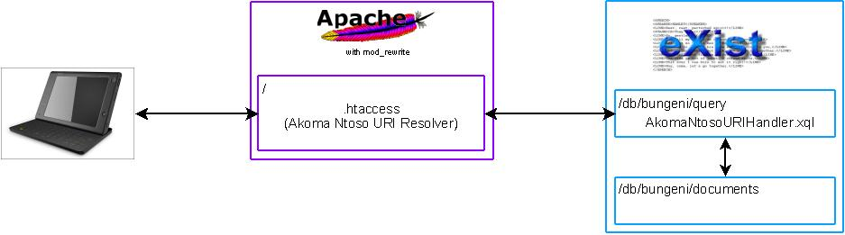
6.1 XQuery
The full code listing of the Akoma Ntoso URI Handler implemented in XQuery can be found in Appendix B.

The Akoma Ntoso URI Handler can handle URI parameters for Works, Expressions and Manifestations; although they are all mapped to Manifestations as these are the physical documents, these documents then detail the URI's of their Works and Expressions.

For a Work or an Expression the URI Handler is capable of returning either an XML 1.0 or XHTML 1.1 document describing and linking to their Expressions or Manifestations respectively. This is controlled by a URL query-string parameter called “output”, valid values are either “xml” (default) or “xhtml”. The transformations for producing the XHTML are in Appendix E.

6.1.1 Expressions of a Work
Given the URL Parameters for a Work, Akoma Ntoso URI's for all Expressions of that Work are returned to the user.

Expected URL Parameters are -
Name | Description | Example
uriType | The type of the Akoma Ntoso URI | work
country | The originating Country of the Work | zaf
type | The type of Work | act
date | The date of the Work | 2008-02-02
number | The number of the Work | 2

Example –
http://localhost:8088/rest/db/bungeni/query/AkomaNtosoURIHandler.xql?uriType=work&country=zaf&type=act&date=2008-02-02&number=2

6.1.2 Manifestations of an Expression
Given the URL Parameters for an Expression, Akoma Ntoso URI's for all Manifestations of that Expression are returned to the user.

Expected URL Parameters are -
Name | Description | Example
uriType | The type of the Akoma Ntoso URI | work
country | The originating Country of the Expression | zaf
type | The type of Expression | act
date | The date of the Expression | 2008-02-02
number | The number of the Expression | 2
lang | The language of an Expression | fr
version | The version of the Expression | 2008-03-02

Example –
http://localhost:8088/rest/db/bungeni/query/AkomaNtosoURIHandler.xql?uriType=work&country=zaf&type=act&date=2008-02-02&number=2&lang=2&version=2008-03-02

6.1.3 Manifestations
Given the URL Parameters for a Manifestation, the Manifestation itself is returned. Manifestation packages are also automatically created on-the-fly and returned if requested.

Expected URL Parameters are -
Name | Description | Example
uriType | The type of the Akoma Ntoso URI | work
country | The originating Country of the Expression | zaf
type | The type of Expression | act
date | The date of the Expression | 2008-02-02
number | The number of the Expression | 2
lang | The language of an Expression | fr
Version | The version of the Expression | 2008-03-02
dataformat | The data format of the Manifestation | xml

Example –
http://localhost:8088/rest/db/bungeni/query/AkomaNtosoURIHandler.xql?uriType=work&country=zaf&type=act&date=2008-02-02&number=2&lang=2&version=2008-03-02&dataformat=xml

6.1.4 Screen shots

Xquery results as XML:

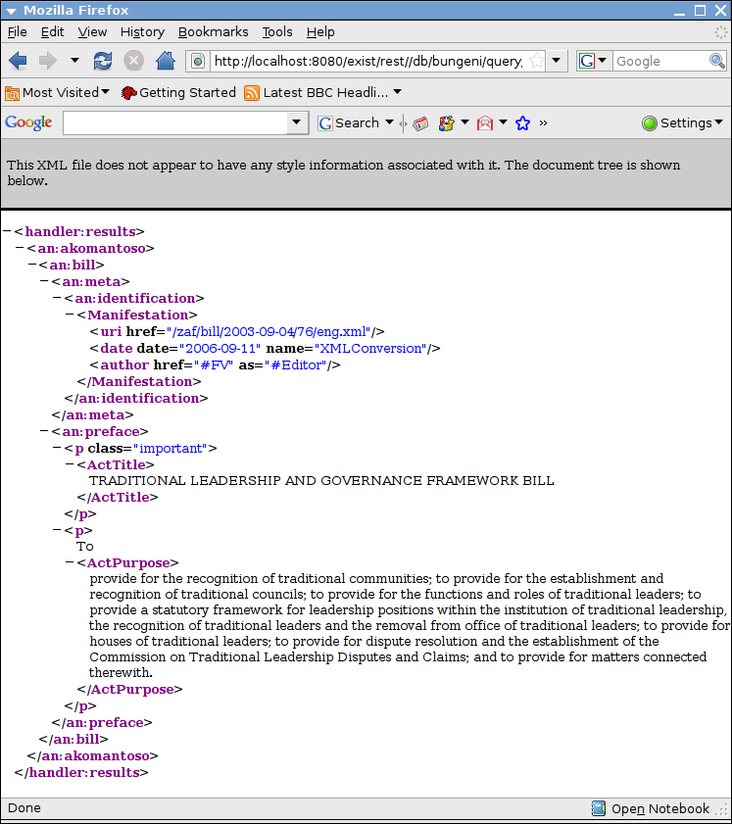
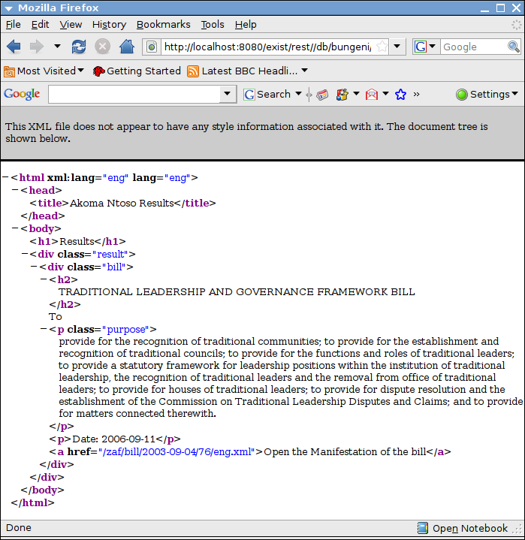
Xquery results as XHTML :

7. XQuery REST API
Whilst the Akoma Ntoso URI Handler detailed in Chapter 6 allows documents to be retrieved from the database, the ability to create new, edit and store documents (versioned or otherwise) is also required, for this purpose a simple REST API was written in XQuery.

7.1 Creating a new document
This is only suitable for XML documents, as detailed in the requirements. Binary documents may be stored directly into the database using a HTTP PUT with appropriate credentials. However this could be easily extended to also cope with Binary documents if desired.

To create a new document in the database, you POST the document to a URL of the following form:
http://localhost:8088/rest/db/bungeni/query/edit.xql?action=new&uri=<AkomaNtosoURI>

AkomaNtosoURI – this is the Akoma Ntoso URI of the document that you wish to store and should be equivalent to the Akoma Ntoso URI's expressed in the document itself.

A process diagram for creating a new document is expressed in Appendix C.1

7.2 Editing an existing document
To edit an existing document in the database, you GET the document using a URL of the following form:
http://localhost:8088/rest/db/bungeni/query/edit.xql?action=edit<&uri=AkomaNtosoURI>[&version=Version]

AkomaNtosoURI – this is the Akoma Ntoso URI of the document that you wish to retrieve for editing.
Version – If the user wishes to edit a versioned document, then they must provide the date of the new version they are creating.

Binary documents are returned directly to the user for editing, XML documents if they are not versioned are also returned directly to the user for editing.
If the XML document is of a versioned type (such as an Act) then the document is adjusted to reflect details of the new version (using the version provided in the request) before it is returned to the user for editing.

A process diagram for creating a new document is expressed in Appendix C.2

7.3 Saving an edited document
After editing a document, to save the document back to the database, you POST the edited document using a URL of the following form:
http://localhost:8088/rest/db/bungeni/query/edit.xql?action=edit<&uri=AkomaNtosoURI>[&version=Version]

AkomaNtosoURI – this is the original Akoma Ntoso URI of the document that you requested to edit.
Version – If the user wishes to save a versioned document, then this must provide the date of the new version they are saving. It should be the same value that was given for Editing the original version; Chapter 7.2.

A process diagram for creating a new document is expressed in Appendix C.3

Appendix A – catalog.xml
<catalog xmlns="urn:oasis:names:tc:entity:xmlns:xml:catalog">
<uri name="http://www.akomantoso.org/1.0" uri="xmldb:exist:///db/bungeni/grammar/akomantoso10.xsd"/>
</catalog>

Appendix B – Akoma Ntoso URI Handler XQuery

The Akoma Ntoso URI Handler XQuery consists of a main XQuery AkomaNtosoURIHandler.xql and two XQuery Modules which are shared with the XQuery REST API. Modules were used as it was decided this code could be useful and reusable for further XQuery development, the modules themselves are in Appendix C.

AkomaNtosoURIHandler.xql
(:~
: Copyright Adam Retter 2008 <adam.retter@googlemail.com>
:
: Akoma Ntoso URI Handler
:
: Designed to work as a receiver for the Akoma Ntoso URI Resolver
: written by Luca Cervone and Fabio Vitali of the University of Bologna
: available from http://akn.web.cs.unibo.it/
:
: @author Adam Retter <adam.retter@googlemail.com>
: @version 1.0
:)
xquery version "1.0";

(: eXist function namespaces :)
declare namespace compression = "http://exist-db.org/xquery/compression";
declare namespace request = "http://exist-db.org/xquery/request";
declare namespace response = "http://exist-db.org/xquery/response";
declare namespace util = "http://exist-db.org/xquery/util";
declare namespace xmldb = "http://exist-db.org/xquery/xmldb";

(: user defined namespaces :)
declare namespace an = "http://www.akomantoso.org/1.0";

(: user defined function modules :)
import module namespace config = "http://exist.bungeni.org/config" at "config.xqm";
import module namespace error = "http://exist.bungeni.org/error" at "error.xqm";

(:~
: Builds a Collection URI from Akoma Ntoso URI parameters
:
: @param $country the country code
: @param $type the document type
: @param $date the date of the document
: @return xs:string of the collection uri
:)
declare function local:buildCollectionURI($country as xs:string, $type as xs:string, $date as xs:string) as xs:string
{
concat($config:data_collection, "/", $country, "/", $type, "/", substring-before($date, "-"))
};

(:~
: Builds a relative Akoma Ntoso Work URI from Akoma Ntoso URI parameters
:
: @param $country the country code
: @param $type the document type
: @param $date the date of the document
: @paran $number the number of the document if any
: @return xs:string of the AkomaNtoso Work URI
:)
declare function local:buildWorkURI($country as xs:string, $type as xs:string, $date as xs:string, $number as xs:string?) as xs:string
{
concat("/", $country, "/", $type, "/", $date,
if($number)then
(
concat("/", $number)
)else()
)
};

(:~
: Builds a relative Akoma Ntoso Expression URI from Akoma Ntoso URI parameters
:
: @param $country the country code
: @param $type the document type
: @param $date the date of the document
: @param $number the number of the document (if any)
: @param $language the language of the document
: @param $version the version of the document (if any)
: @return xs:string of the Akoma Ntoso Expression URI
:)
declare function local:buildExpressionURI($country as xs:string, $type as xs:string, $date as xs:string, $number as xs:string?, $language as xs:string, $version as xs:string?) as xs:string
{
concat(
local:buildWorkURI($country, $type, $date, $number),
"/",
$language,
if($version eq "")then
(
(: first version :)
"@"
)
else if($version)then
(
(: specific version :)
concat("@", $version)
)
else
(
(: in-force version :)
)
)
};

(:~
: Builds a relative Akoma Ntoso Manifestation URI from Akoma Ntoso URI parameters
:
: @param $country the country code
: @param $type the document type
: @param $date the date of the document
: @param $number the number of the document (if any)
: @param $language the language of the document
: @param $version the version of the document (if any)
: @return xs:string of the Akoma Ntoso Manifestation URI
:)
declare function local:buildManifestationURI($country as xs:string, $type as xs:string, $date as xs:string, $number as xs:string?, $language as xs:string, $version as xs:string?) as xs:string
{
concat(local:buildExpressionURI($country, $type, $date, $number, $language, $version), ".xml")
};

(:~
: Returns Expressions of a Work
:
: Looks up manifestations based on their Work URI
: and returns the corresponding Expression URI
:
: @param $country the country code
: @param $type the document type
: @param $date the date of the Work
:
: @requestParam number The number of the Work
:
: @return one or more Expression elements
:)
declare function local:work($country as xs:string, $type as xs:string, $date as xs:string) as element()*
{
(: determine the collection URI :)
let $collectionURI := local:buildCollectionURI($country, $type, $date),

(: determine the work uri :)
$workURI := local:buildWorkURI($country, $type, $date, request:get-parameter("number", ())),

(: build an xpath to return the expressions of the work :)
$xpath := concat("collection(""", $collectionURI, """)/an:akomantoso/an:", $type, "/an:meta/an:identification[an:Work/an:uri/@href eq """, $workURI, """]/an:Expression") return

util:eval($xpath)
};

(:~
: Returns Manifestations of an Expression
:
: Looks up manifestations based on their Expression URI
: and returns the corresponding Manifestation URI
:
: @param $country the country code
: @param $type the document type
: @param $date the date of the Expression
:
: @requestParam number The number of the Expression
: @requestParam lang The language of the Expression
: @requestParam version The version of the Expression
:
: @return one or more Manifestation elements
:)
declare function local:expression($country as xs:string, $type as xs:string, $date as xs:string) as element()*
{
(: determine the collection URI :)
let $collectionURI := local:buildCollectionURI($country, $type, $date),

(: determine the expression uri :)
$expressionURI := local:buildExpressionURI($country, $type, $date, request:get-parameter("number", ()), request:get-parameter("lang", ()), request:get-parameter("version", ())),

(: build an xpath to return the expressions of the work :)
$xpath := concat("collection(""", $collectionURI, """)/an:akomantoso/an:", $type, "/an:meta/an:identification[an:Expression/an:uri/@href eq """, $expressionURI, """]/an:Manifestation") return

util:eval($xpath)
};

(:~
: Returns Manifestations
:
: Looks up manifestations based on their Manifestation URI
: and returns the corresponding Manifestation
:
: @param $country the country code
: @param $type the document type
: @param $date the date of the document
:
: @requestParam number The number of the Manifestation
: @requestParam lang The language of the Manifestation
: @requestParam version The version of the Manifestation
: @requestParam dataformat The data format of the Manifestation
:
: @return one or more XML Manifestations or if a Binary Manifestation it is streamed directly to the HTTP Response
:)
declare function local:manifestation($country as xs:string, $type as xs:string, $date as xs:string) as element()?
{
(: get the dataformat :)
let $dataformat := request:get-parameter("dataformat", ()),

(: determine the collection URI :)
$collectionURI := local:buildCollectionURI($country, $type, $date),

(: determine the manifestation uri :)
$manifestationURI := local:buildManifestationURI($country, $type, $date, request:get-parameter("number", ()), request:get-parameter("lang", ()), request:get-parameter("version", ())),

(: get the xml manifestation :)
$xmlManifestation := util:eval(concat("collection(""", $collectionURI, """)/an:akomantoso[an:", $type, "/an:meta/an:identification/an:Manifestation/an:uri/@href eq """, $manifestationURI, """]")) return

(: what sort of Manifestation do we want? :)
if($dataformat eq "xml")then
(
(: we want the XML Manifestation :)
$xmlManifestation
)
else
(
(: we want a Binary Manifestation :)

(: determine the filename of the binary manifestation :)
let $baseName := substring-before(util:document-name($xmlManifestation), "."),
$binaryManifestationFilename := concat($baseName, ".", $dataformat) return

(: check for a Manifestation package URI :)
if($dataformat eq $config:manifestation_package_extension)then
(
(: we want a Manifestation package, so find all suitable manifestations and package them up :)

(: stream a zip of all relevant resources to the http response :)
response:stream-binary(
compression:zip(
(: get a list of all resources in the collection :)
(
for $anResource in xmldb:get-child-resources($collectionURI)[starts-with(., $baseName)] return
xs:anyURI(concat($collectionURI, "/", $anResource))
),
false()
),
$config:manifestation_package_mimeType,
$binaryManifestationFilename
)
)
else
(
(: we want a specific binary Manifestation file :)

(: determine its URI in the db :)
let $binaryManifestationURI := concat($collectionURI, "/", $binaryManifestationFilename) return

(: stream the binary resource to the http response :)
response:stream-binary(util:binary-doc($binaryManifestationURI), xmldb:get-mime-type(xs:anyURI($binaryManifestationURI)), $binaryManifestationFilename)
)
)
};

(: main entry point - choose a function based on the uri type :)
if(request:get-parameter("uriType", ()))then
(
util:call(util:function(concat("local:", request:get-parameter("uriType",())),3), request:get-parameter("country",()), request:get-parameter("type",()), request:get-parameter("date",()))
)
else
(
(: invalid URI :)
error:response("Invalid URI", request:get-query-string())
)

Appendix C – XQuery REST API

The XQuery REST API consists of a main XQuery edit.xql and four XQuery Modules. Modules were used as it was decided this code could be useful and reusable for further XQuery development.

edit.xql
(:~
: Copyright Adam Retter 2008 <adam.retter@googlemail.com>
:
: Document Version Editor
:
: Designed to work as the server side component
: for client editing with Open Office
:
: @author Adam Retter <adam.retter@googlemail.com>
: @version 1.0
:)
xquery version "1.0";

(: eXist function namespaces :)
declare namespace request = "http://exist-db.org/xquery/request";
declare namespace response = "http://exist-db.org/xquery/response";
declare namespace transform = "http://exist-db.org/xquery/transform";
declare namespace util = "http://exist-db.org/xquery/util";
declare namespace xmldb = "http://exist-db.org/xquery/xmldb";

(: user defined namespaces :)
declare namespace an = "http://www.akomantoso.org/1.0";

(: user defined function modules :)
import module namespace config = "http://exist.bungeni.org/config" at "config.xqm";
import module namespace db = "http://exist.bungeni.org/util/db" at "db.xqm";
import module namespace error = "http://exist.bungeni.org/error" at "error.xqm";
import module namespace uri = "http://exist.bungeni.org/util/uri" at "uri.xqm";

(:~
: Determines whether the document type is versioned
:
: @param akomantoso The akomantoso node from the xml document, for a binary document use the corresponding xml document
: @return xs:boolean true() if the documentType is versioned
:)
declare function local:isVersionedDocumentType($akomantoso as node()+) as xs:boolean
{

node-name($akomantoso/child::node()) = $config:versionedDocumentTypes
};

(:~
: Simple Manifestation URI Resolver
: Given an Akoma Ntoso Manifestation URI the corresponding DB URI is returned
:
: @param akomantosoURI The Akoma Ntoso Manifestation URI
: @return the db URI of the Manifestation
:)
declare function local:ANManifestationURIToDBURI($akomantosoURI as xs:string) as xs:string?
{
let $uriComponents := tokenize($akomantosoURI, "/") return
concat(
$config:data_collection,
"/",
$uriComponents[2],
"/",
$uriComponents[3],
"/",
substring-before($uriComponents[4], "-"),
"/",
substring-after($uriComponents[4], "-"),
"_",
$uriComponents[5],
"_",
$uriComponents[6]
)
};

(:~
: Adds a version to a Manifestation URI
: if a version already exists then it is replaced with the value
: of the version parameter
:
: @param manifestationURI The Akoma Ntoso Manifestation URI to add the version to
: @param version The version to add
: @return The manifestationURI with the specified version
:)
declare function local:manifestationURIWithVersion($manifestationURI as xs:string, $version as xs:string) as xs:string
{
if(contains($manifestationURI, "@"))then
(
replace($manifestationURI, "(.*)@.*(\..*)", concat("$1@", $version, "$2"))
)
else
(
replace($manifestationURI, "(.*)(\..*)", concat("$1@", $version, "$2"))
)
};

(:~
: Returns an Expression URI given a Manifestation URI
:
: @param Manifestation URI
: @return Expression URI
:)
declare function local:expressionURIFromManifestationURI($manifestationURI as xs:string) as xs:string
{
replace($manifestationURI, "(.*)(\.)(.*)", "$1")
};

(:~
: Retreives a document for editing
:
: Binary documents are returned directly to the user
: XML documents if they are not versioned are returned directly to the user for editing,
: if the XML document is of a versioned type (such as an Act) then the
: document is adjusted to reflect details of the new version before it is returned to the user for editing.
:
: @param originalURI The Akoma Ntoso URI of the document to retreive for editing
: @param versionDate The new version date for the document (only used for XML documents that are a versioned type)
: @return The XML un-versioned document or otherwise the XML or binary document is streamed directly to the HTTP Response, otherwise an error element
:)
declare function local:edit($originalURI as xs:string, $versionDate as xs:string?) as element()?
{
(: are we editing a xml or binary document? :)
if(ends-with($originalURI, ".xml"))then
(
(: XML Document :)

(: get the document to edit :)
let $xmlDoc := collection($config:data_collection)/an:akomantoso[child::node()/an:meta/an:identification/an:Manifestation/an:uri/@href eq $originalURI] return

(: is the document a versioned type? :)
if(local:isVersionedDocumentType($xmlDoc))then
(
if($versionDate)then
(
(: prepare a new version of the XML document and stream it to the http response :)
transform:stream-transform(
$xmlDoc,
doc(concat($config:transformation_collection, "/editVersionedDocumentType.xslt")),
<parameters>
<param name="versionDate" value="{$versionDate}"/>
<param name="originalURI" value="{$originalURI}"/>
</parameters>
)
)
else
(
(: versioned document, but no version provided :)
error:response("You are trying to edit a versioned document, but no version was provided", $originalURI)
)
)
else
(
(: return the un-versioned XML document :)
$xmlDoc
)
)
else
(
(: Binary Document :)

(: stream the binary document to the response :)
let $dbBinaryDocURI := local:ANManifestationURIToDBURI($originalURI) return
response:stream-binary(util:binary-doc($dbBinaryDocURI), xmldb:get-mime-type(xs:anyURI($dbBinaryDocURI)), ())
)
};

(:~
: Determines if a document is a valid version
:
: @param $akomantoso The akomantoso node of the document
: @param $originalURI The Manifestation URI of the original document of which this is a version
: @param $versionDate The date of this version
: @return <true/> if a valid version, otherwise <false>error message</false>
:)
declare function local:isValidVersion($akomantoso as node(), $originalURI, $versionDate as xs:string) as element()
{
let $originalVersion := doc(local:ANManifestationURIToDBURI($originalURI)) return

(:
2) the <act> container of the new version has a "contains" attribute, this must be set to "SingleVersion"
<act contains="SingleVersion">
:)
if($akomantoso/an:act/@contains eq "SingleVersion")then
(
(:
3) the work/expression/manifestation element's HREF references in the <identification> block HREF references must be changed
:)
if($akomantoso/an:act/an:meta/an:identification/an:Work/an:uri/@href eq $originalVersion/an:akomantoso/an:act/an:meta/an:identification/an:Work/an:uri/@href)then
(
let $newURI := local:manifestationURIWithVersion($originalURI, $versionDate) return

if($akomantoso/an:act/an:meta/an:identification/an:Expression/an:uri/@href eq local:expressionURIFromManifestationURI($newURI))then
(
if($akomantoso/an:act/an:meta/an:identification/an:Manifestation/an:uri/@href eq $newURI)then
(
(:
4) A reference to the original document must be added in the <references> section of the document...
<references source="#au1">
<Original id="ro1" href="ken/act/1997-08-22/3/en/main" showAs="Original"/>
</references>
:)
if($akomantoso/an:act/an:meta/an:references/an:Original/@href eq $originalURI)then
(
<true/>
)
else
(
<false>Act documents reference to the original document is invalid</false>
)
)
else
(
<false>Act documents Manifestation uri is invalid</false>
)
)
else
(
<false>Act documents Expression uri is invalid</false>
)
)
else
(
<false>Act documents Work uri is invalid</false>
)
)
else
(
<false>Act document is not a single version</false>
)
};

(:~
: Stores an edited document
:
: Binary documents are stored and returned to the user
: XML documents if they are not versioned are stored and returned to the user
: If the XML doument is of a versioned type (such as an Act) then the
: document is checked to make sure it is a valid version before it is stored and returned to the user
:
: @param originalURI The Akoma Ntoso URI of the original document that was edited
: @param versionDate The new version date of this document (only used for XML documents that are a versioned type or versioned Binary documents)
: @param data The HTTP POST data, i.e. the document to Save
: @return The stored XML document or otherwise if a Binary document it is streamed directly to the HTTP Response, otherwise an error element
:)
declare function local:save($originalURI as xs:string, $versionDate as xs:string?, $data) as node()?
{
(: are we saving an xml or binary document? :)
if(ends-with($originalURI, ".xml"))then
(
(: XML Document :)

(: if(local:isVersionedDocumentType($data//an:akomantoso))then :) (: buggy with in-memory nodes - SF Bug ID - 1758589 :)
if(node-name($data/child::node()[position() eq 2]) = $config:versionedDocumentTypes)then (: temporary work around :)
(
if($versionDate)then
(
(: versioned XML document :)
let $valid := local:isValidVersion($data, $originalURI, $versionDate) return
if(node-name($valid) eq xs:QName("true"))then
(
(: save the versioned XML document :)
let $dbNewXMLDocURI := local:ANManifestationURIToDBURI(local:manifestationURIWithVersion($originalURI, $versionDate)),
$storedURI := xmldb:store(
uri:collectionURIFromResourceURI($dbNewXMLDocURI),
uri:resourceNameFromResourceURI($dbNewXMLDocURI),
$data
) return

(: return the stored document :)
doc($storedURI)
)
else
(
error:response($valid, $originalURI)
)
)
else
(
(: versioned document, but no version provided :)
error:response("You are trying to edit a versioned document, but no version was provided", $originalURI)
)
)
else
(
(: save the un-versioned XML document :)
let $dbNewXMLDocURI := local:ANManifestationURIToDBURI($originalURI),
$storedURI := xmldb:store(
uri:collectionURIFromResourceURI($dbNewXMLDocURI),
uri:resourceNameFromResourceURI($dbNewXMLDocURI),
$data
) return

(: return the stored document :)
doc($storedURI)
)
)
else
(
(: Binary Document :)
let $dbOriginalBinaryDocURI := local:ANManifestationURIToDBURI($originalURI) return

(: determine the db uri for storing the binary document :)
let $dbNewBinaryDocURI := if($versionDate)then
(
(: new binary versioned document :)
local:ANManifestationURIToDBURI(local:manifestationURIWithVersion($originalURI, $versionDate))
)
else
(
(: un-versioned binary document :)
$dbOriginalBinaryDocURI
)
return

(: store the document :)
let $storedURI := xmldb:store(
uri:collectionURIFromResourceURI($dbNewBinaryDocURI),
uri:resourceNameFromResourceURI($dbNewBinaryDocURI),
$data,
xmldb:get-mime-type(xs:anyURI($dbOriginalBinaryDocURI))
) return

(: return the stored document :)
response:stream-binary(util:binary-doc($storedURI), xmldb:get-mime-type(xs:anyURI($storedURI)),())
)
};

(:~
: Stores a new document
:
: Currently this only supports XML documents
: The expression uri in the document is checked against the provided Akoma Ntoso URI
: If the document already exists then an error is thrown.
:
: @param newURI The Akoma Ntoso URI for the new document
: @param data The HTTP POST data, i.e. the document to Save
: @return The stored XML document or otherwise an error element
:)
declare function local:new($newURI as xs:string, $data) as node()
{
(: check the expression uri matches the suggested uri :)
if($data/child::node()/an:meta/an:identification/an:Expression/an:uri/@href eq local:expressionURIFromManifestationURI($newURI))then
(
let $dbNewXMLDocURI := local:ANManifestationURIToDBURI($newURI) return

(: check the document does not already exist in the db :)
if(doc-available($dbNewXMLDocURI))then
(
error:response("Document already exists in the database, cannot overwrite!", $newURI)
)
else
(
(: create an appropriate collection (if needed) :)
let $collectionPath := uri:collectionURIFromResourceURI($dbNewXMLDocURI),
$null := db:createCollectionsFromPath($collectionPath),

(: store the document :)
$storedURI := xmldb:store(
$collectionPath,
uri:resourceNameFromResourceURI($dbNewXMLDocURI),
$data
) return

(: return the stored document :)
doc($storedURI)
)
)
else
(
(: expression uri in the document does not correspond to the provided manifestation uri :)
error:response("Expression URI in the New document does not correspond to the provided Manifestation URI", $newURI)
)
};

(: main entry point - choose a function based on the uri :)
if(request:get-parameter("action",()) eq "save" and request:get-parameter("uri",()) and request:get-method() eq "POST")then
(
(: save an edited document, document should be in the POST body :)
local:save(request:get-parameter("uri",()), request:get-parameter("version",()), request:get-data())
)
else if(request:get-parameter("action",()) eq "new" and request:get-parameter("uri",()) and request:get-method() eq "POST")then
(
(: create a new document, document should be in the POST body :)
local:new(request:get-parameter("uri",()), request:get-data())
)
else
(
if(request:get-parameter("uri",()))then
(
(: edit a document :)
local:edit(request:get-parameter("uri",()), request:get-parameter("version",()))
)
else
(
error:response("Editing a document requires a uri", ())
)
)

config.xqm
(:~
: Copyright Adam Retter 2008 <adam.retter@googlemail.com>
:
: Bungeni Configuration settings
:
: @author Adam Retter <adam.retter@googlemail.com>
: @version 1.0
:)

module namespace config = "http://exist.bungeni.org/config";

(: user defined namespaces :)
declare namespace an = "http://www.akomantoso.org/1.0";

(: collections in the database :)
declare variable $config:bungeni_collection as xs:string := "/db/bungeni";
declare variable $config:data_collection as xs:string := concat($config:bungeni_collection, "/data");
declare variable $config:transformation_collection as xs:string := concat($config:bungeni_collection, "/transformation");

(: file extension for the manifestation package file :)
declare variable $config:manifestation_package_extension as xs:string := "akn";
(: mime type for the manifestation package file :)
declare variable $config:manifestation_package_mimeType as xs:string := "applicatiopn/zip";

(: document types that are versioned, currently only acts :)
declare variable $config:versionedDocumentTypes as xs:QName+ := ( xs:QName("an:act"));

db.xqm
(:~
: Copyright Adam Retter 2008 <adam.retter@googlemail.com>
:
: Bungeni Configuration settings
:
: @author Adam Retter <adam.retter@googlemail.com>
: @version 1.0
:)

module namespace db = "http://exist.bungeni.org/util/db";

declare namespace xmldb = "http://exist-db.org/xquery/xmldb";
declare namespace util = "http://exist-db.org/xquery/util";

import module namespace uri = "http://exist.bungeni.org/util/uri" at "uri.xqm";

(:~
: Recursively creates collections to create a collection matching the provided path
:
: @param collectionPath
: @return The sequence of collection paths created
:)
declare function db:createCollectionsFromPath($collectionPath as xs:string) as xs:string*
{
if(xmldb:collection-exists($collectionPath))then
()
else
(
let $parentCollection := uri:collectionURIFromResourceURI($collectionPath),
$collectionName : = uri:resourceNameFromResourceURI($collectionPath) return

if(xmldb:collection-exists($parentCollection))then
(
(: creates the root collection :)
xmldb:create-collection($parentCollection, $collectionName)
)
else
(
(: creates parent and self collection(s) :)
db:createCollectionsFromPath($parentCollection),
xmldb:create-collection($parentCollection, $collectionName)
)
)
};

error.xqm
(:~
: Copyright Adam Retter 2008 <adam.retter@googlemail.com>
:
: Bungeni Configuration settings
:
: @author Adam Retter <adam.retter@googlemail.com>
: @version 1.0
:)

module namespace error = "http://exist.bungeni.org/error";

declare function error:response($message as xs:string, $uri as xs:string?) as element()
{
<error>
<message>{$message}</message>
<params>
<uri>{$uri}</uri>
</params>
</error>
};

uri.xqm
(:~
: Copyright Adam Retter 2008 <adam.retter@googlemail.com>
:
: Bungeni URI Utilities
:
: @author Adam Retter <adam.retter@googlemail.com>
: @version 1.0
:)

module namespace uri = "http://exist.bungeni.org/util/uri";

(:~
: Returns the db Collection URI from a db Resource URI
:
: @param resourceURI The URI of the resource in the db
: @return The Collection part of the Resource URI
:)
declare function uri:collectionURIFromResourceURI($resourceURI as xs:string) as xs:string
{
replace($resourceURI, "(.*)/.*", "$1")
};

(:~
: Returns the Resource filename from a db Resource URI
:
: @param resourceURI The URI of the resource in the db
: @return The filename part of the Resource URI
:)
declare function uri:resourceNameFromResourceURI($resourceURI as xs:string) as xs:string
{
replace($resourceURI, ".*/", "")
};

Appendix C.1 – Process Diagram for New
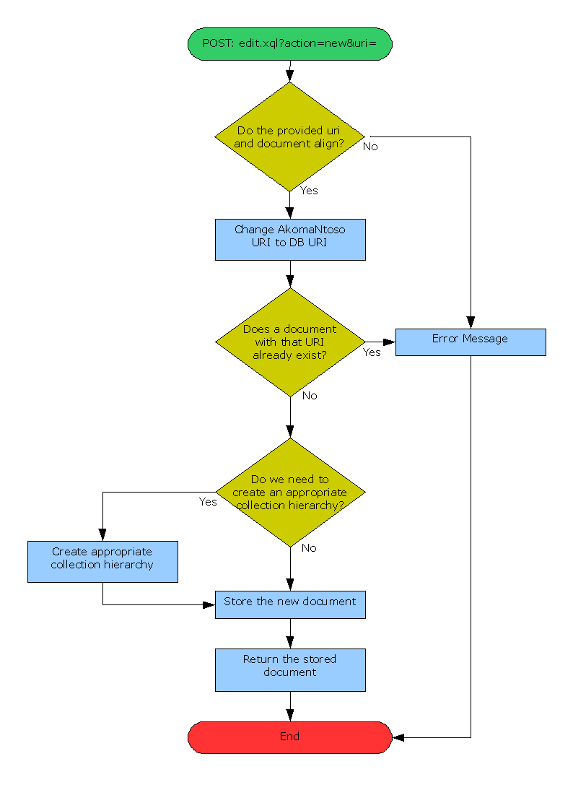

Appendix C.2 – Process Diagram for Edit
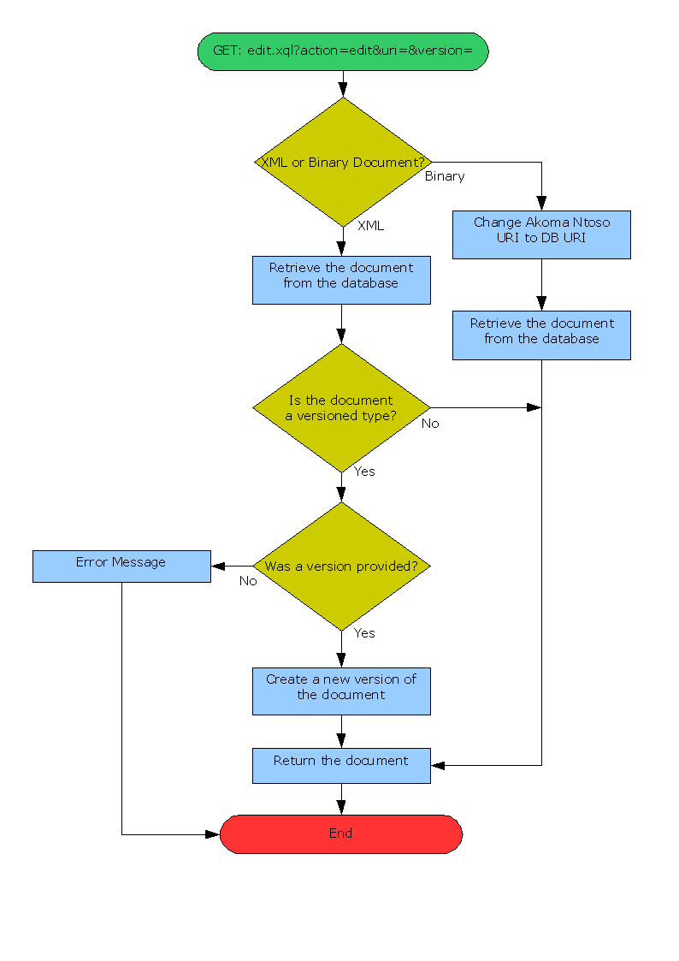

Appendix C.3 – Process Diagram for Save
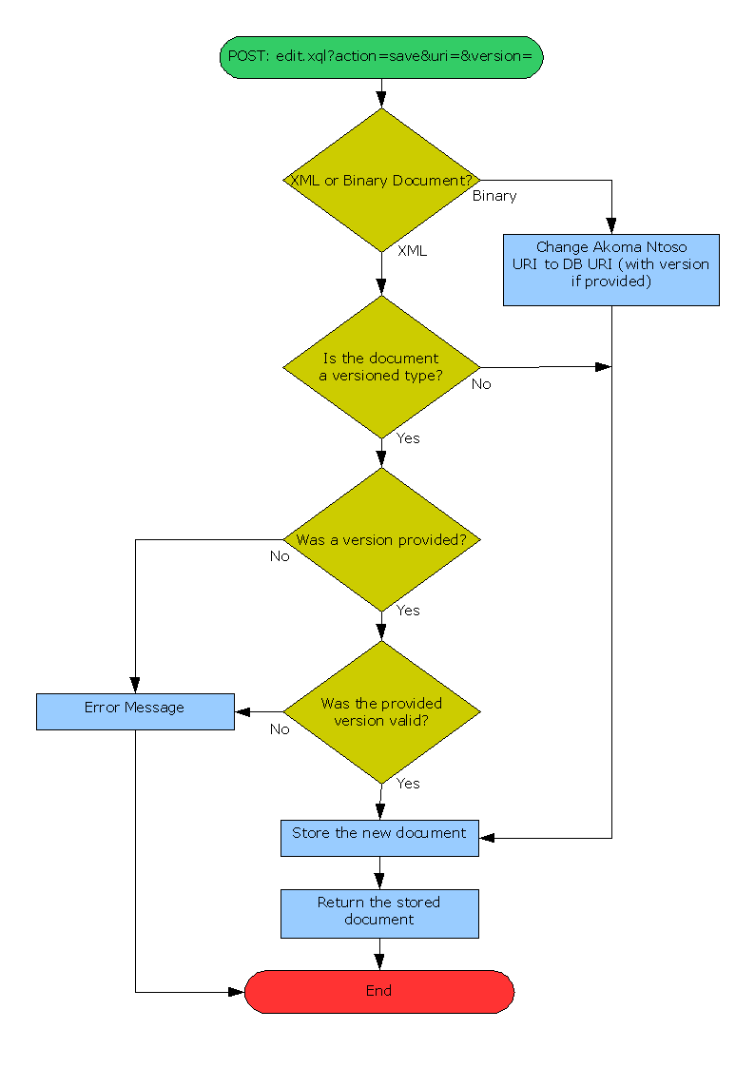

Appendix D – XQuery REST API Unit Tests
package uk.co.adamretter.consultancy.un.desa.bungeni.test.edit;

/**
* Copyright Adam Retter 2008 <adam.retter@googlemail.com>
*/

import junit.framework.TestCase;

import org.apache.commons.httpclient.Credentials;
import org.apache.commons.httpclient.HttpClient;
import org.apache.commons.httpclient.NameValuePair;
import org.apache.commons.httpclient.UsernamePasswordCredentials;
import org.apache.commons.httpclient.auth.AuthScope;
import org.apache.commons.httpclient.methods.ByteArrayRequestEntity;
import org.apache.commons.httpclient.methods.GetMethod;
import org.apache.commons.httpclient.methods.PostMethod;
import java.io.IOException;

/**
* Test harness for Bungeni XQuery REST API
* http://localhost:8088/db/bungeni/query/edit.xql
*
* @author Adam Retter <adam.retter@googlemail.com>
* @version 1.0
*/
public class EditTest extends TestCase
{

private final static int HTTP_OK = 200;
private final static int HTTP_NOT_FOUND = 404;
private final static String EDIT_URL = "http://localhost:8088/db/bungeni/query/edit.xql";
//private final static String EDIT_URL = "http://localhost:8080/exist/servlet/db/bungeni/query/edit.xql";

private final static String ADMIN_USERNAME = "admin";
private final static String ADMIN_PASSWORD = "admin";

private final static String NEW_DOCUMENT_URI = "/ken/act/2008-02-07/1/eng.xml";
private final static String NEW_DOCUMENT =
"<?xml version=\"1.0\" encoding=\"UTF-8\"?>"
+ "<akomantoso xmlns=\"http://www.akomantoso.org/1.0\" xmlns:cirsfid=\"http://www.cirsfid.unibo.it/proprietary\" xmlns:xsi=\"http://www.w3.org/2001/XMLSchema-instance\">"
+ "<act contains=\"OriginalVersion\">"
+ "<meta>"
+ "<identification source=\"#ar1\">"
+ "<Expression>"
+ "<uri href=\"/ken/act/2008-02-07/1/eng\"/>"
+ "</Expression>"
+ "</identification>"
+ "</meta>"
+ "</act>"
+ "</akomantoso>";

/**
* Attempts to store a NEW XML document
* checks the returned document is the same as the posted document
*/
public void testXMLNewDocument()
{
HttpClient http = new HttpClient();
int status = HTTP_NOT_FOUND;

//username and password
Credentials adminCreds = new UsernamePasswordCredentials(ADMIN_USERNAME, ADMIN_PASSWORD);
http.getState().setCredentials(AuthScope.ANY, adminCreds);
http.getParams().setAuthenticationPreemptive(true);

byte[] newDocument = NEW_DOCUMENT.getBytes();
byte[] postDocument = null;
PostMethod post = new PostMethod(EDIT_URL);

post.setDoAuthentication(true);
NameValuePair qsPostParams[] = {
new NameValuePair("action", "new"),
new NameValuePair("uri", NEW_DOCUMENT_URI)
};
post.setQueryString(qsPostParams);
post.setRequestEntity(new ByteArrayRequestEntity(newDocument, "text/xml"));

try
{
status = http.executeMethod(post);

System.out.println(post.getResponseBodyAsString());
assertEquals("POST Request did not return OK", HTTP_OK, status);

postDocument = post.getResponseBody();
post.releaseConnection();
}
catch(IOException ioe)
{
ioe.printStackTrace();
fail(ioe.getMessage());
}
}

/**
* GETs an XML un-versioned document
* and then POSTs it back to the server
* it checks that the documents content
* is the same between the GET response and POST response
*/
public void XtestXMLDocumentVersioned()
{
final String XML_ACT_URI = "/ken/act/1997-08-22/3/eng.xml";
String newVersion = "2007-01-01";

HttpClient http = new HttpClient();
int status = HTTP_NOT_FOUND;

//GET the XML document
byte getDocument[] = null;
GetMethod get = new GetMethod(EDIT_URL);

//set the querystring
NameValuePair qsGetParams[] = {
new NameValuePair("uri", XML_ACT_URI),
new NameValuePair("version", newVersion)
};
get.setQueryString(qsGetParams);

try
{
status = http.executeMethod(get);
assertEquals("GET Request did not return OK", HTTP_OK, status);

getDocument = get.getResponseBody();

//release the connection
get.releaseConnection();

assertTrue("No Response document", getDocument != null);
assertTrue("No Response document", getDocument.length != 0);
}
catch(IOException ioe)
{
ioe.printStackTrace();
fail(ioe.getMessage());
}

//POST the updated XML document
byte[] postDocument = null;
PostMethod post = new PostMethod(EDIT_URL);
NameValuePair qsPostParams[] = {
new NameValuePair("action", "save"),
new NameValuePair("uri", XML_ACT_URI),
new NameValuePair("version", newVersion)
};
post.setQueryString(qsPostParams);
post.setRequestEntity(new ByteArrayRequestEntity(getDocument, "text/xml"));

try
{
status = http.executeMethod(post);
assertEquals("POST Request did not return OK", HTTP_OK, status);

System.out.println(post.getResponseBodyAsString());

postDocument = post.getResponseBody();
post.releaseConnection();

assertEquals("Received document is not the same as the saved document", getDocument.length, postDocument.length);
for(int i = 0; i < getDocument.length; i++)
{
assertTrue("Received document is not the same as the saved document", getDocument[i] == postDocument[i]);
}
}
catch(IOException ioe)
{
ioe.printStackTrace();
fail(ioe.getMessage());
}
}

/**
* GETs a binary un-versioned document
* and then POSTs it back to the server
* it checks that the documents content
* is the same between the GET response and POST response
*/
public void XtestBinaryDocumentNotVersioned()
{
final String BINARY_ACT_URI = "/ken/act/1997-08-22/3/eng.doc";

HttpClient http = new HttpClient();
int status = HTTP_NOT_FOUND;

//GET the binary document
byte getDocument[] = null;
GetMethod get = new GetMethod(EDIT_URL);

//set the querystring
NameValuePair qsGetParams[] = {
new NameValuePair("uri", BINARY_ACT_URI),
};
get.setQueryString(qsGetParams);

try
{
status = http.executeMethod(get);
assertEquals("GET Request did not return OK", HTTP_OK, status);

getDocument = get.getResponseBody();

//release the connection
get.releaseConnection();

assertTrue("No Response document", getDocument != null);
assertTrue("No Response document", getDocument.length != 0);
}
catch(IOException ioe)
{
ioe.printStackTrace();
fail(ioe.getMessage());
}

//POST the updated binary document
byte[] postDocument = null;
PostMethod post = new PostMethod(EDIT_URL);
NameValuePair qsPostParams[] = {
new NameValuePair("action", "save"),
new NameValuePair("uri", BINARY_ACT_URI),
};
post.setQueryString(qsPostParams);
post.setRequestEntity(new ByteArrayRequestEntity(getDocument, get.getResponseHeader("Content-Type").getValue()));

try
{
status = http.executeMethod(post);
assertEquals("POST Request did not return OK", HTTP_OK, status);

postDocument = post.getResponseBody();

assertEquals("Received document is not the same as the saved document", getDocument.length, postDocument.length);
for(int i = 0; i < getDocument.length; i++)
{
assertTrue("Received document is not the same as the saved document", getDocument[i] == postDocument[i]);
}

post.releaseConnection();
}
catch(IOException ioe)
{
ioe.printStackTrace();
fail(ioe.getMessage());
}
}

/**
* GETs a binary versioned document
* and then POSTs it back to the server
* it checks that the new version of the document
* has the same content as the original version
*/
public void XtestBinaryDocumentVersioned()
{
final String BINARY_ACT_URI = "/ken/act/1997-08-22/3/eng.doc";
String newVersion = "2007-01-01";

HttpClient http = new HttpClient();
int status = HTTP_NOT_FOUND;

//GET the binary document
byte getDocument[] = null;
GetMethod get = new GetMethod(EDIT_URL);

//set the querystring
NameValuePair qsGetParams[] = {
new NameValuePair("uri", BINARY_ACT_URI),
new NameValuePair("version", newVersion)
};
get.setQueryString(qsGetParams);

try
{
status = http.executeMethod(get);
assertEquals("GET Request did not return OK", HTTP_OK, status);

getDocument = get.getResponseBody();

//release the connection
get.releaseConnection();

assertTrue("No Response document", getDocument != null);
assertTrue("No Response document", getDocument.length != 0);
}
catch(IOException ioe)
{
ioe.printStackTrace();
fail(ioe.getMessage());
}

//POST the updated binary document
byte[] postDocument = null;
PostMethod post = new PostMethod(EDIT_URL);
NameValuePair qsPostParams[] = {
new NameValuePair("action", "save"),
new NameValuePair("uri", BINARY_ACT_URI),
new NameValuePair("version", newVersion)
};
post.setQueryString(qsPostParams);
post.setRequestEntity(new ByteArrayRequestEntity(getDocument, get.getResponseHeader("Content-Type").getValue()));

try
{
status = http.executeMethod(post);
assertEquals("POST Request did not return OK", HTTP_OK, status);

postDocument = post.getResponseBody();
post.releaseConnection();

assertEquals("Received document is not the same as the saved document", getDocument.length, postDocument.length);
for(int i = 0; i < getDocument.length; i++)
{
assertTrue("Received document is not the same as the saved document", getDocument[i] == postDocument[i]);
}
}
catch(IOException ioe)
{
ioe.printStackTrace();
fail(ioe.getMessage());
}
}
}

Running the Unit tests

The unit tests are provided as an Eclipse Project.
To run the unit tests :
- Download and install Eclipse (http://www.eclipse.org)
- Load the sample database into eXist
- Start eXist in server mode : ./bin/server.sh from the eXist root folder
- Run the unit tests

Appendix E – XQuery REST API XHTML 1.1 Transformations

The XQuery REST API XHTML 1.1 Transformations consist of a main XSLT AkomaNtosoURIHandler_results.xslt and an included error.xslt which is used for transforming error messages and may be included in any other XSLT.

AkomaNtosoURIHandler_results.xslt
<?xml version="1.0" encoding="UTF-8"?>
<xsl:stylesheet xmlns:xsl="http://www.w3.org/1999/XSL/Transform" xmlns:handler="http://exist.bungeni.org/query/AkomaNtosoURIHandler" xmlns:an="http://www.akomantoso.org/1.0" version="2.0">
<!--
Copyright Adam Retter 2008 <adam.retter@googlemail.com>

Akoma Ntoso URI Handler Results Transformation for XML 1.0 to XHTML 1.1

Author: Adam Retter
Version: 1.0
-->
<xsl:output encoding="UTF-8" doctype-public="-//W3C//DTD XHTML 1.1//EN" doctype-system="http://www.w3.org/TR/xhtml11/DTD/xhtml11.dtd" indent="yes" omit-xml-declaration="no" method="xhtml" media-type="text/html"/>
<xsl:include href="error.xslt"/>

<xsl:template match="handler:results">
<html xml:lang="eng" lang="eng">
<head>
<title>Akoma Ntoso Results</title>
</head>
<body>
<h1>Results</h1>
<xsl:apply-templates/>
</body>
</html>
</xsl:template>

<xsl:template match="an:akomantoso">
<div class="result">
<xsl:apply-templates/>
</div>
</xsl:template>

<xsl:template match="an:act | an:bill | an:debaterecord | an:minutes | an:tabled">
<div class="{local-name(.)}">
<xsl:apply-templates/>
<p>Date: <xsl:value-of select="an:meta/an:identification//an:date/@date"/></p>
<a href="{an:meta/an:identification//an:uri/@href}">Open the <xsl:value-of select="local-name(an:meta/an:identification/child::element())"/> of the <xsl:value-of select="local-name(.)"/></a>
</div>
</xsl:template>

<xsl:template match="an:preface">
<xsl:apply-templates/>
</xsl:template>

<xsl:template match="an:p">
<xsl:apply-templates/>
</xsl:template>

<xsl:template match="an:ActTitle">
<h2><xsl:value-of select="."/></h2>
</xsl:template>

<xsl:template match="an:ActPurpose">
<p class="purpose"><xsl:value-of select="."/></p>
</xsl:template>

</xsl:stylesheet>

error.xslt
<?xml version="1.0" encoding="UTF-8"?>
<xsl:stylesheet xmlns:xsl="http://www.w3.org/1999/XSL/Transform" xmlns:error="http://exist.bungeni.org/query/error" version="2.0">
<!--
Copyright Adam Retter 2008 <adam.retter@googlemail.com>

Akoma Ntoso Error Message Transformation for XML 1.0 to XHTML 1.1

Author: Adam Retter
Version: 1.0
-->
<xsl:output encoding="UTF-8" doctype-public="-//W3C//DTD XHTML 1.1//EN" doctype-system="http://www.w3.org/TR/xhtml11/DTD/xhtml11.dtd" indent="yes" omit-xml-declaration="no" method="xhtml" media-type="text/html"/>

<xsl:template match="error:error">
<div class="error">
<h1>An Error Has Occured</h1>
<xsl:apply-templates/>
</div>
</xsl:template>

<xsl:template match="error:message">
<p class="errorMessage"><xsl:value-of select="."/></p>
<xsl:apply-templates/>
</xsl:template>

<xsl:template match="error:params">
<div class="errorParams">
<h2></h2>
<ul>
<xsl:for-each select="child::element()">
<li><xsl:value-of select="local-name(.)"/>: <xsl:value-of select="."/></li>
</xsl:for-each>
</ul>
</div>
</xsl:template>

</xsl:stylesheet>

Appendix F – Updating eXist to XSLT 2.0

(source : http://atomic.exist-db.org/HowTo/XSLT2/ )

1.2 eXist Configuration

In the eXist configuration file EXIST_HOME/conf.xml find the configuration section for the transformer and change:
view plainprint?

1. <transformer class="org.apache.xalan.processor.TransformerFactoryImpl" />

<transformer class="org.apache.xalan.processor.TransformerFactoryImpl" />

to:

1. <transformer class="net.sf.saxon.TransformerFactoryImpl" />

<transformer class="net.sf.saxon.TransformerFactoryImpl" />

1.3 Cocoon Changes (Optional)

If you also wish for Cocoon to use Saxon instead of Xalan, you will also need to make changes to two Cocoon configuration files.

1.3.1 cocoon.xconf

Typically this is found in EXIST_HOME/webapp/WEB-INF

In the XSLT Processor section, comment out the two elements for configuring Xalan xslt and Xalan xsltc, e.g. -

1. <!--+
2. | XSLT Processor using xsltc from Xalan
3. | For Interpreted Xalan use:
4. | <transformer-factory>org.apache.xalan.processor.TransformerFactoryImpl</transformer-factory>
5. +-->
6. <!--
7. <component class="org.apache.excalibur.xml.xslt.XSLTProcessorImpl" logger="core.xslt-processor" role="org.apache.excalibur.xml.xslt.XSLTProcessor/xsltc">
8. <parameter name="use-store" value="true"/>
9. <parameter name="transformer-factory" value="org.apache.xalan.xsltc.trax.TransformerFactoryImpl"/>
10. </component>
11. -->
12.
13. <!--+
14. | Xalan XSLT Processor
15. +-->
16. <!--
17. <component class="org.apache.excalibur.xml.xslt.XSLTProcessorImpl" logger="core.xslt-processor" role="org.apache.excalibur.xml.xslt.XSLTProcessor/xalan">
18. <parameter name="use-store" value="true"/>
19. <parameter name="incremental-processing" value="false"/>
20. <parameter name="transformer-factory" value="org.apache.xalan.processor.TransformerFactoryImpl"/>
21. </component>
22. -->

<!--+ | XSLT Processor using xsltc from Xalan | For Interpreted Xalan use: | <transformer-factory>org.apache.xalan.processor.TransformerFactoryImpl</transformer-factory> +--> <!-- <component class="org.apache.excalibur.xml.xslt.XSLTProcessorImpl" logger="core.xslt-processor" role="org.apache.excalibur.xml.xslt.XSLTProcessor/xsltc"> <parameter name="use-store" value="true"/> <parameter name="transformer-factory" value="org.apache.xalan.xsltc.trax.TransformerFactoryImpl"/> </component> --> <!--+ | Xalan XSLT Processor +--> <!-- <component class="org.apache.excalibur.xml.xslt.XSLTProcessorImpl" logger="core.xslt-processor" role="org.apache.excalibur.xml.xslt.XSLTProcessor/xalan"> <parameter name="use-store" value="true"/> <parameter name="incremental-processing" value="false"/> <parameter name="transformer-factory" value="org.apache.xalan.processor.TransformerFactoryImpl"/> </component> -->

Then uncomment the element for configuring Saxon, and make sure the transformer-factory parameter is set correctly, as below -

1. <!--+
2. | Saxon XSLT Processor
3. | For old (6.5.2) Saxon use:
4. | <parameter name="transformer-factory" value="com.icl.saxon.TransformerFactoryImpl"/>
5. | For new (7+) Saxon use:
6. | <parameter name="transformer-factory" value="net.sf.saxon.TransformerFactoryImpl"/>
7. +-->
8. <component logger="core.xslt-processor"
9. role="org.apache.excalibur.xml.xslt.XSLTProcessor/saxon"
10. class="org.apache.excalibur.xml.xslt.XSLTProcessorImpl">
11. <parameter name="use-store" value="true"/>
12. <parameter name="transformer-factory" value="net.sf.saxon.TransformerFactoryImpl"/>
13. </component>

<!--+ | Saxon XSLT Processor | For old (6.5.2) Saxon use: | <parameter name="transformer-factory" value="com.icl.saxon.TransformerFactoryImpl"/> | For new (7+) Saxon use: | <parameter name="transformer-factory" value="net.sf.saxon.TransformerFactoryImpl"/> +--> <component logger="core.xslt-processor" role="org.apache.excalibur.xml.xslt.XSLTProcessor/saxon" class="org.apache.excalibur.xml.xslt.XSLTProcessorImpl"> <parameter name="use-store" value="true"/> <parameter name="transformer-factory" value="net.sf.saxon.TransformerFactoryImpl"/> </component>

Modify the XPath Processor configuration from:

1. <xpath-processor class="org.apache.excalibur.xml.xpath.XPathProcessorImpl" logger="core.xpath-processor"/>

<xpath-processor class="org.apache.excalibur.xml.xpath.XPathProcessorImpl" logger="core.xpath-processor"/>

to:
1. <xpath-processor class="org.apache.excalibur.xml.xpath.Saxon7ProcessorImpl" logger="core.xpath-processor"/>

<xpath-processor class="org.apache.excalibur.xml.xpath.Saxon7ProcessorImpl" logger="core.xpath-processor"/>

1.3.2 sitemap.xmap

Typically this is found in EXIST_HOME/webapp

Here we need to change the XSLT Transformer section from:

1. <!-- NOTE: This is the default XSLT processor. -->
2. <map:transformer logger="sitemap.transformer.xslt" name="xslt" pool-grow="2" pool-max="32" pool-min="8" src="org.apache.cocoon.transformation.TraxTransformer">
3. <use-request-parameters>false</use-request-parameters>
4. <use-session-parameters>false</use-session-parameters>
5. <use-cookie-parameters>false</use-cookie-parameters>
6. <xslt-processor-role>xalan</xslt-processor-role>
7. <check-includes>true</check-includes>
8. </map:transformer>

<!-- NOTE: This is the default XSLT processor. --> <map:transformer logger="sitemap.transformer.xslt" name="xslt" pool-grow="2" pool-max="32" pool-min="8" src="org.apache.cocoon.transformation.TraxTransformer"> <use-request-parameters>false</use-request-parameters> <use-session-parameters>false</use-session-parameters> <use-cookie-parameters>false</use-cookie-parameters> <xslt-processor-role>xalan</xslt-processor-role> <check-includes>true</check-includes> </map:transformer>

to:

1. <!-- NOTE: This is the default XSLT processor. -->
2. <map:transformer name="xslt"
3. logger="sitemap.transformer.xslt"
4. pool-max="32"
5. src="org.apache.cocoon.transformation.TraxTransformer">
6. <use-request-parameters>false</use-request-parameters>
7. <use-session-parameters>false</use-session-parameters>
8. <use-cookie-parameters>false</use-cookie-parameters>
9. <xslt-processor-role>saxon</xslt-processor-role>
10. <check-includes>true</check-includes>
11. </map:transformer>

<!-- NOTE: This is the default XSLT processor. --> <map:transformer name="xslt" logger="sitemap.transformer.xslt" pool-max="32" src="org.apache.cocoon.transformation.TraxTransformer"> <use-request-parameters>false</use-request-parameters> <use-session-parameters>false</use-session-parameters> <use-cookie-parameters>false</use-cookie-parameters> <xslt-processor-role>saxon</xslt-processor-role> <check-includes>true</check-includes> </map:transformer>

Also comment out the other XSLT transformers for Xalan xslt and xsltc, e.g. -
1. <!-- NOTE: This is the same as the default processor but with a different name (for compatibility) -->
2.
3. lt;!--
4. <map:transformer logger="sitemap.transformer.xalan" name="xalan" pool-grow="2" pool-max="32" pool-min="8" src="org.apache.cocoon.transformation.TraxTransformer">
5. <use-request-parameters>false</use-request-parameters>
6. <use-session-parameters>false</use-session-parameters>
7. <use-cookie-parameters>false</use-cookie-parameters>
8. <xslt-processor-role>xalan</xslt-processor-role>
9. <check-includes>true</check-includes>
10. </map:transformer>
11. ->
12.
13. <!-- NOTE: You can also try XSLTC as the default processor. If you use Xalan extensions, use the "xalan" transformer. -->
14.
15. lt;!--
16. <map:transformer logger="sitemap.transformer.xsltc" name="xsltc" pool-grow="2" pool-max="32" pool-min="8" src="org.apache.cocoon.transformation.TraxTransformer">
17. <use-request-parameters>false</use-request-parameters>
18. <use-session-parameters>false</use-session-parameters>
19. <use-cookie-parameters>false</use-cookie-parameters>
20. <xslt-processor-role>xsltc</xslt-processor-role>
21. <check-includes>true</check-includes>
22. </map:transformer>
23. ->

