For this assignment, write queries using SQL to acquire data about customers, vendors, products, and employees in a fictitious sales database. These queries will cover many of the core aspects of writing SQL to produce data for reporting and analyzing information. There may be multiple ways to produce the same results, but ensure you are returning the requested fields.

Using the Sales Orders database, complete the queries below.

1. **Show all the information on our customers**.
2. Query: SELECT * FROM customers;
3. Columns: 9
4. Expected Row Count: 28
5. Screenshot: 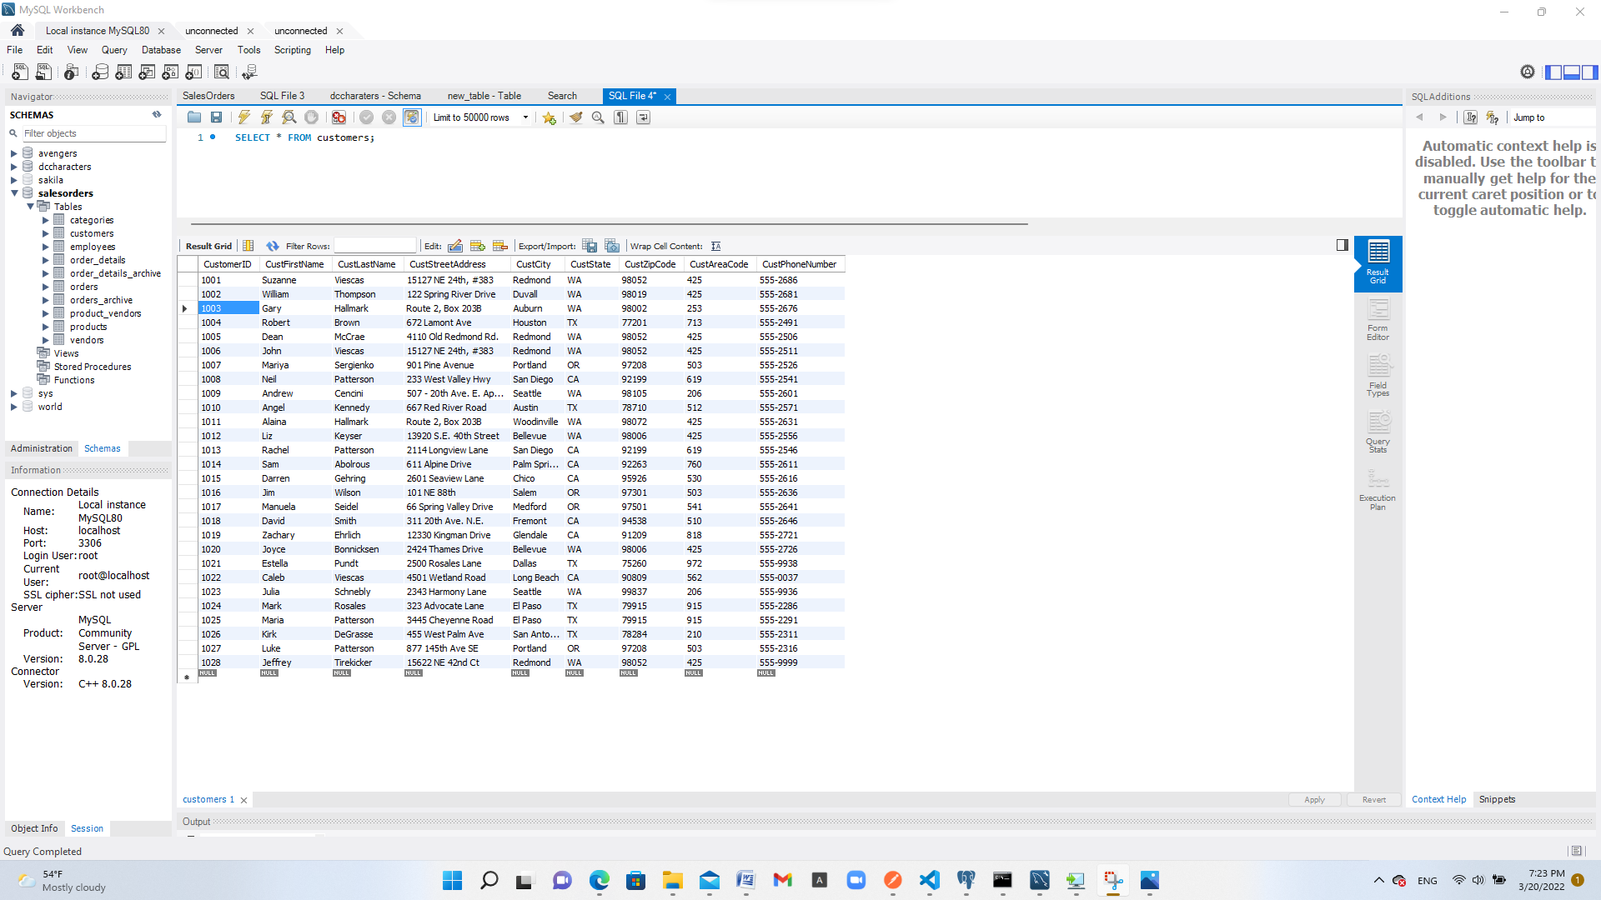
6. **Show a list of states, in reverse alphabetical order, where our vendors are located, and include the names of the vendor.**
7. Query: SELECT vendName,vendState FROM vendors ORDER BY vendState DESC;
8. Columns: 2
9. Expected Row Count: 11
10. Screenshot: 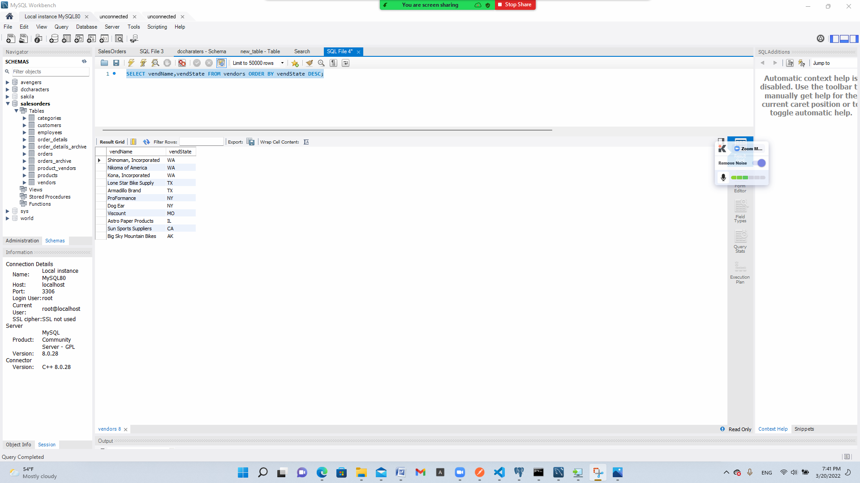
11. **What if we adjusted the retail price of each product by increasing it 7 percent?**
12. Query: SELECT (RetailPrice * 0.7) + RetailPrice FROM salesorders.products;
13. Columns: 1
14. Expected Row Count: 40
15. Screenshot: 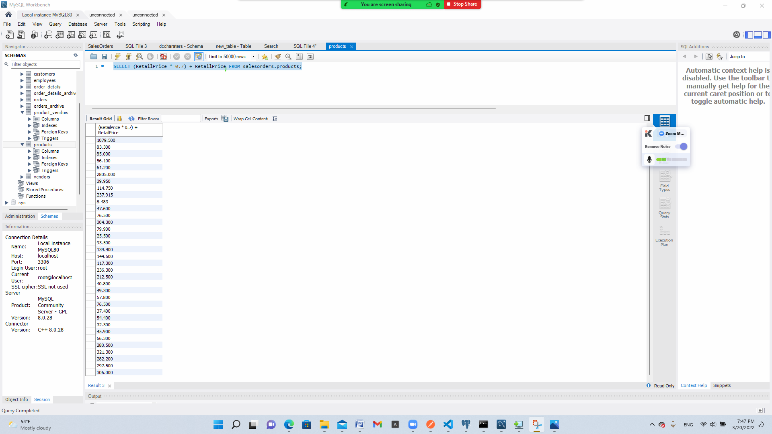
16. **Show a list of orders made by each customer in ascending date order.**

a) Query: SELECT * FROM orders ORDER BY OrderDate ASC;

b) Columns: 2

c) Expected Row Count: 944

d)Screenshot: 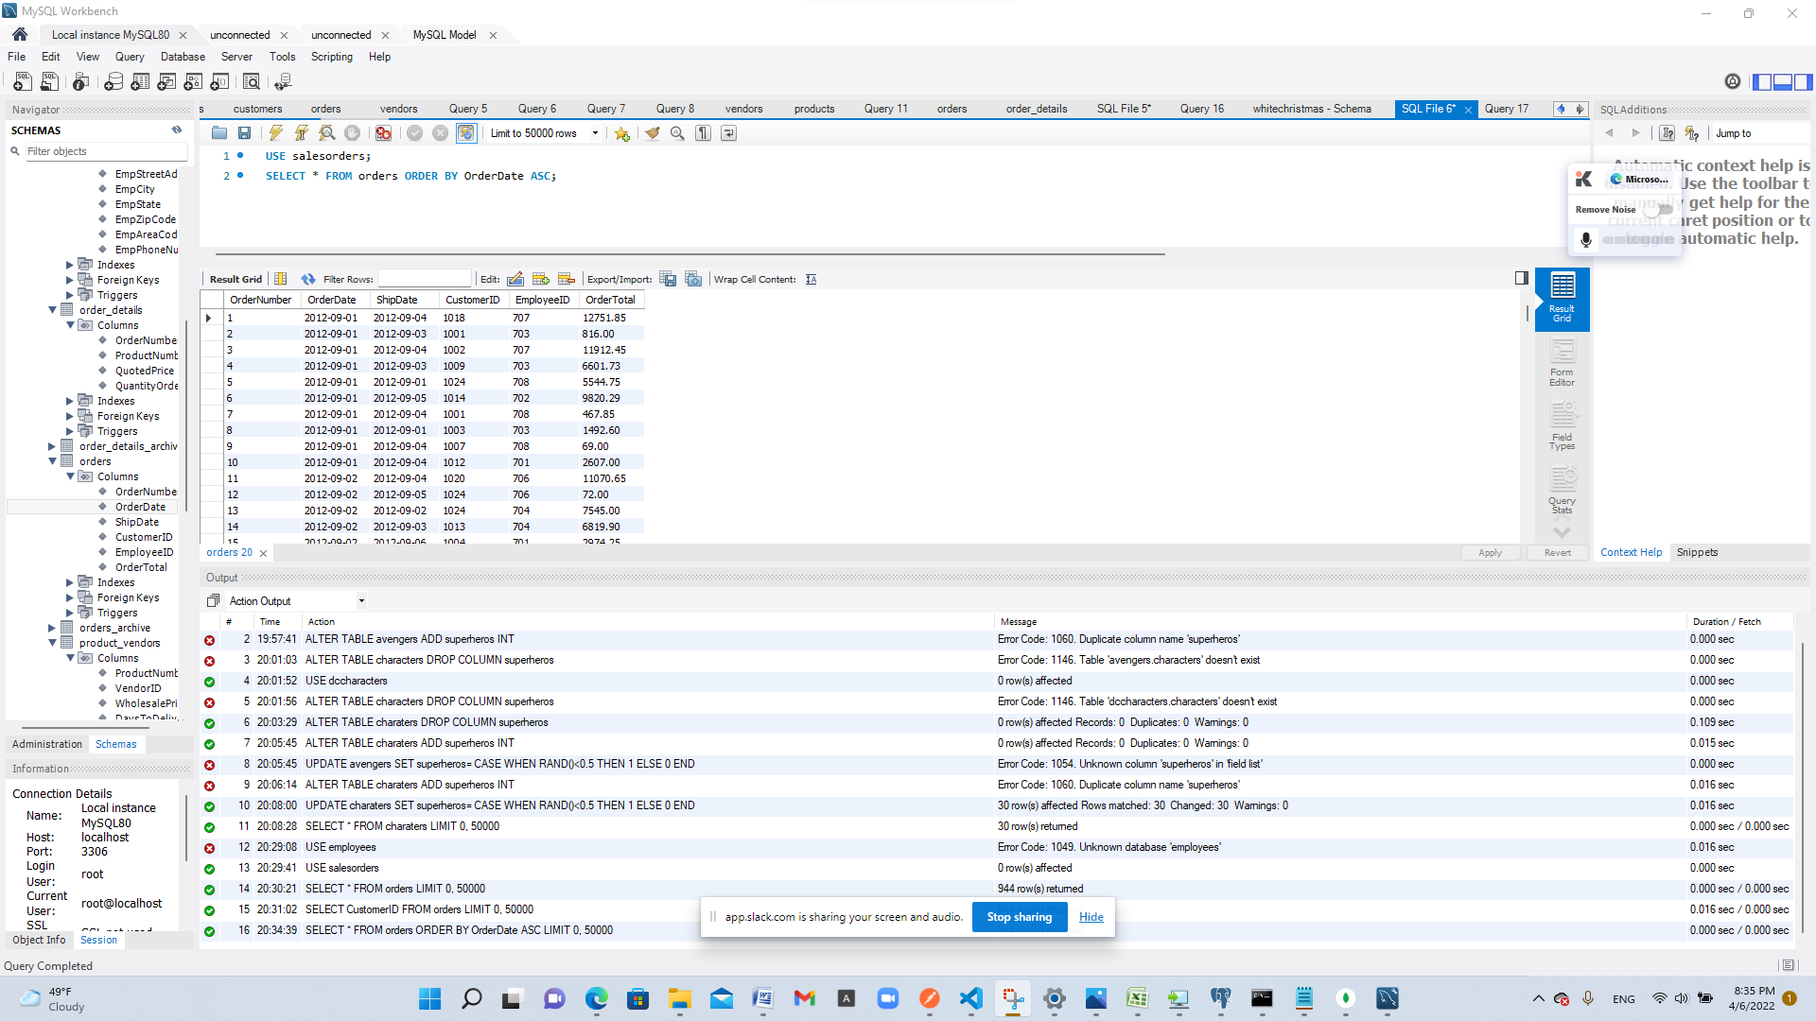

1. **Give the names of all vendors based in Albany, Anchorage, and Dallas.**
2. SELECT VendCity,VendName FROM vendors WHERE VendCity IN ('Albany','Anchorage','Dallas');
3. Columns: 3
4. Expected Row Count: 11
5. Screenshot: 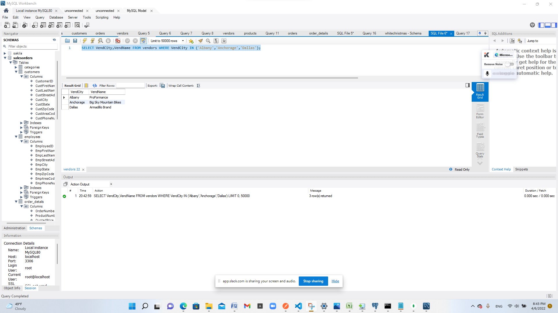
6. **Show an alphabetized list of products with a quantity on hand greater than or equal to 30.**
7. Query: SELECT * FROM products WHERE QuantityOnHand >= 30 ORDER BY ProductName ASC;
8. Columns: 6
9. Expected Row Count: 9
10. Screenshot: 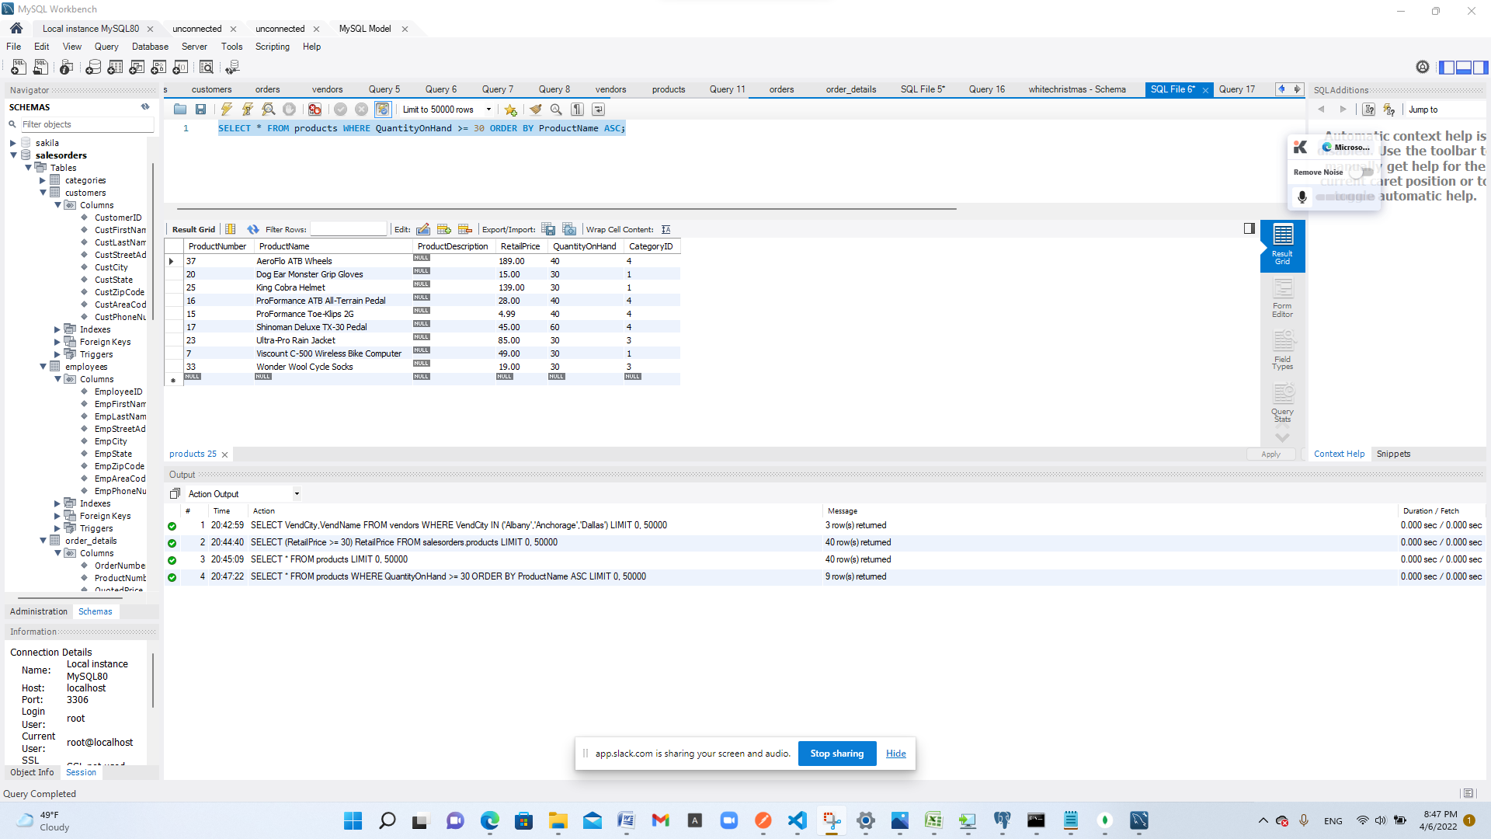
11. **What vendors do we work with that don’t have an email address?**
12. Query: SELECT VendEMailAddress FROM vendors WHERE VendEmailAddress is null;
13. Columns: 1
14. Expected Row Count: 5
15. Screenshot: 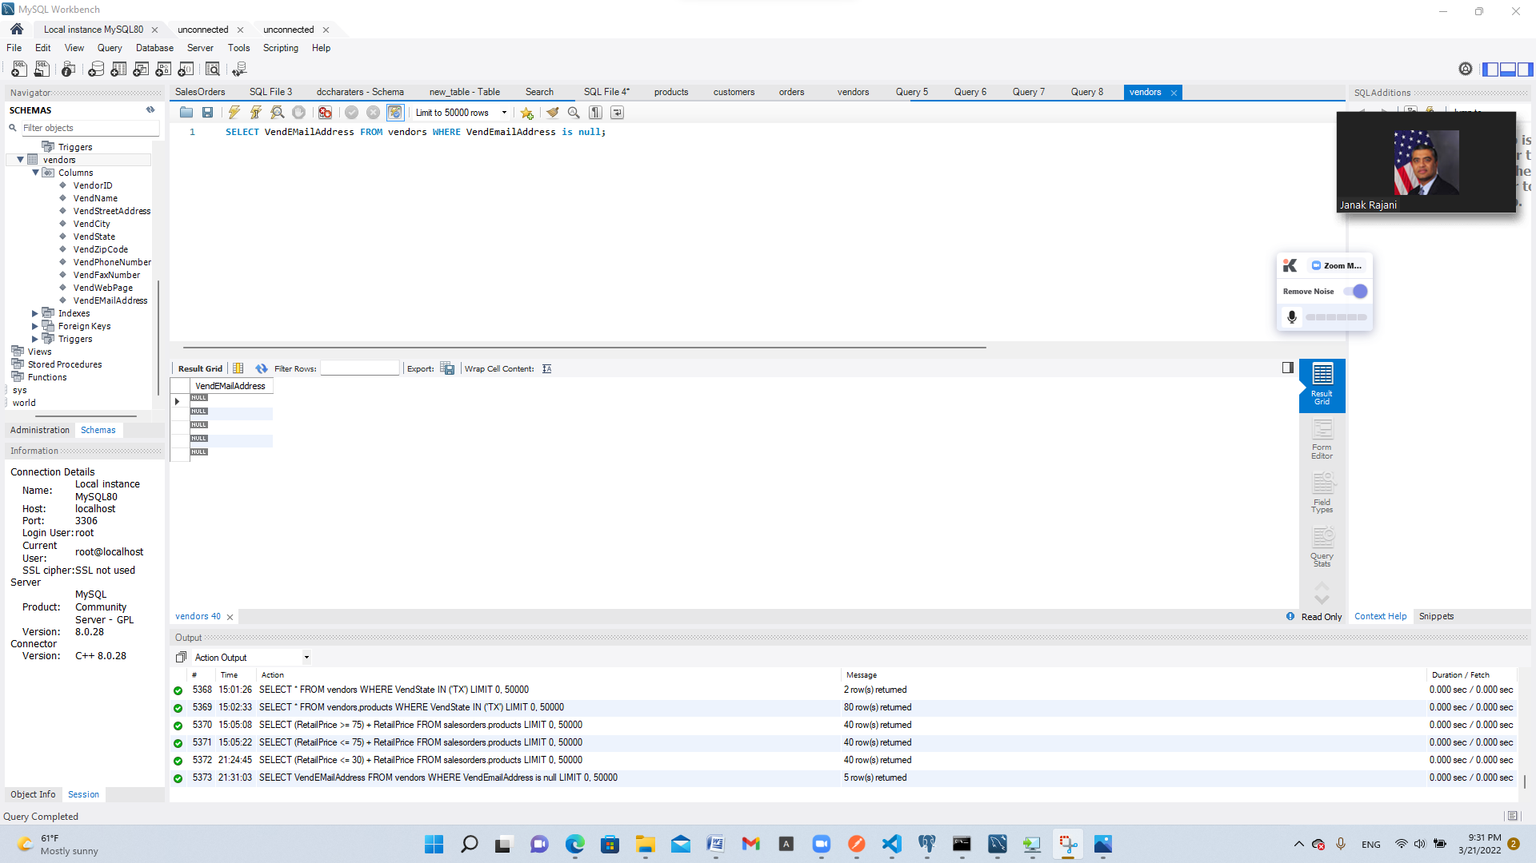
16. **List employees and the dates their orders shipped sorted by order date.**
17. Query: SELECT EmployeeID,OrderDate,ShipDate FROM orders;
18. Columns: 3
19. Expected Row Count: 944
20. Screenshot: 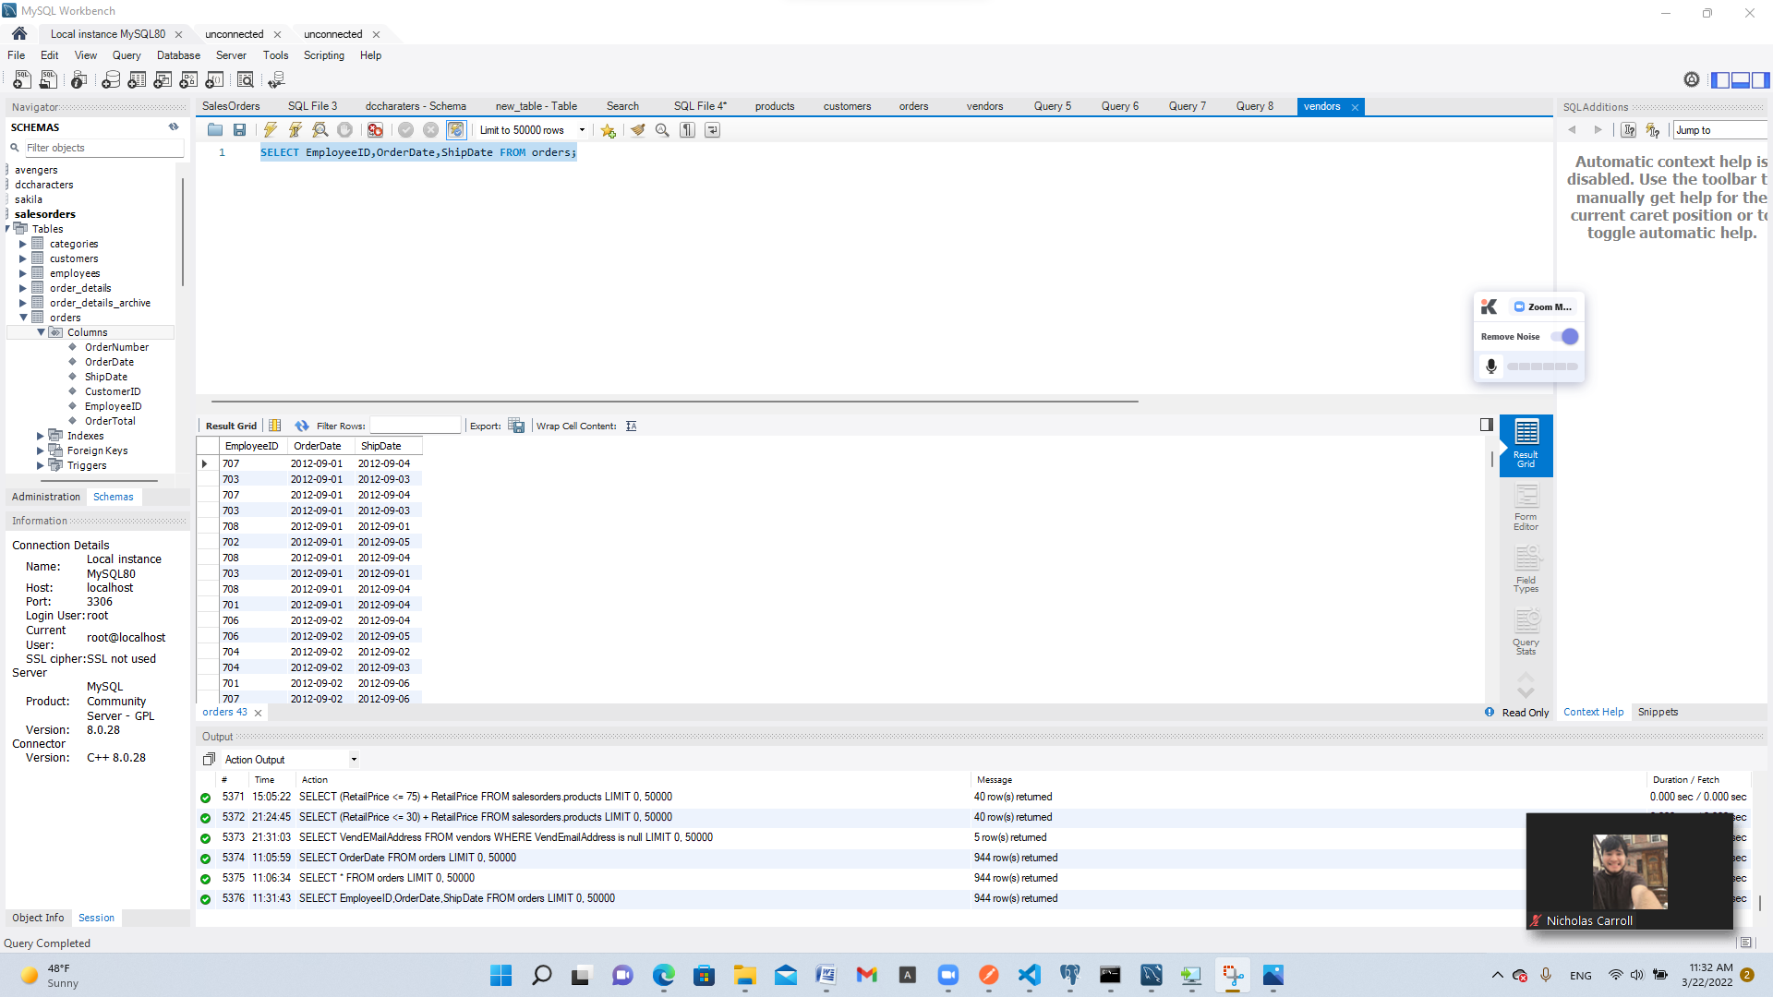
21. **Show the vendors and products they supply to us for products over $75 for vendors in Texas.**
22. Query: SELECT vendors.VendState, vendors.VendName, product_vendors.VendorID, product_vendors.ProductNumber, products.ProductNumber,products.ProductName,products.RetailPrice
23. FROM ((vendors
24. INNER JOIN product_vendors ON vendors.VendorID = product_vendors.VendorID)
25. INNER JOIN products ON products.ProductNumber = product_vendors.ProductNumber) WHERE products.RetailPrice > 75 AND vendors.VendState = "TX"
26. Columns: 7
27. Expected Row Count: 14
28. Screenshot: 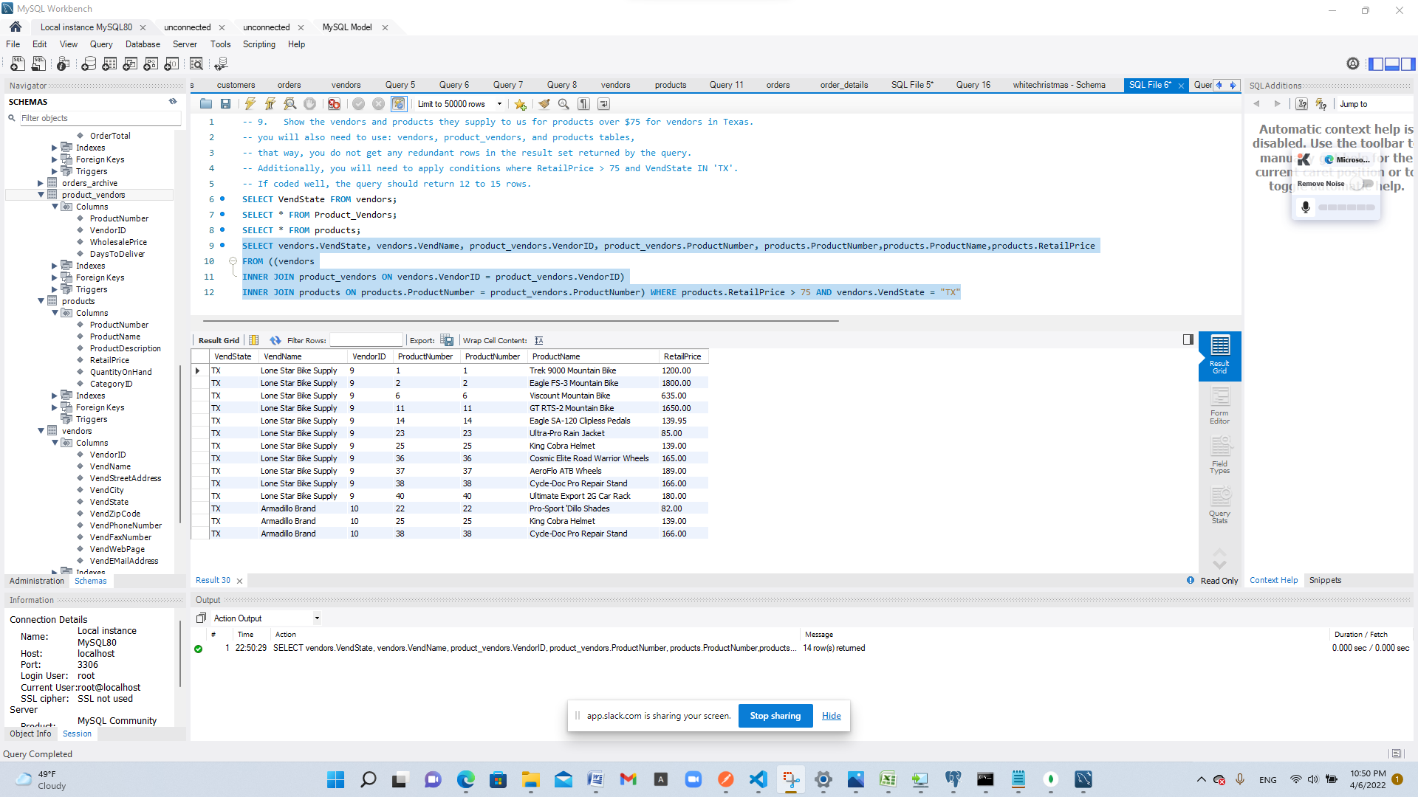
29. **Show employees who live in the same city and state as our vendors.**
30. Query: SELECT employees.EmpCity, employees.EmpState, employees.EmpFirstName, employees.EmpLastName,vendors.VendCity,vendors.VendState,vendors.VendName
31. FROM employees
32. INNER JOIN vendors ON employees.EmpCity = vendors.VendCity;
33. Columns: 7
34. Expected Row Count: 2
35. Screenshot: 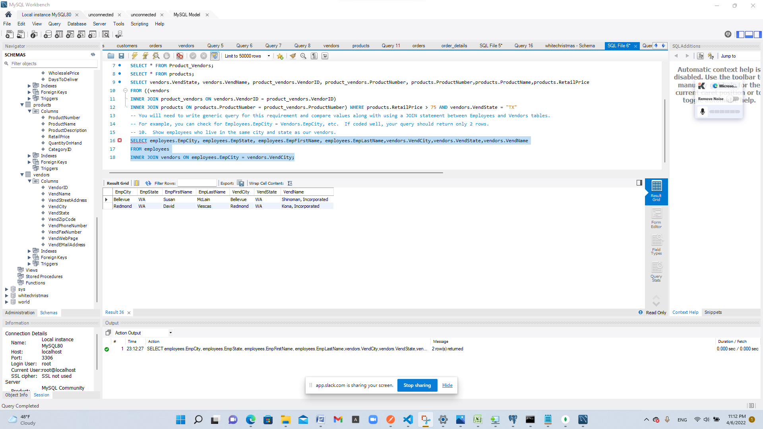
36. **Display customers who have no sales rep (employees) in the same state.**
37. Query: SELECT customers.CustFirstName, customers.CustLastName, customers.CustState
38. FROM customers LEFT JOIN employees ON customers.CustState = employees.EmpState WHERE Employees.EmployeeID is NULL;
39. Columns: 3
40. Expected Row Count: 11
41. Screenshot: 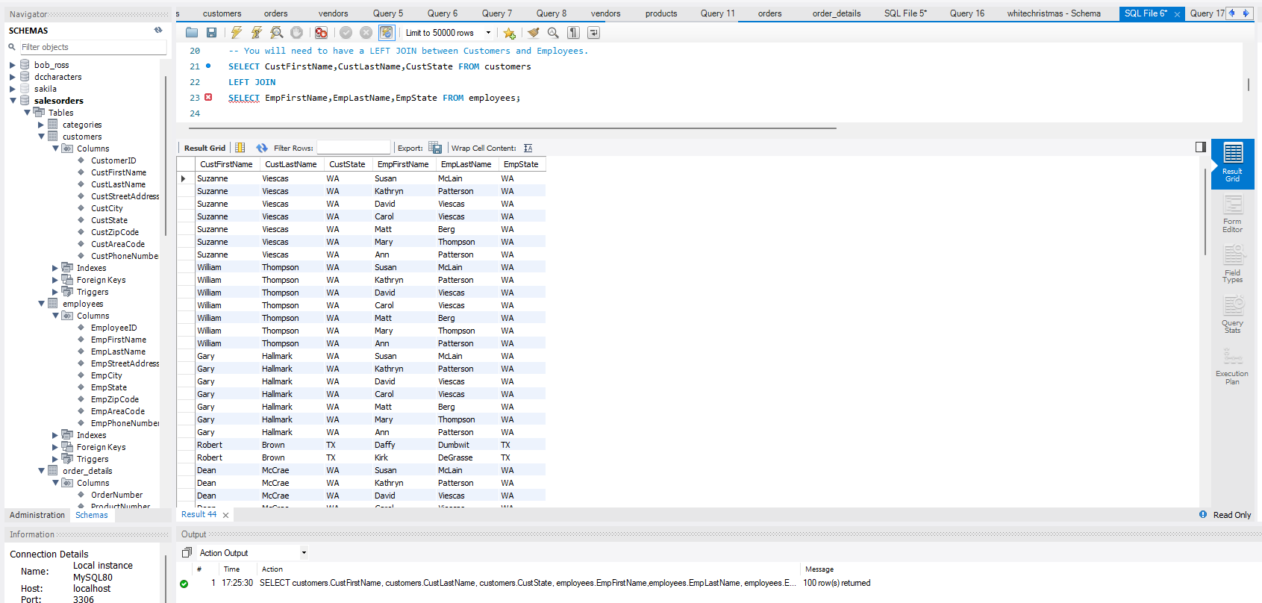
42. **What is the average quoted price of a helmet?**
43. Query: SELECT products.ProductNumber,products.ProductName,AVG(order_details.QuotedPrice) AS 'price'
44. FROM products
45. INNER JOIN order_details
46. ON products.ProductNumber = order_details.ProductNumber WHERE products.ProductName LIKE '%helmet%' GROUP BY ProductNumber;
47. Columns: 3
48. Expected Row Count: 4
49. Screenshot: 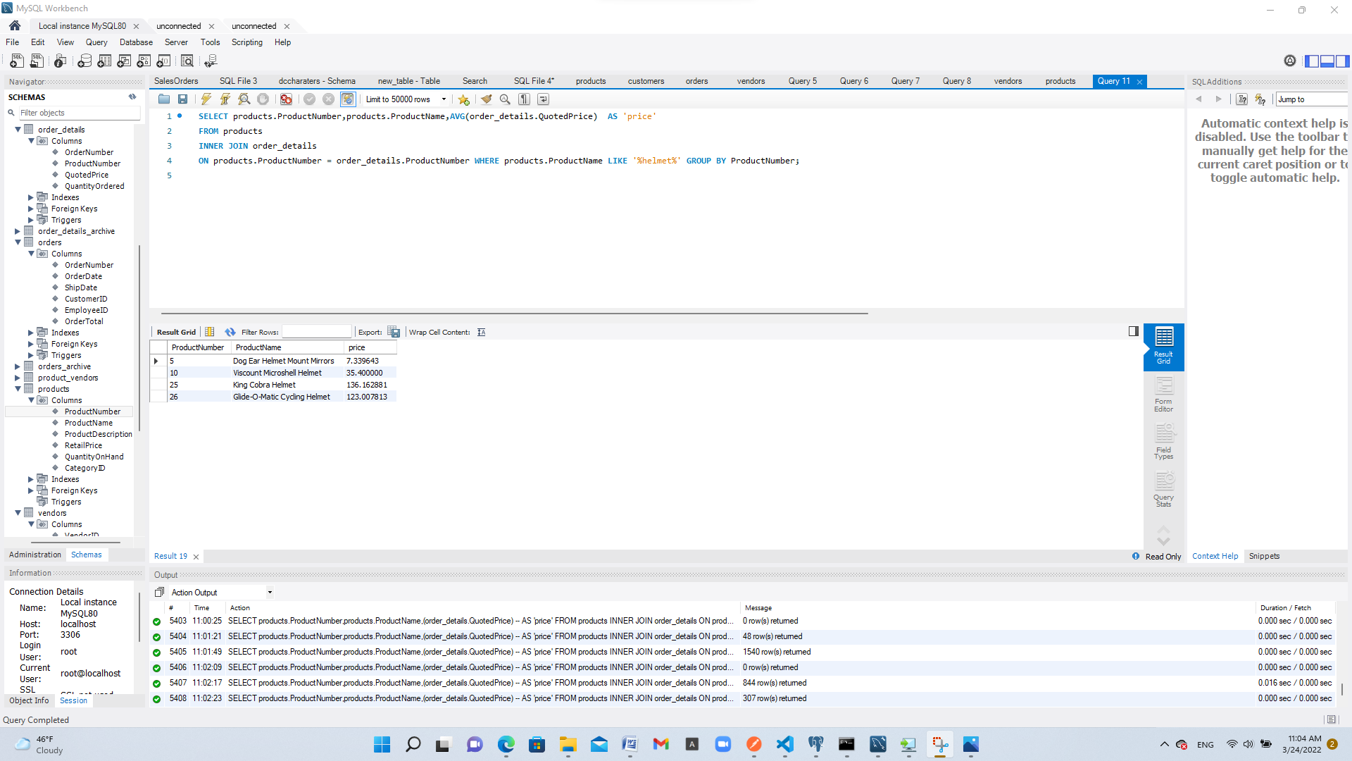
50. **What was the date of the earliest ship date?**
51. Query: SELECT MIN(ShipDate) FROM orders;
52. Columns: 1
53. Expected Row Count: 1
54. Screenshot: 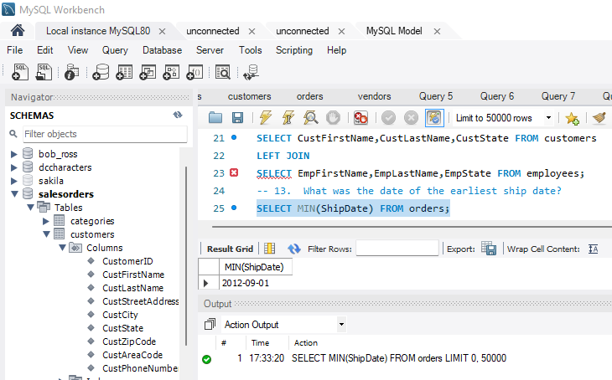
55. **What is the total amount (in dollars) of orders from the state of Oregon?**
56. Query: SELECT SUM(OrderTotal) FROM orders INNER JOIN customers ON orders.CustomerID = customers.CustomerID WHERE customers.CustState = 'OR';
57. Columns: 1
58. Expected Row Count: 1
59. Screenshot: 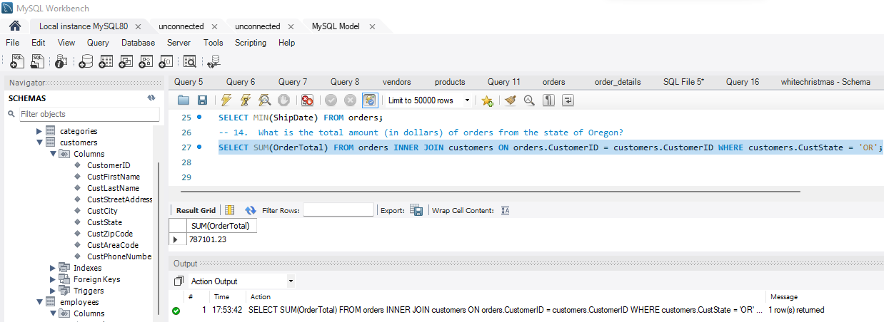
60. **Show each employee, the employee’s total sales (in dollars), the employee’s total sales item quantity, and the average item sales price ordered by the employee’s average item sales price highest to lowest.**
61. Query: SELECT EmpFirstName,employees.EmployeeID,SUM(QuantityOrdered),SUM(OrderTotal),AVG(RetailPrice) FROM employees
62. INNER JOIN orders
63. ON orders.EmployeeID = employees.EmployeeID
64. INNER JOIN order_details
65. ON orders.OrderNumber = order_details.OrderNumber
66. INNER JOIN products
67. ON products.ProductNumber = order_details.ProductNumber GROUP BY EmpFirstName;
68. Columns: 5
69. Expected Row Count: 8
70. Screenshot: 