**Exercise 1: How many directories are contained in this archive? Show in detail how you answered this question, with screenshots.**

There are 4 main directories within **2121_example_dir/**

There are 22 including subdirectories, which end with **[ / ]**

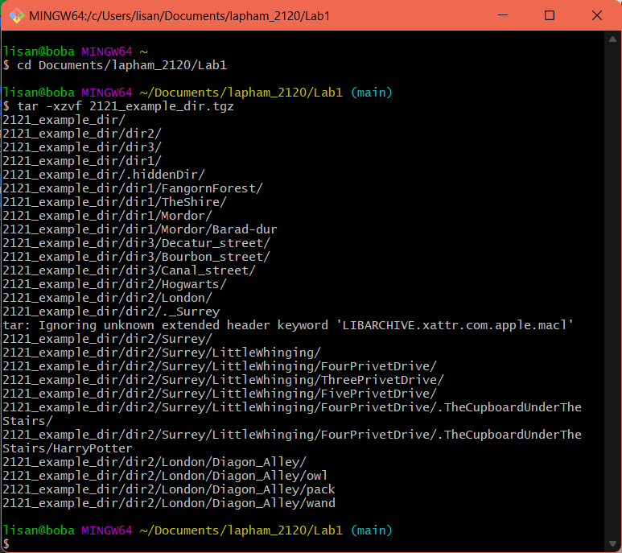

**Exercise 2: Are there any hidden directories? If so, where are they located? Show in detail how you answered this question, with screenshots.**

There are 2 hidden directories under **2121_example_dir/** which start with **[ . ]** and end with **[ / ]** (see below)

**../.hiddenDir/**

**../dir2/Surrey/LittleWhinging/FourPrivetDrive/.TheCupboardUnderTheStairs/**

**Exercise 3: Issue the printenv command. printenv lists a bunch of things called environment variables, that are specific to this instance of a shell, such as your username, what shell is running, where to find executable files (in the PATH variables), and LOTS of other things. These variables can be modified in real-time in the shell itself, or can be set up so that every new shell you create has a particular environment variable defined in a specific way. Send the output of printenv to a file so that it’s easier to work with, and open that file in your favorite text editor.**

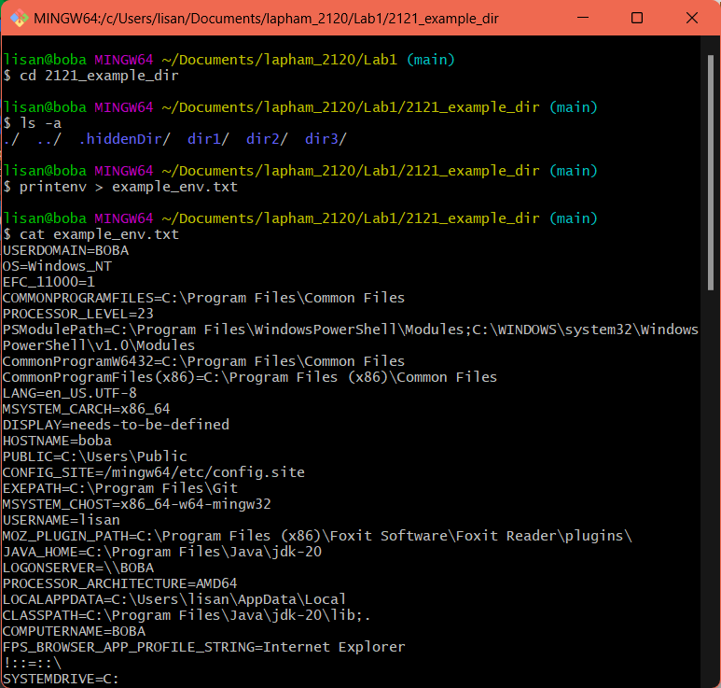

**What SHELL are you running, and where is the executable file for this shell?**

SHELL=/usr/bin/bash

**Where is your HOME directory?**

HOME=/c/Users/lisan

**What is the PWD (the present working directory)?**

/c/Users/lisan/Documents/lapham_2120/Lab1/2121_example_dir

**What directories will the shell go to when looking for a command you issue at the shell prompt? (PATH)**

MANPATH=/mingw64/local/man:/mingw64/share/man:/usr/local/man:/usr/share/man:/usr/man:/share/man

**Exercise 4: ls has another flag, -l , for Long-form listing. (I had hoped to get you to practice using the man pages to figure out how to do this but the bash shell provided by gitbash in Windows is not full strength and doesn’t have man). Use this version of the ls command to produce a long-form listing of 2121_example_dir, and send the results to a file. Then output the contents of this file to the shell, and copy and paste it as part of your answer to this exercise. Take screenshots showing your process, what commands you are issuing, and explain.**

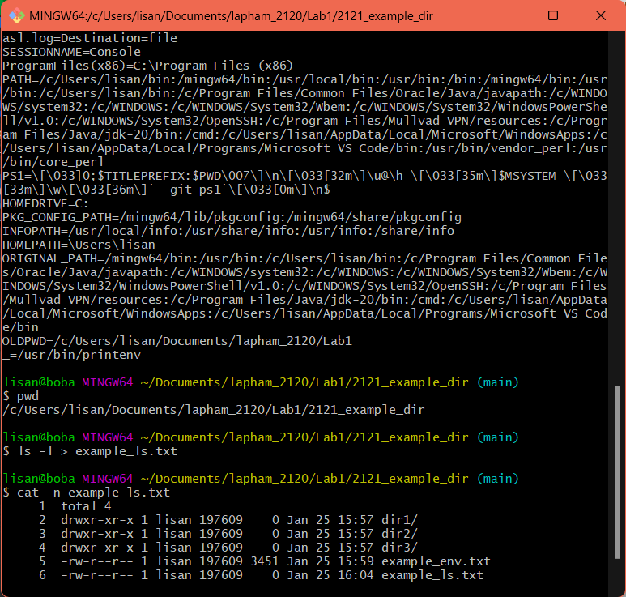

**[ > ]** stores output of command **[ ls -l ]** to file **“example_ls.txt”**

**[ cat ]** displays content of **“example_ls.txt”** to shell

**output:**

total 4

drwxr-xr-x 1 lisan 197609 0 Jan 25 15:57 dir1/

drwxr-xr-x 1 lisan 197609 0 Jan 25 15:57 dir2/

drwxr-xr-x 1 lisan 197609 0 Jan 25 15:57 dir3/

-rw-r--r-- 1 lisan 197609 3451 Jan 25 15:59 example_env.txt

-rw-r--r-- 1 lisan 197609 0 Jan 25 16:04 example_ls.txt

**Exercise 5:**

**Where is Harry Potter? Again, screenshots showing your process, and the commands issued. Make a hidden directory in Hogwarts called RoomOfRequirement and move Harry into it. Show that you’ve done this (using ls). (as usual, screenshots and explanation of your process).**

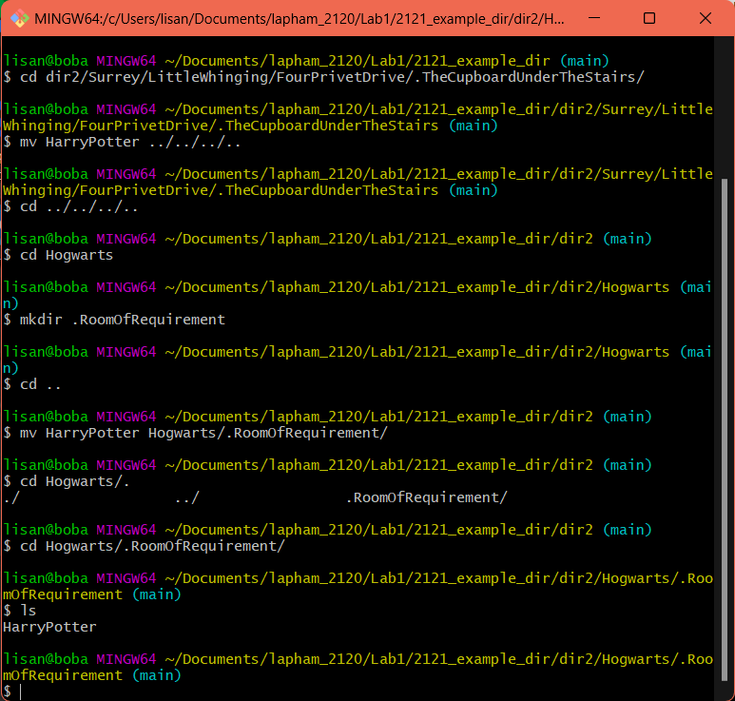

**cd 2121_example_dir/dir2/Surrey/LittleWhinging/FourPrivetDrive/**

**.TheCupboardUnderTheStairs** navigate to **HarryPotter’s** location

**mv HarryPotter ../../../..** move Harry to fourth containing folder **(dir2)**

**cd ../../../../Hogwarts** navigate to **dir2/Hogwarts/**

**mkdir .RoomOfRequirement** create folder

**cd ..** go back to where Harry is waiting and move

**mv HarryPotter Hogwarts/.RoomOfRequirement**

**At the end of the Lord of the Rings, Mordor was effectively destroyed when Sauron’s tower, Barad-dur, collapsed when the One Ring was thrown into Mount Doom. Remove the Mordor directory. Show that you’ve done this (using ls). (as usual, screenshots and explanation of your process).**

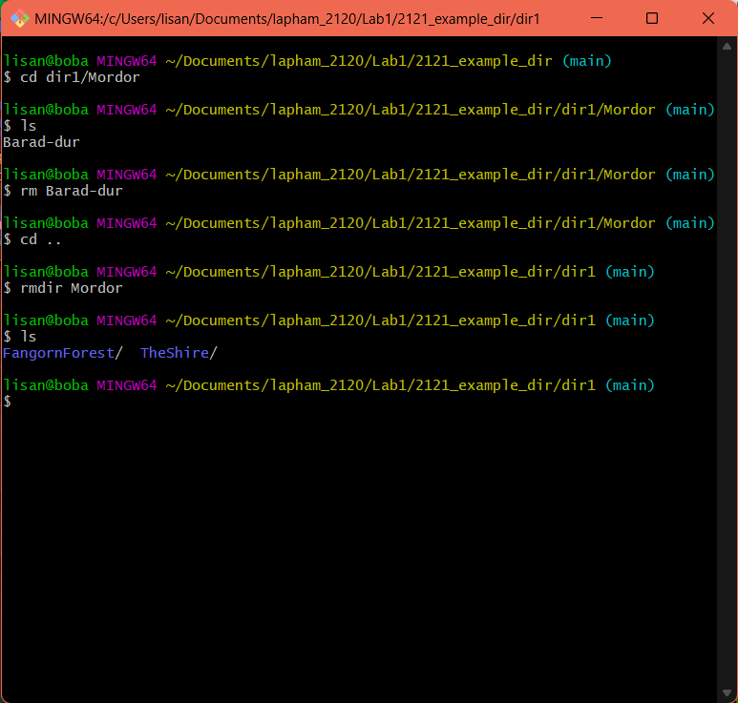

**cd dir1/Mordor/**

**rm Barad-dur**  remove files in **Mordor/** to delete

**cd ..**  navigate to previous folder, containing **Mordor/**

**rmdir Mordor**  remove directory

**ls**  Mordor is gone