VIETNAM NATIONAL UNIVERSITY OF HOCHIMINH CITY THE INTERNATIONAL UNIVERSITY
SCHOOL OF COMPUTER SCIENCE AND ENGINEERING



ALGORITHMS & DATA STRUCTURES

PROJECT REPORT

Flappy Bird

Instructor : Trần Thanh Tùng

Number | Name | Student ID
1 | Dương Đặng Minh Cường | ITCSIU22285

TABLE OF CONTENTS
- Introduction
- Game Overview
- Mechanics
- Data structure and Algorithm
- Data structure
- Algorithm
III. Important Class Analysis
- Bird.java
- FlappyBird.java
- GamePanel.java
IV. Game States and Logic
- Initialization
- Collission detection
A. Player input
V. Library used in the game
VI. Conclusion

- Introduction
Flappy Bird is an arcade, side-scrolling game in which a player takes it through a pair of narrow pipes and vertical obstacles. This very popular game makes use of very simple game mechanics with pixel art graphics. It requires a player to tap the screen so that the bird doesn't crash. This project does not only re-implement the game's mechanics but enhances it by including additional attributes: dynamic difficulty adjustment, modular design, and efficient data structures for smooth performance. This is a practical exploration of the development of games in relation to principles, algorithms, and data structures.

- Game Overview
- Mechanics
Player Control:
The player controls the bird's vertical movement by pressing the UP arrow key (e.g., the UP arrow key). Each tap causes the bird to flap its wings and ascend, while gravity continuously pulls it downward.
The player must maintain their height to pass through the obstacles.

Obstacles:
If the bird collides with a pipe or the ground, the game ends, and the player is presented with their score.

Scoring System:
Players earn points for each pipe they successfully pass through. The score is displayed on the screen and updates in real-time.
Collectible items, such as candies, can also be collected for additional points, encouraging players to explore the game area.

Game States:
The game features multiple states, including:
Menu State: The initial screen where players can start the game or view instructions.
Playing State: The main gameplay state where the player controls the bird.
Game Over State: Displayed when the player collides with an obstacle, showing the final score and options to restart or return to the menu.

Dynamic Difficulty:
As the player progresses, the speed of the pipes may increase, adding to the challenge. This dynamic difficulty adjustment keeps the gameplay engaging and encourages players to improve their skills.
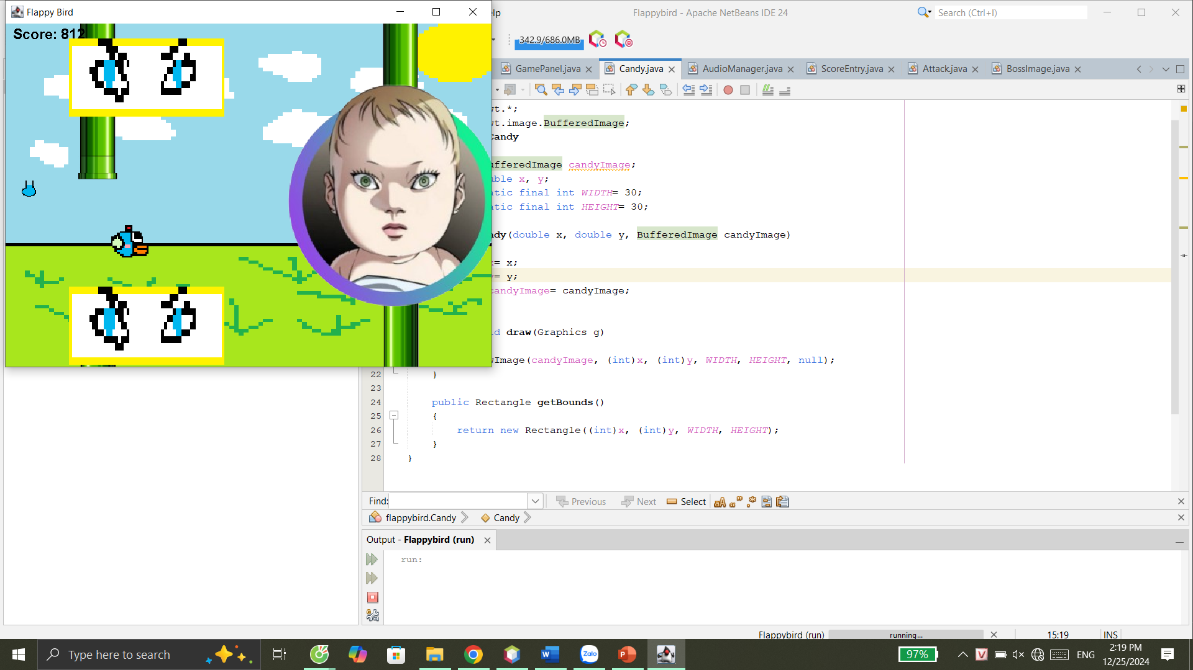
B. Data Structures and Algorithm
- Data Structures
ArrayList:
Bird: The player-controlled character.
Rectangles: Representing the pipes that serve as obstacles.
Candies: Collectible items that provide additional points.
Attacks: Objects that pose a threat to the player.
ScoreEntry: Objects that store player names and scores for the leaderboard.

Rectangle:
The Rectangle class is used for collision detection between the bird and obstacles. Each pipe and the bird itself can be represented as rectangles, allowing for straightforward intersection checks.
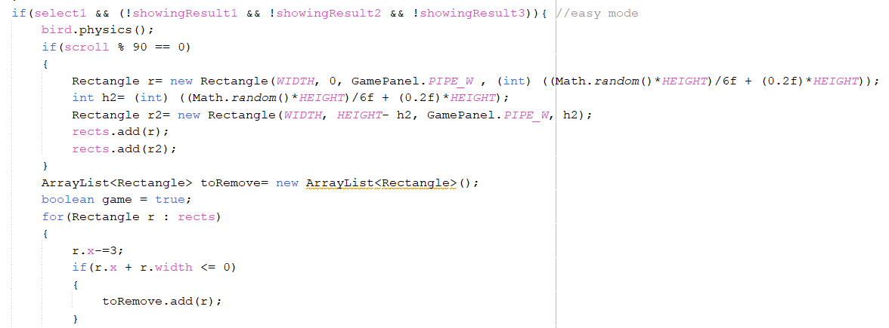

2. Algorithm
Game Loop:
The core of the game is driven by a game loop that continuously updates the game state and renders graphics. The loop runs at a fixed frame rate (FPS) to ensure smooth gameplay.

Implementation: The game loop is implemented using a Timer that triggers an actionPerformed method at regular intervals. This method updates the positions of game objects, checks for collisions, and repaints the game panel.

Time Complexity: The time complexity of the game loop is O(n), where n is the number of game objects being updated and rendered.

Collision Detection:
Collision detection is performed to determine if the bird intersects with any pipes or attacks.

Implementation: For each frame, the game checks if the bird's rectangle intersects with any of the rectangles representing pipes or attacks.

Time Complexity: The time complexity is O(m), where m is the number of obstacles (pipes and attacks) currently in the game.
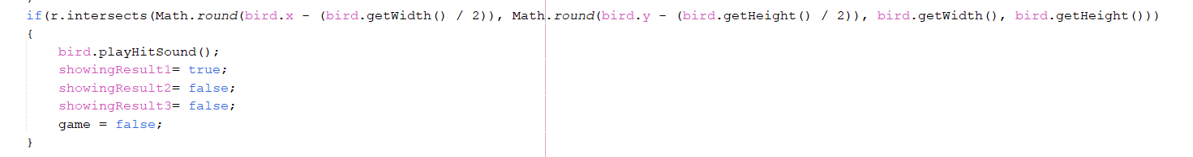

Sorting Algorithm:
The Bubble Sort algorithm is used to sort the leaderboard by player names when displaying the leaderboard.

Implementation: The algorithm iterates through the list of ScoreEntry objects, comparing player names and swapping them as necessary to achieve a sorted order.
Time Complexity: The time complexity of Bubble Sort is O(n^2), where n is the number of entries in the leaderboard. 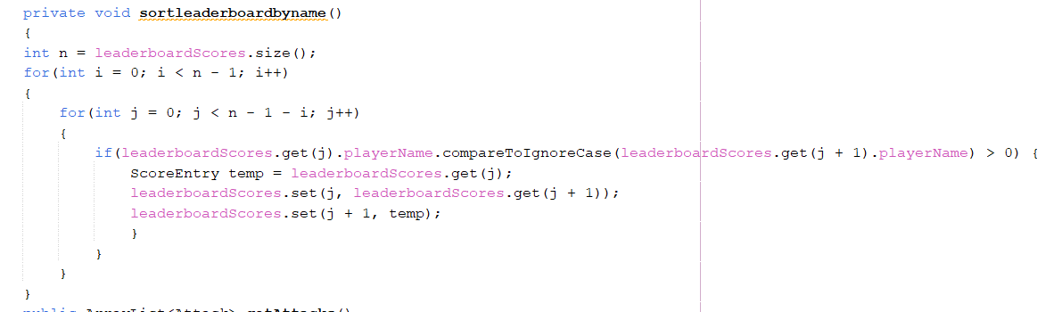

Search Algorithm:
A linear search algorithm is used to find a player by name in the leaderboard.
Implementation: The algorithm iterates through the list of ScoreEntry objects, checking each player's name against the input name.
Time Complexity: The time complexity is O(n), where n is the number of entries in the leaderboard. 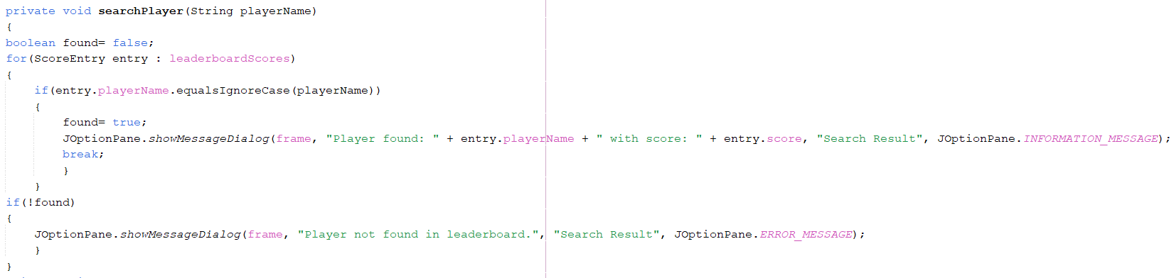

- Important Class Analysis
- Bird.java
The Bird class represents the player-controlled character in the Flappy Bird game.
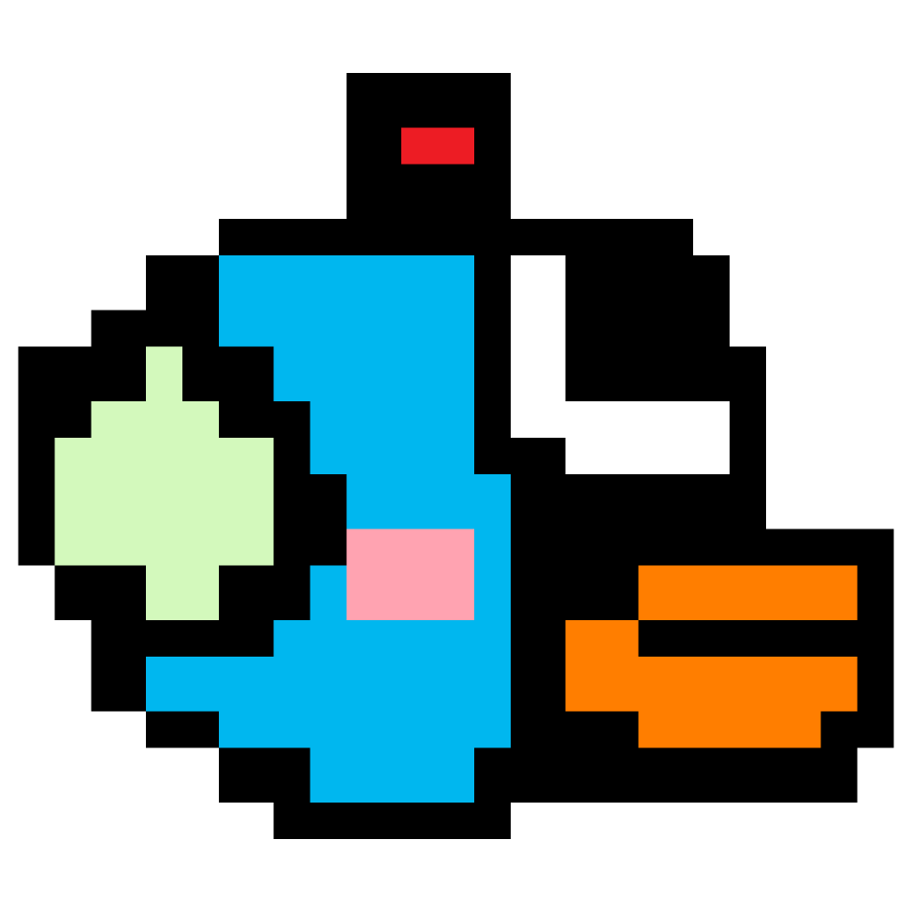
Position Management: The class maintains the bird's position (x, y) and velocity (vx, vy).
Rendering: The class is responsible for rendering the bird's image on the screen using the update method.

Sound Effects: It manages sound effects related to the bird's actions, such as jumping and colliding with obstacles.

Key Methods:
Constructor: Initializes the bird's position, size, and loads the necessary images and sound effects.

jump(): create a jumping effect and plays the jump sound.

physics(): Updates the bird's position.

playHitSound(): Plays the sound effect when the bird collides with an obstacle.
reset(): Resets the bird's position and velocity.
- FlappyBird.java
The FlappyBird class serves as the main controller for the game. It manages the overall game logic, including the game loop, user input, and interactions between game objects.

Game Initialization: Sets up the game window, initializes game objects, and starts the game loop.

Game State Management: Handles different game states (e.g., playing, paused, game over).

Collision Detection: Checks for collisions between the bird and obstacles, as well as between the bird and collectible items.

Key Methods:
go(): Initializes the game window and starts the game loop.

actionPerformed(): The main game loop that updates the game state, checks for collisions, and repaints the game panel.

fetchLeaderboardScores(): Retrieves the leaderboard scores from the database and populates the leaderboardScores list.

showLeaderboard(): Displays the leaderboard on the screen.
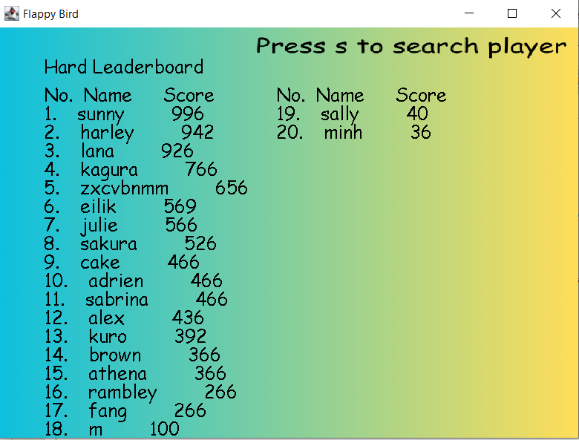
spawnAttacks(): Spawns attack objects at specified intervals and plays the associated sound.

- GamePanel.java
The GamePanel class is responsible for rendering the game graphics and handling the visual representation of game objects. It extends JPanel and overrides the paintComponent method to draw the game elements.

Responsibilities:
Rendering Game Objects: Draws the bird, pipes, candies, attacks, and any other game elements on the screen.

Handling Game States: Displays different screens based on the current game.
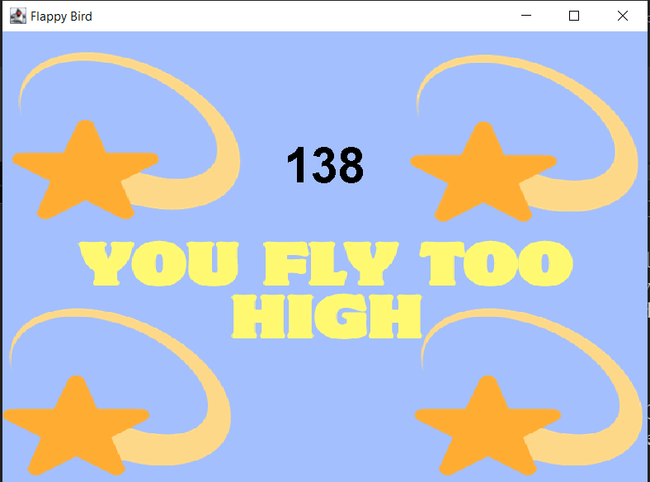
User Interface: Manages the visual aspects of the game, including score display and background images.

Methods:
paintComponent(Graphics g): The main method for rendering graphics.

drawImage(): Utilizes the Graphics object to draw images on the panel.

handleGameStates(): Manages the rendering of different game states, such as instructions and results.
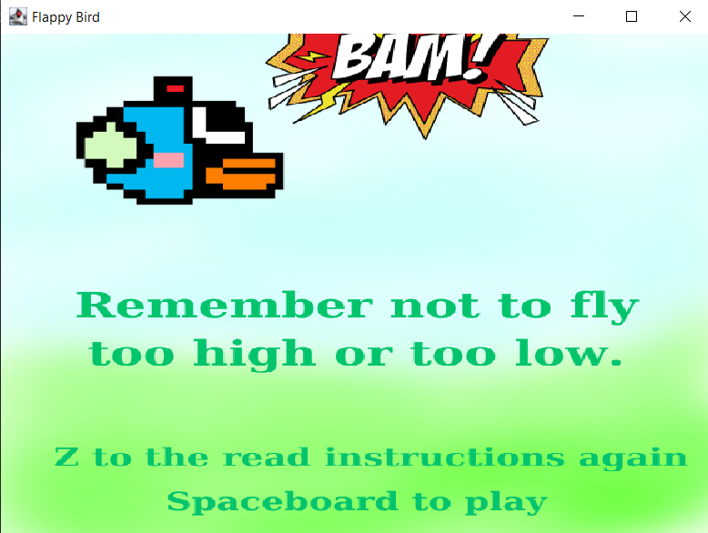
- Game states and logic
- Initialization
The game loads images (e.g., the bird, pipes, candies, and background) and sound files (e.g., jump sound, hit sound) using the ImageIO and AudioSystem classes.

The main game class (FlappyBird) initializes the bird, pipes, candies, attacks, and other game entities.
The ArrayList data structures are used to store these objects dynamically, allowing for easy addition and removal during gameplay.
Setting Up the Game Window:

The game window is created using JFrame, and the main game panel (GamePanel) is added to it.

A Timer is set up to control the game loop, which updates the game state and renders graphics at a fixed frame rate (FPS).
The game enters the paused state initially, waiting for the player to start.
- Collission detection
Collision detection is a critical aspect of the game, determining whether the bird has collided with obstacles or collectible items. The game uses rectangular bounding boxes to simplify the collision detection process.

Each game object (the bird, pipes, attacks) is represented by a Rectangle that defines its position and size.
The Rectangle class provides methods to check for intersections between rectangles.

During each update cycle in the game loop, the game checks if the bird's bounding box intersects with any of the pipes or attacks.
If a collision is detected, the game triggers the appropriate response, such as playing a hit sound and transitioning to the game over state.

The collision detection algorithm operates in O(n) time complexity, where n is the number of obstacles. This is efficient for the limited number of pipes and attacks present in the game.
- Player input
Player input handling is essential for creating an interactive experience. The game captures keyboard events to control the bird's movement and navigate menus.
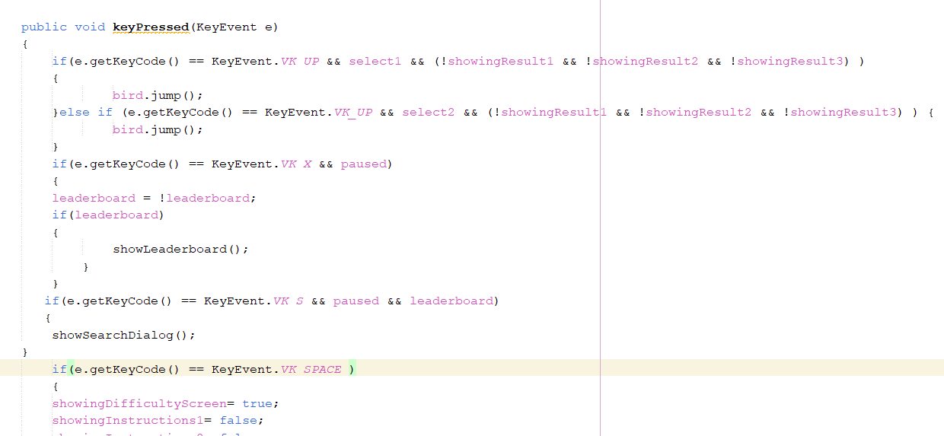
Key Aspects of Player Input Handling:

KeyListener Interface:

The FlappyBird class implements the KeyListener interface to capture key events.
The keyPressed, keyReleased, and keyTyped methods are overridden to respond to player actions.
Jumping Mechanic:

When the player presses the UP arrow key, the bird's vertical velocity is set to create a jumping effect.
The jump action is accompanied by a sound effect to enhance feedback.

Menu Navigation:
The game allows players to navigate through menus and options using specific key presses.
Input handling is also used to display instructions and manage game.
- Library used in game
Java Swing
The game window is created using JFrame, which serves as the main container for the game.
The JPanel class is used to create the game panel (GamePanel), where all game graphics are rendered.
Swing components are utilized for handling user input through the KeyListener interface, allowing the game to respond to keyboard events.

Java AWT (Abstract Window Toolkit)
The Graphics class from AWT is used for drawing images and shapes on the game panel.
AWT's event handling capabilities are utilized to manage user input and interactions.

Java Sound API
The game uses the Clip class to manage sound effects, such as jump sounds, hit sounds, and background music.
Audio files (WAV format) are loaded and played in response to specific game events, enhancing the overall gaming experience.

Java ImageIO
The game uses ImageIO.read() to load images for the bird, pipes, candies, attacks, and backgrounds.

Java SQL (JDBC)
The game connects to a MySQL database to fetch and store leaderboard scores.
SQL queries are executed to retrieve player names and scores, which are then displayed in the game.

- Conclusion
The Flappy Bird project is a successful remake of the classic game, entertaining a player with its easy-to-play yet addictive gameplay. The game effectively manages graphics and user input through Java's Swing and AWT libraries. Implementation of data structures like ArrayList and algorithms for collision detection and scoring makes the game smooth. Sound effects improve player interaction, while the leaderboard feature adds a competitive element. Overall, this is a great project that shows a good understanding of game development principles, with room for future enhancement and scaling.

