Question 1 [6 Points]
Create a shell script named analyze.sh that accepts exactly ONE command-line argument.
• If the argument is a file: – Display the number of lines, words, and characters in the file.
• If the argument is a directory: – Display the total number of files present. – Display the number of .txt files in the directory.
• If the argument count is invalid or the path does not exist: – Display an appropriate error message.
Answer:
1) Creating a shell scipt file named " analyze.sh " using the touch cmd.
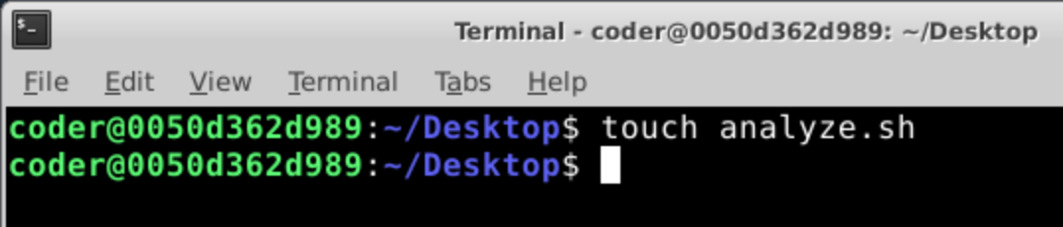
2) I used "nano analyze.sh " to open the file in editor.
3)
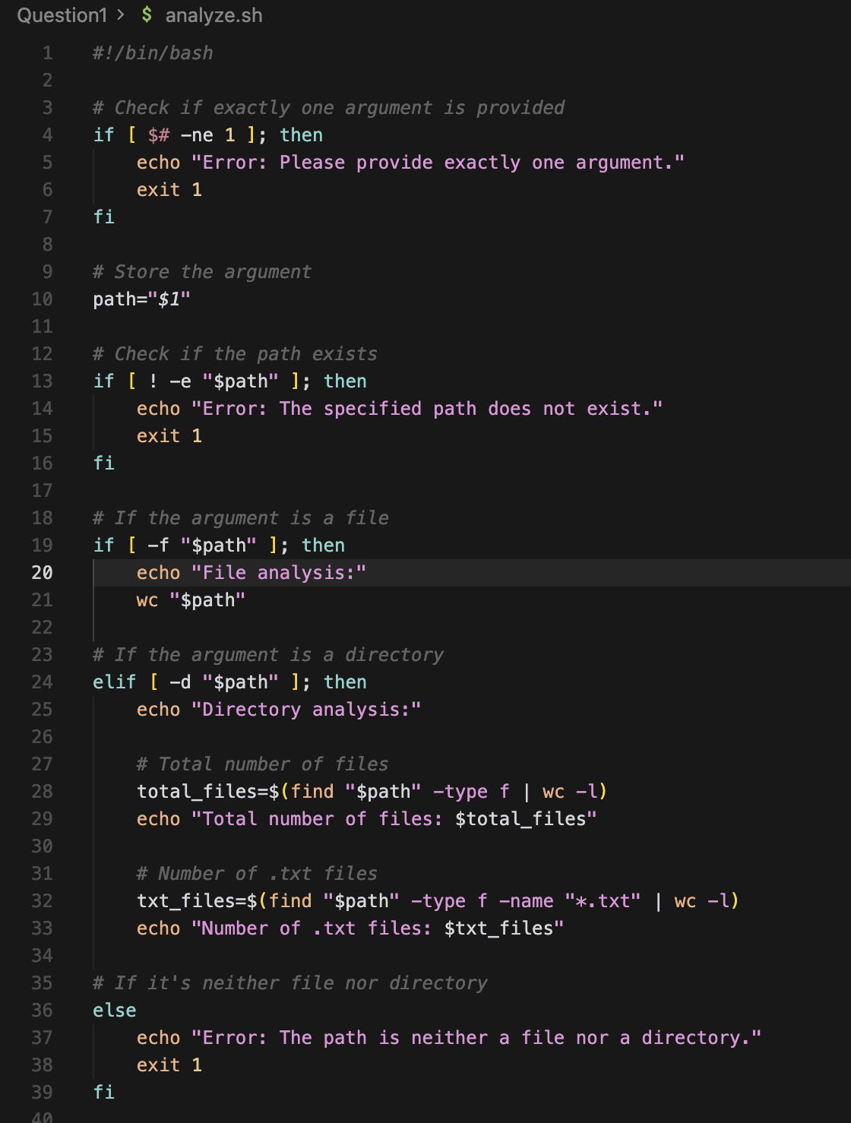

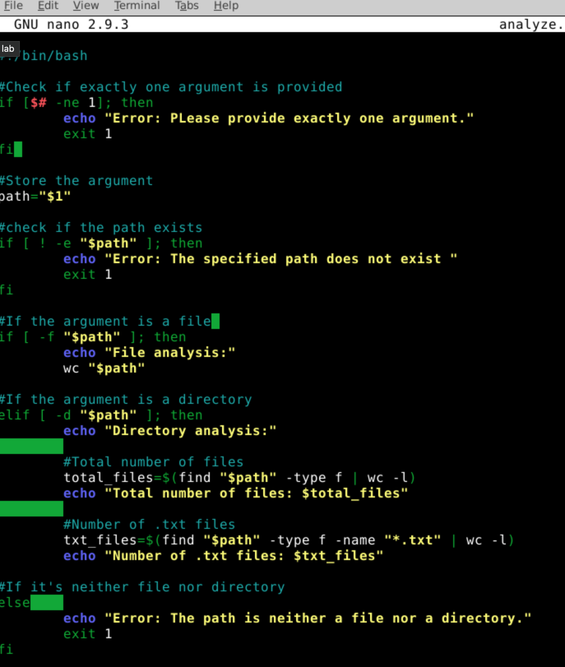
Terminal Output: 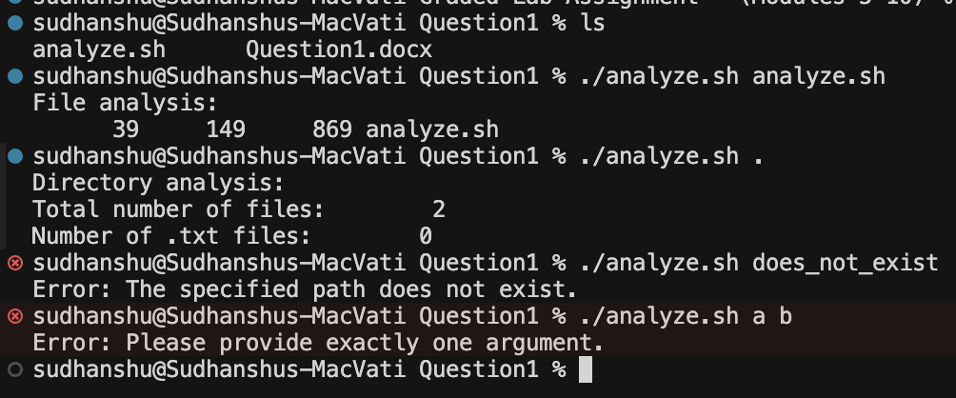
Explanation:
#!/bin/bash - This is telling linux, when someone runs this file, use bash to execute it. Without this line Linux may not know how to interpret the script.
# - Used to put out any comments in the scipt for explanation.
if [ $# -ne 1 ]; then : This starts the conditional statement
-ne : "not equal"
-lt: "less than"
-gt : "greater than"
exit 1: Exit the scipt immediately
fi : means end the if block
wc "$path" : It prints the following things
- Number of lines
- Number of words
- Number of characters
- File name

total_files=$(find "$path" -type f | wc -l)
-type f : Excludes directories, Only regular files
| : Pipe used to send output of left cmd to right cmd
wc -l : Counts the number of lines

