

DATABASE TECHNOLOGIES

LAB WORK

Name: KARTHIKEYAN.J

PROGRAM: Master of Computer Application
SUBJECT CODE: 26MC103

PROGRAM 1: DDL AND DML OPERATIONS

Aim
To create a Product table and perform DDL and DML operations using SQL commands.

Procedure
- Create a database named ShopDB.
- Create a Product table with suitable fields.
- Insert product records into the table.
- Display the records using SELECT.
- Update the price of a product using UPDATE.
- Delete a product using DELETE.
- Add a new column using ALTER TABLE.
- Display the table structure using DESC.
- Remove all records using TRUNCATE.
- Stop the program.

Source Code
-- Create Database Table
-- Oracle uses the connected user schema.
-- Create Product Table

CREATE TABLE Product (
Product_ID NUMBER(5) PRIMARY KEY,
Product_Name VARCHAR2(30),
Category VARCHAR2(20),
Price NUMBER(10)
);

-- Insert Product Records
INSERT INTO Product VALUES (101, 'Keyboard', 'Electronics', 800);

INSERT INTO Product VALUES (102, 'Mouse', 'Electronics', 500);

INSERT INTO Product VALUES (103, 'Notebook', 'Stationery', 100);

-- Display Initial Records
SELECT * FROM Product;

-- Update Product Price
UPDATE Product
SET Price = 900
WHERE Product_ID = 101;

-- Display Records After UPDATE
SELECT * FROM Product;

-- Delete a Product
DELETE FROM Product
WHERE Product_ID = 103;

-- Display Records After DELETE
SELECT * FROM Product;

-- Add a New Column
ALTER TABLE Product
ADD Stock NUMBER(5);

-- Display Table Structure
DESC Product;

-- Update Stock Values
UPDATE Product
SET Stock = 20
WHERE Product_ID = 101;

UPDATE Product
SET Stock = 35
WHERE Product_ID = 102;

-- Display Records After ALTER TABLE
SELECT * FROM Product;

-- Remove All Records
TRUNCATE TABLE Product;

-- Display Empty Table
SELECT * FROM Product;

-- Stop the Program
EXIT;

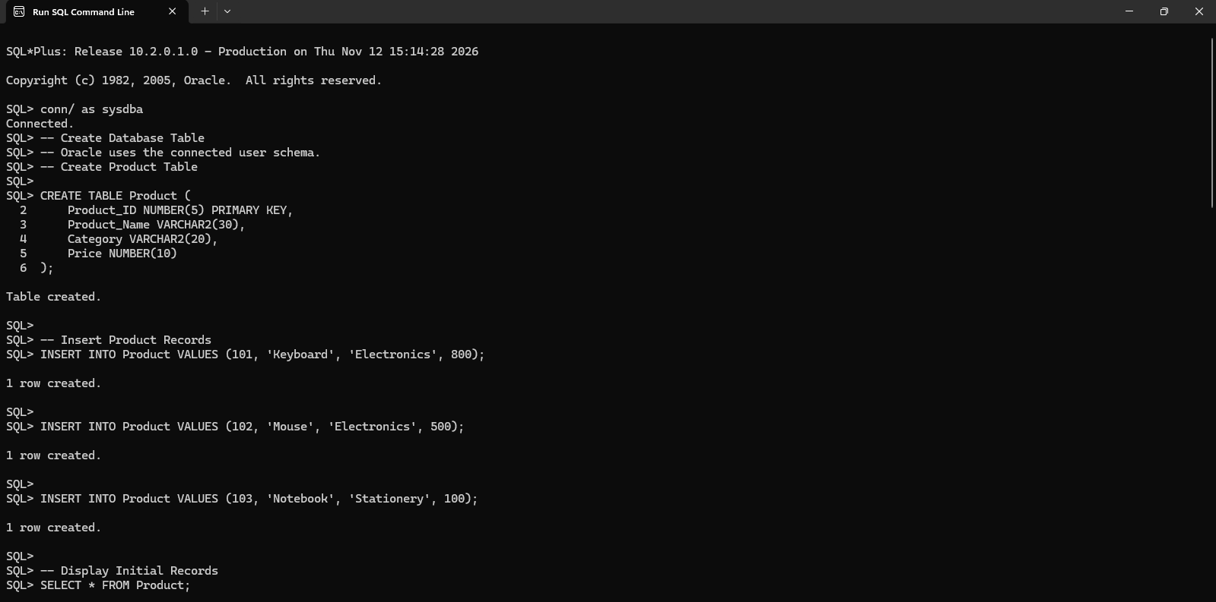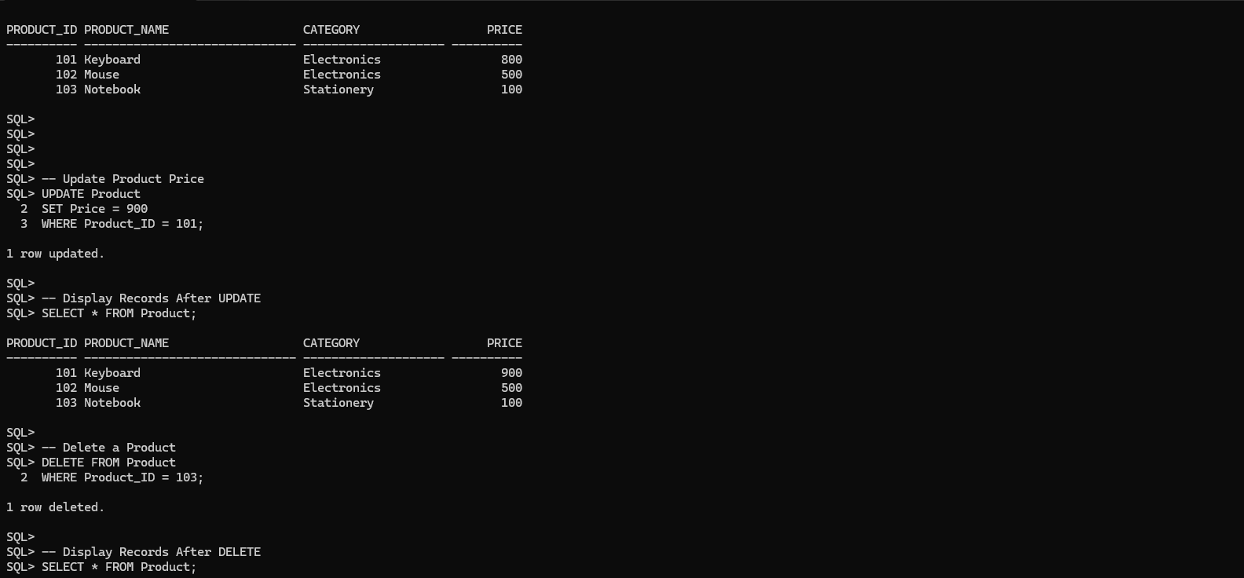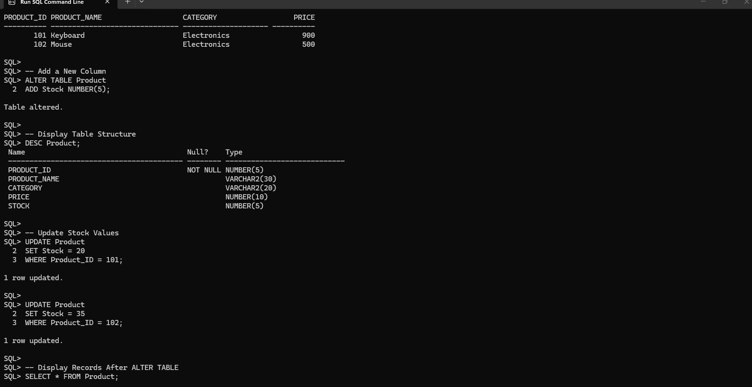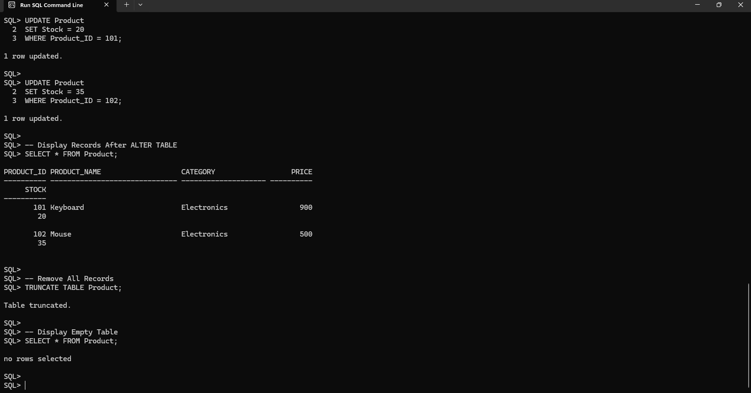

Output
Initial records

Product_ID Product_Name Category Price

101 Keyboard Electronics 800
102 Mouse Electronics 500
103 Notebook Stationery 100

After UPDATE

Product_ID Product_Name Category Price

101 Keyboard Electronics 900
102 Mouse Electronics 500
103 Notebook Stationery 100

After DELETE

Product_ID Product_Name Category Price

101 Keyboard Electronics 900
102 Mouse Electronics 500

After ALTER TABLE, the Stock column is added. After TRUNCATE, the table contains zero records.

Product_ID Product_Name Category Price Stock

101 Keyboard Electronics 900 20
102 Mouse Electronics 500 35

Result
Thus, DDL and DML operations were performed successfully on the Product table.

PROGRAM 2: FOREIGN KEY AND REFERENTIAL INTEGRITY

Aim
To create related Customer and Orders tables and implement foreign key constraints to maintain referential integrity.

Procedure
- Create a database named SalesDB.
- Create a Customer table with Customer_ID as the primary key.
- Create an Orders table with Order_ID as the primary key and Customer_ID as a foreign key.
- Insert customer records.
- Insert orders for existing customers.
- Display the records from both tables.
- Attempt to insert an order for a customer who does not exist.
- Verify the foreign key constraint.
- Stop the program.

Source Code

-- Create Customer Table
CREATE TABLE Customer (
Customer_ID NUMBER(5) PRIMARY KEY,
Customer_Name VARCHAR2(30) NOT NULL,
City VARCHAR2(30)
);

-- Create Orders Table
CREATE TABLE Orders (
Order_ID NUMBER(5) PRIMARY KEY,
Order_Date DATE,
Amount NUMBER(10),
Customer_ID NUMBER(5),
CONSTRAINT fk_customer
FOREIGN KEY (Customer_ID)
REFERENCES Customer(Customer_ID)
);

-- Insert Customer Records
INSERT INTO Customer
VALUES (1, 'Arun', 'Chennai');

INSERT INTO Customer
VALUES (2, 'Priya', 'Madurai');

INSERT INTO Customer
VALUES (3, 'Kumar', 'Coimbatore');

-- Insert Orders Records
INSERT INTO Orders
VALUES (101, TO_DATE('10-01-2026','DD-MM-YYYY'), 2500, 1);

INSERT INTO Orders
VALUES (102, TO_DATE('12-01-2026','DD-MM-YYYY'), 1800, 2);

INSERT INTO Orders
VALUES (103, TO_DATE('15-01-2026','DD-MM-YYYY'), 3200, 1);

INSERT INTO Orders
VALUES (104, TO_DATE('20-01-2026','DD-MM-YYYY'), 1500, 3);

-- Display Customer Table
SELECT * FROM Customer;

-- Display Orders Table
SELECT * FROM Orders;

-- Test Referential Integrity
INSERT INTO Orders
VALUES (105, TO_DATE('25-01-2026','DD-MM-YYYY'), 2000, 5);

-- Exit
EXIT;

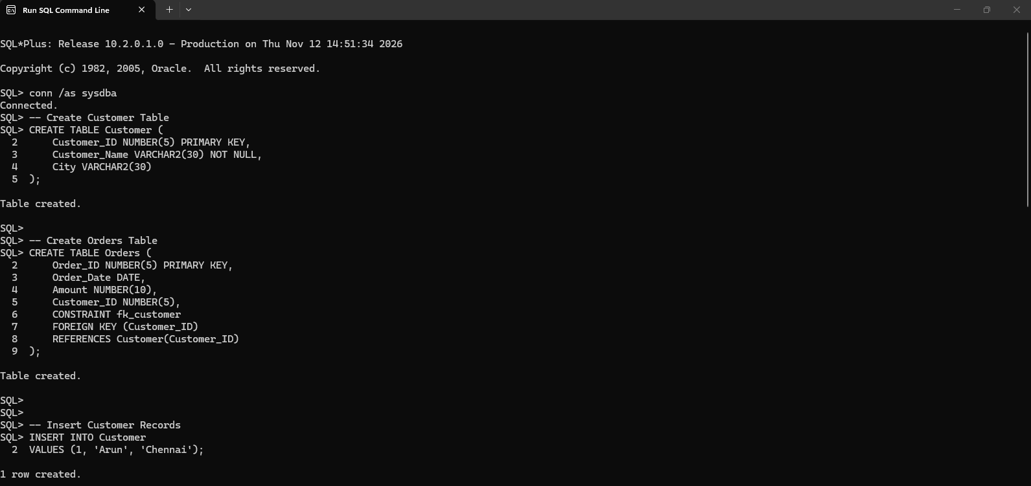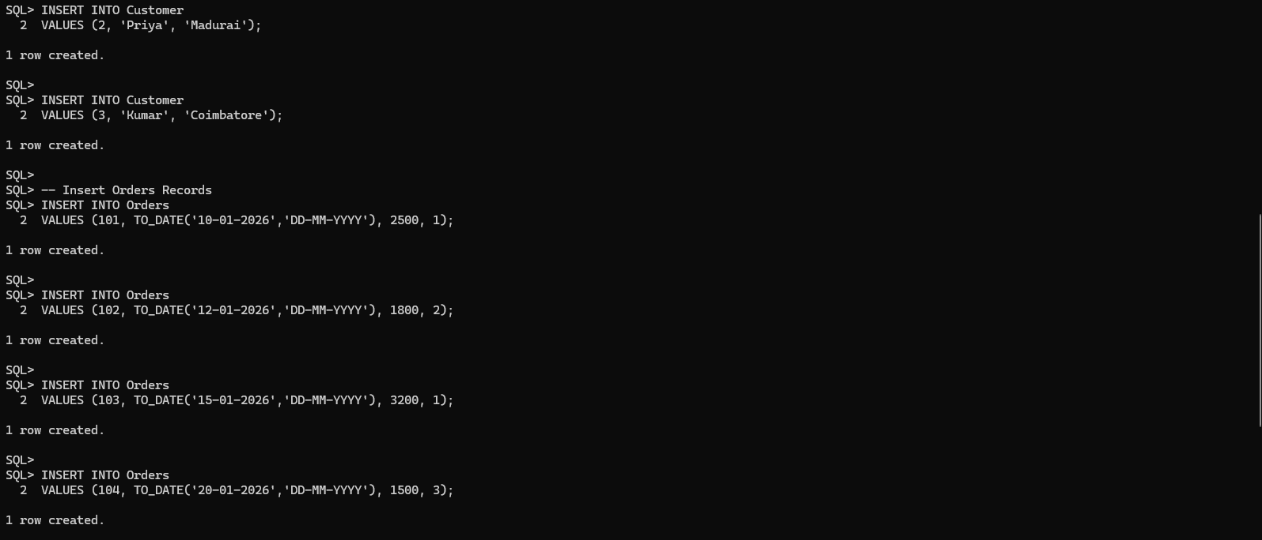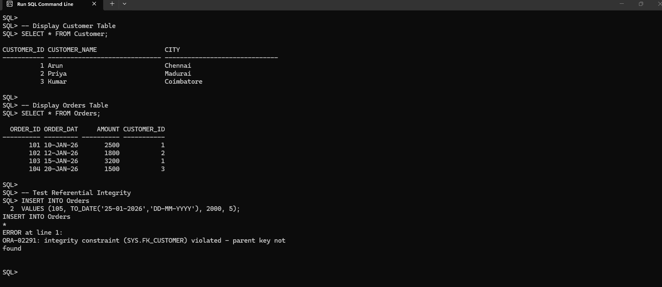

Output
Customer Table

Customer_ID Customer_Name City

1 Arun Chennai
2 Priya Madurai
3 Kumar Coimbatore

Orders Table

Order_ID Order_Date Amount Customer_ID

101 2026-01-10 2500 1
102 2026-01-12 1800 2
103 2026-01-15 3200 1
104 2026-01-20 1500 3

Invalid insertion
The insertion of Order_ID 105 is rejected because Customer_ID 5 does not exist in the Customer table.

Result
Thus, foreign key constraints were implemented successfully, and referential integrity was maintained between the Customer and Orders tables.

PROGRAM 3: WHERE CLAUSE AND AGGREGATE FUNCTIONS

Aim
To retrieve book details using the WHERE clause and calculate aggregate values using COUNT(), SUM(), AVG(), MAX() and MIN().

Procedure
- Create a Book table.
- Insert sample book records.
- Retrieve books with a price greater than 300 using WHERE.
- Calculate the total number of books.
- Calculate the total and average price.
- Find the highest and lowest prices using aggregate functions.
- Display the results.
- Stop the program.

Source Code

CREATE TABLE Book (
Book_ID NUMBER(5) PRIMARY KEY,
Book_Name VARCHAR2(40),
Category VARCHAR2(20),
Price NUMBER(10)
);
-- Insert Book Records
INSERT INTO Book VALUES (1, 'SQL Basics', 'Database', 450);
INSERT INTO Book VALUES (2, 'Python Guide', 'Programming', 600);
INSERT INTO Book VALUES (3, 'Java Basics', 'Programming', 500);
INSERT INTO Book VALUES (4, 'Web Design', 'Web', 300);
INSERT INTO Book VALUES (5, 'DBMS Guide', 'Database', 400);
-- Display All Book Records
SELECT * FROM Book;
-- Display Books Priced Above 300
SELECT *
FROM Book
WHERE Price > 300;
-- Aggregate Functions for Database Category
SELECT
COUNT(*) AS Total_Books,
SUM(Price) AS Total_Price,
AVG(Price) AS Average_Price,
MAX(Price) AS Highest_Price,
MIN(Price) AS Lowest_Price
FROM Book
WHERE Category = 'Database';

-- Stop the Program
EXIT;

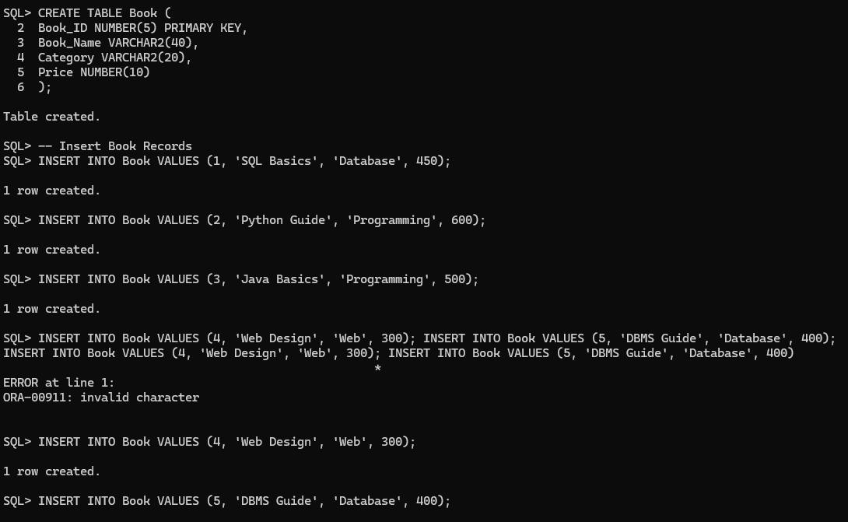

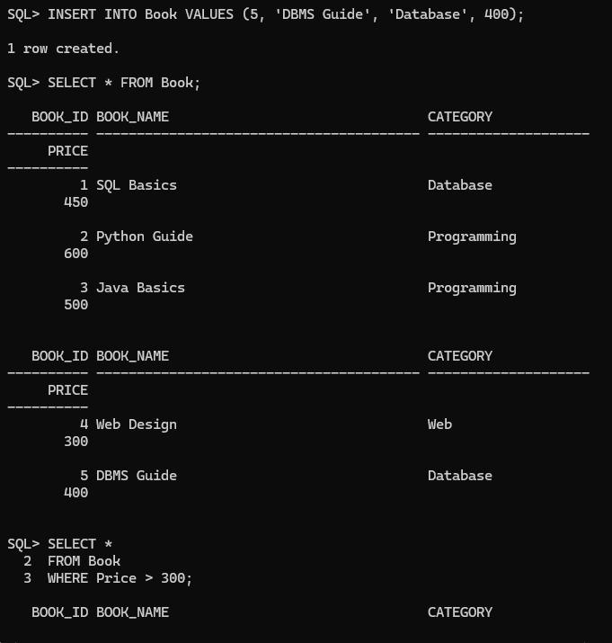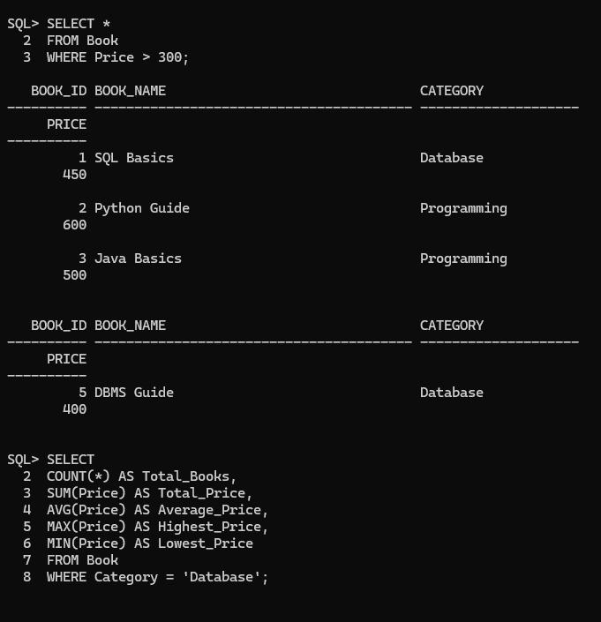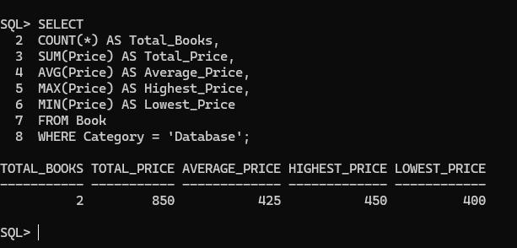

Output

Book_ID Book_Name Category Price

1 SQL Basics Database 450
2 Python Guide Programming 600
3 Java Basics Programming 500
4 WebDesign Web 300
5 DBMS Guide Database 400

Books priced above 300

Book_ID Book_Name Category Price

1 SQL Basics Database 450
2 Python Guide Programming 600
3 Java Basics Programming 500
5 DBMS Guide Database 400

Aggregate Function Output

Total_Books Total_Price Average_Price Highest_Price Lowest_Price

2 850 425 450 400

Result
Thus, the WHERE clause and aggregate functions were executed successfully to retrieve and summarize book details.

PROGRAM 4: SUBQUERIES AND SIMPLE JOINS

Aim
To execute SQL queries using the WHERE clause, subquery with IN, INNER JOIN and LEFT JOIN using Library and Publisher details.

Procedure
- Create a Publisher table and a LibraryBook table.
- Insert records into both tables.
- Retrieve books with a price greater than 400.
- Use a subquery with IN to retrieve books from selected publishers.
- Perform an INNER JOIN to display books with matching publisher details.
- Perform a LEFT JOIN to display all books, including books without a matching publisher.
- Display the results.
- Stop the program.

Source Code

-- Create Publisher Table
CREATE TABLE Publisher (
Publisher_ID NUMBER(5) PRIMARY KEY,
Publisher_Name VARCHAR2(30)
);

-- Create LibraryBook Table
CREATE TABLE LibraryBook (
Book_ID NUMBER(5) PRIMARY KEY,
Book_Name VARCHAR2(30),
Price NUMBER(10),
Publisher_ID NUMBER(5)
);

-- Insert Publisher Records
INSERT INTO Publisher VALUES (10, 'Sun Publications');

INSERT INTO Publisher VALUES (20, 'Tech Publications');

INSERT INTO Publisher VALUES (30, 'Global Books');

-- Insert LibraryBook Records
INSERT INTO LibraryBook VALUES (1, 'SQL Guide', 450, 10);

INSERT INTO LibraryBook VALUES (2, 'Python Guide', 600, 20);

INSERT INTO LibraryBook VALUES (3, 'Java Guide', 500, 10);

INSERT INTO LibraryBook VALUES (4, 'Web Design', 350, 30);

INSERT INTO LibraryBook VALUES (5, 'C Programming', 400, NULL);

-- Display Publisher Table
SELECT * FROM Publisher;

-- Display LibraryBook Table
SELECT * FROM LibraryBook;

-- 1. WHERE Clause
SELECT *
FROM LibraryBook
WHERE Price > 400;

-- 2. Subquery Using IN
SELECT Book_Name, Price
FROM LibraryBook
WHERE Publisher_ID IN (
SELECT Publisher_ID
FROM Publisher
WHERE Publisher_Name IN
('Sun Publications', 'Tech Publications')
);

-- 3. INNER JOIN
SELECT LibraryBook.Book_Name,
Publisher.Publisher_Name
FROM LibraryBook
INNER JOIN Publisher
ON LibraryBook.Publisher_ID = Publisher.Publisher_ID;

-- 4. LEFT JOIN
SELECT LibraryBook.Book_Name,
Publisher.Publisher_Name
FROM LibraryBook
LEFT JOIN Publisher
ON LibraryBook.Publisher_ID = Publisher.Publisher_ID;

-- Stop the Program
EXIT;

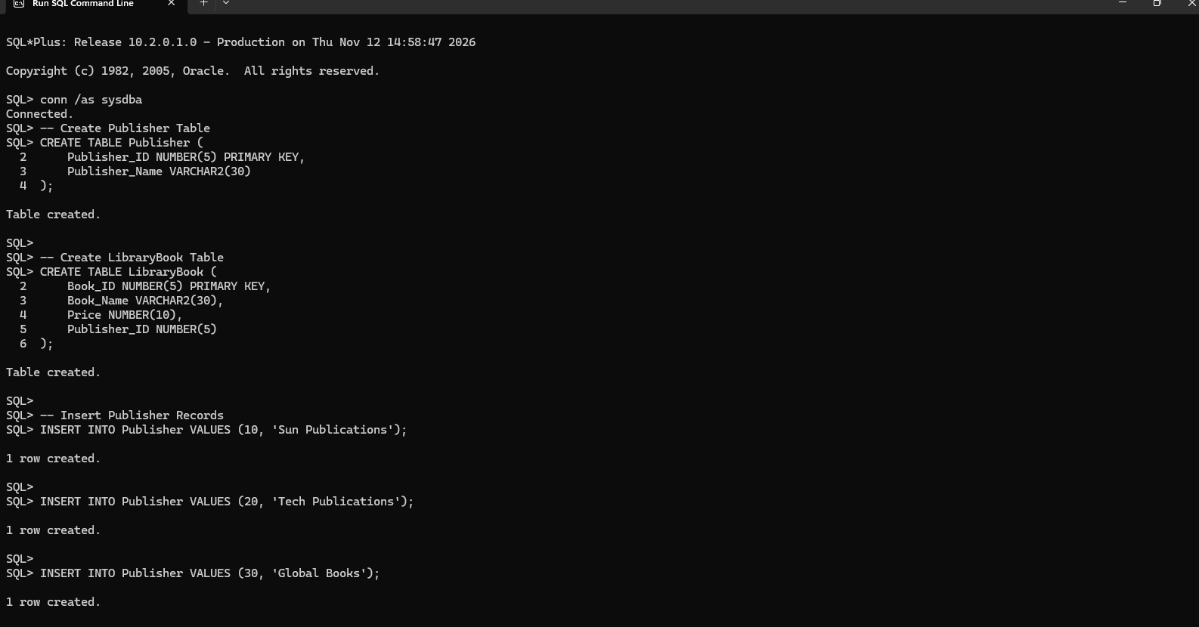
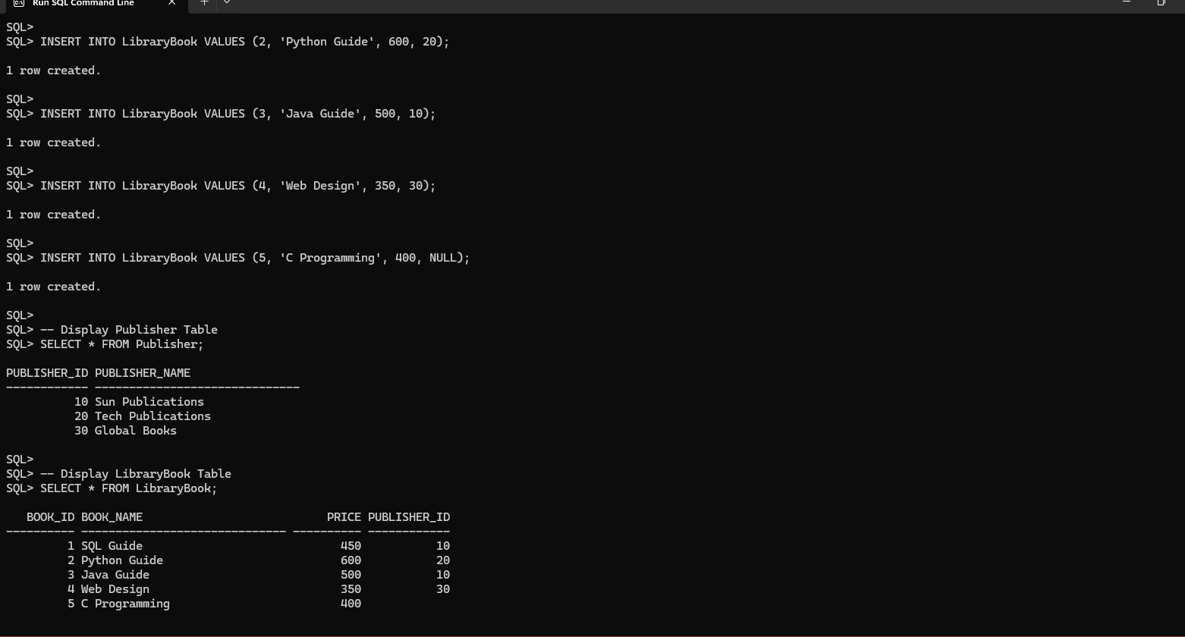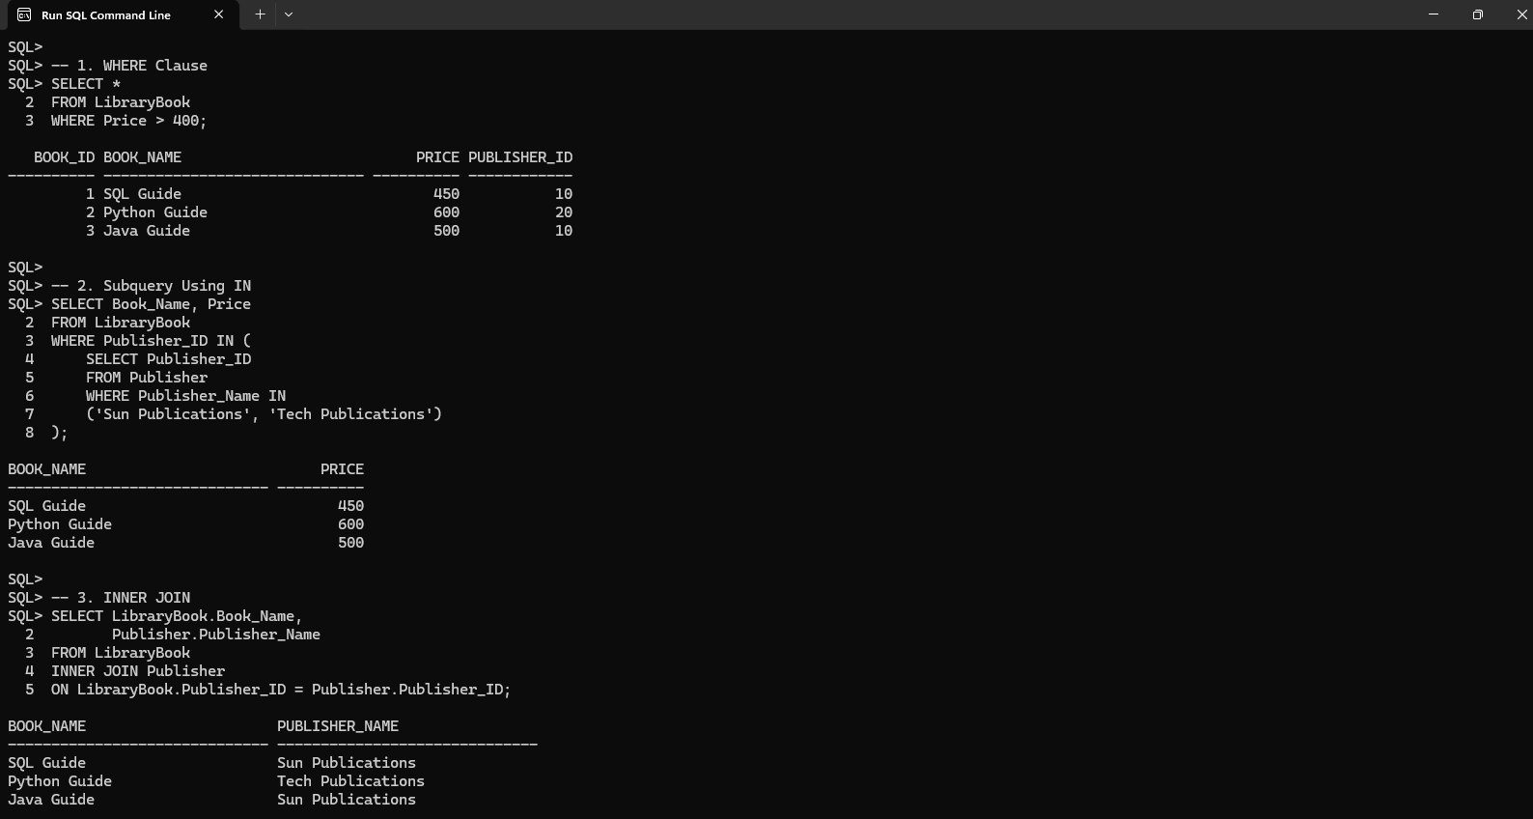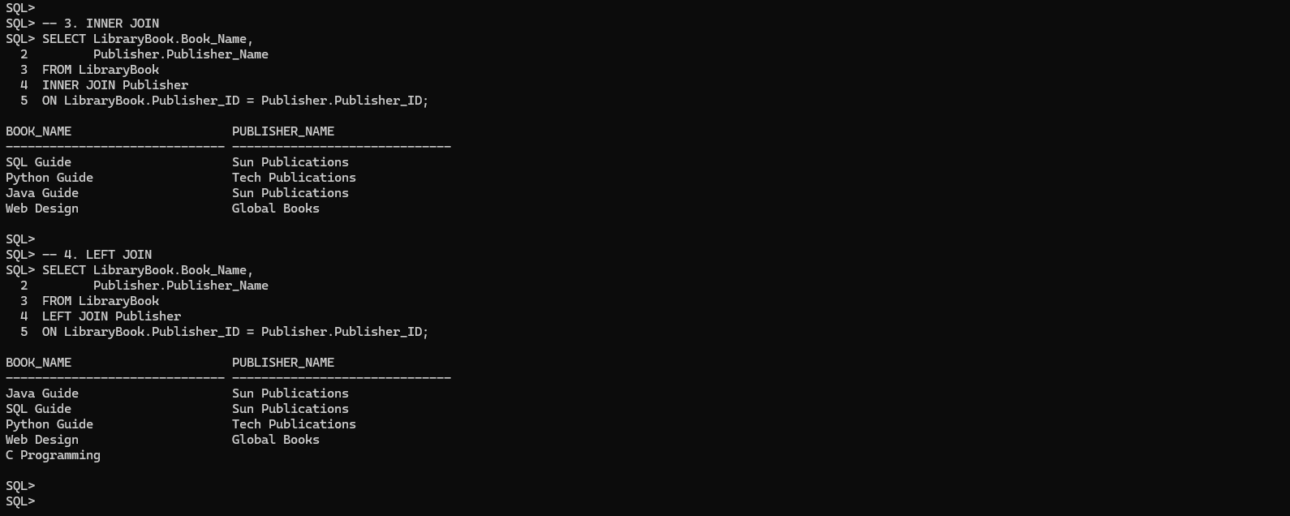

Output
1. WHERE Clause
Book_ID Book_Name Price Publisher_ID

1 SQL Guide 450 10
2 Python Guide 600 20
3 Java Guide 500 10

2. Subquery using IN

Book_Name Price

SQL Guide 450
Python Guide 600
Java Guide 500

3. INNER JOIN

Book_Name Publisher_Name

SQL Guide Sun Publications
Python Guide Tech Publications
Java Guide Sun Publications
Web Design Global Books

4. LEFT JOIN

Book_Name Publisher_Name

SQL Guide Sun Publications
Python Guide Tech Publications
Java Guide Sun Publications
Web Design Global Books
C Programming NULL

Result
Thus, the WHERE clause, subquery with IN, INNER JOIN and LEFT JOIN were executed successfully to retrieve library book and publisher details.

PROGRAM 5: NATURAL JOIN, EQUI JOIN AND OUTER JOINS

Aim
To perform Natural Join, Equi Join, Left Outer Join and Right Outer Join using Vehicle and VehicleType tables.

Procedure
- Create Vehicle and VehicleType tables.
- Insert sample vehicle and vehicle type records.
- Perform a NATURAL JOIN using the common Type_ID column.
- Perform an EQUI JOIN using the equality operator.
- Perform a LEFT OUTER JOIN to display all vehicles and their types.
- Perform a RIGHT OUTER JOIN to display all vehicle types and matching vehicles.
- Display the results.
- Stop the program.

Source Code

-- Create Vehicle Table
CREATE TABLE Vehicle (
Vehicle_ID NUMBER(5) PRIMARY KEY,
Vehicle_Name VARCHAR2(30),
Type_ID NUMBER(5)
);

-- Create VehicleType Table
CREATE TABLE VehicleType (
Type_ID NUMBER(5),
Type_Name VARCHAR2(30)
);

-- Insert Vehicle Records
INSERT INTO Vehicle VALUES (1, 'Honda City', 10);

INSERT INTO Vehicle VALUES (2, 'Royal Enfield', 20);

INSERT INTO Vehicle VALUES (3, 'Hyundai i20', 10);

INSERT INTO Vehicle VALUES (4, 'Hero Cycle', 30);

-- Insert VehicleType Records
INSERT INTO VehicleType VALUES (10, 'Car');

INSERT INTO VehicleType VALUES (20, 'Bike');

INSERT INTO VehicleType VALUES (40, 'Bus');

-- Display Vehicle Table
SELECT * FROM Vehicle;

-- Display VehicleType Table
SELECT * FROM VehicleType;

-- 1. NATURAL JOIN
SELECT *
FROM Vehicle
NATURAL JOIN VehicleType;

-- 2. EQUI JOIN
SELECT Vehicle.Vehicle_ID,
Vehicle.Vehicle_Name,
Vehicle.Type_ID,
VehicleType.Type_Name
FROM Vehicle
JOIN VehicleType
ON Vehicle.Type_ID = VehicleType.Type_ID;

-- 3. LEFT OUTER JOIN
SELECT Vehicle.Vehicle_ID,
Vehicle.Vehicle_Name,
Vehicle.Type_ID,
VehicleType.Type_Name
FROM Vehicle
LEFT OUTER JOIN VehicleType
ON Vehicle.Type_ID = VehicleType.Type_ID;

-- 4. RIGHT OUTER JOIN
SELECT Vehicle.Vehicle_ID,
Vehicle.Vehicle_Name,
VehicleType.Type_ID,
VehicleType.Type_Name
FROM Vehicle
RIGHT OUTER JOIN VehicleType
ON Vehicle.Type_ID = VehicleType.Type_ID;

-- Stop the Program
EXIT;

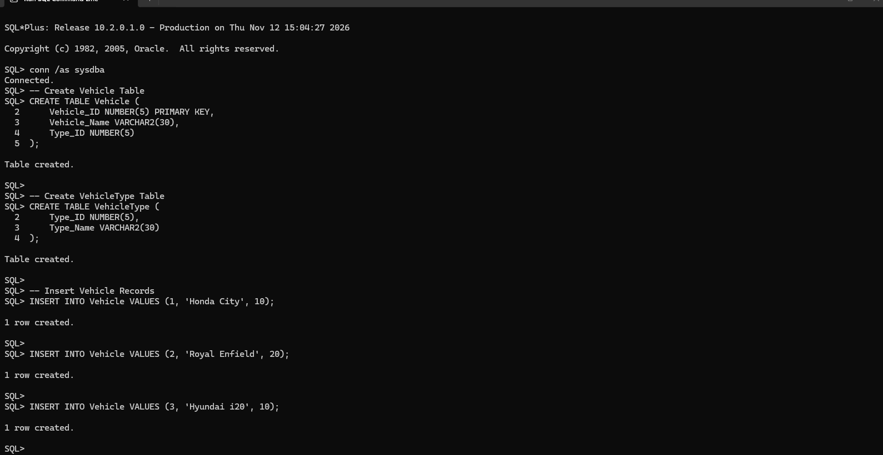
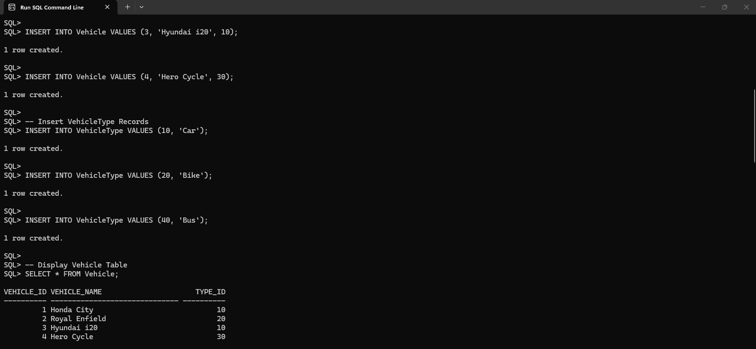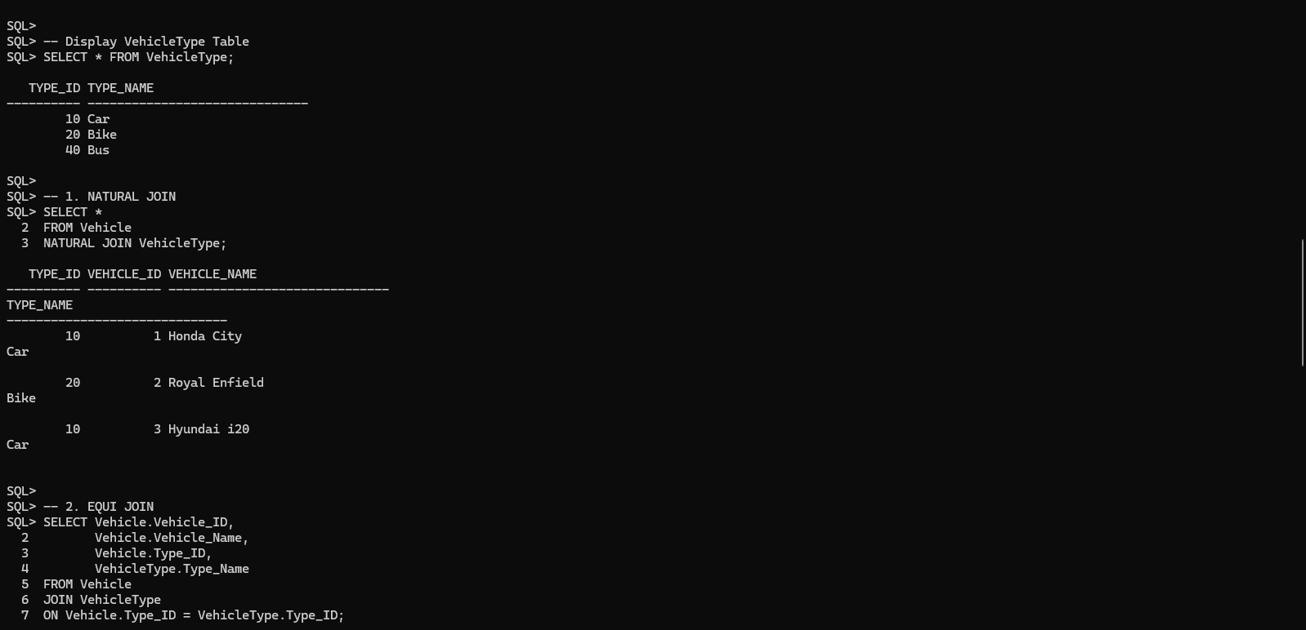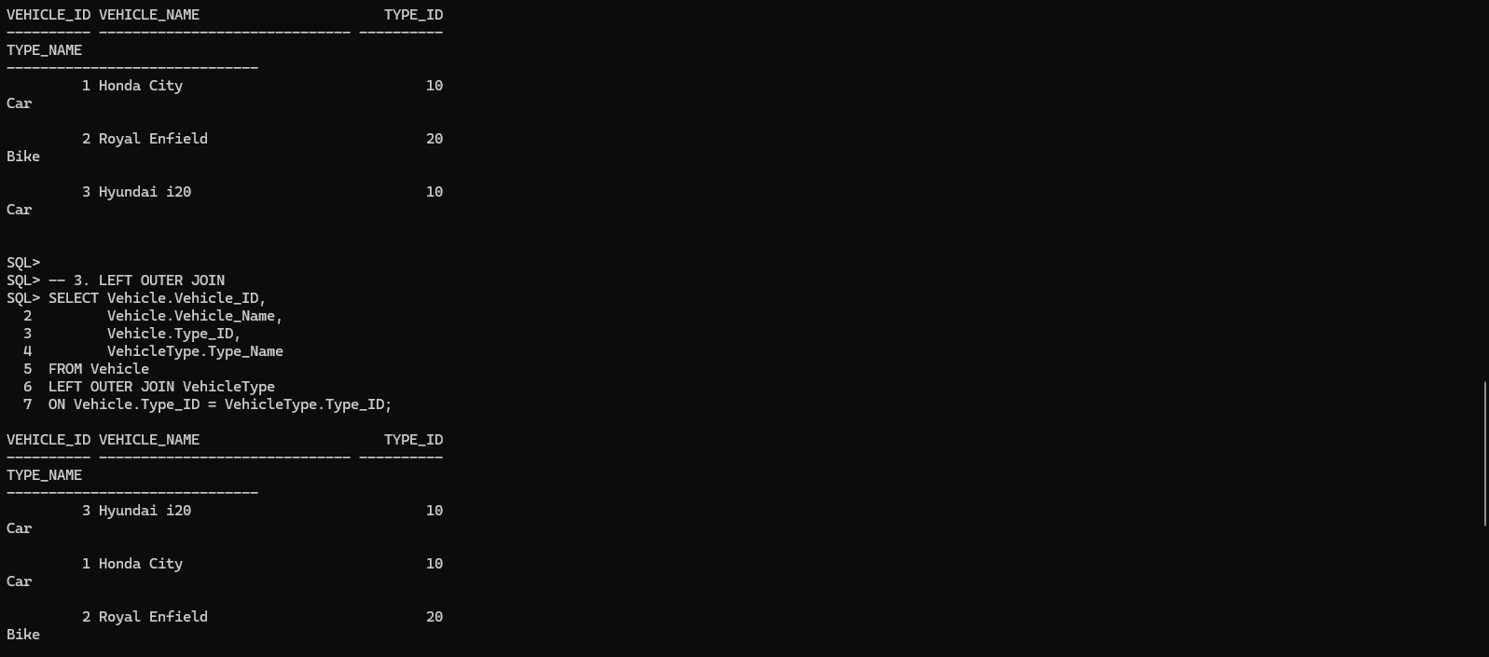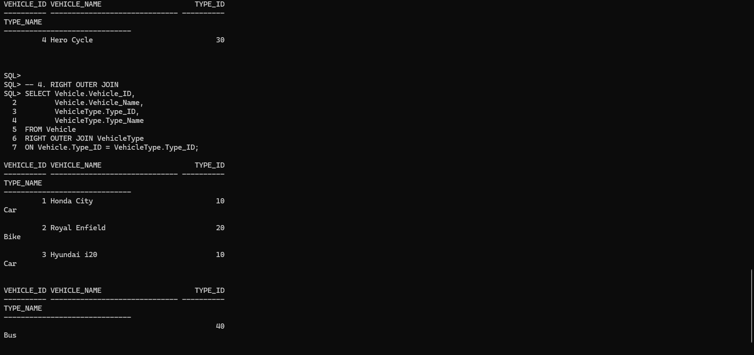

Output
1. Natural Join
Type_ID Vehicle_ID Vehicle_Name Type_Name

10 1 Honda City Car
20 2 Royal Enfield Bike
10 3 Hyundai i20 Car

2. Equi Join

Vehicle_ID Vehicle_Name Type_ID Type_Name

1 Honda City 10 Car
2 Royal Enfield 20 Bike
3 Hyundai i20 10 Car

3. Left Outer Join

Vehicle_ID Vehicle_Name Type_ID Type_Name

1 Honda City 10 car
2 Royal Enfield 20 Bike
3 Hyundai i20 10 Car
4 Hero Cycle 30 NULL

4. Right Outer Join

Vehicle_ID Vehicle_Name Type_ID Type_Name

1 Honda City 10 Car
2 Royal Enfield 20 Bike
3 Hyundai i20 10 Car
NULL NULL 40 Bus

Result
Thus, Natural Join, Equi Join, Left Outer Join and Right Outer Join were executed successfully to retrieve vehicle and vehicle type details.

