AI ASSISTED CODING
LAB ASSIGNMENT-1
Name: Kavati Chaitanya
HT.NO: 2303A51677
Batch: 22
Question-1:
AI-Generated Logic Without Modularization (Factorial without Functions)
Prompt:
# generate a code to get factorial of a number without using functions
Code and Output Screenshot:
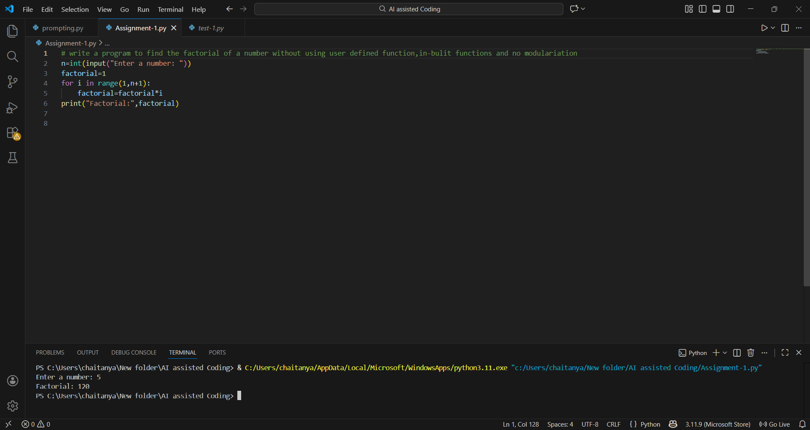
Observation:
As a beginner, GitHub Copilot really helped me think through the right logic for loops and control flow.
It saved time on syntax and small details like variable initialization and loop conditions.
Overall, it feels like a smart coding assistant that boosts confidence and speed, as long as I keep learning the fundamentals alongside it.

Question-3: Modular Design Using AI Assistance (Factorial with Functions)
Prompt: # generate a code to get factorial of a number with using functions
Code and Output Screenshot:
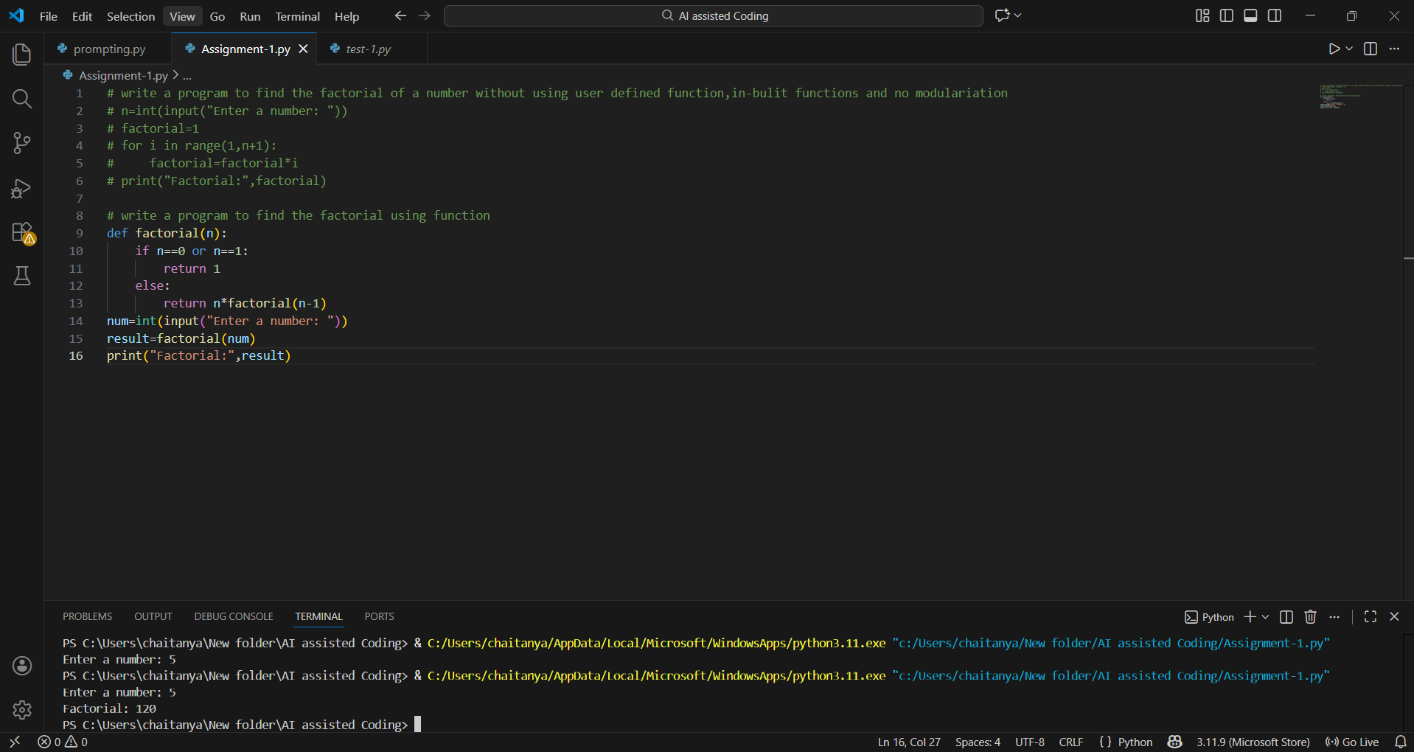
Observation:
Using GitHub Copilot for a modular design made the code more structured and easier to understand.
It suggested clear function names, meaningful parameters, and helpful inline comments that improved readability.
By separating the factorial logic into a reusable function, Copilot naturally encouraged good programming practices, especially for beginners

Question-4: Comparative Analysis – Procedural vs Modular AI Code (With vs Without Functions)
Comparison Table:
Feature | Without Functions | With Functions
Code structure | Simple and linear | Organized and modular
Calling mechanism | Executes directly | Executed through function calls
Code length | Shorter | Slightly longer
Reusability | Hard to reuse | Easily reusable in multiple programs

Technical Report:
For debugging, modular code has a clear advantage because issues can be traced to a specific function, while procedural code becomes harder to manage as scripts grow longer.
Regarding AI dependency risk, both styles require careful human review, but modular design slightly reduces this risk by making AI-generated logic easier to read and validate.
In terms of logic clarity, procedural code is fine for very small programs, but modular code scales better by organizing functionality into well-named functions that improve readability and understanding.

Question-5: AI-Generated Iterative vs Recursive Thinking
Iterative:
Prompt: # generate a code to get factorial iteratively
Code :
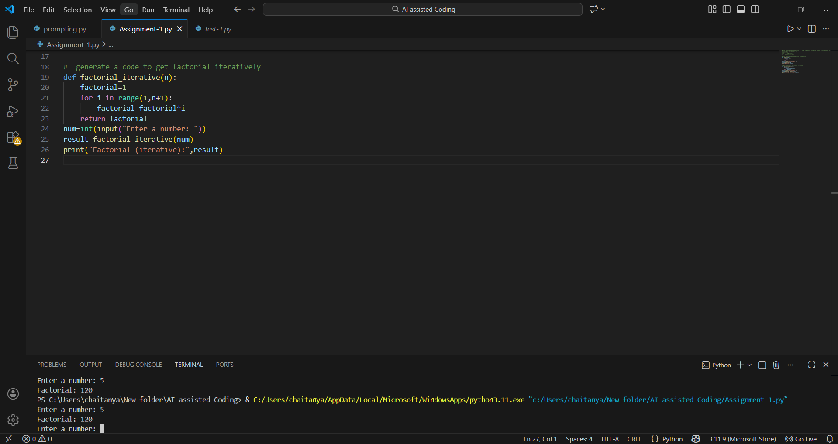
Recursive:
Prompt: # generate a code to get factorial recursively
Code :
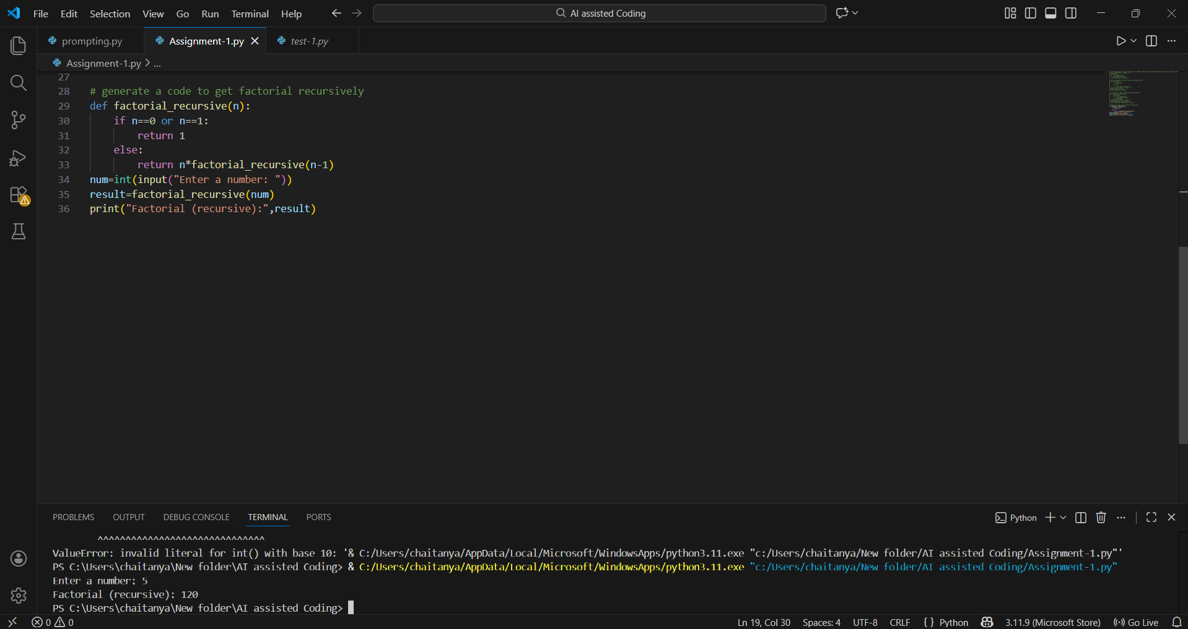
Execution Flow Explanation:
In the iterative approach, the program initializes the result as 1 and uses a loop to multiply it by each number from 1 to the given input, updating the result step by step until the loop finishes.
In the recursive approach, the problem is divided into smaller subproblems where each function call depends on the next one until a base case (0 or 1) is reached. The final factorial is then computed as the values return back through the call stack and get multiplied together.

Comparative Analysis:
1.Performance considerations show that the iterative approach is usually faster and more memory-efficient, while recursion introduces extra overhead because of repeated function calls and stack usage.
2.From a memory perspective, iterative code uses constant space, whereas recursive solutions consume additional stack memory for each call, which can become problematic for large inputs.
3.In terms of readability, iterative code is generally easier for beginners to follow, while recursive code aligns well with mathematical definitions but is harder to trace step by step.
4.Recursion is not recommended when input sizes are very large due to the risk of stack overflow, in performance-critical or memory-limited applications, or when the problem does not naturally suit a recursive structure.

