TASKS
Ok, here a first task:
- The goal of this task is to get an understanding of how packet prioritization at the border router works. In case the border router needs to forward more packets over a certain interface, than the link connected to that interface supports, a scheduler needs to decide which packets to forward, and which packets to drop. In the figure below, the sum of traffic that is being sent towards interface 4, is 30 Gbps. Because the link at interface 4 only supports 10 Gbps, not all traffic can be forwarded. The basics about scheduling can be found here: https://en.wikipedia.org/wiki/Network_scheduler
T1: Explain why the border router needs to forward reservation packets (= Colibri or Helia packets) with higher priority than best-effort.
T2: [Go] Get familiar with the concept of channels, go routines, and slices.
T3: [Go] Define a struct "Packet", that contains the fields "Payload" ([]byte) and "Type" (int). If the type is 0, then the packet is a best-effort packet, if the type is 1, it is a reservation packet.
T4: [Go] Create a channel (= queue) for such Packets.
T5: [Go] Create and run two go routines that continuously create best-effort Packets and add them to the queue (i.e., simulate interfaces 1 and 3 from the figure).
Create one go routine that continuously creates reservation Packets and adds them to the queue (i.e., simulate interface 2 from the figure).
T5: [Go] Create and run a go routine (the actual scheduler, i.e., interface 4 in the figure) that simply reads packets from the channel and prints them to the console (i.e., it prints for each packet the type and the size of the payload). This simple scheduler is called FIFO. T6: Is the FIFO scheduler a good solution for our use in Colibri or Helia? (edited)
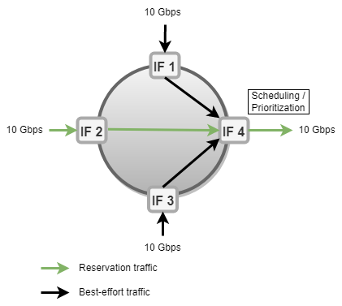

Answers

T1: Explain why the border router needs to forward reservation packets (= Colibri or Helia packets) with higher priority than best-effort?
Answer: We know that the internet is an interconnection of multiple ASes and ASes connect with each other at interfaces where border routers forward traffic between the networks. The majority of ASes traffic is devoted to forwarding best effort traffic i.e., all other kinds of non-detrimental traffic. Only a small part of the bandwidth is reserved for the high paying customers who want extremely high uptimes. So, one of the reasons that border router forwards reservation packets with higher priority then the best effort is that that reservation traffic is for those customers who have paid high amount of money to get best services that’s why those packets get high priority. High Money is equal to Best Services.
Secondly, in data transmission phase, if the reservation packets are successfully validated, then they will be sent with the highest priority thus, increase QoS.
Thirdly, If the packet time stamp and the computed RVF is correct then the border router will forward the packet with high priority. The reservation packets must reach the destination that’s why its given most priority.The prioritization of successfully validated reservation traffic can be done through scheduling.
We are reserving the bandwidth for single AS hops and then the traffic that flows through that reservation will be forwarded with priority protecting it from congestion.

T2: [Go] Get familiar with the concept of channels, go routines, and slices.
Answer: Done

T3: [Go] Define a struct "Packet", that contains the fields "Payload" ([ ]byte) and "Type" (int). If the type is 0, then the packet is a best-effort packet, if the type is 1, it is a reservation packet.

