**Day 21**

* S3 Buckets
* Files and Folders and how to access files via ACLs.
* 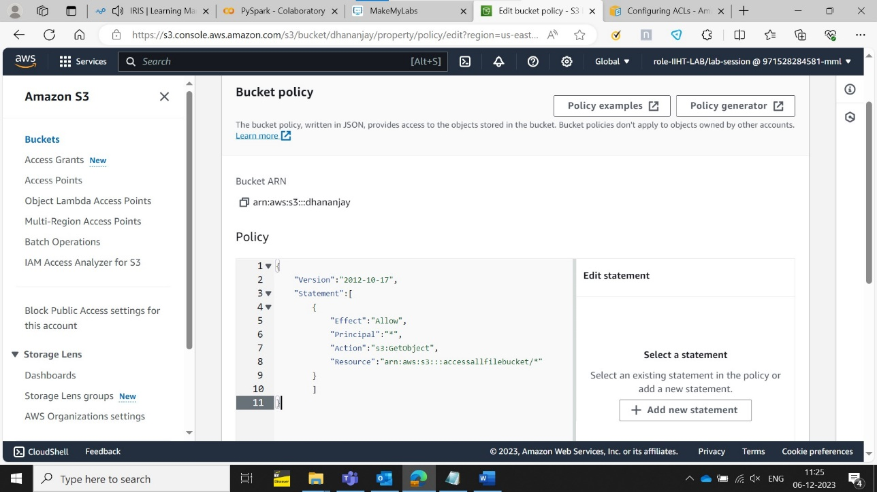Bucket Policy
* Effect: is the task we want to do for ex: Allow or Deny
* Principal is to select users who can be allowed access.
* Action is the process we want to do on the S3 bucket for example in this case we want get the file.
* Resource is the path of the file.
* IAM- Identity and Access Management – to assign roles and create user profiles so that another person can access the cloud if we give them the console link, User-ID and password.

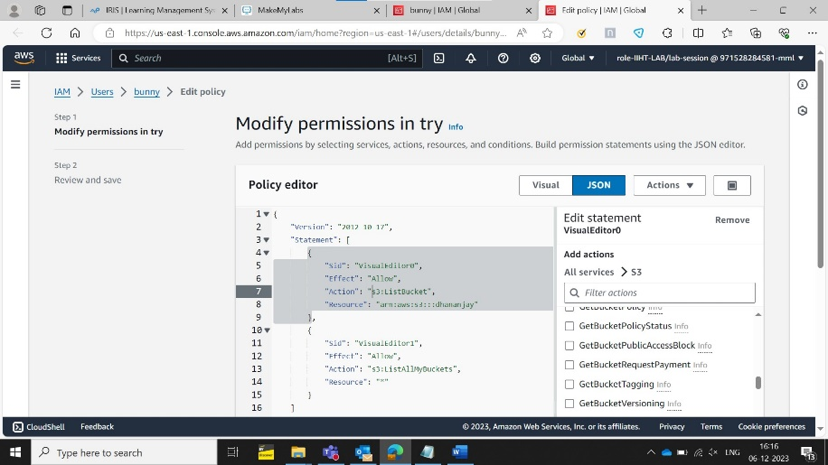

**Day 22**

* Glue-an ETL tool like Data factory.
* We need to create a role for the S3 bucket in order for Glue to access the data.
* Partition in AWS helps us find the data Faster.
* Glue crawler-scans data from various sources and creates tables in data catalog making it searchable.Steps-

1. Scan- reads from source.
2. Identify determines the data format ex-JSON.
3. Catalog-

* How to make a database and a table in AWS Glue
* Crawler to make new tables from a data source. Crawler can help us to derive from a data source or put data into a ready-made table
* For taking the data out of S3 storage to AWS Glue and analyse data we created three folders Temp,Data,Script
* Athena can use Trino SQL(data) or PySpark SQL(big data) to analyse data but keep in mind it needs a query result location to store its outputs.

Day 23

**Day 24**

* Read parquet file directly from athena
* RDS,Redshift
* RDS=Relational Database System supports many different DB engines like MySQL,SQL server while its counterpart Azure SQL can work only with SQL server
* AWS Glue is like a file system that stores tables together while RDS is full fledged Database system.
* Before connecting your DB to any application we need to make it publicly accessible
* So we need to set up inbound rules for people to certifiably enter