# ping

Ping is a basic Internet program that allows a user to verify that a particular IP address exists and can accept requests.

Ping is used diagnostically to ensure that a host computer the user is trying to reach is actually operating. Ping works by sending an Internet Control Message Protocol (ICMP) Echo Request to a specified interface on the network and waiting for a reply. Ping can be used for troubleshooting to test connectivity and determine response time.

In computer networking, [ping](https://www.lifewire.com/definition-of-ping-817864) is a specific method for sending messages from one computer to another as part of troubleshooting [Internet Protocol (IP)](https://www.lifewire.com/internet-protocol-explained-3426713) network connections. A ping test determines whether your client (computer, phone, or similar device) can communicate with another device across a network.

In cases where network communication is successfully established, ping tests can also determine the connection [latency](https://www.lifewire.com/latency-on-computer-networks-818119) (delay) between the two devices.

**Note:** Ping tests are not the same as [internet speed tests](https://www.lifewire.com/internet-speed-test-sites-2626177) that determine how fast your internet connection is against a specific website. Ping is more appropriate to test whether or not a connection can be made, not how fast the connection is.

### How Ping Tests Work

Ping uses the [Internet Control Message Protocol (ICMP)](https://www.lifewire.com/icmp-and-icmpv6-ip-networking-818135) to generate requests and handle responses.

Starting a ping test sends ICMP messages from the local device to the remote one. The receiving device recognizes the incoming messages as an ICMP ping request and replies accordingly.

The elapsed time between sending the request and receiving the reply on the local device constitutes the ping time.

### How to Ping Networked Devices

In the Windows [operating system](https://www.lifewire.com/operating-systems-2625912), the ping [command](https://www.lifewire.com/what-is-a-command-2625828) is used for running ping tests. It's built-in to the system and is executed through [Command Prompt](https://www.lifewire.com/command-prompt-2625840). However, alternative utilities are also freely available for download.

The [IP address](https://www.lifewire.com/what-is-an-ip-address-2625920) or [hostname](https://www.lifewire.com/what-is-a-hostname-2625906) of the to-be-pinged device needs to be known. This is true whether a local device behind the network is going to be pinged or if it's a website server. However, typically, an IP address is used to avoid issues with [DNS](https://www.lifewire.com/what-is-dns-domain-name-system-2625855) (if DNS doesn't find the right IP address from the hostname, the issue might rest with the [DNS server](https://www.lifewire.com/what-is-a-dns-server-2625854) and not necessarily with the device).

The Windows command for running a ping test against a router with the 192.168.1.1 IP address would look like this:

**ping 192.168.1.1**

The same [syntax](https://www.lifewire.com/what-is-syntax-2626014) is used to ping a website:

**ping lifewire.com**

See the [ping command syntax](https://www.lifewire.com/ping-command-2618099) to learn how to customize the ping command in Windows, like to adjust the timeout period, Time To Live value, buffer size, etc.

### How to Read a Ping Test

Executing the second example from above might produce results like this:

Pinging *lifewire.com* [151.101.1.121] with 32 bytes of data:

Reply from 151.101.1.121: bytes=32 time=20ms TTL=56

Reply from 151.101.1.121: bytes=32 time=24ms TTL=56

Reply from 151.101.1.121: bytes=32 time=21ms TTL=56

Reply from 151.101.1.121: bytes=32 time=20ms TTL=56

Ping statistics for 151.101.1.121:

Packets: Sent = 4, Received = 4, Lost = 0 (0% loss),

Approximate round trip times in milli-seconds:

Minimum = 20ms, Maximum = 24ms, Average = 21ms

The IP address shown above belongs to Lifewire, which is what the ping command tested. The 32 [bytes](https://www.lifewire.com/definition-of-byte-816252) is the buffer size, and it's followed by the response time.

The result of a ping test varies depending on the quality of the connection. A good [broadband](https://www.lifewire.com/definition-of-broadband-816297) internet connection (wired or wireless) typically results in ping test latency of less than 100 ms, and often less than 30 ms.

A [satellite internet](https://www.lifewire.com/definition-of-satellite-internet-817782) connection normally suffers from latency above 500 ms.

See our guide on [how to ping a computer or website](https://www.lifewire.com/how-to-ping-computer-or-website-818405) to learn more about the results of a ping test.

<https://www.lifewire.com/computer-ping-test-817743>

|  |
| --- |
| > ping www.google.com Pinging www.google.akadns.net [216.239.41.99] with 32 bytes of data:  Reply from 216.239.41.99: bytes=32 time=1ms TTL=128. Reply from 216.239.41.99: bytes=32 time=<10ms TTL=128. Reply from 216.239.41.99: bytes=32 time=<10ms TTL=128. Reply from 216.239.41.99: bytes=32 time=1ms TTL=128.  Ping statistics for 216.239.41.99:   Packets: Sent = 4, Received = 4, Lost = 0 (0% loss), Approximate round trip times in milli-seconds:   Minimum = 0ms, Maximum = 1ms, Average = 0ms  > |

Notice how the ping command translated the FQDN into an IP address. This is actually ping using [nslookup](http://www.csit.parkland.edu/~smauney/csc130/nslookup.shtml) in order to determine the IP address of www.google.com.

# ipconfig

What do you mean by ipconfig?

In computing, **ipconfig** (internet protocol configuration) in Microsoft Windows is a console application that displays **all** current TCP/IP network configuration values and can modify Dynamic Host Configuration Protocol (DHCP) and Domain Name System (DNS) settings.

ipconfig is a very simple, text-based ip setup utility. It has all of the functionality of winipcfg, but without the fancy interface. winipcfg is now obsolete because it is an old Win9x utility. If you wanted to check your ip address, you would type ipconfig. To release your ip address, the command would be ipconfig /release. If you wanted to renew, it would be ipconfig /renew. If you need to see your MAC address, you would type ipconfig /all. The screens look something like this:

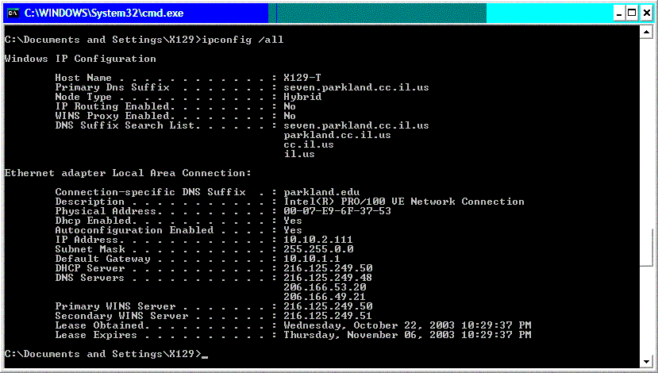

# nslookup

nslookup is a command that is useful for finding the ip address of a machine that you only have a FQDN for. If I needed the ip for www.google.com, I would type something like this:

|  |
| --- |
| > nslookup www.google.com Server:   ns1.parkland.edu Address:   216.125.249.48  Non-authoritative answer: Name:    www.google.akadns.net Addresses:   216.239.41.104,  216.239.41.99 Aliases:   www.google.com |

What this tells me is that that google actually has two ip addresses, so this is what is called a multi-homed host (See the web page on the [DNS](http://www.csit.parkland.edu/~smauney/csc130/dns.shtml) system). This is not uncommon for larger sites, as they may actually be hosted on multiple machines.   
  
Another interesting fact is that nslookup returns a **'Non-authoritative'** answer. This is because the name server that is being used is ns1.parkland.edu and is sending us a cached copy, which is not the authorative name server for google, but our name server at one time got the information from a name server that was authoritative for google and then cached it so that it could answer queries for the address www.google.com without having to constantly ask..

# The OSI Model

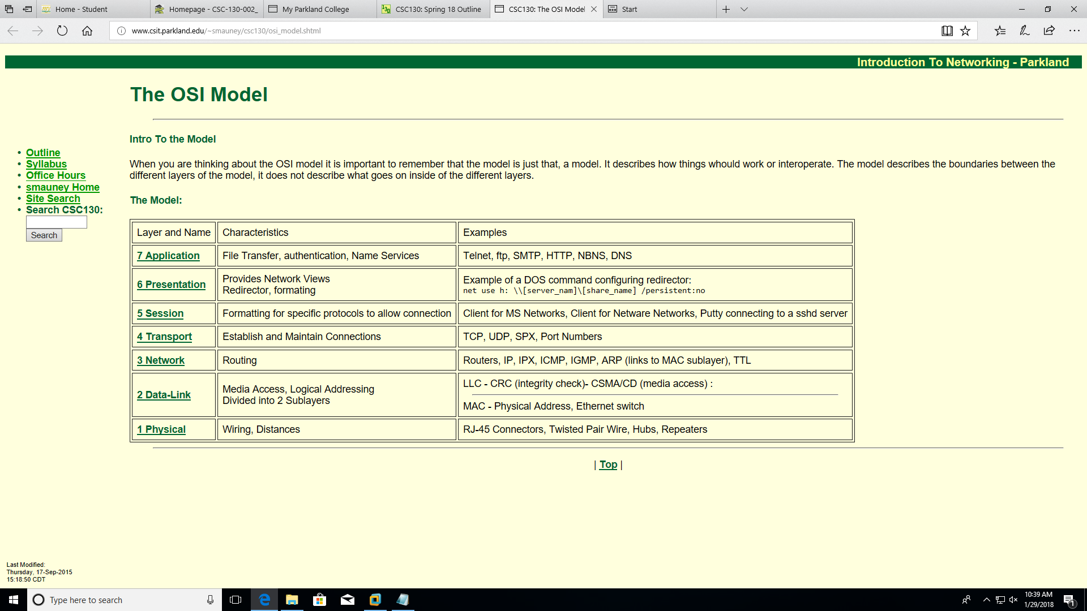

# Reverse Address Resolution Protocol (RARP)

RARP (Reverse Address Resolution Protocol) is a [protocol](http://searchnetworking.techtarget.com/definition/protocol) by which a physical machine in a local area network can request to learn its [IP address](http://searchwindevelopment.techtarget.com/definition/IP-address) from a [gateway](http://searchnetworking.techtarget.com/definition/gateway) server's Address Resolution Protocol (ARP) table or cache. A network administrator creates a table in a local area network's gateway [router](http://searchnetworking.techtarget.com/definition/router) that maps the physical machine (or Media Access Control - [MAC address](http://searchnetworking.techtarget.com/definition/MAC-address)) addresses to corresponding Internet Protocol addresses. When a new machine is set up, its RARP [client](http://searchenterprisedesktop.techtarget.com/definition/client) program requests from the RARP [server](http://whatis.techtarget.com/definition/server) on the router to be sent its IP address. Assuming that an entry has been set up in the router table, the RARP server will return the IP address to the machine which can store it for future use.

# TTL

An IP TTL is set initially by the system sending the packet. It can be set to any value between 1 and 255; different operating systems set different defaults. Each router that receives the packet subtracts at least 1 from the count; if the count remains greater than 0, the router forwards the packet, otherwise it discards it and sends an Internet Control Message Protocol (ICMP) message back to the originating host, which may trigger a resend.

The point of the TTL/hop limit is to keep streams of undeliverable packets stuck in routing loops (perhaps due to incorrect routing tables) from circulating forever and clogging up the networks in question. In Multiprotocol Label Switching (MPLS) clouds, the MPLS TTL is copied from the IP TTL when the IP packet enters the cloud. On egress, the MPLS TTL value is copied into the IP TTL field (as long as it is less than the value in the field).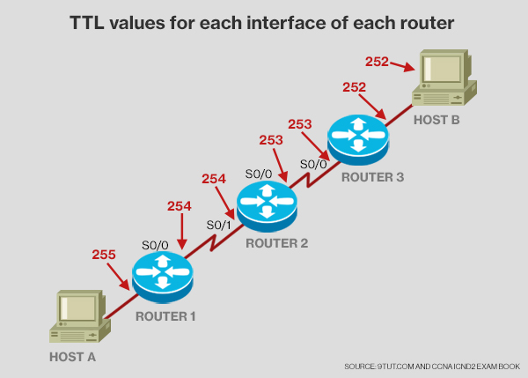

<http://searchnetworking.techtarget.com/definition/time-to-live>

# Frame relay

Frame relay is a packet-switching telecommunication service designed for cost-efficient data transmission for intermittent traffic between local area networks ([LANs](http://searchnetworking.techtarget.com/definition/local-area-network-LAN)) and between endpoints in wide area networks ([WANs](http://searchenterprisewan.techtarget.com/definition/WAN)). The service, once widely available and implemented, is in the process of being discontinued by major Internet service providers.

Frame relay puts data in a variable-size unit called a [*frame*](http://searchnetworking.techtarget.com/definition/frame) and leaves any necessary error correction (retransmission of data) up to the endpoints, which speeds up overall data transmission. For most services, the network provides a permanent virtual circuit ([PVC](http://searchnetworking.techtarget.com/definition/permanent-virtual-circuit)), which means that the customer sees a continuous, dedicated connection without having to pay for a full-time leased line, while the service provider figures out the route each frame travels to its destination and can charge based on usage. Switched virtual circuits (SVC), by contrast, are temporary connections that are destroyed after a specific data transfer is completed.

# NetBIOS Name Resolution

NetBIOS name resolution is the process of successfully mapping a NetBIOS name to an IP address. A NetBIOS name is a 16-byte address used to identify a NetBIOS resource on the network. A NetBIOS name is either a unique (exclusive) or group (nonexclusive) name. When a NetBIOS process communicates with a specific process on a specific computer, a unique name is used. When a NetBIOS process communicates with multiple processes on multiple computers, a group name is used.

The NetBIOS name acts as a session layer application identifier. For example, the NetBIOS Session service operates over TCP port 139. All NetBIOS over TCP/IP session requests are addressed to TCP destination port 139. When identifying a NetBIOS application with which to establish a NetBIOS session, the NetBIOS name is used.

An example of a process using a NetBIOS name is the file and print sharing server service on a Windows 2000–based computer. When your computer starts up, the server service registers a unique NetBIOS name based on your computer's name. The exact name used by the server service is the 15 character computer name plus a 16th character of 0x20. If the computer name is not 15 characters long, it is padded with spaces up to 15 characters long. Other network services also use the computer name to build their NetBIOS names so the 16th character is used to uniquely identify each service, such as the redirector, server, or messenger services. Figure 1.13 shows the NetBIOS names associated with the server, redirector, and messenger services.

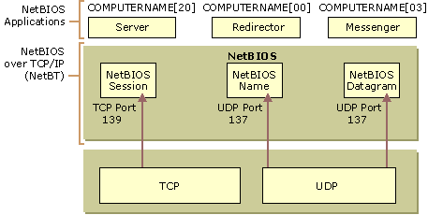

**Figure 1.13 NetBIOS Names and Services**

When you attempt to make a file-sharing connection to a Windows 2000–based computer by name, the server service on the file server you specify corresponds to a specific NetBIOS name. For example, when you attempt to connect to the computer called CORPSERVER, the NetBIOS name corresponding to the server service is "CORPSERVER     <20>" (note the padding using the space character). Before a file and print sharing connection can be established, a TCP connection must be created. In order for a TCP connection to be established, the NetBIOS name "CORPSERVER     <20>" must be resolved to an IP address.

To view the NetBIOS names registered by NetBIOS processes running on a Windows 2000 computer, type **nbtstat -n** at the Windows 2000 command prompt.

# DNS Server

A [DNS](https://www.lifewire.com/what-is-dns-domain-name-system-2625855) server is a computer server that contains a database of [public IP addresses](https://www.lifewire.com/what-is-a-public-ip-address-2625974)and their associated [hostnames](https://www.lifewire.com/what-is-a-hostname-2625906), and in most cases, serves to resolve, or translate, those common names to [IP addresses](https://www.lifewire.com/what-is-an-ip-address-2625920) as requested.

DNS servers run special software and communicate with each other using special protocols.

In more easy to understand terms: a DNS server on the internet is the device that translates that *www.lifewire.com* you type in your browser to the 151.101.129.121 IP address that it really is.

**Note:** Other names for a DNS server include name server, nameserver, and domain name system server.