BASIC DOS COMMANDS
cd – change directory
Ex. cd windows (as long as windows is in the current directory!)
dir – lists files in current directory
Ex. dir (use on any directory structure and it will lists files and folders in the current directory, unless other directed to display from a different location.)
mkdir or md – create a directory
Ex. mkdir chinton (makes a directory in the current directory named chinton)
rmdir – remove a directory
rmdir chinton (removes a directory in the current directory named chinton)
copy and xcopy – copy one file or use xcopy to copy an entire folder structure
Ex. Syntax is copy [source] [destination] where source is the file being copied and destination is where you want the file to be copied to.
move – similar to copy, except when you move, it moves the file to the new location but does not leave the original copy in place.
Ex. move [source] [destination]
move chinton.txt chinton2.txt
chinton is now a file called chinton2 and chinton does not exist.
rename – changes the name of the file
del – deletes files
Ex. del [filename]
deltree – deletes folders and files within them. Use this command with caution.
Wildcards - * and ? * is used to include a whole group of possible letters or numbers, ? represents one character and that is all.
edit – simple text editor that allows you to edit plain text files.
Ex. edit [filename]
mem – gives you a listing of your memory of your system.
ipconfig – shows you IP address
echo – displays what you type after the echo on your screen
pause – pauses your processes in a batch file.
net user – use this command to create users on the local machine

net localgroup – add, delete, view, and otherwise manage network groups

start – Starts a separate window to run a specified program or command

net use - Connects or disconnects your computer from a shared resource or displays information about your connections

- Open Notepad
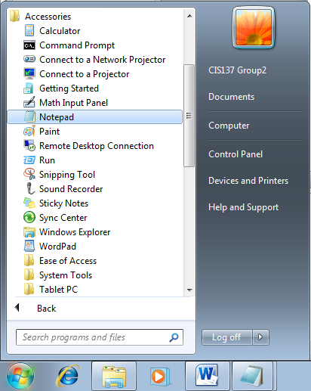

- Enter the command keep the command prompt from printing the command being run
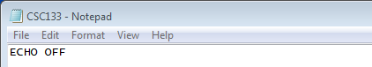

- Creates User Accounts called user1 – user5 with Passwords of 1234 for all accounts
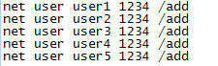

- Makes these newly created user accounts Local Administrator accounts
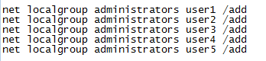

- Creates directories named A, B, C, D, …., Y, Z that are placed wherever the batch file is located
on the drive
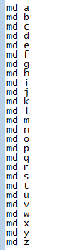

- Starts the Calculator and Windows Media Player programs

- Make the batch file stop until you press a key

- Go to File and click Save As
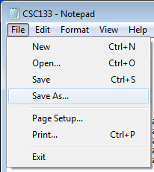

- In the Save as type: drop-down menu select All Files and in the File name field type CSC133.bat
(Adding the .bat file extension is what makes this a batch file)
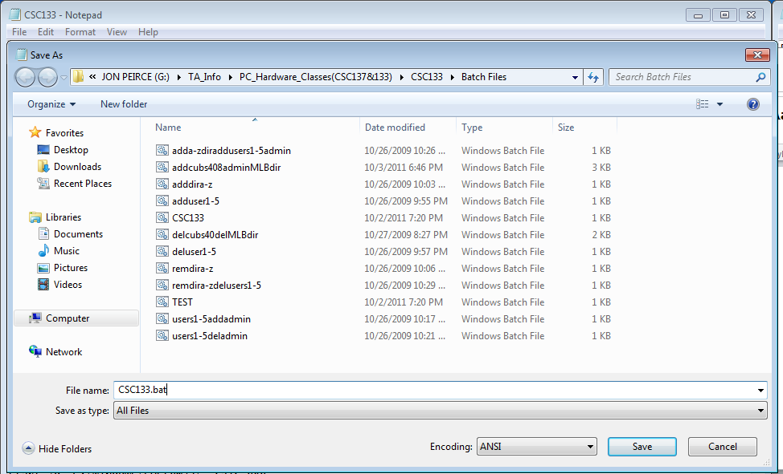

When you are finished the batch file should look something like this:

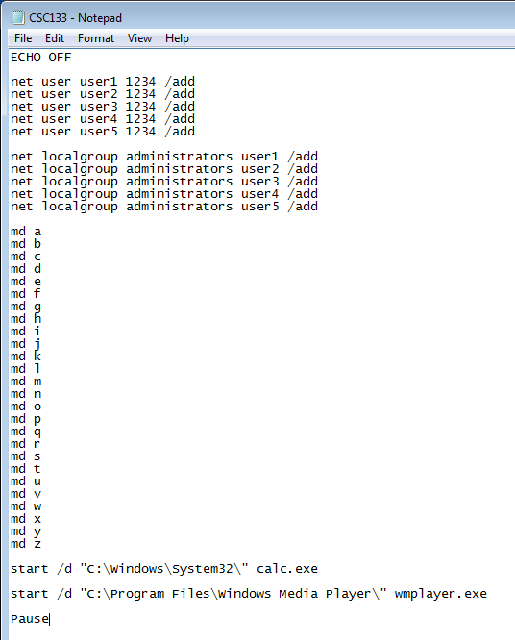

Create the batch file for removing the newly created users and directories

- Open Notepad

- Enter the command keep the command prompt from printing the command being run

- Delete User Accounts user1 – user5
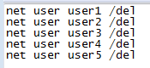

- Remove the directories A, B, C, D…..X, Y, Z
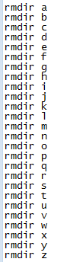

- Make the batch file stop until you press a key

- Go to File and click Save As

- In the Save as type: drop-down menu select All Files and in the File name field type CSC133_Remove.bat
(Adding the .bat file extension is what makes this a batch file)
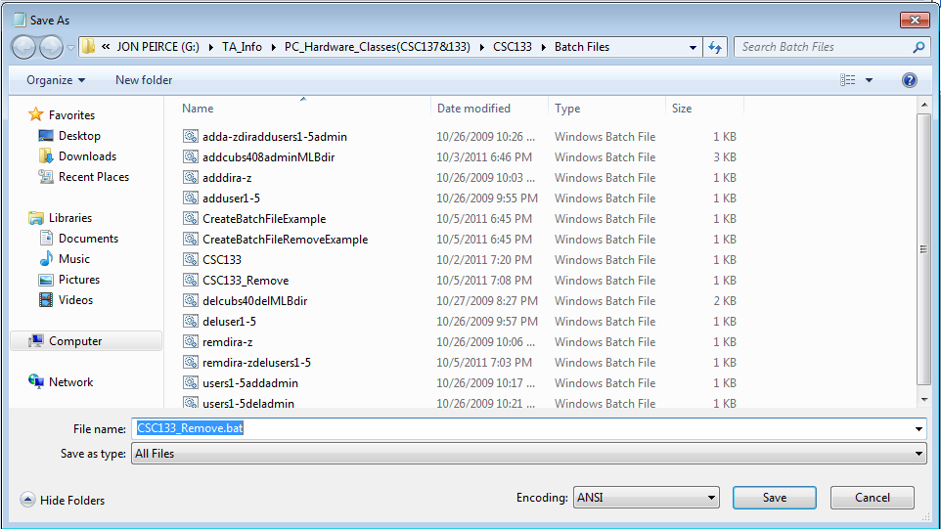

When you are finished the batch file should look something like this:
