Name: __Biruo Zhao_______ Instructor sign:______________
Print this worksheet. Perform the steps below on your lab PSU. Fill out this worksheet as you complete the steps. When you have completed all the requirements have the instructor or teacher’s assistant sign off on this sheet to receive credit for this lab.
ASSIGNED LAB STEPS:

1) Measure wall outlet voltage
Ground-to- Hot = __124V___
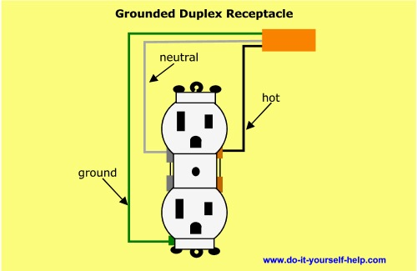
Ground-to-Neutral = ___.3V____
Hot-to-Neutral = ___7V_____

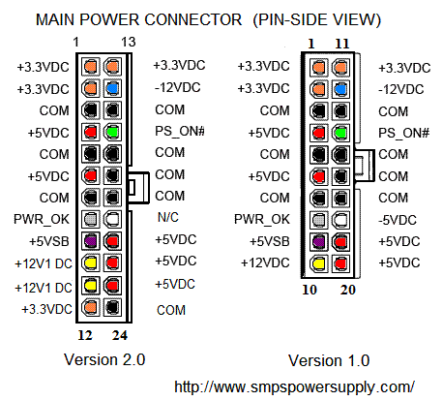

2) Measure PC Power Supply voltages at motherboard (20 or 24 PIN ).

RED:-----5.25------- ORANGE: ____3.374_____ BLUE:--------11.40---------

GREEN:__POWERON____ YELLOW:___11.74V______ WHITE:___4.62______

PURPLE:___5.16V____ BLACK:___0V______ GRAY:____5.25V_____

3. Test the Laptop AC adapter. (measure voltage in V DC)

Note: Use multimeter to test this adapter.

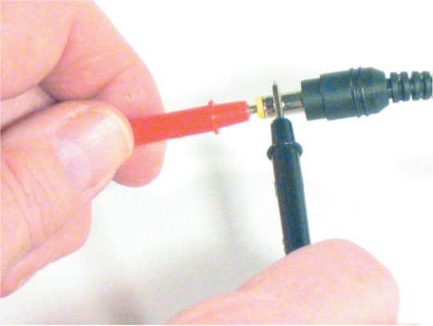

Voltage:_____19.71____

Name of adapter you are Dell AC Adapter
D using: ______________

