Name: ___Biruo Zhao____ Instructor sign:______________

Print this worksheet. Perform the steps below on your lab PC. Fill out this worksheet as you complete the steps. When you have completed all the requirements have the instructor or teacher’s assistant sign off on this sheet to receive credit for this lab.
- Install assigned disk as a 2nd drive on your lab machine.

- 3 (Primary) Partitions Identified as: (F:, I:, H:)
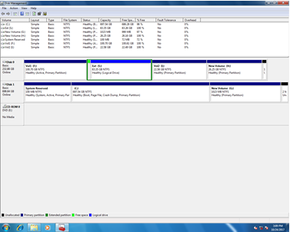

- 1 Partitions to be extended ( S: )

- Delete all the created partition and make it unallocated once again.

- Look-up and provide the following information:

- Proper storage size to Upgrade & Max. Upgrade size (no of hard disk you can install).

Type HDD Western Digital Blue 250 GB

Max Size 250 GB Max Amount 250 GB

Hard disk Name: Western Digital Blue 250 GB

- View the UEFI/BIOS setup information on your computer, and write down all the UEFI/BIOS settings that apply to your hard drive. Explain each setting that you can. What is the size of the installed drive? Does your system support S.M.A.R.T.? If so, is it enabled?
Controller details:
Controller = Serial ATA
Port = SATA-1
Drive details:
Drive ID = WDC WD2500AAJS-00L7A0
Capacity = 250 GB
BIOS = Controlled by the AHCI BIOS
Does support S.M.A.R.T. but, it is not enabled

