Solve the given problems and suggest the appropriate solution for it. Write down all the answers save the file and finally upload it to windows installation lab dropbox.
Note: You can take help of internet and book to solve the given problems.

1. How many ways are there to install OS on one machine?
There are 3 ways to install an OS on a machine.
(a) Run it as a virtual machine on your current operating system; (b) dual-boot it alongside your current operating system; or (c) perform a full install and overwrite the OS you're currently rolling with.

2. What is the best possible way to install windows 10 as a dual boot on windows 8 if your DVD/CD drive is not working.
Get Windows 10 in an ISO on a flashdrive, create a partition to install the OS so you can dual boot, and then launch the ISO/installer.

3. How many types of windows 7 editions are available and which are they? Which of those editions are widely used?
There are 6 editions of Windows 7. Starter, Home Basic, Home Premium, Professional, Enterprise, and Ultimate. The most widely used ones are Home Basic, Home Premium, and Professional.

4. How many types of windows 8 editions are available and which are they? Which are windows 7 editions those can be upgraded to windows 8?
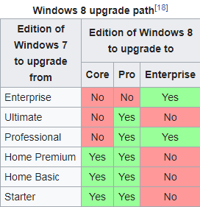
There are 3 editions of Windows 8. Windows 8, Pro, and Enterprise. All versions of Windows 7 had the ability to upgrade to Windows 8.

5.How many types of windows 10 editions are available and which are they?
There are 12 different types of Windows 10 Editions. Home, Pro, Enterprise, Education, Pro Education, Enterprise LTSB, Mobile Enterprise, Mobile, IoT, S, and Team.

6. How many OS can be install on one machine if your Hard-disk support MBR (master boot record)?
You can have 4 OSes installed on one machine on MBR.

7. How many OS can be install on one machine if your Hard-disk support GPT (GUID partition table)? List down the OS which uses GPT?
You can have up to 128 partitions using GPT so theoretically if you had the Hard Drive space, 128 OSes can be installed. But only Windows 64 bit versions can be installed on GPT since it’s a newer type of formatting.

8. Consider the scenario where a user forgot his/her PC password and wants to reset the new password for that PC at home. What is the best and most inexpensive way for solving this problem and how? Write down the steps to solve it.
Make Guesses at Your Windows Password
Reset Your Microsoft Account Password Online(You can reset a forgotten Windows password online like this only if you're using a Microsoft account. If you're using a local account, your password is not stored with Microsoft online and so can't be reset by them)
Use That Windows Password Reset Disk You Made
Have Another User Change Your Windows Password
Use This Hack to Reset Your Windows Password(https://www.lifewire.com/how-to-reset-a-windows-8-password-2626230)
Reset or Recover Your Windows Password With One of These Tools
(A number of software-based hacking tools, called Windows password recovery programs, are available from various companies and software developers)
Reset Your PC( Troubleshoot > Reset Your PC)

9. What is the need of BIOS settings in computer? List down the changes you can perform on BIOS settings also write down how to access BIOS settings on windows 10?

You need the BIOS because it can perform basic tasks. This can be very useful when you have a major problem with the system, whether the OS or hard drive is damaged, computer settings crashing, constant blue screening, etc. You can overclock/change clockspeeds of components in the BIOS like the speed of your RAM, clock speeds on your CPU, and even the voltage. You can also change the speeds of your fans if they are directly connected to your motherboard. To access the BIOS directly in Windows 10 you have to click the start menu and select settings. Select Update and Security, click recovery, and under the advanced startup you want to click restart now. Select troubleshoot and choose the advance options. Select UEFI Firmware settings, then click restart to restart your system and enter the BIOS.

10. what is the price for windows 7, windows 10, windows 8? which OS is the most widely used or most popular among these three????
Mobile, IoT, S, and Team.
6. how many OS can be install on one machine if your Hard-disk support MBR (master boot record)?
You can have 4 OSes installed on one machine on MBR.
7. how many OS can be install on one machine if your Hard-disk support GPT (GUID partition table)? List down the OS which uses GPT ?
You can have up to 128 partitions using GPT so theoretically if you had the Hard Drive space, 128 OSes can be installed. But only Windows 64 bit versions can be installed on GPT since it’s a newer type of formatting.
8. Consider the scenario where a user forgot his/her PC password and wants to reset the new password for that PC at home. What is the best and most inexpensive way for solving this problem and how? Write down the steps to solve it.
Get an ISO of whatever OS you have on your PC at home, boot up the installation software on launch, reformate your hard drive to wipe anything on the drive and reinstall windows to clear the password, and also have a fresh OS install.
9. What is the need of BIOS settings in computer? List down the changes you can perform on BIOS settings also write down how to access BIOS settings on windows 10?
You need the BIOS because it can perform basic tasks. This can be very useful when you have a major problem with the system, whether the OS or hard drive is damaged, computer settings crashing, constant blue screening, etc. You can overclock/change clockspeeds of components in the BIOS like the speed of your RAM, clock speeds on your CPU, and even the voltage. You can also change the speeds of your fans if they are directly connected to your motherboard. To access the BIOS directly in Windows 10 you have to click the start menu and select settings. Select Update and Security, click recovery, and under the advanced startup you want to click restart now. Select troubleshoot and choose the advance options. Select UEFI Firmware settings, then click restart to restart your system and enter the BIOS.
10. what is the price for windows 7, windows 10, windows 8? which OS is the most widely used or most popular among these three????
Windows 7: $140, Windows 8: $119.99, Windows 10: $119
The most popular to date is currently still Windows 7.

11. How can you check motherboard details on your machine? Write down steps for it?
Windows 10 & Windows 8
On the Windows Desktop screen, press Windows key + X to open the Power User Task menu.
Select the Run option in the menu.
In the Run text field, type msinfo32 and press Enter.
Windows 7 and earlier versions
Open the Start Menu.
Click on All Programs > Accessories > System Tools, then select the System Information utility.

This utility provides a good bit of information about your computer. On the System Summary screen, you will find the motherboard manufacturer (System Manufacturer) and motherboard model (System Model).
12. what are the parameters to be considered when deciding whether or not computer meets the minimum hardware requirement?
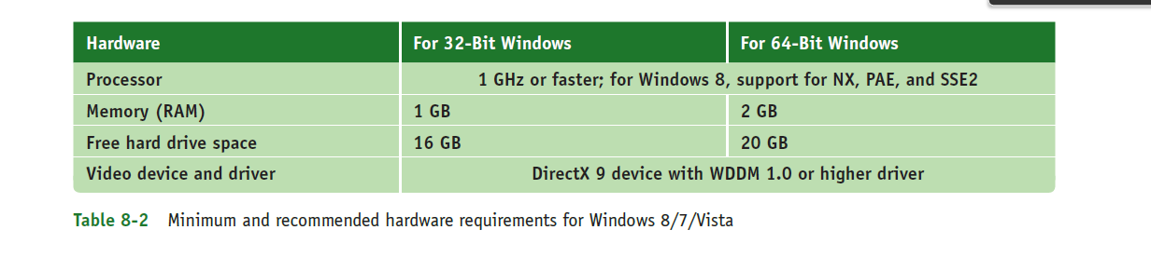
The minimum hardware requirements for Windows 8/7/Vista are listed in Table 8-2. (These minimum requirements are also the Microsoft recommended requirements.) In addition to the requirements listed, Microsoft added to Windows 8 requirements three technologies used by the processor (NX, PAE, and SSE2). All processors built in the last 10 years use these technologies, so the move was intended to not allow Windows 8 to be installed on a system that was older than 10 years.
13. If you have windows 7 Home basic installed in your computer and you want to install windows 8, what will you do?
1. Prepare for an Upgrade
Determine whether your computer hardware meet the following system requirements before you can install Windows 8
2. Determine the best method for upgrading your model computer from Windows 7 to Windows 8
- In-place Upgrade - installs Windows 8 over an existing Windows 7 installation. This is the easier and faster method to upgrade and is the better option for most people. Most or all of your existing software programs, drivers, and personal files are available after upgrading. You can only perform an Upgrade if your computer has Windows 7 Starter, Home Basic, Home Premium, Business or Ultimate Edition, and some models require an upgraded BIOS Version.
- Clean Installation (custom) - erases all files on the hard drive and removes any hard drive partitions before installing Windows 8. If your computer meets the minimum hardware requirements from Microsoft, you can use a Clean Installation. However, the original drivers and programs provided by HP and any other software you installed, will no longer be available.
3. Prepare your computer for In-place Upgrade method
Step 1: Updating the BIOS
Step 2: Getting the latest Windows 7 software and drivers
Step 3: Getting Windows 8 software and drivers
Step 4: Creating Recovery discs and backing up your important files
Step 5: Installing updates from Windows Update
Step 6: Updating Microsoft Office Starter Edition (optional)

Step 7: Downloading a digital copy of Windows 8

4. Install Now

14.If your current installed OS is slugging or creating problem and it is not allowing you for upgrade, what is the best option to fix the problem?
This is probably because you have your Automatic Updates turned off. Head over to the Control Panel, click on System and then choose Automatic Updates. You can also manually choose to update absolutely everything. Leave no update box unchecked. When your computer is through, reboot and you should see the icon to get the Windows 10 upgrade.
If you do not use automatic updating, you will need to go over to Settings, select Change PC Settings, and then choosing Update and Recovery. This will allow you to do a full update across the board and reboot your PC, after which the Windows 10 icon should appear fresh and happy in your system tray. This menu also lets you choose to expand your automatic updates under the Choose how updates get installed tab.

15. what is the firmware in computer ? What are the two main types of it?
Firmware is software that is embedded in a piece of hardware. You can think of firmware simply as "software for hardware." When a computer is first turned on, it uses some devices such as the keyboard, monitor, and hard drive before the OS starts up. The motherboard UEFI/BIOS is contained on a chip on the motherboard and manages these essential devices. This chip is called a firmware chip because it holds programs.
Two types of firmware may be used on motherboards:
The older BIOS (basic input/output system) contains system BIOS to manage essential devices (such as the keyboard, mouse, hard drive, and monitor) before the OS is launched, startup BIOS to start the computer, and BIOS setup to change the motherboard configuration or settings.
Newer motherboards use Unified Extensible Firmware Interface (UEFI) firmware that is more robust and secure than BIOS. Just as with BIOS, UEFI is responsible for managing essential devices before the OS is launched, starting the computer, and managing motherboard settings. UEFI can also assure that the boot is secure and no rogue operating system hijacks the system.

16. list down minimum and recommended memory and hard-disk space requirement for windows vista, 7,8 and 10.
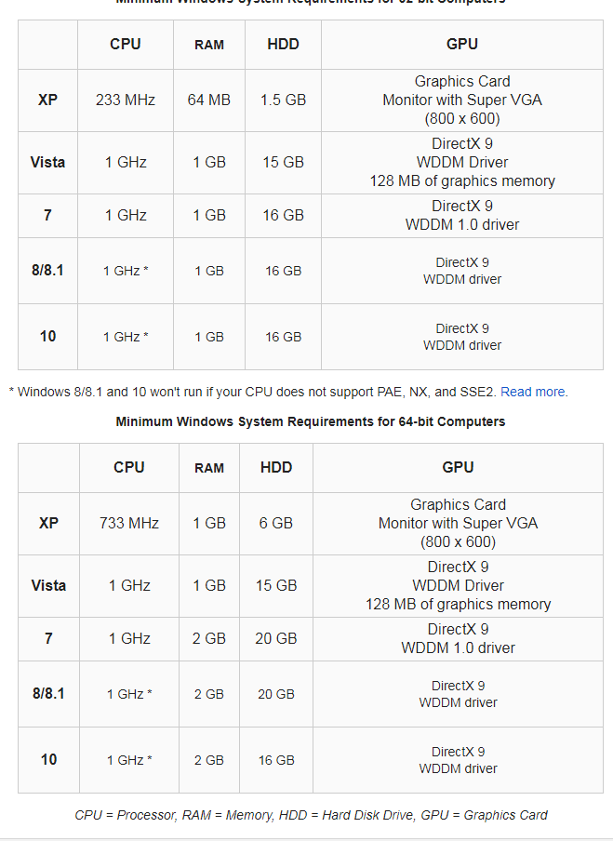
17. What is the basic and important thing you should do before installing any OS on your machine?

- Verify you have all application software CDs or DVDs available and all device drivers.
- Back up all important data on the drive.
- For upgrade installations and clean installs in which you do not plan to reformat the hard drive, run antivirus/anti-malware software to make sure the drive is free from malware. If Windows will not start and you suspect malware might be a problem, plan to reformat the hard drive during the installation so you know the hard drive is clean of malware.
- If you want to begin the installation by booting from the Windows setup DVD or other media such as a USB device, use UEFI/BIOS setup to verify that the boot sequence is first the optical drive or USB device, and then the hard drive.
- In UEFI/BIOS setup, disable any virus protection setting that prevents the boot area of the hard drive from being altered.
- For a system that uses UEFI firmware, set the firmware to use UEFI mode (to use GPT and possibly Secure Boot) or UEFI CSM mode (to use MBR partitions on the hard drive). Know that Windows will install on a GPT drive only when UEFI CSM mode is disabled and will install on an MBR drive only when UEFI CSM mode is enabled.
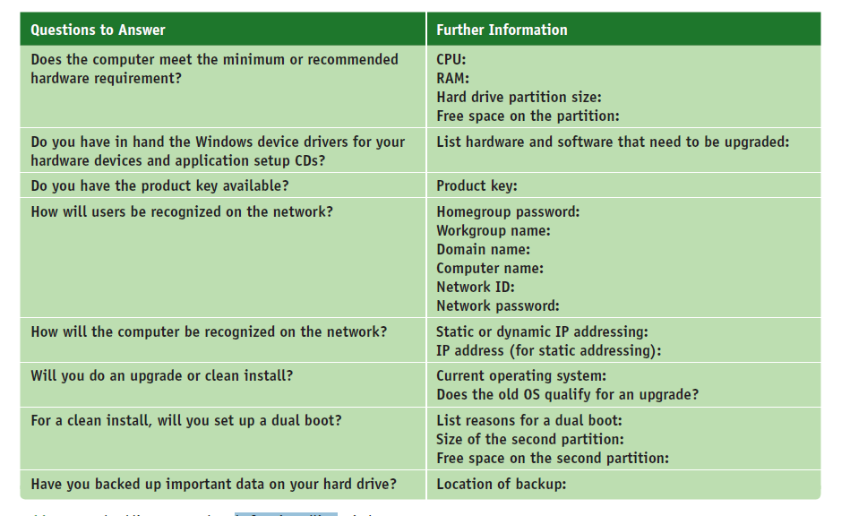
18. Go to your LAB computers BIOS settings and note down the boot sequence, also write down name of your BIOS.
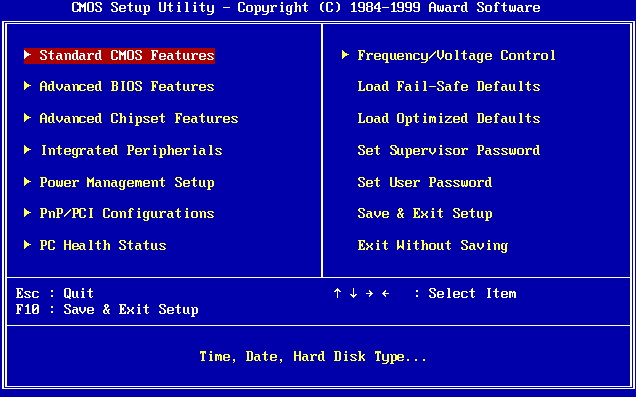

19. What are the different types of installation you can do on your computer?
1. Clean install. You can perform a clean install, overwriting the existing operating system and applications. In the Windows setup program, a clean install is called a custom installation. The main advantage of a clean install is that problems with the old OS are not carried forward and you get a fresh start. During the installation, you will have the option to reformat the hard drive, erasing everything on the drive. If you don’t format the drive, the data will still be on the drive. The previous operating system settings and user profiles are collectively stored in the Windows.old folder that setup creates on the hard drive. After Windows is installed, you will need to install the applications. After you’re sure the new installation is working as expected, you can delete the Windows.old folder to save space on the drive. Windows 8 automatically deletes most of the content of this folder 28 days after the installation.
2. In-place upgrade. If the upgrade path allows it, you can perform an in-place upgrade installation. An in-place upgrade is a Windows installation that is launched from the Windows desktop and the installation carries forward user settings and installed applications from the old OS to the new one.
A Windows OS is already in place before you begin the new installation. An in-place upgrade is faster than a clean install and is appropriate if the system is generally healthy and does not have problems.
In order to perform an in-place upgrade, Microsoft requires that certain editions and versions of Windows be installed already. These qualifying OSs are called upgrade paths. Table 8-3 outlines the acceptable upgrade paths for Windows 8.1. There is no upgrade path from Windows Vista or XP to Windows 8.1. Even though you can purchase an upgrade license to install Windows 8.1 on these systems, you must perform a clean install.

