Major Video Card Types
The following are some of the newer video card technologies being used.
Hybrid SLI- Uses the motherboard’s graphical processing unit (GPU) when low level graphics are needed (keeping the discrete GPU off initially), then as more powerful graphics are needed, it will automatically turns on the discrete GPU and uses it in SLI with the motherboard GPU. This form of SLI gives you a much larger percentage of graphical processing ability than normal SLI.

Nvidia SLI (Scalable Link Interface)-Ideally you are supposed to have two identical cards that are setup in a master-slave setup. Where the slave card does one half of the screen and then sends it to the master card while the master card is working on the other half. Then the master card displays the entire picture, splitting up the work equally between the two cards, to get twice the performance. However, due to bandwidth, bottlenecking, and latency issues these results have never been met. Trying to make improvements to solve this problem Nvidia introduced SLI Bridges for dual card SLI (2X), three card SLI (3X), and four card SLI (4X). Pictures below show the ribbon / bridge setup on each of these SLI setups.

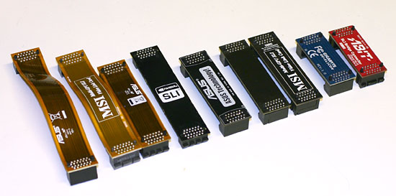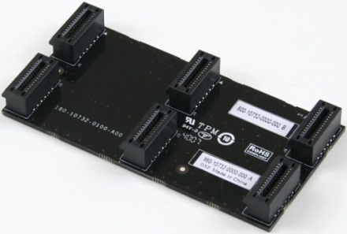
Bridges/Ribbons for SLI
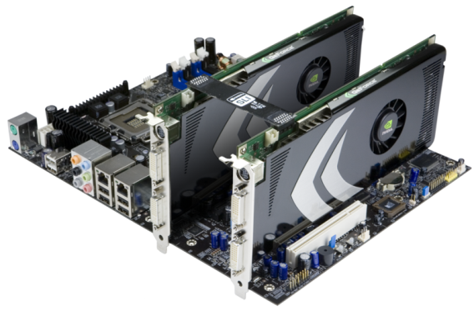
2 card SLI
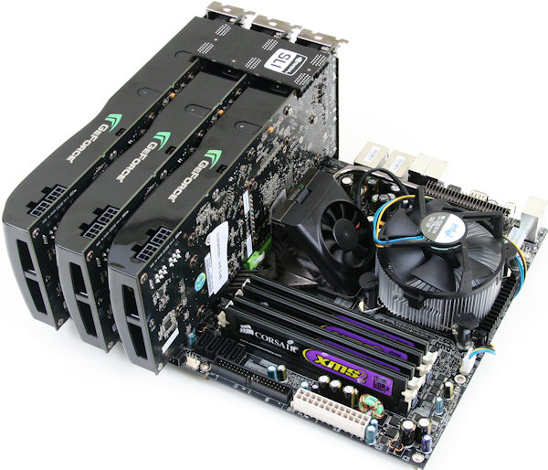
Tri SLI (3 card)
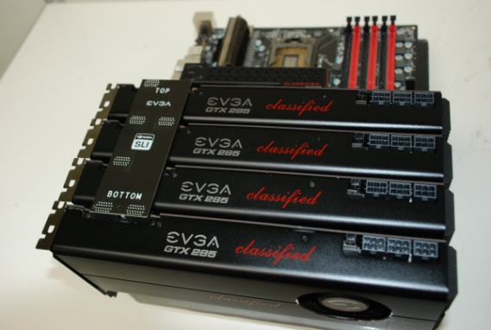
Quad SLI (4 card)

ATI Crossfire (Generational)- When Crossfire was first created you were required to buy a master, and a regular card, this was because the master card had 5 extra image compositing chips which allowed the master card to combine the output of both cards. You also received a Y-dongle which connected both cards through their DVI ports and then connected to the monitor. This allowed the two cards to talk directly to each other and give the monitor the combined image once created. Crossfire has refined itself over the years and eliminated the need for both the Y-Dongle and the need for a master card. You can even use different cards from the same generation now (ex. 4850 and 4870). They now use a similar ribbon to that of the Nvidia bridge which allows for an 8x transfer between two cards per ribbon. Since each card has 2 ports per card you can currently get up to 16x in CrossfireX (2 cards) and 8x per card in quad-crossfire. Pictures below show the ribbon / bridge setup on each of these Crossfire configurations.

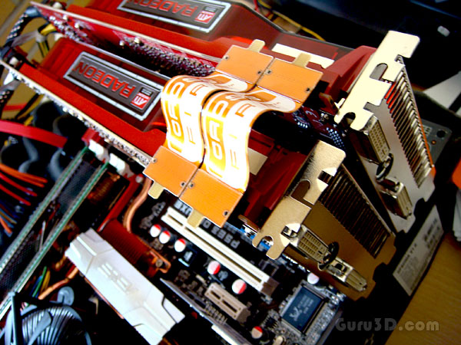
CrossfireX with two ribbons
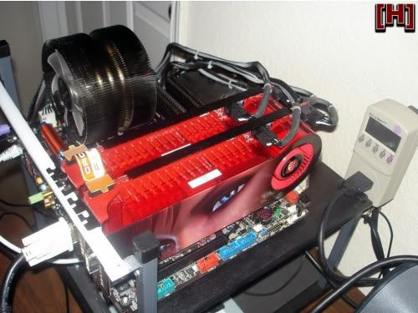
CrossfireX with single ribbon
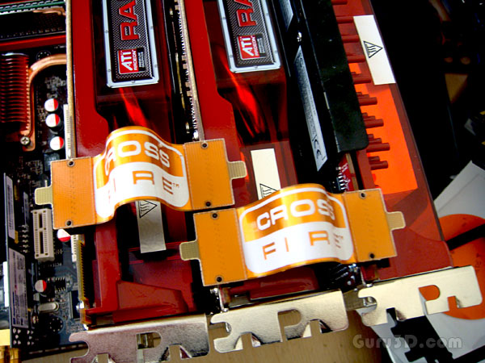
3-way Crossfire
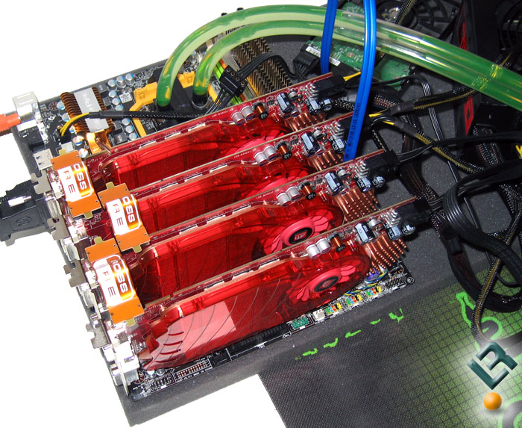
Quad Crossfire
Dual GPU Cards- Both Nvidia and ATI now have advanced graphics cards that use two GPU’s in a single card, thus effectively creating an SLI or CrossfireX configuration without needing a separate card. Some consider connecting two dual GPU cards as a quad setup.

AGP (Accelerated Graphics Port)-This is an older form of slot for graphics cards, which was used when a bandwidth barrier was hit by single core cards. So to solve that problem AGP was created and this increased the bandwidth considerably which allowed graphics cards to grow in power and size. However AGP also had a limit to how much information it could handle at a single time and was also replaced by PCI and PCIe.
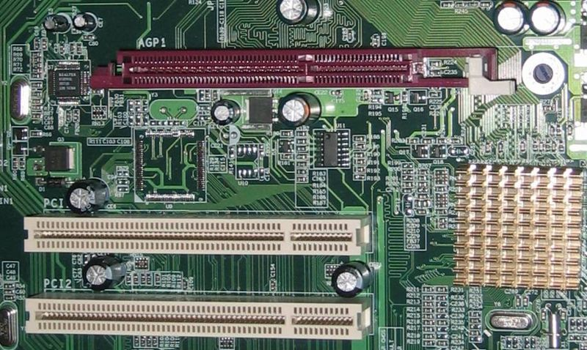
AGP slot (maroon)
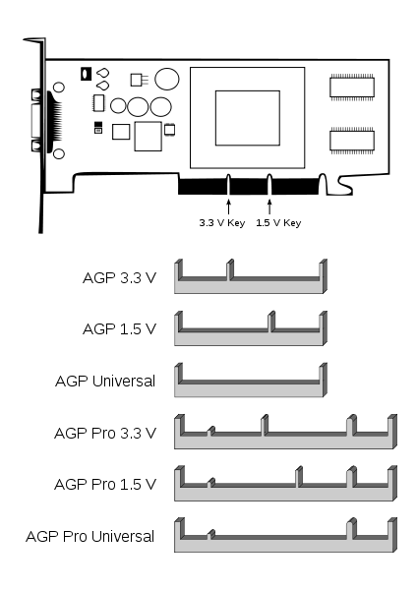
Different AGP slot keying.
PCI/PCIe (Peripheral Component Interconnect) – Today’s standard for pretty much any form of peripheral that is used in a pc. However for video cards especially PCI is a great thing. It once again increased the bandwidth barrier higher than that of AGP, and through its several updates has increased it even more than original PCI. Now we used the latest form of PCI called PCI express 2.1 which is faster better and yet higher bandwidth. PCIe 3.0 was announced in August 2007. AMD latest flagship graphic card, the Radeon HD 7970, launched on January 9, 2012, is the world's first PCIe 3.0 graphic card.

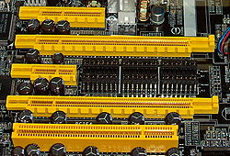
PCI Express slots (from top to bottom: x4 , x16, x1 and x16),
compared to a traditional 32-bit PCI slot (bottom), as seen on DFI's LAN Party nF4 SLI-DR.

