Complete the tables below. When you have completed the assignment save and upload to the Boot File Worksheet DropBox in cobra.
Explain what each of these are and do
File | Purpose | OS
NTLDR | is the boot loader for all releases of Windows NT operating system  The purpose of NTLDR is so that a user can choose which operating system to boot into. Without it, there would be no way to direct the boot up process to load the operating system you want to use at the time. | Windows NT operating system Windows XP Windows Server 2003
BOOT.INI | Is a Microsoft initialization file, is used by Microsoft Windows as a method of displaying a menu of operating systems currently on the computer and allowing the user to select what operating system to load. The information in boot.ini is also used to point to the locations of each of the operating systems. | Microsoft Windows NT, Microsoft Windows 2000 Microsoft Windows XP operating systems.
BOOTSECT.DOS | A hidden, read-only file on the root of the system partition of Microsoft Windows NT that is used during the boot sequence. The bootsect.dos file is included to support dual-boot installations where another operating system is installed with Windows NT. When the boot loader menu appears, the user selects the operating system he or she wants to boot. If a non–Windows NT operating system is selected, the ntldr program immediately loads bootsect.dos and turns control of the boot process over to it. Bootsect.dos contains the location of the partition boot sector that existed on the partition prior to the installation of Windows NT. Thus, bootsect.dos enables the system to locate and load the alternate operating system. Bootsect.dos is not loaded during a normal boot of the Windows NT operating system. | Windows XP  Windows 2000
NTDETECT.COM | is a component of Microsoft Windows NT-based operating systems that operate on the x86 architecture.  The bootstrap loader takes the control over the booting process and loads NTLDR. Ntdetect.com is invoked by NTLDR, and returns the information it gathers to NTLDR when finished, so that it can then be passed on to ntoskrnl.exe, the Windows NT kernel.  Ntdetect.com is used on computers that use BIOS firmware. Computers with Extensible Firmware Interface, such as IA-64, use a method of device-detection that is not tied to the operating system.[1] | Windows 2000 Windows XP
NTBOOTDD.SYS | Ntbootdd.sys is a copy of the SCSI device driver and resides on the system partition. Ntbootdd.sys is used when using the SCSI or Signature syntax in the file Boot.ini.  Additionally, if you have multiple SCSI controllers that use different device drivers, include only the controllers that are controlled by Ntbootdd.sys when determining the value of the W parameter. | Windows 2000
NTOSKRNL.EXE | known as kernel image, provides the kernel and executive layers of the Windows NT kernel space, and is responsible for various system services such as hardware virtualization, process and memory management, thus making it a fundamental part of the system. It contains the cache manager, the executive, the kernel, the security reference monitor, the memory manager, and the scheduler. | Windows 10

What are different types of file systems used by windows?
FAT
The family of FAT file systems is supported by almost all operating systems for personal computers, including all versions of Windows and MS-DOS/PC DOS, OS/2, and DR-DOS. (PC DOS is an OEM version of MS-DOS, MS-DOS was originally based on SCP's 86-DOS. DR-DOS was based on Digital Research's Concurrent DOS, a successor of CP/M-86.) The FAT file systems are therefore well-suited as a universal exchange format between computers and devices of most any type and age.
The FAT file system traces its roots back to an (incompatible) 8-bit FAT precursor in Standalone Disk BASIC and the short-lived MDOS/MIDAS project.
Over the years, the file system has been expanded from FAT12 to FAT16 and FAT32. Various features have been added to the file system including subdirectories, codepage support, extended attributes, and long filenames. Third parties such as Digital Research have incorporated optional support for deletion tracking, and volume/directory/file-based multi-user security schemes to support file and directory passwords and permissions such as read/write/execute/delete access rights. Most of these extensions are not supported by Windows.
The FAT12 and FAT16 file systems had a limit on the number of entries in the root directory of the file system and had restrictions on the maximum size of FAT-formatted disks or partitions.
FAT32 addresses the limitations in FAT12 and FAT16, except for the file size limit of close to 4 GB, but it remains limited compared to NTFS.
FAT12, FAT16 and FAT32 also have a limit of eight characters for the file name, and three characters for the extension (such as .exe). This is commonly referred to as the 8.3 filename limit. VFAT, an optional extension to FAT12, FAT16 and FAT32, introduced in Windows 95 and Windows NT 3.5, allowed long file names (LFN) to be stored in the FAT file system in a backwards compatible fashion.

NTFS
Main article: NTFS
NTFS, introduced with the Windows NT operating system in 1993, allowed ACL-based permission control. Other features also supported by NTFS include hard links, multiple file streams, attribute indexing, quota tracking, sparse files, encryption, compression, and reparse points (directories working as mount-points for other file systems, symlinks, junctions, remote storage links).

exFAT
Main article: exFAT
exFAT is a proprietary and patent-protected file system with certain advantages over NTFS with regard to file system overhead.
exFAT is not backward compatible with FAT file systems such as FAT12, FAT16 or FAT32. The file system is supported with newer Windows systems, such as Windows Server 2003, Windows Vista, Windows 2008, Windows 7, Windows 8, and more recently, support has been added for Windows XP.
exFAT is supported in OS X starting with version 10.6.5 (Snow Leopard). Support in other operating systems is sparse since Microsoft has not published the specifications of the file system and implementing support for exFAT requires a license. exFAT is the only file system that is fully supported on both OS X and Windows that can hold files bigger than 4 GB.

What OS’s work with each of the file systems?
FAT, Microsoft Windows 95 and Microsoft Windows 98 use the FAT file system. These operating systems do not support NTFS.
NTFS, an acronym that stands for New Technology File System, is a file system first introduced by Microsoft in 1993 with the release of Windows NT 3.1.NTFS is the primary file system used in Microsoft's Windows 10, Windows 8, Windows 7, Windows Vista, Windows XP, Windows 2000, and Windows NT operating systems.
exFAT is not backward compatible with FAT file systems such as FAT12, FAT16 or FAT32. The file system is supported with newer Windows systems, such as Windows Server 2003, Windows Vista, Windows 2008, Windows 7, Windows 8, and more recently, support has been added for Windows XP.
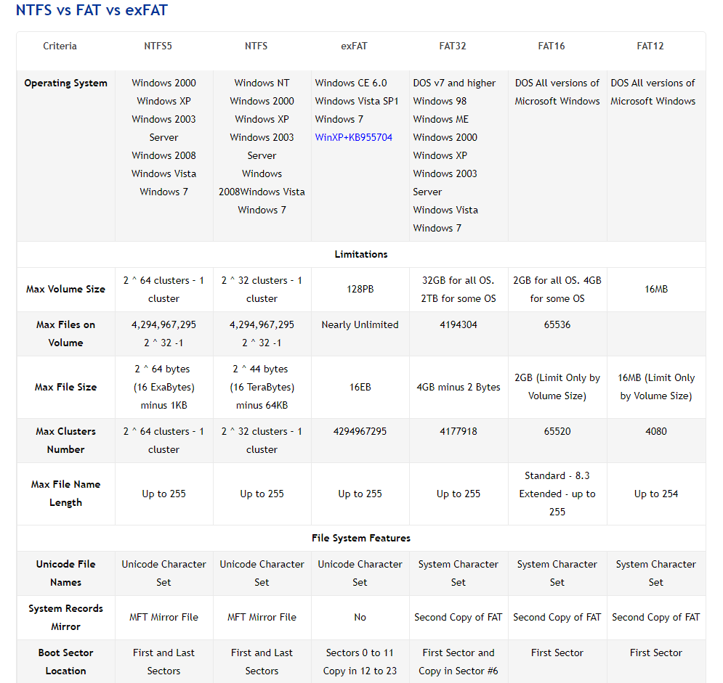
http://www.ntfs.com/ntfs_vs_fat.htm

What is the maximum Partition size for each file system?
See the table above.

