The purpose of this lab is to get students to understand the liability they face when administering an enterprise network. The student should create a banner that will appear when anyone logs into the windows 7 installed on their lab PCs.
The banner should state the following:
This Virtual Machine is for the use of [your name here]. Use or modification by any other person could result in death or dismemberment.
Note: the “warning” in the picture is a title of message and the actual message is body.
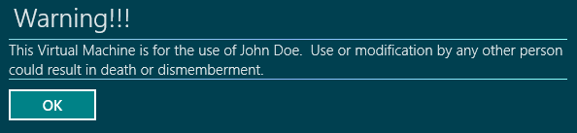

Take screenshots of Warning messages and place in the appropriate places below. Write down the steps you followed while creating and applying banner. When complete, save this document as a PDF and place in the Logon Banner Worksheet DropBox in Cobra.

Windows 7:
steps:
1. Enter “secpol.msc” into the Search programs and files box on the Start menu and press Enter or click the link.
2. Expand the Local Policies node in the tree in the left pane and select the Security Options node.
3. Double-click the Interactive logon: Message text for users attempting to log on setting in the right pane.
4. On the Local Policy Setting tab, enter your message in the text box and click OK.
5. Double-click on the Interactive logon: Message title for users attempting to log on setting.
6. On the Local Policy Setting tab, enter a title for your message in the text box and click OK.
7. Your title and message now displays on the screen before the available users are displayed. Click OK to select the user and log on.

Screenshot:
