**Batch File Worksheet**

**Note**:-Write down the code for given title and execute it using DOS. In the result section take a screenshot of your output window of Dos and paste here. Assume suitable data wherever necessary.

**Q.1. Create a batch file to display your student information (name, college, course, parkland id ).use title of file as your firstname.lastname.**

**Code:-**

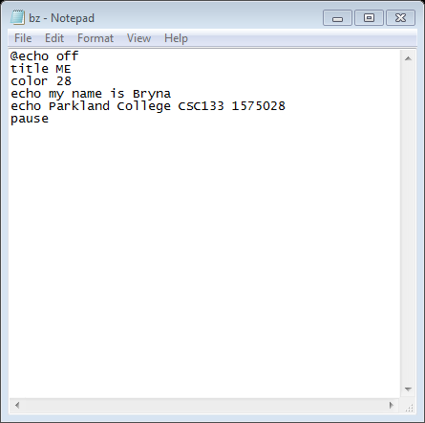

**Result/output:-**

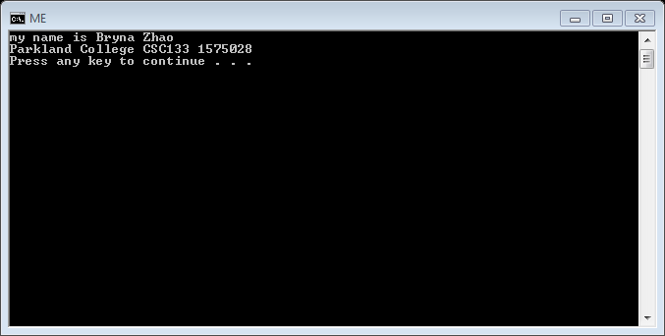

**Q2. Create a batch file to start calculator, Microsoft word and parkland college website in google chrome using different DOS commands.**

**Code:-**

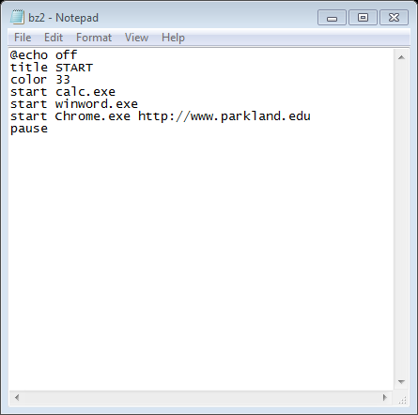

**Result/Output:-**

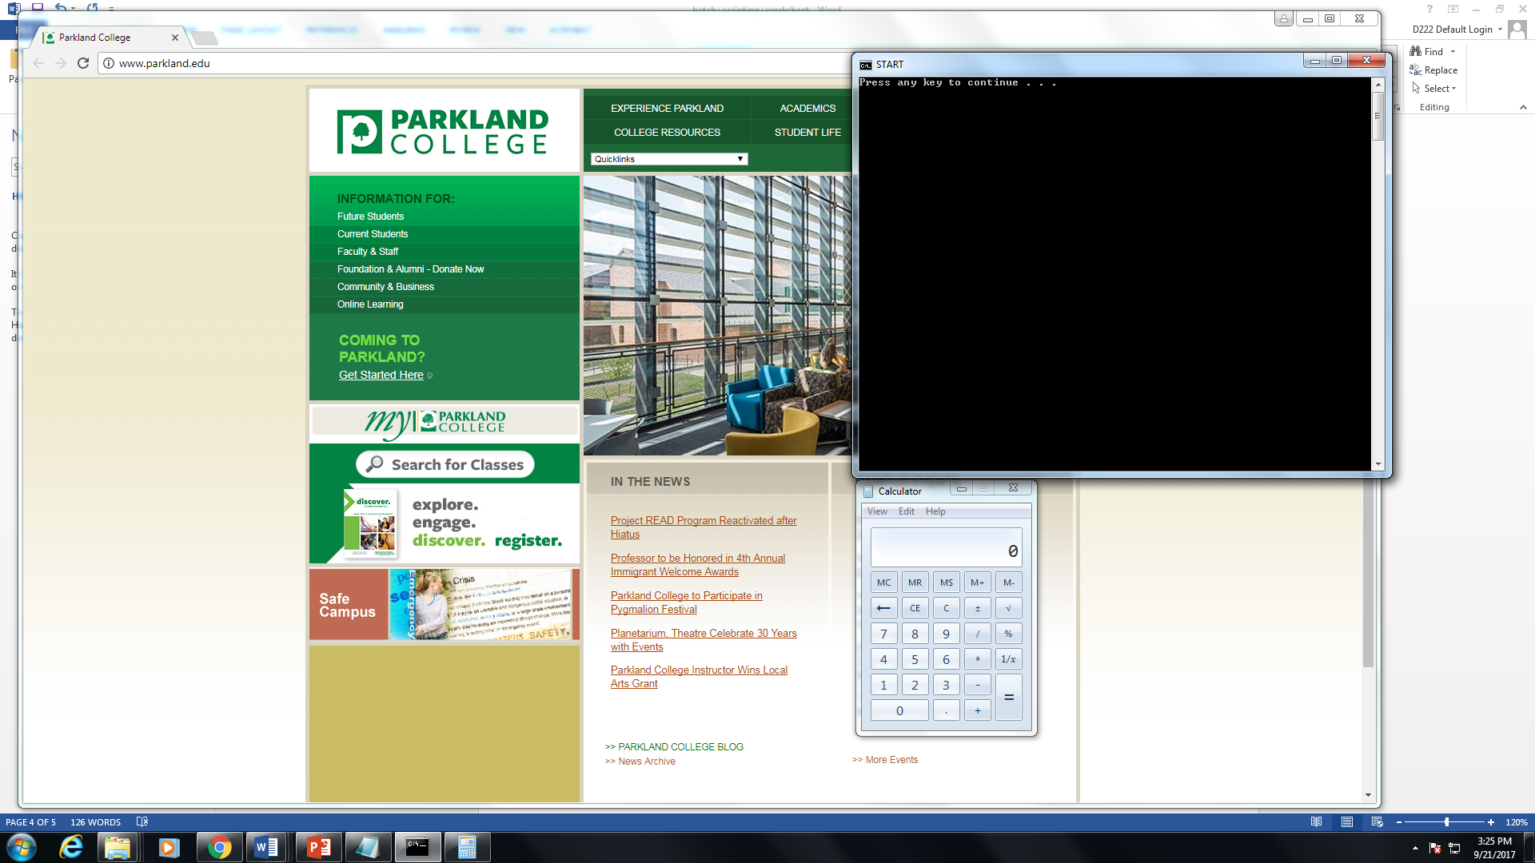

**Q.3 create a batch file to display different colors on background and foreground. Use following sequence of colors to display. Color should change every time u click on the button (pause).**

**white(b) and green(f) first**

**aqua(b) and red(f)**

**black(b) and purple(f)**

**code:-**

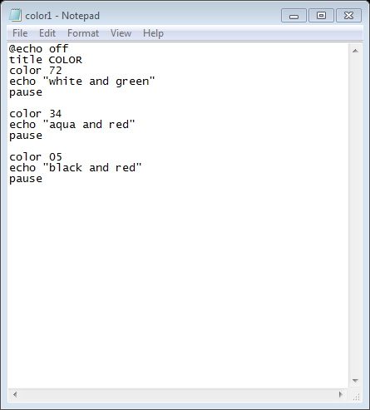

**Result/output:-**

