**Ch. 11 – Performance Monitor Worksheet**

Perform the following Hands-on Projects and Applying Concepts: *Take Screenshots along the way to show completion of projects.*

***Note: Take help of book to perform the task. Create file in (.doc) or (.pdf )only.***

*1. display available tools in administrative tools. Take screen shot and paste all three one by one. (page 505)*

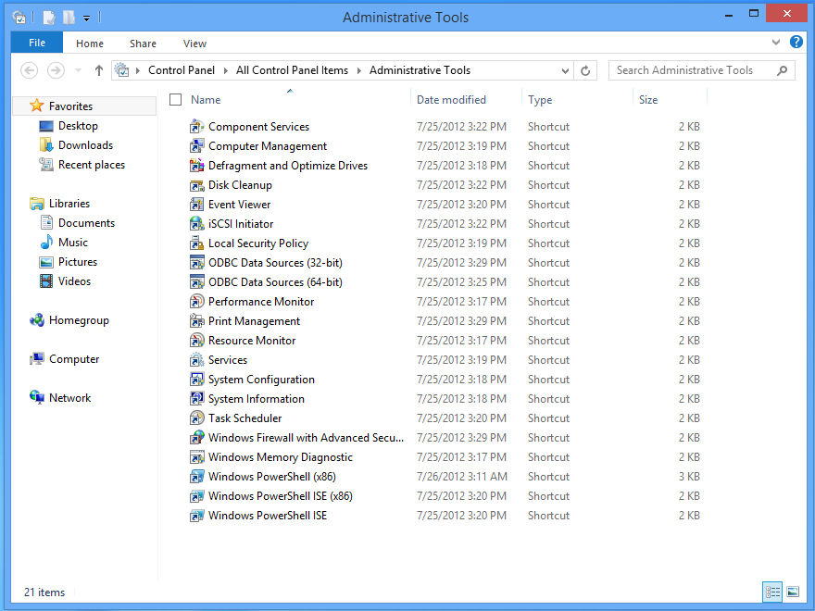

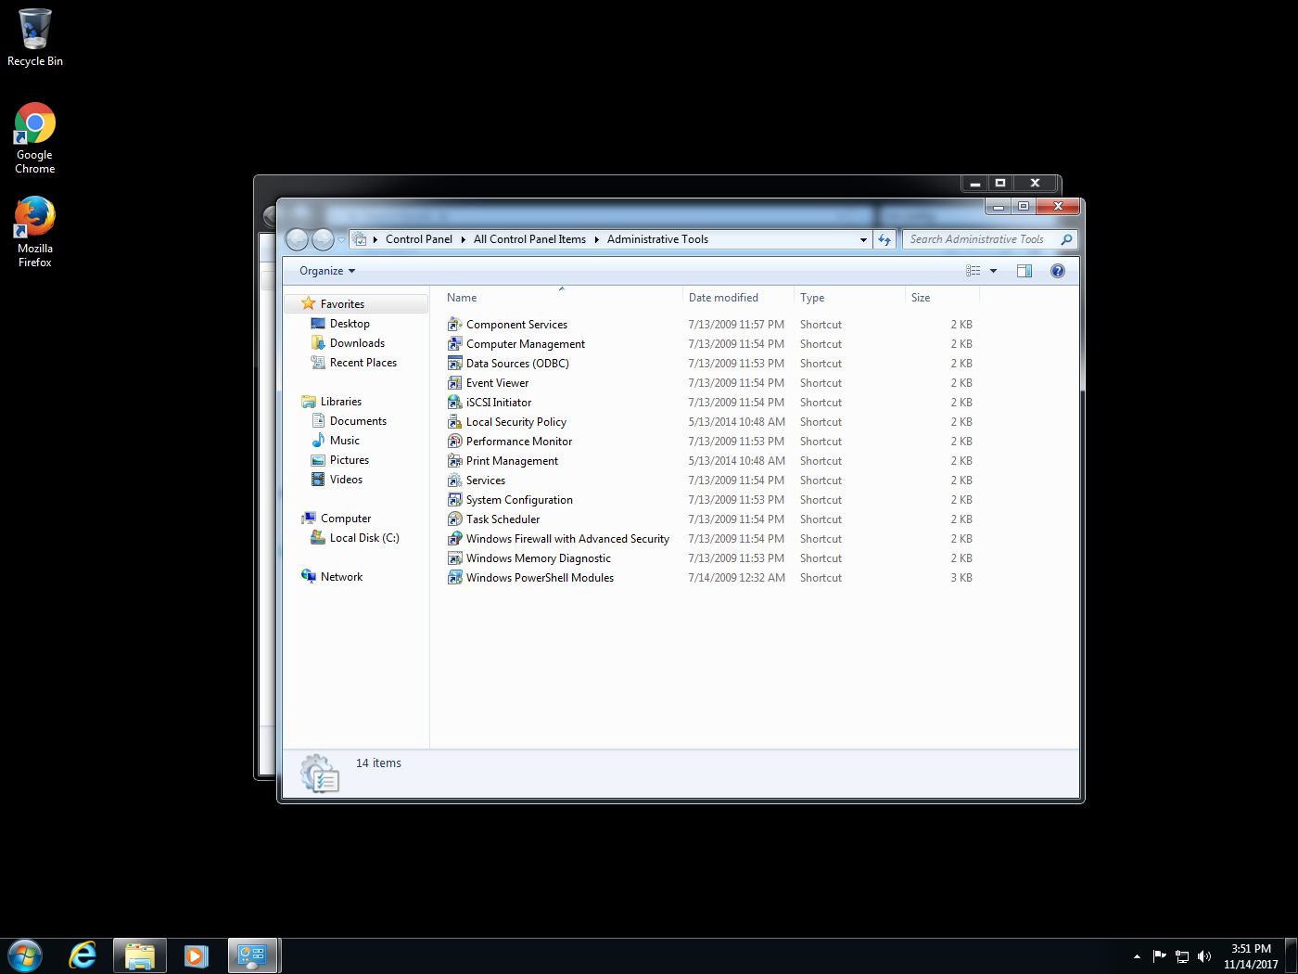

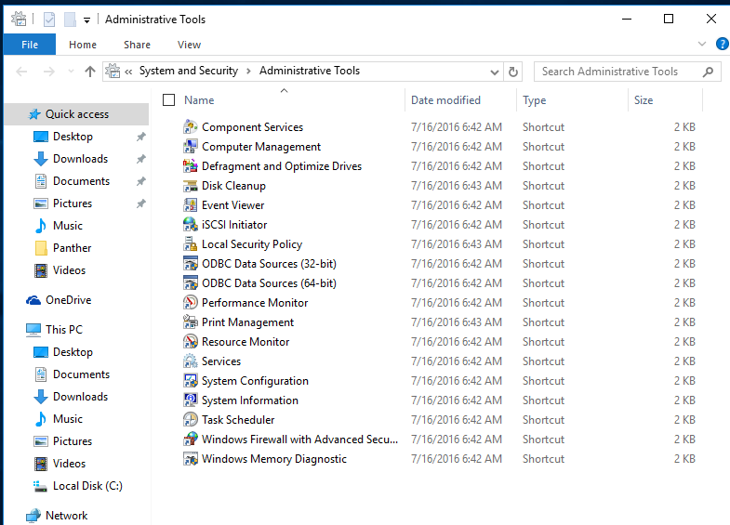

*2. Page 510 open service console. Right Click on any running task and select properties. Work on this and paste the screenshot here.(* services.msc)

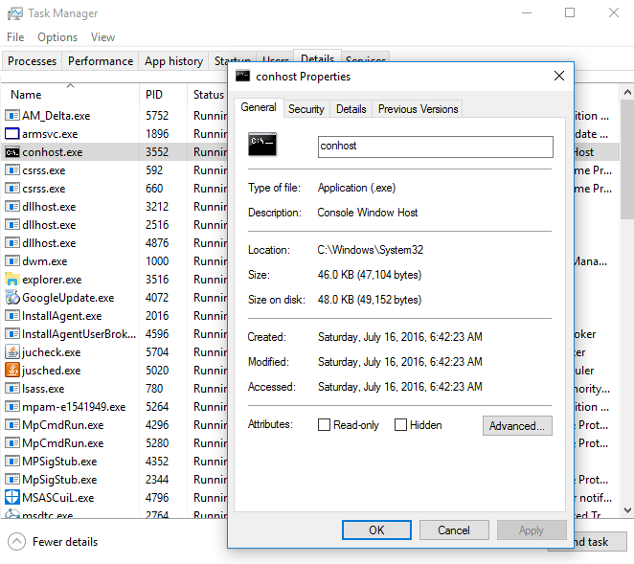

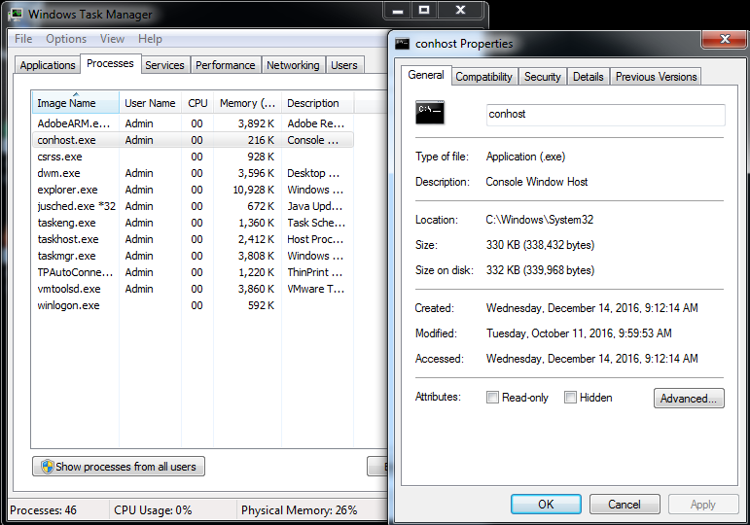

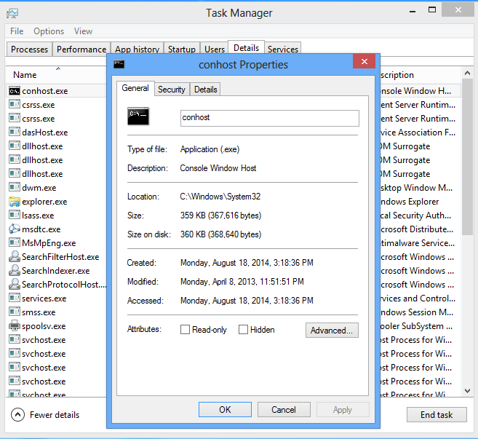

*3.Page 511 go to computer management tab. paste the screenshot.* (compmgmt.msc)

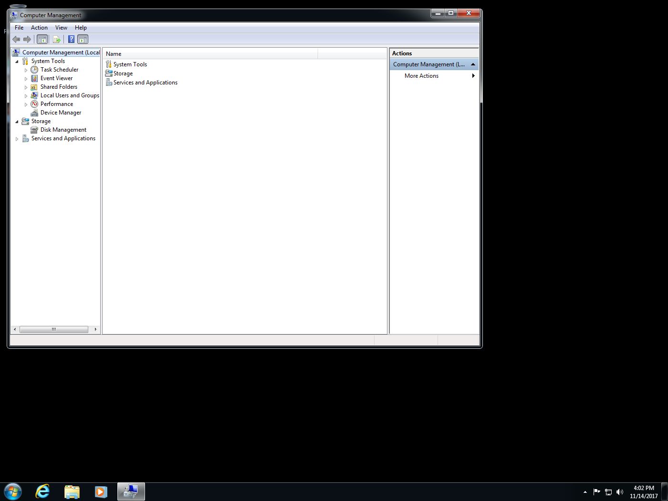

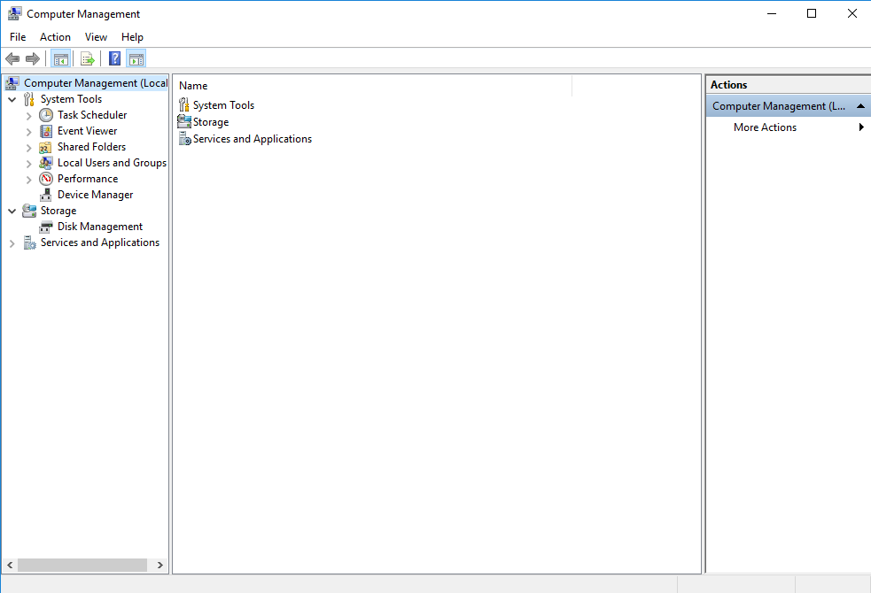



*4. page 513 open event viewer tab for all OS and paste the screenshot.* (eventvwr.msc)

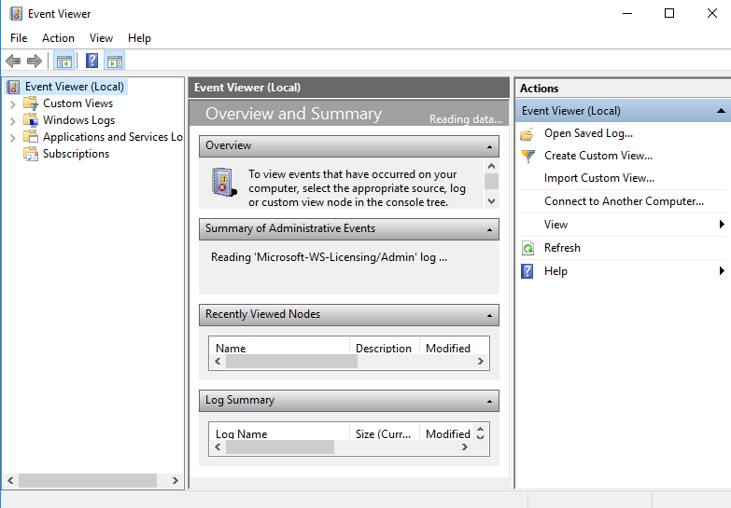

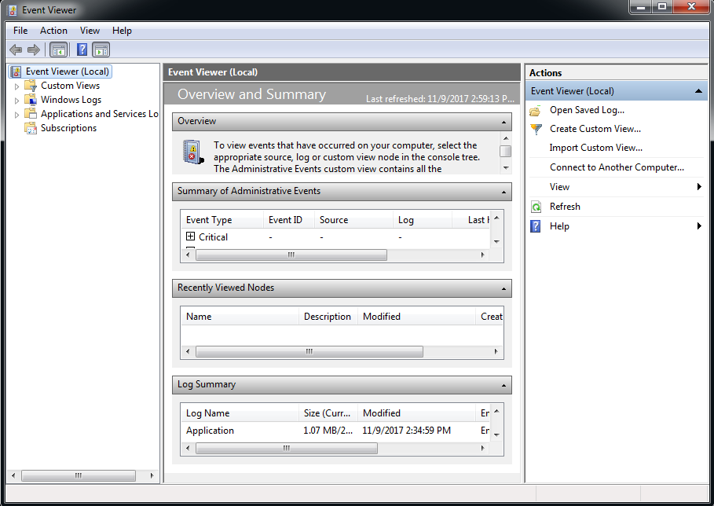

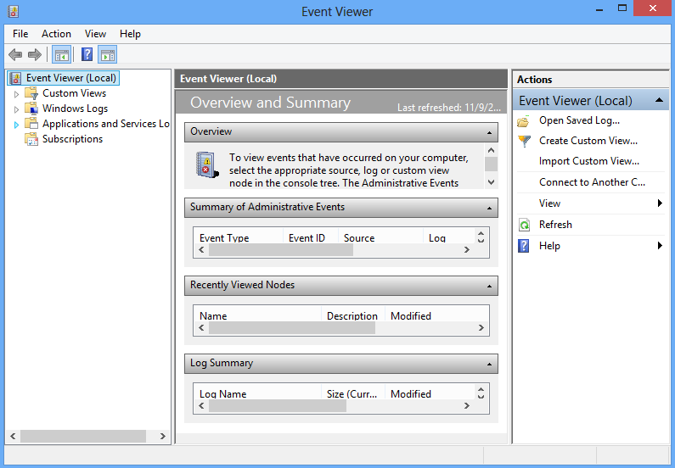

*5.page 518 open task scheduler and study the use of it also paste the screenshot.* (taskschd.msc)

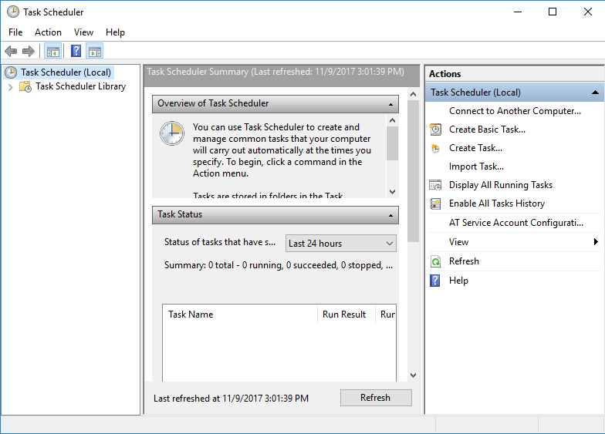

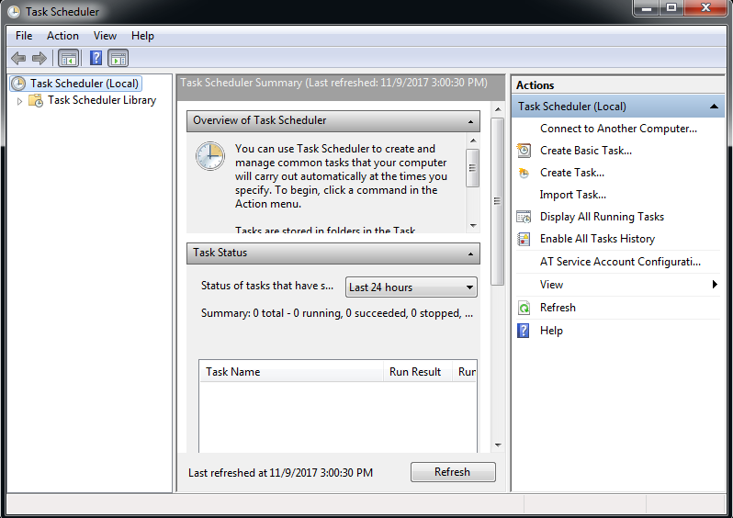

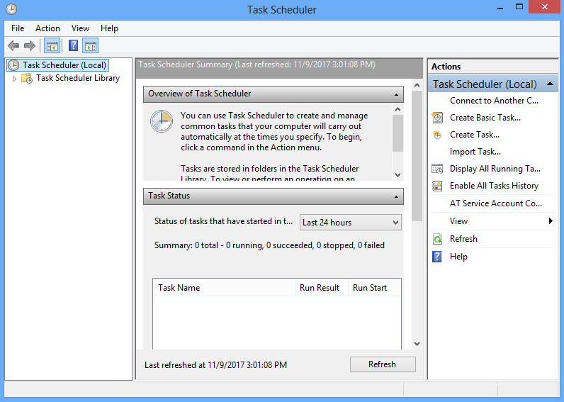

*6. page 520 open performance monitor tab and then click on performance monitor in the left column then paste screenshot for all OS.* (perfmon.msc)

