**WIRING LAB PRACTICAL**

**Name: Biruo Zhao class:**

**Note: solve this file individually.**

1. **Write down the steps you performed to make cat5e crossover cable.**

Cut the shell of the cable so you have access to the wiring. Do this to both sides and untangle/straighten the wiring. Then on both sides arrange the wires in the correct color arrangement, measure the wires to fit the end connectors that you are going to add on. Cut the wires and then put the connectors on. Use the Paladin Tool you are given to secure the connectors onto both ends of the cable. Now test the cable using the LAN cable meter to see if you wired the cable correctly on both ends, and see if it has been verified to function properly. Now you are able to use the cable on two PCs enabling the ability to transfer files from one of the connected PCs to the other.

1. **What is the color sequence you use on both the side of wiring? Write down colors in sequence with pictures.**

1. White/Orange 2. Orange 3. White/Green 4. Blue 5. White/Blue 6. Green 7. White/Brown 8. Brown

1. **Write down steps you performed to connect two pc’s in LAN.**

Connect your cable into both PCs. Format your C drives on your PC so you are able to shrink it to make another drive. The second drive, enable sharing and change security settings so that everyone has the ability to read, write, and execute on this newly made drive (on both PCs). Change your IPs to a default like 192.168.1.x (do this for both PCs). Now have one of the computers go to the windows button, and type in the search bar “\\the ip address of the PC you are going to connect to”. Now you are connected to the other PC’s second drive that they shared with you. You are also now able to create, delete, move, copy over any files into the drive.

1. **Are you able to ping to systems?? If no why??**

Yes we are both able to ping each other.

1. **What are the IP address for both PC’s?**

PC 1: 192.168.1.6

PC 2: 192.168.1.5

1. **Are you able to share folder on desktop? If not why?**

Yes

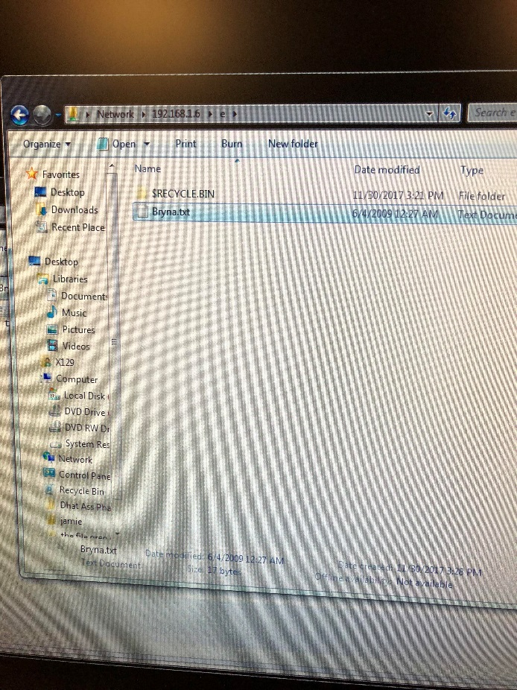

1. **What are the tools you used for making cable? Describe tools along with pictures.**

Scissors, connectors, wire, a cable crimping tool, a cable stripping tool, and a cable testing tool.