**CSC133**

**Research Laptop Service Manual Lab**

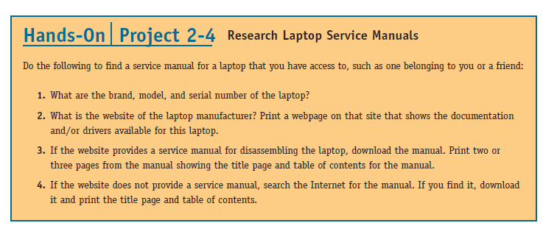Write down answers of following questions and attach screenshots wherever necessary.

1.

Brand: Dell

Model: Vostro 2510

Serial Number:

00144-447-133-569

2.

Manufacturer website:

www.dell.com/

Screenshot of the webpage:

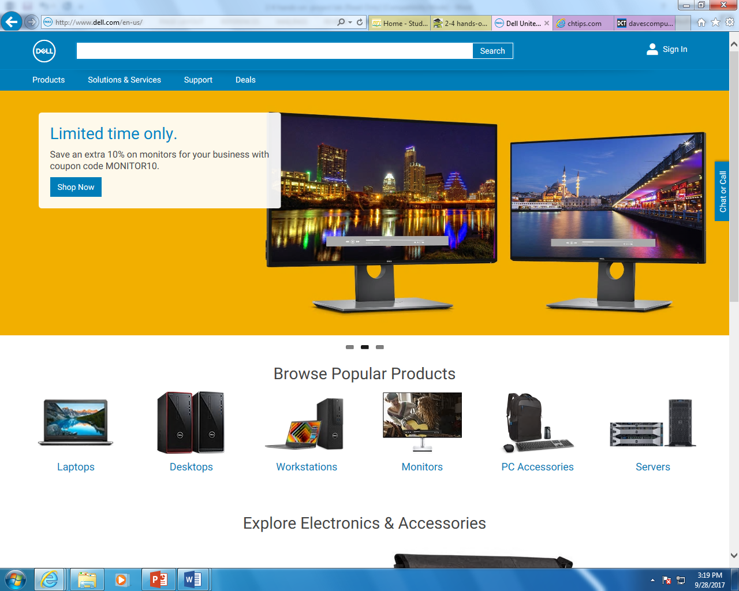

Screenshot of drivers available for laptops:

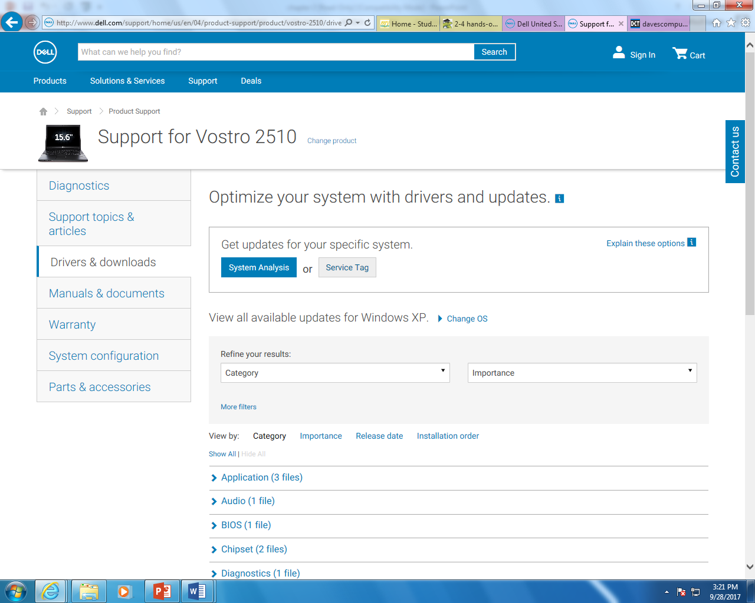

3.

Service manual available?? (yes or no)

YES!!

If yes paste screenshot of first page and table of content:

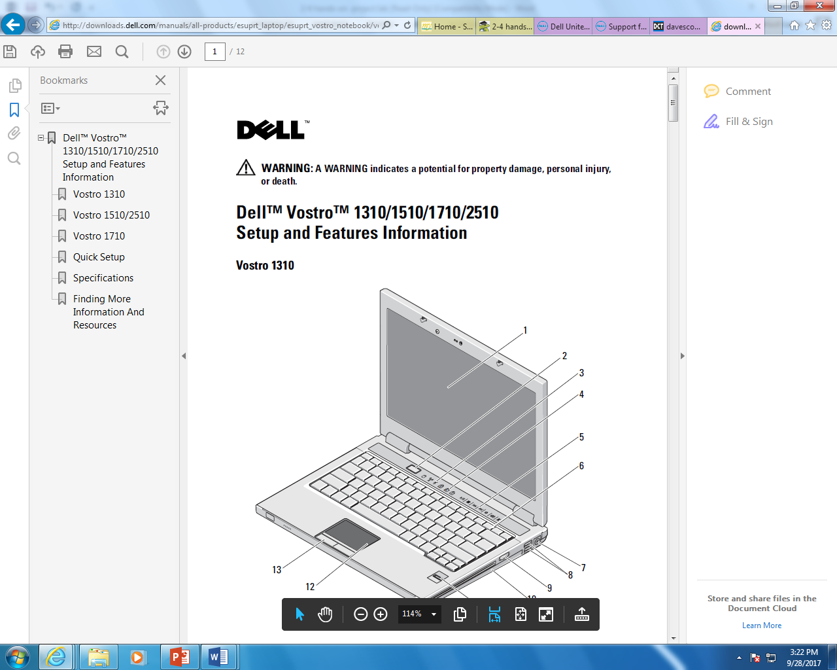

4. look for the service manual on internet.

<http://www.dell.com/support/home/us/en/19/product-support/product/vostro-2510/manuals>