**Examine Motherboard in Details Lab**

1. Search a picture of motherboard you have in your system with manufacurar name and model number. Paste picture here and label these parts on it.

-processor socket (name and manufacturar ?)

-chipset (north bridge and south bridge)

-RAM (total number?)

-CMOS battery

-Expansion slots (PCI, PCI X1,PCI X16)

-Power supply connection

-SATA drive connectors

-on board ports and connectors

-heat sink/ cooling fan

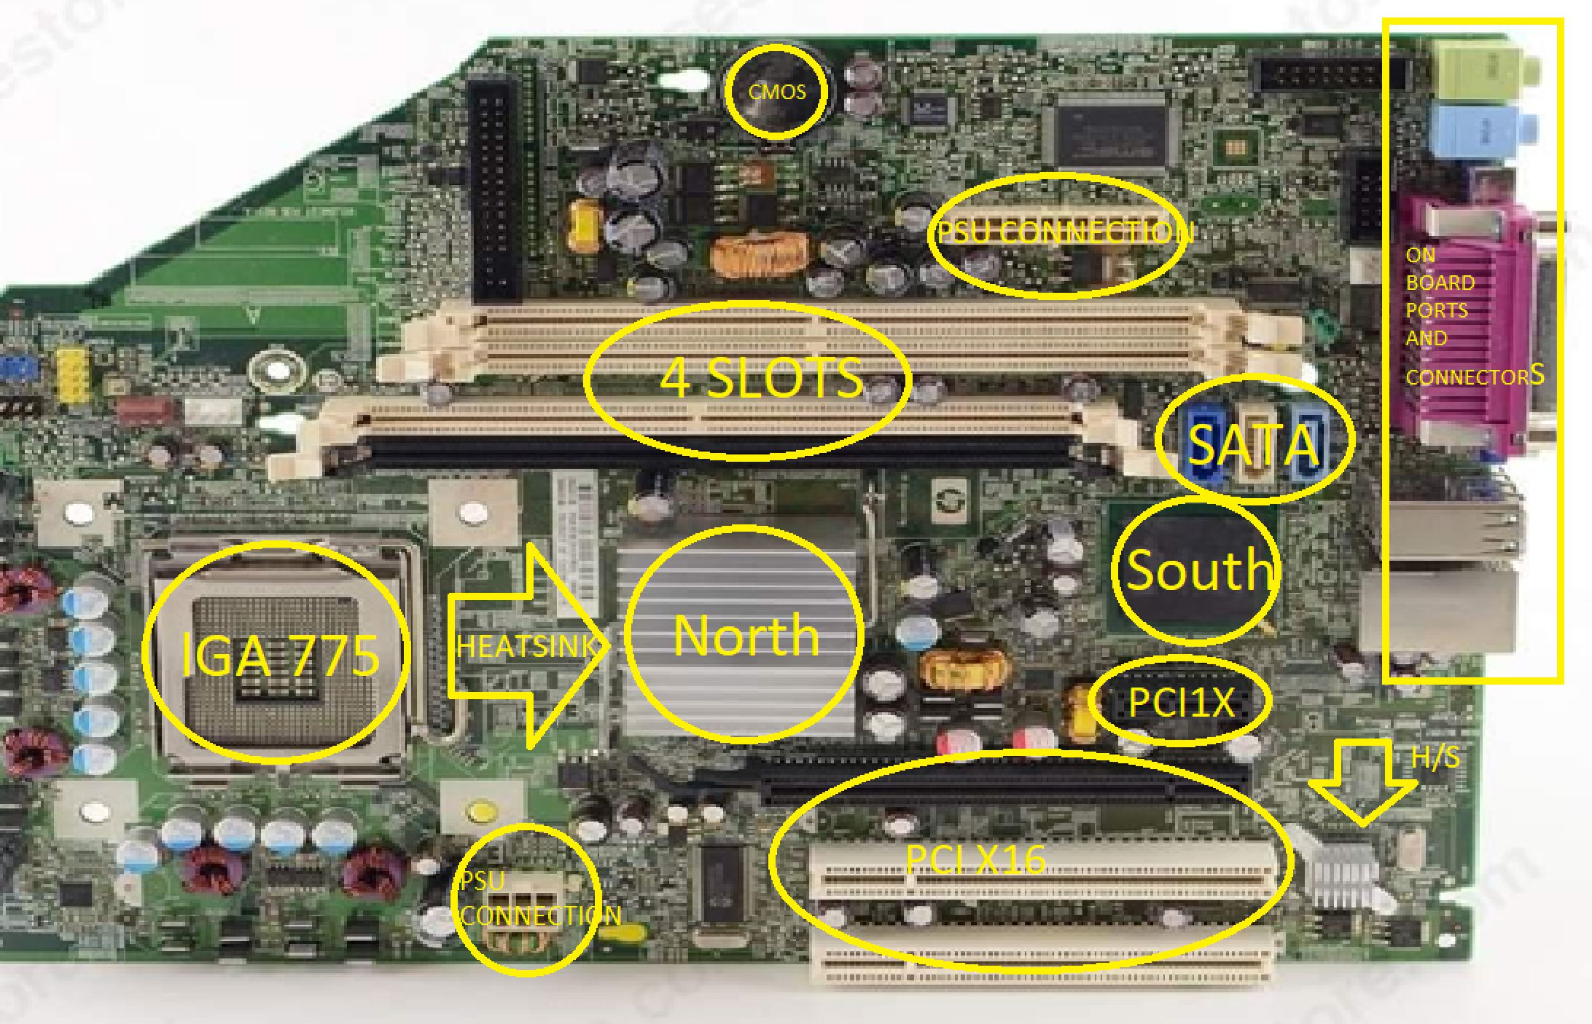

2.what is the brand and model of the motherboard?

HP 404674-001 DC7700

3.locate manufacturar website and try to find manual for motherboard.

http://h10032.www1.hp.com/ctg/Manual/c00768080.pdf

4. Reassemble your computer.