BookNest
Where Stories Nestle

Full Stack Development (MERN) Documentation

React.js | Node.js | Express.js | MongoDB

1. Introduction
Project Title:
BookNest: Where Stories Nestle — A Full-Stack MERN Book Store Application

Team ID: LTVIP2026TMIDS77558

Team Members & Roles:
Name | Role | Responsibilities
Sankar Donga | Full Stack Developer | Frontend & Backend Integration, Auth Module
Dileep Karthikeya Kovela | Frontend Developer | React UI, Components, State Management
Duggirala Sai Koushya | Backend Developer | REST APIs, Express.js, Controllers
Chandana Janjanam | Database Engineer | MongoDB Schema Design, Mongoose Models

2. Project Overview

Purpose
BookNest is a comprehensive full-stack e-commerce web application designed for the book industry. It connects three types of stakeholders — book buyers (Users), independent book sellers (Sellers), and platform managers (Admins) — through a unified, role-based digital marketplace.

The platform aims to:
- Provide users with an intuitive interface to discover, search, and purchase books.
- Empower sellers to list books, manage inventory, and fulfill orders efficiently.
- Give administrators complete control over platform content, accounts, and analytics.
- Foster a community of readers through an integrated review and rating system.

Features

User Features
- Account registration, login, and profile management.
- Book browsing with genre filters, keyword search, and detailed book pages.
- Shopping cart with quantity management and secure checkout.
- Order history and purchase tracking.
- Book and seller review/rating submission.

Seller Features
- Seller account registration and business profile management.
- Book listing with full metadata (title, author, genre, price, stock).
- Inventory management — update, remove, and track listings.
- Order fulfillment dashboard with status management.
- Sales analytics and performance statistics.

Admin Features
- Full system oversight and user/seller/book management.
- Approve new seller accounts and manage platform content.
- Platform-wide analytics and reporting.
- Review moderation and account deactivation.

3. Architecture

Frontend
The frontend is built with React.js using Vite as the build tool, organized as a Single Page Application (SPA):

- Component-based architecture with reusable UI components.
- React Router for client-side routing with protected and role-based route guards.
- Context API for global state management (AuthContext for user sessions, CartContext for cart state).
- Axios for HTTP communication with the backend REST API.
- Pages are organized by role: admin, seller, user, and common pages.

Key frontend modules:
- components/common: Navbar, ProfileForm, ProtectedRoute, RoleBasedRoute
- components/reviews: AddReview, RatingDistribution, RatingSummary, StarRating
- components/seller: SellerReview, ImageManagement, MiniCart
- pages/admin: AdminCreate, AdminOrders, AdminReviews, AdminStats, EditAccount, ManageAccounts, ManageSellers
- pages/commonpages: AddBook, Dashboard, EditBook, InventoryManagement, ManageBooks
- pages/seller: SellerOrders, SellerReviews, SellerStats
- pages/user: Cart, Checkout, History, OrderHistory, Payment, UserStats
- pages: BookDetails, Books, Home, NotFound, ProfilePage

Backend
The backend is built with Node.js and Express.js following MVC (Model-View-Controller) architecture:

- RESTful API design with organized route files for each module.
- Middleware layer for JWT authentication verification and role-based authorization.
- Controllers handle business logic, separated by domain: auth, book, cart, order, review, admin, dashboard, profile, userAnalytics.
- Environment-based configuration using .env for secrets and database URIs.
- Error handling middleware for consistent API error responses.

Controller modules:
- authController.js — Registration, login, JWT issuance
- bookController.js — Book CRUD, search, filtering
- cartController.js — Cart management, item add/remove/update
- orderController.js — Order creation, status updates, history
- reviewController.js — Review submission and retrieval
- adminController.js — Admin-level CRUD operations
- dashboardController.js — Analytics data aggregation
- profileController.js — Profile view and update
- userAnalyticsController.js — User activity and purchase analytics

Database
MongoDB is used as the primary database with Mongoose as the ODM (Object Document Mapper):

Model | Key Fields | Purpose
User | name, email, password (hashed), role, createdAt | Stores buyer/seller/admin accounts
Book | title, author, genre, description, price, stock, sellerId, ratings | Book listings and metadata
Cart | userId, items[ {bookId, quantity} ], updatedAt | User shopping cart state
Order | userId, items, totalAmount, status, createdAt | Purchase records and order status
Review | userId, bookId/sellerId, rating, comment, createdAt | User reviews and ratings

4. Setup Instructions

Prerequisites
Ensure the following software is installed on your development machine:

Software | Version | Download Link
Node.js & npm | v18.x or higher | https://nodejs.org/en/download/
MongoDB | v6.x or higher | https://www.mongodb.com/try/download/community
Git | Latest | https://git-scm.com/downloads
VS Code (recommended) | Latest | https://code.visualstudio.com/download

Installation
Step 1: Clone the Repository
git clone <your-repository-url>
cd booknest

Step 2: Setup Environment Variables
Create a .env file inside the server directory with the following variables:
MONGO_URI=mongodb://localhost:27017/booknest
JWT_SECRET=your_jwt_secret_key
PORT=5000

Step 3: Install Client Dependencies
cd client
npm install

Step 4: Install Server Dependencies
cd ../server
npm install

5. Folder Structure

Client (React Frontend)
Path | Description
client/src/components/common/ | Shared components: Navbar, ProfileForm, ProtectedRoute, RoleBasedRoute
client/src/components/reviews/ | Review components: AddReview, RatingDistribution, StarRating, etc.
client/src/components/seller/ | Seller-specific UI: SellerReview, ImageManagement, MiniCart
client/src/context/ | Global state: AuthContext.js, CartContext.js
client/src/hooks/ | Custom React hooks
client/src/pages/admin/ | Admin pages: ManageAccounts, ManageSellers, AdminStats, etc.
client/src/pages/commonpages/ | Shared pages: AddBook, Dashboard, EditBook, ManageBooks
client/src/pages/seller/ | Seller pages: SellerOrders, SellerReviews, SellerStats
client/src/pages/user/ | User pages: Cart, Checkout, History, Payment, UserStats
client/src/pages/ | Core pages: Books, BookDetails, Home, NotFound, ProfilePage
client/src/services/ | API service modules for Axios calls

Server (Node.js Backend)
Path | Description
server/config/ | Database connection configuration
server/controllers/ | Business logic: adminController, authController, bookController, etc.
server/middleware/ | Auth middleware: JWT verification, role authorization
server/models/ | Mongoose models: Book.js, Cart.js, Order.js, Review.js, User.js
server/routes/ | Express route definitions for each module
server/utils/ | Utility/helper functions
server/.env | Environment variables (not committed to Git)
server/node_modules/ | Installed npm dependencies

6. Running the Application

Frontend
Navigate to the client directory and start the Vite development server:

cd client
npm run dev

The React application will be available at: http://localhost:5173

Backend
Navigate to the server directory and start the Express server:

cd server
npm start / node server.js / npm run dev

The backend API server will run at: http://localhost:5000

Notes
- Ensure MongoDB is running locally before starting the backend server.
- Both frontend and backend must be running simultaneously for full functionality.
- The .env file must be configured correctly with MONGO_URI and JWT_SECRET before starting the server.

7. API Documentation

Authentication Endpoints
Method | Endpoint | Description | Auth Required
POST | /api/auth/register | Register a new user or seller account | No
POST | /api/auth/login | Login and receive JWT token | No
GET | /api/auth/profile | Get current user profile | Yes

Book Endpoints
Method | Endpoint | Description | Auth Required
GET | /api/books | Get all books with optional filters | No
GET | /api/books/:id | Get book details by ID | No
POST | /api/books | Add a new book listing | Seller/Admin
PUT | /api/books/:id | Update book details | Seller/Admin
DELETE | /api/books/:id | Remove a book listing | Seller/Admin

Cart Endpoints
Method | Endpoint | Description | Auth Required
GET | /api/cart | Get current user's cart | User
POST | /api/cart/add | Add item to cart | User
PUT | /api/cart/update | Update item quantity in cart | User
DELETE | /api/cart/remove/:bookId | Remove item from cart | User

Order Endpoints
Method | Endpoint | Description | Auth Required
GET | /api/orders | Get order history for current user | User
POST | /api/orders | Create a new order (checkout) | User
GET | /api/orders/seller | Get all orders for seller | Seller
PUT | /api/orders/:id/status | Update order fulfillment status | Seller/Admin

Review Endpoints
Method | Endpoint | Description | Auth Required
GET | /api/reviews/book/:bookId | Get all reviews for a book | No
POST | /api/reviews | Submit a review for a book/seller | User
DELETE | /api/reviews/:id | Delete a review | Admin

Admin Endpoints
Method | Endpoint | Description | Auth Required
GET | /api/admin/users | Get all user accounts | Admin
DELETE | /api/admin/users/:id | Delete a user account | Admin
GET | /api/admin/sellers | Get all seller accounts | Admin
PUT | /api/admin/sellers/:id/approve | Approve a seller account | Admin
GET | /api/admin/stats | Get platform-wide statistics | Admin

8. Authentication

Overview
BookNest uses JSON Web Token (JWT) based authentication for stateless, secure session management. Passwords are hashed using bcrypt before storage in MongoDB.

Authentication Flow
1. Registration:
- User submits name, email, password, and role (user/seller).
- Password is hashed using bcrypt with a salt round of 10.
- User document is saved to MongoDB.
- A signed JWT token is returned to the client.

2. Login:
- User submits email and password.
- Server looks up the user by email and compares password hash using bcrypt.compare().
- On success, a JWT token is signed with the user's ID and role, with a configurable expiry.
- Token is returned to the client and stored (e.g., localStorage or memory).

3. Protected Routes:
- Every protected API endpoint uses an authMiddleware that extracts the JWT from the Authorization header (Bearer token).
- The token is verified using jwt.verify() with the JWT_SECRET.
- The decoded user payload (id, role) is attached to req.user for downstream controller use.

Role-Based Authorization
A separate roleMiddleware checks req.user.role against the allowed roles for each route:

Role | Access Level | Accessible Areas
User | Standard | Browse, cart, checkout, orders, reviews, profile
Seller | Elevated | User access + book listings, inventory, seller orders, seller analytics
Admin | Full | All areas including user/seller/book management and platform stats

Token Details
- Algorithm: HS256 (HMAC with SHA-256)
- Payload: { userId, role, iat, exp }
- Expiry: Configurable via environment variable (default: 7 days)
- Storage: Client-side in memory or localStorage

9. User Interface

UI Overview
BookNest features a clean, responsive interface built with React.js. The UI is organized around the three user roles, each with its own dashboard and navigation flow.

Key Interface Screens

Home Page
Displays featured books, genre categories, and a search bar. Accessible to all visitors without login.

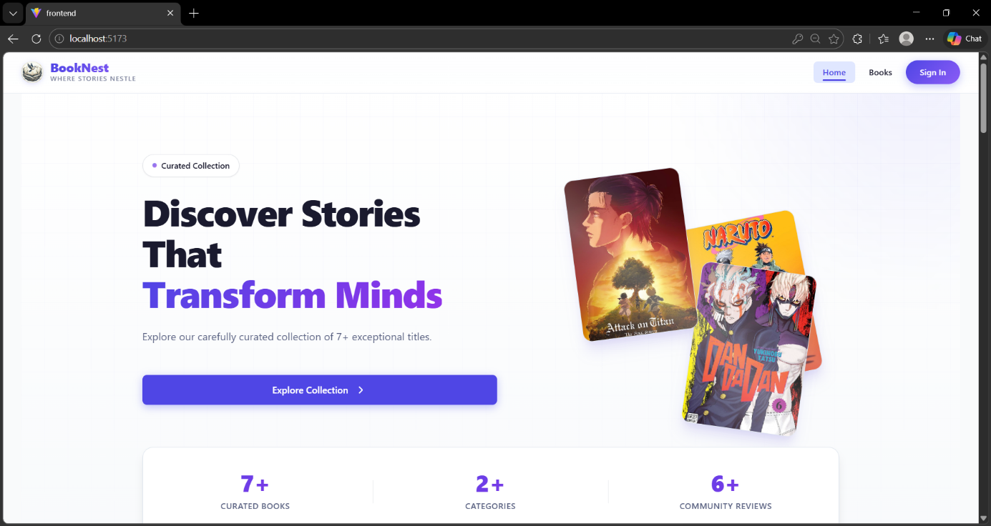

Home Page

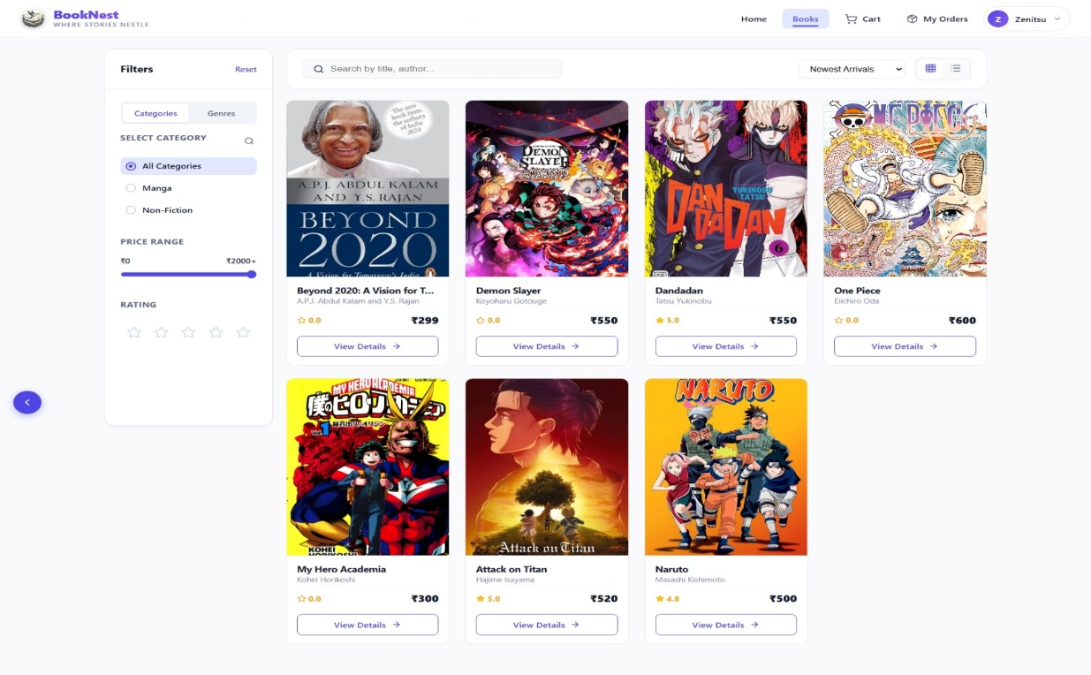
Book Listings Page

Authentication Pages
Clean registration and login forms with role selection (User / Seller). Validation feedback displayed inline.

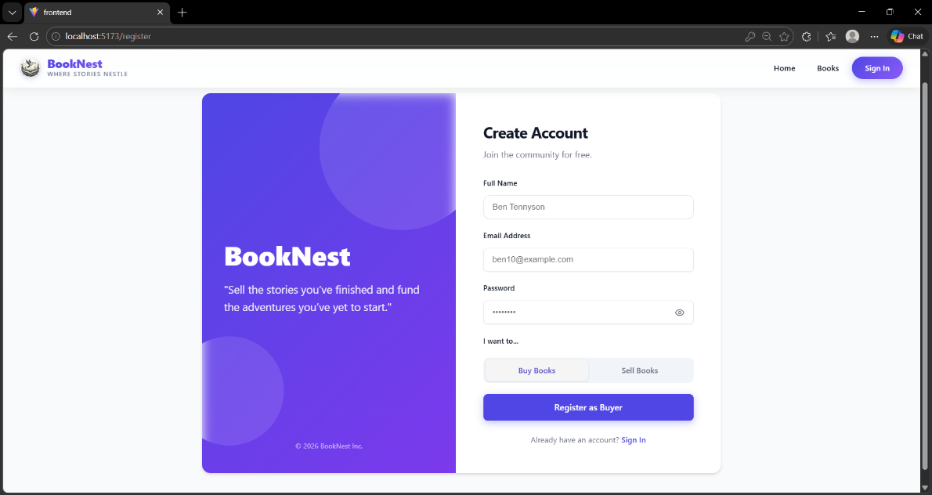
Seller/User Registration Page

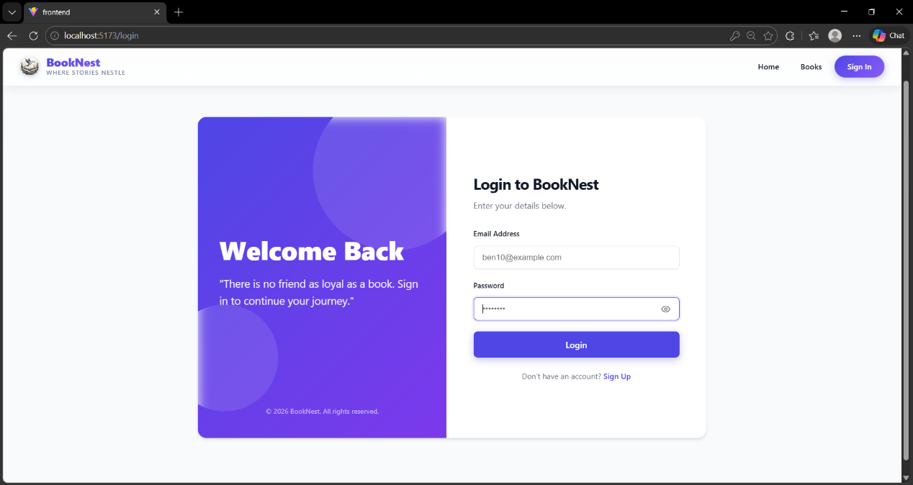

Admin/Seller/User Login Page

Book Detail Page
Full book information including description, price, seller info, and the review/rating section with star ratings and written reviews.

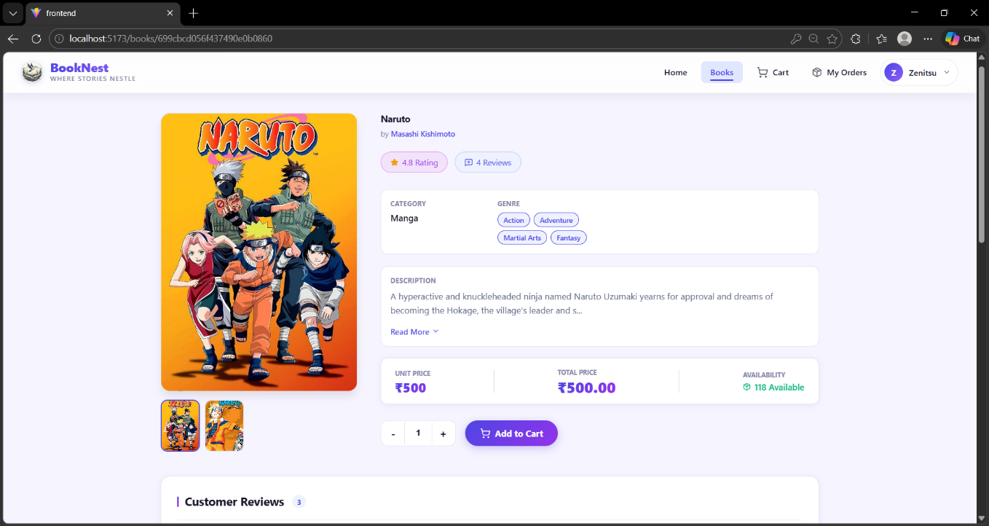Book Detail Page with Reviews

Cart & Checkout
Shopping cart with quantity controls, price summary, and a multi-step checkout flow with payment integration.

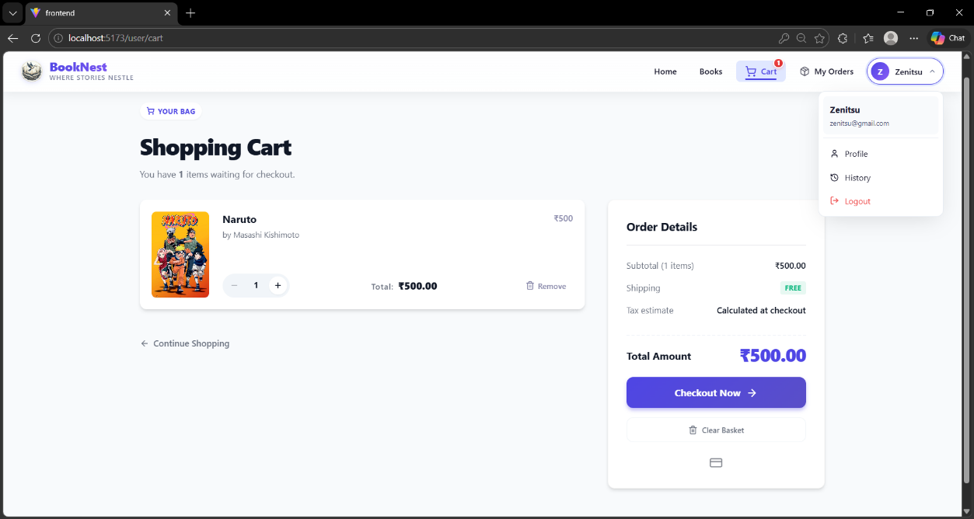
Cart Page

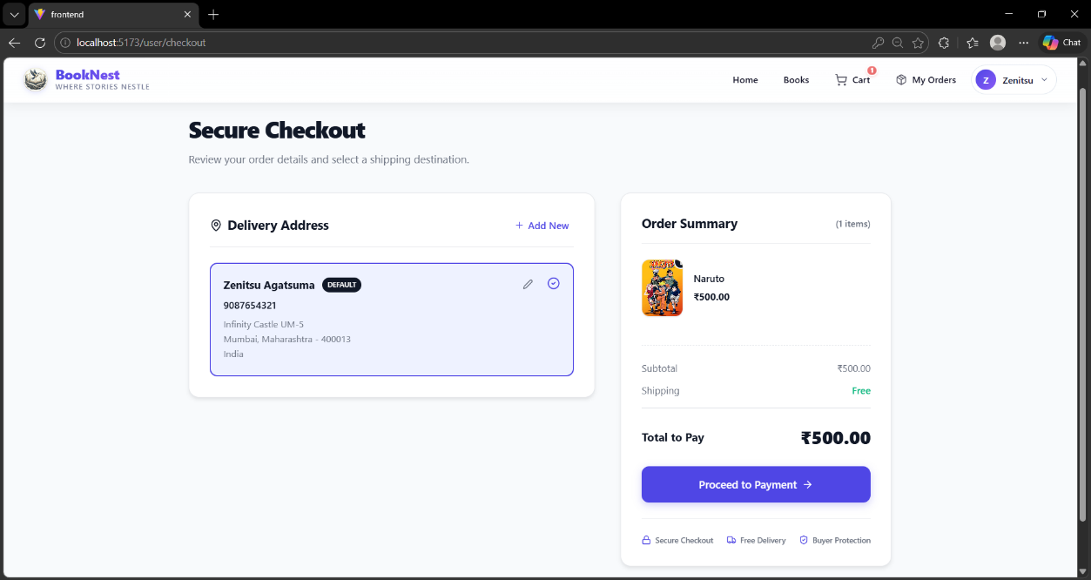
Checkout Page

Seller Dashboard
Inventory table with add/edit/delete controls, order management view, and sales analytics charts.

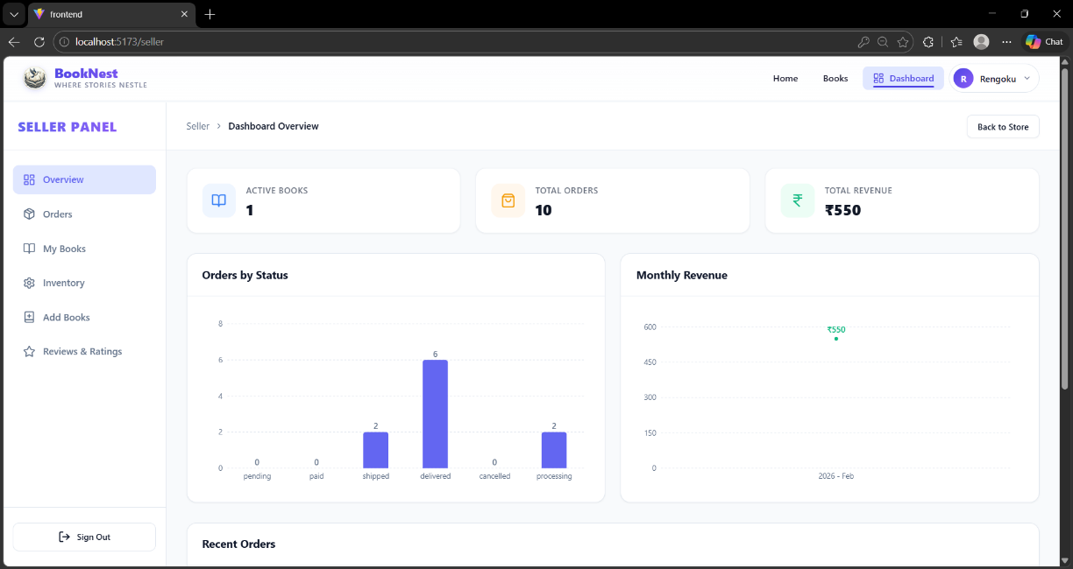
Seller Dashboard

Admin Panel
Tabbed interface for managing users, sellers, books, reviews, and accessing platform statistics.

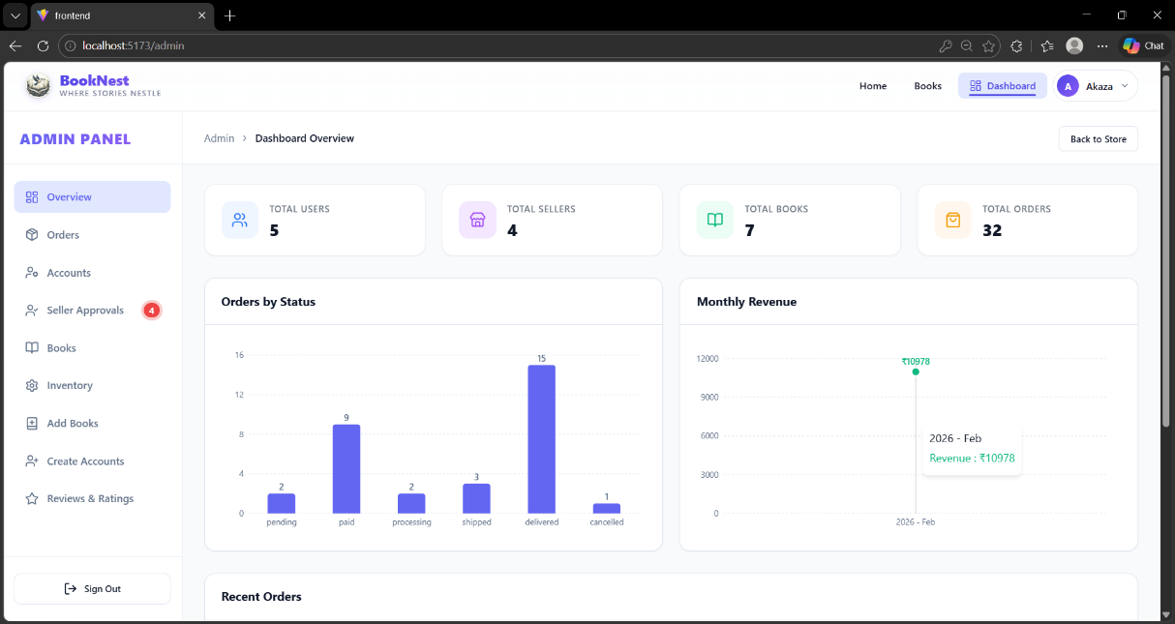
Admin Panel

10. Testing

Testing Strategy
BookNest was tested across multiple layers to ensure reliability, correctness, and performance:

Functional Testing
# | Test Case | Steps | Expected Result | Status
1 | User Registration | Submit valid name, email, password | Account created, JWT returned | Pass
2 | User Login | Submit correct credentials | Token returned, redirect to home | Pass
3 | Invalid Login | Submit wrong password | 401 error with message | Pass
4 | Book Search | Enter keyword in search bar | Matching books displayed | Pass
5 | Add to Cart | Click 'Add to Cart' on book | Cart count updated | Pass
6 | Checkout | Complete checkout form | Order created, confirmation shown | Pass
7 | Seller Add Book | Seller submits new book form | Book appears in listings | Pass
8 | Admin Delete User | Admin deletes a user account | User removed from system | Pass
9 | Submit Review | User submits star rating + comment | Review saved and displayed | Pass
10 | Protected Route | Unauthenticated user visits /cart | Redirected to login page | Pass

Performance Testing
- API response time: Average < 200ms for standard CRUD endpoints.
- Page load time: < 2.5 seconds for initial React bundle load.
- Concurrent requests: Tested with 100 simultaneous API requests.
- Database: MongoDB indexed queries on book title, author, and genre fields.
- Cart updates: Real-time UI update without full page reload.

Tools Used
- Manual testing via Postman for all API endpoints.
- Browser DevTools for frontend performance profiling.
- MongoDB Compass for database query inspection and index analysis.

11. Screenshots or Demo

The following are placeholder sections for application screenshots. Add actual screenshots or demo link before submitting documentation.

Demo Link: BookNest Video Demo Link

12. Known Issues
The following known issues and limitations have been identified during development and testing:

# | Issue | Affected Area | Workaround / Notes
1 | No real-time order notifications | Orders | Users must refresh page to see status updates
2 | Image upload stored locally (no cloud) | Book Listings | Images lost on server restart; use persistent storage for production
3 | No email verification on registration | Authentication | Users can register with invalid emails
4 | Cart not persisted across sessions | Cart | Cart resets on logout; requires backend session storage
5 | Basic payment simulation only | Checkout | No real payment gateway; integrate Stripe/Razorpay for production
6 | No SEO optimization (SPA) | Frontend | Search engine indexing limited; SSR with Next.js recommended
7 | No automated test suite | Testing | All testing done manually; Jest/Cypress integration planned

13. Future Enhancements
The following enhancements are planned for future versions of BookNest:

Short-Term (Next Release)
- Email Verification: OTP-based email verification during user registration for account security.
- Real-Time Notifications: WebSocket integration (Socket.io) for instant order status and review alerts.
- Payment Gateway: Stripe or Razorpay integration for real payment processing with receipt generation.

Mid-Term
- AI Book Recommendations: Machine learning model to suggest books based on purchase history and preferences.
- Mobile Application: React Native app for iOS and Android with full feature parity.
- E-book Support: Digital download support alongside physical book purchases.

Long-Term
- Automated Testing Suite: Full Jest unit tests and Cypress end-to-end test coverage.
- CI/CD Pipeline: GitHub Actions automated build, test, and deployment pipeline.
- Cloud Deployment: AWS or Azure deployment with auto-scaling, load balancing, and CDN.
- Multi-language & Multi-currency: Internationalization (i18n) for global markets.
- Social Features: Reading lists, book clubs, follow-an-author, and social sharing.
- Loyalty Program: Points-based rewards system for frequent buyers with discount redemption.
- Subscription Model: Monthly subscription for exclusive discounts and early access to new listings.

